Strategic Plan Appendices

Cumberland County Substance Abuse Strategic Plan 2007

Table of Contents:

Appendix A: Assessment Report (please see separate Assessment Report and Assessment Appendix)

Appendix B: Planning Model……………………………………….pg. 2

Appendix C: MOUs………………………………………………....pg. 5

Appendix D: Comprehensive Approach Strategy Models………….pg. 7

Appendix B: Planning Models

Planning Model for High Risk Drinking Among Youth

Problem Goals Objectives Strategies Planning Model for High Risk Drinking Among Young Adults

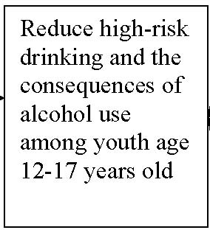
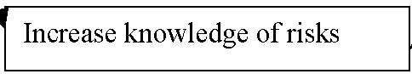
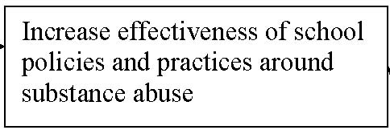
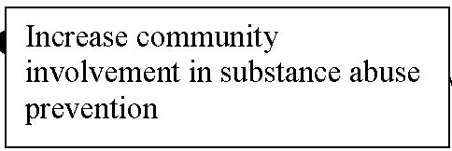
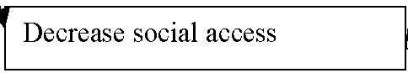

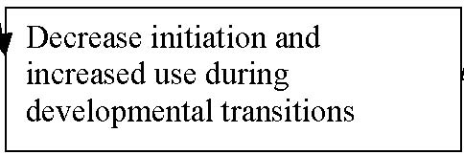
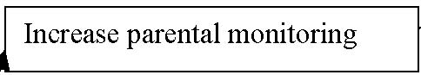

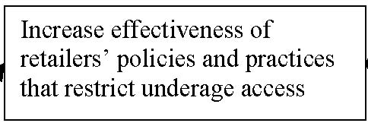

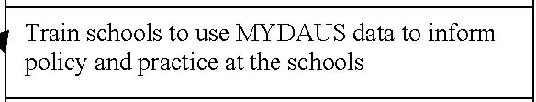
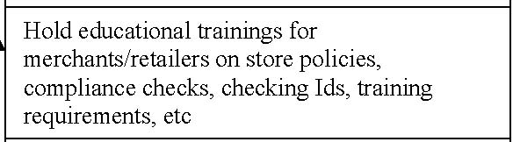
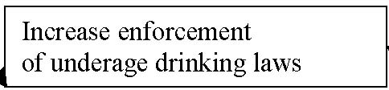
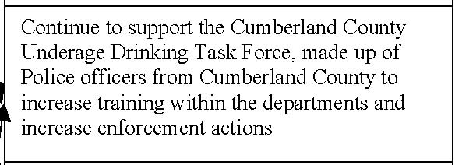
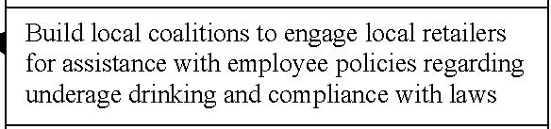


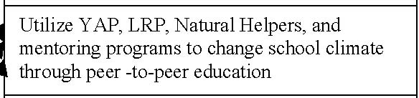

Decrease initiation and increased use during developmental transitions

Increase community involvement in substance abuse prevention

Decrease social access

Increase knowledge of risks

Increase effectiveness of schoolpolicies and practices around substance abuse

Increase effectiveness of retailers’ policies and practices that restrict underage access

Increase enforcement
of underage drinking laws

Increase parental monitoring

Reduce high-risk drinking and the consequences of alcohol use among youth age 12-17 years old

Increase in sexual risks while using alcohol, high rates of alcohol use in attempted suicides, neurocognitive impairment from alcohol use ;
High rates of underage drinking in all parts of Cumberland County

Advocate for implementation of prevention strategies during transition periods and train decision makers in the importance of identify youth at risk during transition times

Train schools to use MYDAUS data to inform policy and practice at the schools

Utilize YAP, LRP, Natural Helpers, and mentoring programs to change school climate through peer -to-peer education

Build local coalitions to engage local retailers for assistance with employee policies regarding underage drinking and compliance with laws

Hold educational trainings for merchants/retailers on store policies, compliance checks, checking Ids, training requirements, etc

Build local coalitions with participation from schools, parents, youth, retailers and prevention providers to work on substance abuse prevention strategies

Implement a positive tickets campaign

Continue to support the Cumberland County Underage Drinking Task Force, made up of Police officers from Cumberland County to increase training within the departments and increase enforcement actions

Disseminate social marketing materials from OSA directed at parental monitoring skills

Problem Goals Objectives Strategies Planning Model for Prescription Drug Misuse
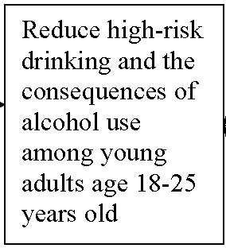
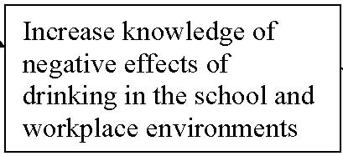

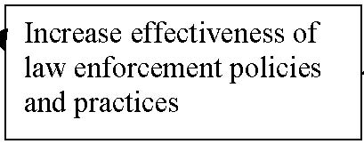
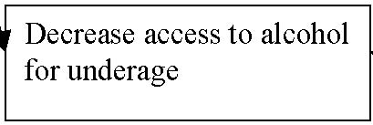

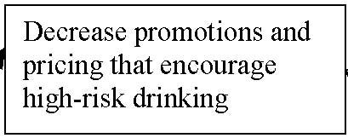
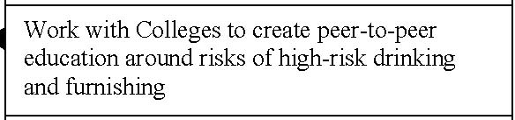
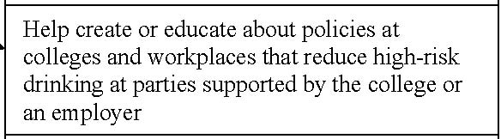

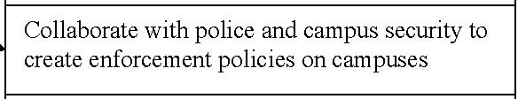



Advocate for alternative activities without alcohol

Distribute information about personalized assessment-feedback and brief intervention services
Work with colleges and workplaces to distribute informational materials and make employers drug-free workplace policy known to all employees

Educate merchants about negative impact and advocate for limiting promotions that encourage high-risk drinking

Work with Colleges to create peer-to-peer education around risks of high-risk drinking and furnishing

Help create or educate about policies at colleges and workplaces that reduce high-risk drinking at parties supported by the college or an employer

Work with Law enforcement to check compliance of pricing and promotion laws

Collaborate with police and campus security to create enforcement policies on campuses

Implement a social marketing campaign about the consequences of furnishing to minors

Decrease promotions and pricing that encourage high-risk drinking

Increase knowledge of negative effects of drinking in the school and workplace environments

Increase effectiveness of law enforcement policies and practices

Decrease access to alcohol for underage

Increase knowledge of health risks of high-risk drinking

Increase in sexual risks while using alcohol, high rates of binge drinking, neurocognitive impairment from alcohol use, high rates of fatal traffic accidents that are alcohol involved in Cumberland County, and high rates of alcohol addiction among this age group

Reduce high-risk drinking and the consequences of alcohol use among young adults age 18-25 years old

Problem Goals Objectives Strategies


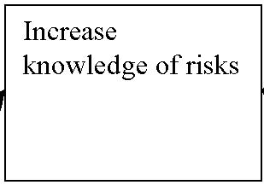

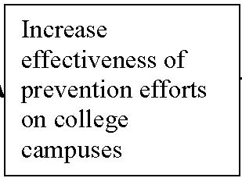

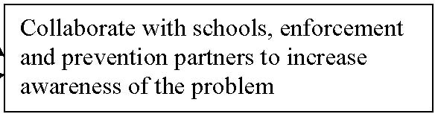
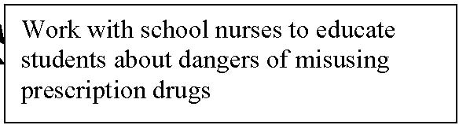

Educate general population about proper disposal of prescription drugs

Educate youth and parents about the risks of misusing prescription drugs

Work with school nurses to educate students about dangers of misusing prescription drugs

Collaborate with schools, enforcement and prevention partners to increase awareness of the problem

Increase effectiveness of prevention efforts on college campuses

Increase knowledge of risks

High rates of addicition among young adult population, increases in ER visits associated with Rx Misuse; misuse of Prescription drugs

Reduce Prescription drug misuse

Appendix C: MOUs

Please see original signed MOUs sent in the mail

People who signed MOUs and the organizations they represent:

Margaret Jones | Day One
Malory Shaughnessy | County of Cumberland
Malory Shaughnessy | Maine Association of Prevention Programs
Colleen Taylor-Capano | Parent in Gray/ New Gloucester
Michael Clifford | Portland Public Schools
Robin Haley | Falmouth School Department
Dona Forke | Healthy Options Together
Carol Troy | The Women’s Project
Erica Schmitz | 21 Reasons
Sandra Hale | Westbrook School Department
Christina Lamarre | Raymond Mentoring Partnership
Amanda Beal | PROP’s Drug Free Community Program
LeeAnne Dodge | USM
Tina Pettingill | City of Portland

Below is a copy of the MOU used by the Collective and signed by the members. Memorandum of Understanding
Between Communities Promoting Health Coalition,
The Cumberland County Comprehensive Community Health Coalition and
Member Organizations of the Cumberland County SPEP Collective

Purpose: Communities Promoting Health Coalition (CPHC), The Cumberland County Comprehensive Community Health Coalition (CCCHC) and the member organizations of the SPEP “Collective”, share the common objective of preventing substance abuse in Cumberland County. The member organizations have worked together to assess the scope of the problem within the county and identify the priorities to work on collectively in the future. Through this memorandum of understanding, CPHC and the member organizations agree to continue our work into the implementation phase with future funding and to build the Collective’s capacity to do so. We agree to collaborate by sharing our expertise, knowledge and our commitment to prevention with one another in the Collective.

Roles and Responsibilities for Communities Promoting Health Coalition
- • CPHC, through the position funded by OSA – Department of Health and Human Services, will continue to organize the Collective monthly meetings and recruit new members to ensure county-wide representation
- • CPHC and CCCHC will work to achieve the goals of the strategic plan created by the Collective
- • CPHC and CCCHC will work to build the capacity of the Collective to address the priorities set forth by the member organizations and the requirements of OSA

Roles and Responsibilities for member organizations of “The Collective”
- • Member organizations will continue their participation in the Collective
- • Member organizations will provide their support, knowledge, and expertise to achieve the goals of the strategic plan created by the Collective
- • Member organizations will support the implementation of evidence-based strategies to reduce alcohol use among youth
- • Member organizations will support the implementation of evidence-based strategies to reduce high risk drinking among adults (especially 18-25 year olds)

The undersigned member organization agrees to the spirit of this memorandum of understanding with Communities Promoting Health Coalition and The Cumberland County Comprehensive Community Health Coaltion and agrees to participate as a Community Partner in this effort.

Name of Organization

Name of Administrator or Member and Title

Signature of Administrator or Member Date

Communities Promoting Health Coalition

Name of Administrator and Title

Signature of Administrator Date

Phone email

Please return a copy of this signed MOU by, May 22, 2007 to:
Or fax to Liz at 874-1155

Liz Blackwell-Moore
PROP
510 Cumberland Ave
Portland, ME 04101

Appendix D: Comprehensive Approach Strategy Models

The models below were created by members of the Core Group. After the Collective brainstormed strategies during the strategic planning workshop, Core Group members expanded the strategies and found tools, resources, and/or citations to back up the strategies. The Core Group members who created these models are: Erica Schmitz, Liz Blackwell-Moore, Amanda Beal, Lucie Rioux, Kaki Dimock, and Ronni Katz.

High Risk Drinking Among Youth:

Intervening Factor | Sample comprehensive approach using evidence-based strategies | Tools/Resources/Citations  (note: this is a sample, and not a comprehensive list)
Alcohol Access: RETAIL | Enforcement: Retail Compliance Checks; investigation of underage drinking incidents to ensure retail violations are addressed.  Collaboration: Community organizing for policy changes to reduce youth access to alcohol; Collaboration with retailers to prioritize reducing underage access and implement strategies such as voluntary mystery shopper program.  Education: Merchant education, Clerk training, Responsible Beverage Service Training (RBS)  Communications: Alcohol Warning Posters; Strategic use of the Media to increase public perception that the laws are being enforced and that retailers will not sell to minors.  Policy –Retailers: Minimum age of seller requirements, Training requirements, Checking age identification requirements , Responsible Retailing systems—management policies & practices.  Policy-Community: Community festivals regulations; Zoning ordinances to limit alcohol outlet density  Policy- State: Administrative Penalties; Minimum Age of Seller Requirements; Pricing strategies to make alcohol less available to minors. | Community Trials/PIRE: http://www.pire.org/CommunityTrials/  Treno, A.J. and Holder, H.D. (1997). Community mobilization: evaluation of an environmental approach to local action. Addiction. 92 (Supplement 2): S173-S187; and Grube JW. (1997). Preventing sales of alcohol to minors: results from a community trial. Addiction 92: S251-60.  Responsible Sales Guides/UDETC/PIRE/OJJDP:  http://www.udetc.org/documents/PreventingSales.pdf - Merchant Education Programs  http://www.udetc.org/documents/ReduceAlsal.pdf - Compliance Checks  CMCA/University of Minnesota: http://www.epi.umn.edu/alcohol/cmca/index.shtm  Wagenaar, A.C., Gehan, J.P., Jones-Webb, R., Toomey, T.L., Forster, J.L. (1999). Communities Mobilizing for Change on Alcohol: Lessons and results from a 15-community randomized trial. Journal of Community Psychology. 27(3):315-326.  Sample Policies & Materials/ UMN: http://www.epi.umn.edu/alcohol/policy/access.shtm  Wagenaar, A. C., T. L. Toomey, et al. (2005). Preventing youth access to alcohol: Outcomes from a multi-community time-series trial. Addiction, 100(3), 335-345.  · Compliance Checks – includes guide for law enforcement · Administrative Penalties  · Responsible Beverage Service Training · Checking Age Identification  · Regulations or Bans on Home Delivery of Alcohol · Minimum Age of Seller  · Alcohol Warning Posters  Community Festivals Materials/UMN: http://www.epi.umn.edu/alcohol/festivals/index.shtm  Toomey TL, Erickson DJ, Patrek W, Fletcher LA, Wagenaar AC. (2005). Illegal alcohol sales and use of alcohol control policies at community festivals. Public Health Reports, 120(2):165-173.  Integrated Responsible Retailing Model: http://fcpr.fsu.edu/retail/integrated_RR_model.html  http://fcpr.fsu.edu/retail/documents/BP_Report_Conference_Edition.pdf (CSAP document)  Pricing Strategies: http://www.cspinet.org/booze/taxguide/TaxIndex.htm  Chaloupka F, et al. (2002). The effects of price on alcohol consumption and alcohol-related problems. Alcohol Research and Health, 26(1):22-34.  Maine-specific resources:  - - State-Approved RBS Trainings: http://www.maine.gov/dps/liqr/Docs/CertTrain.doc  - - State-level policy change – Maine Association of Prevention Programs & Maine Alcohol Impact Coalition – mshaughnessy@masap.org  - - Coming soon (summer/fall 2007): Lessons Learned & Sample Materials from HEAPP’s Responsible Retailing pilot program

Intervening Factor | Sample comprehensive approach using evidence-based strategies | Tools/Resources/Citations  (note: this is a sample, and not a comprehensive list)
Parental monitoring practices | Communications: Social marketing campaign & materials targeting parents; publicize school policies and law enforcement policies regarding underage drinking.  Collaboration: Partnership with local media, parent groups, schools, doctor’s offices, businesses, etc. to get the message out  Enforcement: Increase enforcement of underage drinking laws (see below)  Policy: Notification of parents required by school policy (within confidentiality regulations) and police department policy  Education*: Community parent meetings to educate parents about effective monitoring practices  * What about curriculum-based parent education programs?  In the One ME evaluation, most communities did not report positive outcomes from curriculum-based programs. This was due to challenges with implementation, including difficulty getting enough participants to make the programs cost-effective. In designing a strategy to increase parental monitoring, consider issues of cost vs. benefit, reach, saturation, and dosage. | Parental Monitoring  Beck, K.H., Shattuck, T., Haynie, D. Crump, A.D., and Simons-Morton, B. (1999). Associations between parent awareness, monitoring, enforcement and adolescent involvement with alcohol. Health Education Research, 14(6), 765-775.  Shillington, A. M., S. Lehman, et al. (2005). Parental monitoring: Can it continue to be protective among high-risk adolescents? Journal of Child & Adolescent Substance Abuse, 15(1), 1-15.  Parent Media Campaigns  Stephenson MT, Quick BL. (2005). Parent ads in the National Youth Anti-Drug Media Campaign. J Health Commun. Dec;10(8):701-10.  Surkan PJ, Dejong W, Herr-Zaya KM, Rodriguez-Howard M, Fay K. (2003). A paid radio advertising campaign to promote parent-child communication about alcohol. J Health Commun. Sep-Oct;8(5):489-95.  OSA Parent Campaign/Social marketing materials  Developing an effective social marketing campaign can be expensive and challenging, and can end up doing more harm than good if not based in solid research and expertise (see Why Bad Ads Happen to Good Causes, by Andy Goodman). Rather than create stand-alone local campaigns, Maine communities are encouraged to expand local dissemination of the OSA Parent Campaign:  - - Television ads: http://www.maineparents.net/tv_ads.html  - - Materials for parents: http://www.maineparents.net/useful_info_for_parents.html  - - Community parent forums & discussion guide: coming soon from OSA (summer/fall 2007), pilot materials available now  School policy guidelines: coming soon from OSA (early 2008)  One ME evaluation of parenting programs:  http://www.maine.gov/dhhs/osa/pubs/prev/2006/onemefinaleval.doc  “Even with extensive recruitment efforts, most coalitions who selected programs targeting parents had little success in getting them to actually attend the sessions. …Most coalitions will not sustain parenting programs because they weighed the effort and associated costs of recruitment and implementation with the numbers of parents served and decided the programs are not a good use of prevention resources” (p.117).

Intervening Factor | Sample comprehensive approach using evidence-based strategies | Tools/Resources/Citations  (note: this is a sample, and not a comprehensive list)
Effectiveness of law enforcement | Enforcement: Increase enforcement actions related to underage drinking, furnishing, and hosting laws  Collaboration: Coalition-building between law enforcement and prevention community to establish underage drinking enforcement as shared priority  Policy: Departmental policy around underage drinking enforcement, based on model policy  Education: Training for officers regarding best practices, model policy implementation, & why it’s important  Communications: Work with police & DA’s office to publicize incidents of furnishers/hosts being caught & prosecuted. Publicize penalties for furnishing and hosting. Use media strategically to increase community support for enforcement. | Enforcement of possession laws & deterrence:  Dent WC, Grube JW, Biglan A. Community level alcohol availability and enforcement of possession laws as predictors of youth drinking. Preventive Medicine 40 (2005) 355-362.  Grovesnor, D., Toomey, T.L., Wagenaar, A.C. (1999). Deterrence and the Adolescent Drinking Driver. Journal of Safety Research. 30(3) 187-191.  Enforcement of social host laws & deterrence:  Jones-Webb R, Toomey T, Miner K, Wagenaar AC, Wolfson M, Poon R. Why and in what context adolescents obtain alcohol from adults: A pilot study. Substance Use & Misuse , (2):219-28, 1997.  Wagenaar AC, Toomey TL, Murray DM, Short BJ, Wolfson M, Jones-Webb R. Sources of alcohol for underage drinkers. Journal of Studies on Alcohol , 57(3):325-33, 1996.  Party Patrols: http://www.udetc.org/documents/UnderageDrinking.pdf  Reducing Third-Party Transactions: http://www.udetc.org/documents/Reducing3rdParty.pdf  Media Advocacy for Enforcement: http://www.udetc.org/documents/mediaadvocacy.pdf  Maine Model Policy from Maine Chiefs of Police Association & OSA http://www.maine.gov/dhhs/osa/prevention/lawenforcement/policy.htm  Sticker Shock (sample warning posters about furnishing): http://www.maine.gov/dhhs/osa/prevention/youth/sticker.htm  Other OSA Resources for underage drinking enforcement: http://www.maine.gov/dhhs/osa/prevention/lawenforcement/resources.htm

Intervening Factor | Sample comprehensive approach using evidence-based strategies | Tools/Resources/Citations  (note: this is a sample, and not a comprehensive list)
School Climate | Communications:  Utilize School newsletters & websites – messaging about parents talking with kids about s/a regularly, and especially prior to monumental events (prom, graduation, sports finals, etc).  Youth develop series on substance abuse (using existing media) – create own intro’s  Collaboration:  Annual community forum to present s/a data  Create strong connections/utilize community org’s providing youth services & programming  Mentoring programs b/w incoming students and upperclassmen & peer mentoring  Enforcement:  Get coaches on board with school policies, and enforce them  S/A screenings/education at gateway to school events  Policy:  Establish youth council’s as liason’s to school board, town council, etc  S/A related presentations to school board  Education:  Train school admin how to interpret MYDAUS data  Student access to full-time substance abuse counselors  Look at prevention curriculum – when delivered, frequency, evaluation? Provide information to school administrators, school board, and PTA/PTO about available curriculum-based model programs to address s/a prevention  Create speakers bureau for S/A issues and distribute to schools  Other: | Programs:  Youth Advocacy Program – The YAP program engages youth in learning and designing activities aimed at creating environmental change around health related issues, including tobacco and substance abuse.  Leadership & Resiliency Program (model program) – LRP recruits identified at-risk high school age students, and engage them in activities that foster leadership skills, a sense of community, and enhance relationships with key adults and organizations. LRP youth then design and carry out community projects that benefit their peers and community, such as organizing school forums on underage drinking. http://modelprograms.samhsa.gov/pdfs/model/leadership.pdf  Raymond Mentoring Partnership - The Raymond Mentoring Partnership coordinates two types of mentoring relationships. One matches adult and teen mentors with K-8 grade students for long-term caring, committed, supportive friendships. Pairs meet once a week for 1-2 hours during the school year. The other type of mentoring relationship, called Kids 2 Kids, involves training 7th and 8th grade students to be mentors to elementary school students. http://www.raymondmaine.org/civic_groups/Communities%20for%20Children/raymond_mentoring_partnership.htm  Natural Helpers Program (Day One) - Peer listening and support program for High School students.  http://www.day-one.org/07_schools/schools.html  Curriculum-based program: Protecting You/Protecting Me (model program) – 5 year, classroom-based alcohol –use prevention curriculum for elementary students in grades 1-5 and high school students in grades 11 & 12. Focus on the brain, growth & development, health & safety, rules & laws, friends, choices & decisions, media awareness, and communication skills. Outcomes include reduced binge drinking by 72% , 56% increase in knowledge about brain development and negative impact of alcohol. http://modelprograms.samhsa.gov/pdfs/model/PYPM.pdf  Resources:  Leadership to Keep Children Alcohol Free – Resources, sample policies & statistics for educators  http://www.alcoholfreechildren.org/en/audiences/educators.cfm  National Institutes of Health: National Institute on Alcohol Abuse and Alcoholism – Initiative on Underage Drinking provides stats and links to research on underage drinking, as well as posters and other resources for teachers.  http://www.niaaa.nih.gov/AboutNIAAA/NIAAASponsoredPrograms/underage.htm  Youth On Board - www.youthonboard.org - Youth on Board helps young people and adults think differently about each other so that they can work together to change their communities and schools- build skills, mutually respectful relationships between young people and adults that allow young people to move from the margins of their communities into the center.

Intervening Factor | Sample comprehensive approach using evidence-based strategies | Tools/Resources/Citations  (note: this is a sample, and not a comprehensive list)
Developmental Transitions | Collaboration: Partner with Schools  Communications: Media Campaign- transitions- targeting parents of 5th, 8th, and 12th graders  Articles in the school paper  Policy: Develop policy- how to deal with transitions, examine the ways new students are integrated into school- school building- climate, culture, integration  Education:  - • Teacher Training  - • Peer Leader Training for Middle School  - • Parent Education- school forum  - • HS students mentor middle school students  - • College Students educate HS students  Enforcement: School Resource Officer  Other: | Programs:  Too Good For Drugs (TGFD) model CSAP Program for ages K-12 that utilizes multi-lesson, multi-grade level programming that can be implemented in schools, after school programs and for staff development.  http://wch.uhs.wisc.edu/14-Archives/14-SIG/02-SIG-ModelProg-MatrixHTML.html#TGFD  Resources:  ONDCP describes the evidence-based principles of substance abuse prevention includes strategies that are targeting to youth during transition times whether they are expected transitions (such as puberty, adolescence, graduating from school) or unexpected (like the death of a loved one).  http://www.ncjrs.gov/ondcppubs/publications/prevent/evidence_based_eng.html

Intervening Factor | Sample comprehensive approach using evidence-based strategies | Tools/Resources/Citations  (note: this is a sample, and not a comprehensive list)
Community Climate | Communications:  Increase community awareness on the importance of positive adult modeling; Increase public perception of risks; Increase community awareness that alcohol is a gateway drug and can lead to other addictions; Increase knowledge on the consequences of furnishing alcohol to minors (family); Knowledge of how kids are gaining access to alcohol; Regular parent-youth check-ins; Liquor cabinet lock ups  Collaboration:  Alcohol-free events/activities; creating places and spaces for kids to congregate that are visible and open to the public encouraging positive relationships  Enforcement:  Positive ticketing; party patrols; special enforcement campaigns; parents informing police when they are out of town  Policy:  Prohibition of alcohol sponsorship at public events; controls on alcohol advertising – billboards, buses, etc; Increase opportunities for youth to be involved such as creating a youth council  Education:  Portion size training; drinking patterns training, risks and expectations – genetic risks; how alcohol affects the body; brain development; stress management skills  Other: | Communities Mobilizing for Change on Alcohol Model Program –  http://modelprograms.samhsa.gov/pdfs/model/Cmca.pdf  Effectively limits access to alcohol of people under legal drinking age and to communicate a clear message to the community that underage drinking is inappropriate and unacceptable. Education to alter perceptions of societal norms and expectations  Across Ages  http://modelprograms.samhsa.gov/pdfs/model/AcrossAges.pdf Mentoring combined with community service and drug education  Positive Tickets: Businesses, law enforcement, prevention educators, teachers and all members of the community work together to commend youth who do positive things by giving them free entry into an alcohol and drug free event www.positivetickets.com  Families That Care: Guiding Good Choices  http://modelprograms.samhsa.gov/pdfs/model/GGC.pdf  BEHAVIOR MODIFICATION, COMMUNITY INVOLVEMENT, INFORMATION SHARING, MEDIA EDUCATION, PARENT-CHILD INTERACTIONS, PARENT TRAINING, PEER LEADERSHIP, COUNSELING OR SUPPORT, SKILL DEVELOPMENT  Community Trials Intervention to Reduce High-Risk Drinking  http://modelprograms.samhsa.gov/pdfs/model/Community%20Trials.pdf  RBS training of alcohol establishments and related sales and service policies  • Enforcement of drinking and driving laws  • Publicity surrounding changes in youth alcohol access and drink and drive enforcement  • Media advocacy in support of alcohol policy change  • Decreased alcohol outlet density  • Decreased formal and informal youth access to alcohol  Across Ages  http://modelprograms.samhsa.gov/pdfs/model/AcrossAges.pdf  Changes in teaching approaches and parent involvement, with classroom drug education  School-based support group and skills development class
Intervening Factor | Sample comprehensive approach using evidence-based strategies | Tools/Resources/Citations  (note: this is a sample, and not a comprehensive list)
Parental Knowledge of Risks | Collaboration: Coordinating efforts/ regionalizing efforts- consistent messages; involving all stakeholders (businesses, local organizations, churches, law enforcement)  Communications: Public Access tv/ video/messages; small papers/editorials; press releases; letters to parents via school or online  Policy: Required class for parents; school policies  Education: Distributing materials, events, PTA/PTO- involving youth/ youth participation, skits, etc  Family events; ex parents and kid class  Enforcement: Safe guard, Legal consequences/ liability info for parents  Other: | Programs:  Project Northland: Project for 6-8th graders involving students, peers, parents, and community members in a 3 year program that takes place in the home, at school, and finally in the community to delay the onset of alcohol use, reduce use among those already drinking, and decrease consequences related to use. (On SAMSHA Registry of programs)  http://www.nrepp.samhsa.gov/programfulldetails.asp?PROGRAM_ID=100#studies  Keep A Clear Mind (KACM) CSAP Model Program designed to increase knowledge of 9-11 year olds about alcohol and drug use to delay age of onset of use.  http://wch.uhs.wisc.edu/14-Archives/14-SIG/02-SIG-ModelProg-MatrixHTML.html#KACM  Resources:  National website with information on Health Risks for Parents:  http://www.family.samhsa.gov/  Maine website with information for parents  www.maineparents.net

High Risk Drinking for Young Adults

Intervening Factor | Sample comprehensive approach using evidence-based strategies | Tools/Resources/Citations  (note: this is a sample, and not a comprehensive list)
Access: Promotions & Pricing | Collaboration: Collaboration with retailers to limit promotions that encourage high-risk drinking, including cheap drink specials. Community mobilizing for local and state-level policy changes to limit promotions and increase pricing.  Education: Merchant education about the negative impacts of low pricing and promotions  Communications: Strategic use of the media to increase public awareness of negative impacts of low pricing and promotions.  Policy –Retailers: Bar Owners’ Agreement/Policy to limit pricing specials, limit serving sizes, only one drink per customer at a time, etc.  Policy-College or Workplace: Policies to reduce high-risk drinking among legal drinkers at college or workplace parties where alcohol service is appropriate. E.g. no self-service of alcohol; no free or low-cost alcohol; limit serving sizes; only one drink per customer at a time; comparably priced and equally appealing non-alcoholic beverages.  Policy- State: Limits on cheap drink specials and other promotions that encourage high-risk drinking. Increase price of alcohol.  Enforcement: Compliance checks to make sure pricing and promotions are compliant with law. Increase communication with law enforcement and Liquor Licensing regarding citizen concerns about promotions by local establishments. Ensure that Drug-Free Workplace Policies are followed when planning work-sponsored events. | Pricing:  Chaloupka F., et al. (2002). The effects of price on alcohol consumption and alcohol-related problems. Alcohol Research and Health, 26(1):22-34.  Kuo, M.C. et al.. (2003) The marketing of alcohol to college students: The role of low prices and special promotions. American Journal of Preventive Medicine. 25:204-211.  - • Alcohol taxes: http://www.cspinet.org/booze/taxguide/TaxIndex.htm  - • Limits on low pricing & promotions:  - o AMA literature review: http://www.alcoholpolicymd.com/alcohol_and_health/study_high_risk.htm  College setting:  Gebhardt, T.L. et al. (2000). A campus-community coalition to control alcohol-related problems off campus: An environmental management case study. Journal of American College Health. 48(5):211-214.  Workplace setting:  National Institute on Alcohol Abuse and Alcoholism, Alcohol Alert: Alcohol and the Workplace (1999), #44: http://pubs.niaaa.nih.gov/publications/aa44.htm  U.S. DOL Working Partners for an Alcohol and Drug-Free Workplace, Impaired Driving – Nine tips for Office Celebrations. www.dol.gov/asp/programs/drugs/workingpartners/sp_iss/ninetips.asp  CSAP, Drugs in the Workplace Fact Sheet http://dwp.samhsa.gov/DrugTesting/Files_Drug_Testing/FactSheet/factsheet041906.aspx  Maine-specific resources:  - - State-level policy change – Maine Association of Prevention Programs & Maine Alcohol Impact Coalition – mshaughnessy@masap.org  - - Workplace policy change – Maine Office of Substance Abuse, Substance Abuse and the Workplace Program: www.maineosa.org/prevention/workplace  - - Title 28-A Maine Liquor Laws: http://janus.state.me.us/legis/statutes/

Intervening Factor | Sample comprehensive approach using evidence-based strategies | Tools/Resources/Citations  (note: this is a sample, and not a comprehensive list)
Knowledge of health risks of binge drinking | Communications: Distribute information about available assessment-feedback services, educational programs and/or “self-help” materials including self-administered survey and feedback. Conduct media advocacy to increase public awareness of consequences resulting from high-risk drinking. Include information regarding health and safety risks and consequences of violating policy when employees are informed of the employer’s drug-free workplace policy.  Collaboration: Work with colleges and workplaces to distribute informational materials and/or pass policies to institutionalize the program.  Policy: College or workplace policies to offer personalized assessment-feedback to every student/employee, and/or require all students/employees to take evidence-based course as part of general orientation. Require those who break school/business substance abuse policy to participate in assessment-feedback and/or educational program.  Education: Web-based assessment-feedback program such as e-CHUG, web-based course such as College-alc, or other evidence-based program.  Enforcement: Drug-free workplace policy enforced consistently with communication of policy, education, assessment and referral to treatment as important supporting components. | Personalized assessment-feedback and brief intervention: There is promising evidence that personalized assessment-feedback (in person, on web, or even through the mail) may help to reduce high-risk drinking behavior and increase use of protective behaviors. Note: These brief interventions are meant for high-risk or problem drinkers who are not addicted or dependent (don’t need treatment). Below is a list of some of the latest studies and resources.  Walters, S. et al. (2007). A controlled trial of web-based feedback for heavy drinking college students. Prevention Science. 8(1):83-88. (e-CHUG study)  - • e-CHUG: www.e-chug.com  Saitz, R. et al. (2007). Screening and brief intervention online for college students: The iHealth study. Alcohol & Alcoholism. 42(1):28-36.  - • iHealth survey: http://www.bu.edu/dbin/sph/research_centers/SurveyAudit.htm)  Wild, T.C.et al. (2007).Controlled study of brief personalized assessment-feedback for drinkers interested in self-help. Addiction. 102(2):241-250. (aimed at general adult population)  Larimer, M.E. et al. (2007). Personalized mailed feedback for college drinking prevention: a randomized clinical trial. Journal of Consulting and Clinical Psychology. 75(2):285-293.  - • AUDIT – Alcohol Use Disorders Identification Test by the World Health Organization: http://whqlibdoc.who.int/hq/2001/WHO_MSD_MSB_01.6a.pdf  Web-based courses:  Bersamin, M.J. (2007). Effectiveness of a web-based alcohol misuse and harm-prevention course among high- and low-risk students. Journal of American College Health. 55(4):247-254.  - • College-alc: www.preventionstrategies.com/CA_purpose.html  Alcohol and Drug-Free Workplace Programs:  CSAP, Substance Abuse Prevention in the Workplace is Good Business, 2001: http://www.workplace.samhsa.gov/WPResearch/CollaborativeResearch/GoodBusiness.pdf  National Institute on Alcohol Abuse and Alcoholism, Alcohol Alert – Alcohol and the Workplace (1999), #44. http://pubs.niaaa.nih.gov/publications/aa44.htm  OSA SAW Program: www.maineosa.org/prevention/workplace (links to national resources)  U.S. Department Of Labor Working Partners Drug Free Workplace: www.dol.gov/asp/programs/drugs/workingpartners/dfworkplace/dfwp.asp  Other resources:  - • www.alcoholscreening.org (a free service by Join Together)  - • Training on Brief Alcohol Screening and Intervention for College Students (BASICS) Program: Maine's Higher Education Alcohol Prevention Partnership (HEAPP), Becky Ireland; bireland@usm.maine.edu

Intervening Factor | Sample comprehensive approach using evidence-based strategies | Tools/Resources/Citations  (note: this is a sample, and not a comprehensive list)
School Climate | Collaboration: College- campus/communication  Communications: School norms  Social Marketing  College TV/ Radio/ podcasts- media studies majors, that age group/ peers  Myspace/ facebook  Policy: Relooking at policies/ updated  Model policies  Aware- get info out there to coaches/advisors/role models  Party registration  “drunk bus”  Education: Health Center  Party/ peer education: train the trainer  Quick trainings in cafeteria or other student spaces  Enforcement: With RAs/ campus security issues  Other: | Programs:  “ Challenging College Alcohol Abuse” (CCAA), is a model NREPP program that utilizes a mass media campaign on a College Campus to reduce binge drinking.  http://www.nrepp.samhsa.gov/programfulldetails.asp?PROGRAM_ID=96  This strategy was first used at University of Arizona and they have a website dedicated to the program: http://www.socialnorms.campushealth.net.  Social Norms Campaigns  Social Marketing campaigns that have been effective on college campuses:  http://www.higheredcenter.org/socialnorms/  School Policies  List of Colleges and Universities and their various school policies regarding alcohol use and furnishing  http://www.higheredcenter.org/ideasamplers/#increasing  Resource for alcohol policies on campuses:  http://www.collegedrinkingprevention.gov/  Enforcement: see enforcement  Assessment of the College Environment Survey to help guide future prevention work on a college campus:  https://www.faceproject.org/Resources/PDF/college-cap-survey.pdf

Intervening Factor | Sample comprehensive approach using evidence-based strategies | Tools/Resources/Citations  (note: this is a sample, and not a comprehensive list)
Workplace Climate | Communications: Employee bulletin board, company newsletter, OSA website, Public Health website and publications, radio psa’s.  Collaboration: community coalitions, local merchants, corporations, law enforcement, treatment providers, HR Departments, Public Health workers, social service agencies  Enforcement: Employer must make maintaining drug-free workplace an ongoing effort, Employees must read and agree to policy as condition of employment, enforcement guided by Maine workplace laws  Policy: Provide technical assistance to companies as they develop policies, define consequences and back-to-work agreements, drug testing, offer treatment and support options to employees who are using, employer and employees write policy together  Education: OSA tools, evidenced-based programs, employee handouts, peer to peer programs, supervisor training  Other: | http://www.maine.gov/dhhs/osa/prevention/workplace/index.htm  http://www.maine.gov/dhhs/osa/prevention/workplace/laws.htm  http://www.dol.gov/elaws/asp/drugfree/drugs/supervisor/screen45.asp  http://www.dol.gov/elaws/asp/drugfree/drugs/employee/screen68.asp  http://www.maine.gov/dhhs/osa/prevention/workplace/index.htm  Evidenced-based programs: The Healthy Workplace, Team Awareness, Wellness Outreach at Work, Parenting Partnership:  http://workplace.samhsa.gov/Interventions/WPResources020604.htm

Intervening Factor | Sample comprehensive approach using evidence-based strategies | Tools/Resources/Citations  (note: this is a sample, and not a comprehensive list)
Social Access | Communications:  Collaboration:  Enforcement:  Policy:  Education:  Other: | Provide information to broad audience re: furnishing laws & consequences  Promote alternative activities, provide information on ways to have fun without alcohol  College administration, student groups, employers & law enforcement work together to create coordinated response and message to 21-25 year olds re: furnishing & promote alternative activities  Party patrols & investigations that focus on furnishing: Shoulder Tap and Fake ID Programs  http://www.nhtsa.dot.gov/people/injury/alcohol/Community%20Guides%20HTML/Book5_Enforcement.html#Shoulder%20tap  No self-service at college and/or worksite parties  Alcohol-free event policies at colleges and/or worksites  ID access to parties & social host liability  http://captus.samhsa.gov//northeast/PDF/critical/envicr.pdf  National Institute on Alcohol Abuse and Alcoholism, Alcohol Alert: Alcohol and the Workplace (1999), #44: http://pubs.niaaa.nih.gov/publications/aa44.htm  U.S. DOL Working Partners for an Alcohol and Drug-Free Workplace, Impaired Driving – Nine tips for Office Celebrations. www.dol.gov/asp/programs/drugs/workingpartners/sp_iss/ninetips.asp  CSAP, Drugs in the Workplace Fact Sheet http://dwp.samhsa.gov/DrugTesting/Files_Drug_Testing/FactSheet/factsheet041906.aspx  Training on furnishing laws for students and employers – maybe at freshman orientation or through RAs and/or through employee orientation

Prescription Drug Misuse

Intervening Factor | Sample comprehensive approach using evidence-based strategies | Tools/Resources/Citations  (note: this is a sample, and not a comprehensive list)
Perceived Risk | Collaboration: Dr’s, school based health centers/ nurses  Communications: Risks to parents- proper disposal, communicate risks to kids, fatalities  Messages out about affect on academic performance; peer messaging  Policy:  Education: Look at campaign for antibiotic overuse- have Dr’s communicate school based health centers/school curriculum  Enforcement:  Other: | Proper disposal of Rx:  http://www.whitehousedrugpolicy.gov/drugfact/factsht/proper_disposal.html  Facts about Rx Misuse:  http://www.nida.nih.gov/nida_notes/NNVol16N3/Tearoff.html  Programs to help educate Dr’s on identifying Rx misuse, educating pharmacists and parents:  http://cadca.org/PrescriptionDrugAbuse/CADCAInitiatives.htm  Specific information about Rx Misuse and how to disseminate it to young adults  http://cadca.org/PrescriptionDrugAbuse/Strat38.pdf

Intervening Factor | Sample comprehensive approach using evidence-based strategies | Tools/Resources/Citations  (note: this is a sample, and not a comprehensive list)
School Climate | Communications:  Collaboration:  Enforcement:  Policy:  Education:  Other: | Include information on prescription drug use in health class curriculum  Provide general information on side effects of commonly misused prescription drugs at school  School administration, public health advocates, parents and local law enforcement work together to include prescription drug misuse on radar for all  Students receive prescribed & OTC medication through nurses office  Chem-free campuses  Provide general information on side effects of commonly misused prescription drugs at school

