Assessment Appendices:

Cumberland County Substance Abuse Assessment June 2007

Table of Contents:

Appendix A: Highlights from the Preliminary Assessment……..pg. 2

Appendix B: Focus Group Questions……………………………pg. 21

Appendix C: Focus Group Results………………………………pg. 27

Appendix D: Key Leader Questions…………………………….pg. 31

Appendix E: Key Leader Results………………………………..pg. 32

Appendix F: Key Findings Summary…………………………...pg. 35

Appendix G: Capacity Report……………………………….….pg. 48

Appendix A:

Highlights from Preliminary Assessment

Cumberland County SPEP Project

ALCOHOL

Youth and Alcohol:

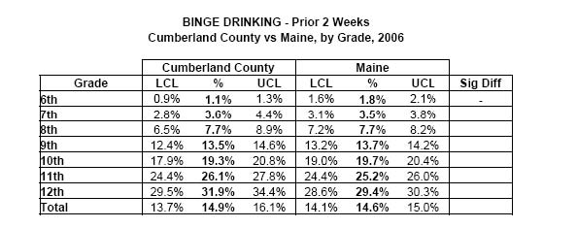
Source: Cumberland Co MYDAUS 2006

Urban MYDAUS data 2004 from One Maine Assessment:
- • 16% increase in 30-day Alcohol use between grade 8 & 9
- • 10% increase in Binge Drinking past 2 weeks between grades 7 & 8

13.4% increase btwn 8th and 9th grade

5.8% increase btwn 8th and 9th grade and 6.8% increase btwn 10th and 11th

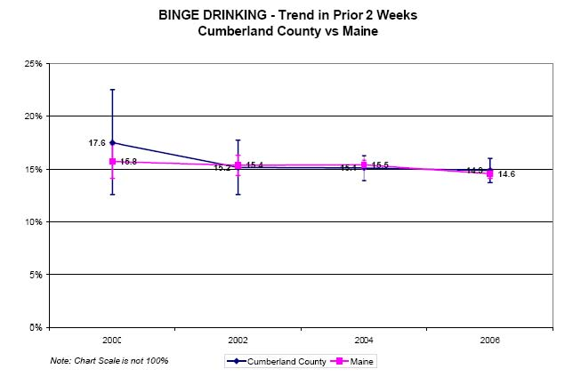

unsafe inschool peaks in9th grade
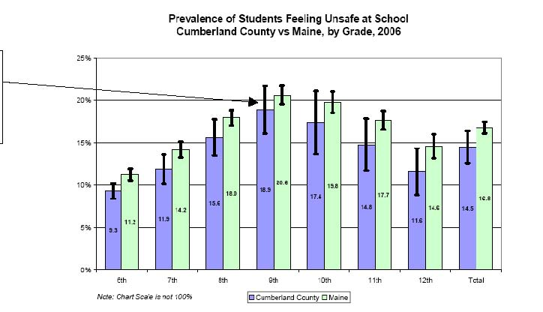

- • Perceived availability of drugs 2006


6th grade | 8th grade | 10th grade | 12th grade
23% | 28.7% | 39.2% | 48.4%

- • Parental attitude Favorable to Drug Use

6th grade | 8th grade | 10th grade | 12th grade
9.9% | 21% | 41.7% | 43.4%

- • Attitude favorable to Drug Use

6th grade | 8th grade | 10th grade | 12th grade
15.4% | 28.1% | 45.8% | 45.6%

Correlation between Alcohol and Other Drug Use: Analysis of county-wide MYDAUS data for students in grades 6-12 shows a high correlation between alcohol and other drug use:
- • Very strong association between 30-day alcohol and marijuana use (gamma =.913)
- • Very strong association between 30-day alcohol and cigarette use (gamma=.856); and

Strong association between 30-day alcohol and other drug use (gamma=.806) –includes psychedelics, cocaine/crack, MDMA (ecstasy), inhalants, stimulants, heroin, prescription drugs not prescribed for the student by a physician, and "other illegal drugs”.

Source: Needs and Resource Assessment for Portland’s 2010 Substance Abuse Prevention Plan

11% increase between 8th and 10th grade

20% increase btwn 8th and 10th grade

18% increase btwn 8th and 10th grade

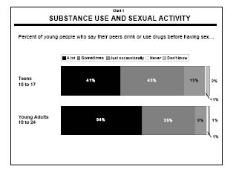
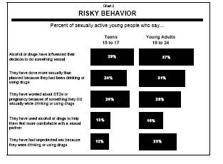
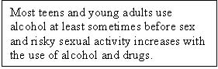
Source: CASA Website Report 2002



Most teens and young adults use alcohol at least sometimes before sex and risky sexual activity increases with the use of alcohol and drugs.

MYDAUS data shows a significant increase in alcohol use and binge drinking between 8th and 9th grade as well as increases in perceived availability of drugs, parental attitude favorable to drug use and personal attitude favorable to drug use. This data, coupled with the data that feeling unsafe in school peaks in 9th grade, indicates a place for further investigation. The consequences of high risk drinking within this age group, such as increased risky sexual behavior, a strong association between drinking and using other drugs, and the morbidity and mortality that can occur with high risk drinking, also merit more investigation.
18-24 year olds and Alcohol:
National Data: Current, Binge, and Heavy Alcohol Use among Persons Aged 12 or Older, by Age: 2005
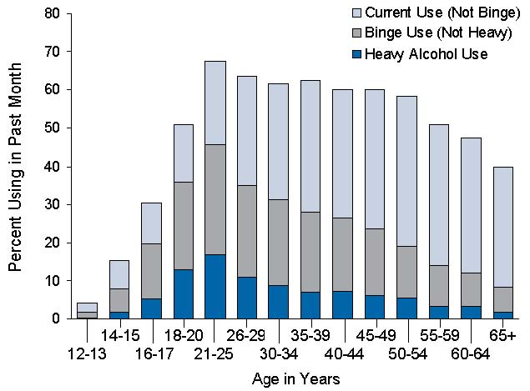
Source: 2005 National Survey on Drug Use & Health: National Results

Maine Data: BRFSS Maine Binge drinkers (adults having five or more drinks on one occasion) 2005
Age: |  | Yes | No
18-24 | % CI n | 27.9 (20.0-35.8) 44 | 72.1 (64.2-80.0) 116
25-34 | % CI n | 23.3 (18.5-28.1) 96 | 76.7 (71.9-81.5) 386
35-44 | % CI n | 17.6 (14.4-20.8) 117 | 82.4 (79.2-85.6) 601
45-54 | % CI n | 11.4 (9.0-13.8) 98 | 88.6 (86.2-91.0) 850
55-64 | % CI n | 8.5 (6.2-10.8) 59 | 91.5 (89.2-93.8) 685
65+ | % CI n | 1.7 (0.8-2.6) 15 | 98.3 (97.4-99.2) 861

Binge drinking comparison 2002-2005
Year: |  | 18-24 | 25-34 | 35-44 | 45-54 | 55-64 | 65+
2005 | % CI n | 27.9 (20.0-35.8) 44 | 23.3 (18.5-28.1) 96 | 17.6 (14.4-20.8) 117 | 11.4 (9.0-13.8) 98 | 8.5 (6.2-10.8) 59 | 1.7 (0.8-2.6) 15
2002 | % CI n | 30.4 (22.6-38.2) 49 | 28.5 (23.1-33.9) 92 | 17.3 (13.5-21.1) 78 | 11.5 (8.6-14.4) 62 | 8.6 (5.3-11.9) 29 | 2.7 (1.1-4.3) 12

The rate of binge drinking was 41.9 percent for young adults aged 18 to 25. Heavy alcohol use was reported by 15.3 percent of persons aged 18 to 25. These rates are similar to the rates in 2002, 2003, and 2004.

Very high rate among the 18-24 year olds

County Data:
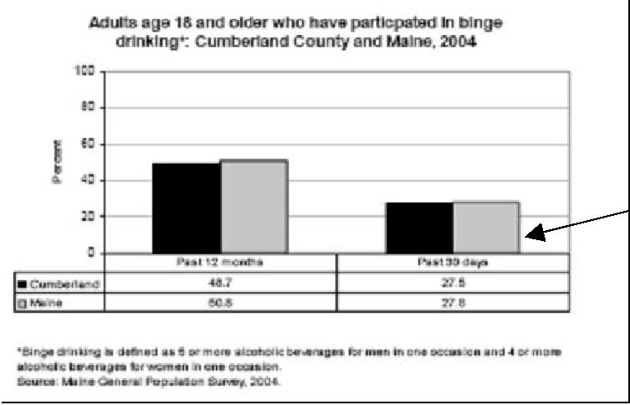
Source: Cumb Co Profile


. Percentage of Respondents Using Specific Drugs in Past 30 Days
18-25 year old non-college population in Androscoggin Co.
Drug | Percent Using:
Any Tobacco | 59.9%
Cigarette use | 58.3%
Alcohol | 63.8%
Binge Alcohol Use* (defined as 5 or more drinks in one sitting) | 38.4%
Marijuana | 27.5%
Any Illicit Drug Use | 29%
Any Illicit Drug Use Other than Marijuana | 7.3%


Source: Healthy Androscoggin Study

Substance use comparison of unemployed/non-students with employed/non-students
18-25 year old non-college population in Androscoggin Co.
Substance | Unemployed/non-student using  (n=70 | Employed/non-student using  (n=136
Alcohol Use | 9.9 drinks per sitting | 5.3 drinks per sitting

Cumberland Co. data consistent with BRFSS Maine data (27% in past 30 days)

Of the 63.8% of respondents that drank in the past 30 days, on average they drank 6.6 drinks per sitting and reported an average of 10.8 binges over the past 30 days.

Overall rate of binge drinking in ME for 18-24 yr. olds is 27.9%. Among non-college 18-25 yr. olds in Androscoggin it is 10% more (38.4%). Although we don’t have Cumb. Co data, it is probable that the non-college population in Cumb. Co also has high rates of binge drinking.
Source: Healthy Androscoggin Study

Heavy drinkers (adult men having more than two drinks per day and adult women having more than one drink per day) 2005
Age: |  | Yes | No
18-24 | % CI n | 6.7 (2.7-10.7) 14 | 93.3 (89.3-97.3) 144
25-34 | % CI n | 5.7 (2.6-8.8) 27 | 94.3 (91.2-97.4) 449
35-44 | % CI n | 6.6 (4.6-8.6) 45 | 93.4 (91.4-95.4) 665
45-54 | % CI n | 6.4 (4.6-8.2) 62 | 93.6 (91.8-95.4) 876
55-64 | % CI n | 4.6 (2.9-6.3) 36 | 95.4 (93.7-97.1) 709
65+ | % CI n | 3.1 (1.7-4.5) 27 | 96.9 (95.5-98.3) 832



Source: Maine BRFSS 2005
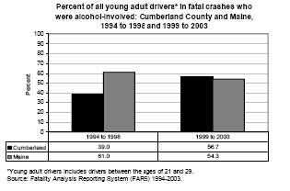

S
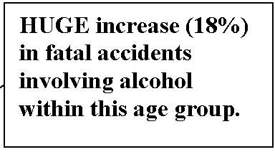

Again, the highest rates of heavy drinking are among 18-24 yr olds

HUGE increase (18%) in fatal accidents involving alcohol within this age group.
C
• Alcohol is a factor in 23% of all Maine crash costs.
- • Alcohol-related crashes in Maine cost the public an es
- includes $0.2 billion in monetary costs and $0.3 billion in quality of life losses. The average alcohol-related fatality in Maine costs $3.7 million
- • The estimated cost per injured survivor of an alcohol-related cras

C

• Our student survey, restricted to the SMCC campus where
- commuters versus residents (residing on campus), found a 75% rate of consumption repomales, and a 43% rate for females - 33% for underage females. Bar and tavern owners interviewed indicated:
- • Males prefer beer, while female
  - Fe
  - • Females are more often observed drinking in groups of females, or in mixed g
  - rather than in male/female or female/female couples. Females report their motivation for drinking is to ‘be so
  - sit prevalent risk factor for female student alcohol consumption appears to be the
- normative nature of the behavior

C• Nationally, A
- or subjected to nonconsensual sex, compared to only 3 percent of non-bingeing female students. Most campus rapes occur after heavy drinking (CAS). Ninety percent (90%) of all reported colleg
- rape cases involve the use of alcohol by at least one party, and 60% of college women who reported having sexually transmitted diseases link alcohol with their infection.



They have the highest rates of binge drinking and heavy drinking and thstudy of the non-college population seems to indicate an even greater problem with alcohol among the unemployed/non student. Considerinthe increased rates of fatal accidents involving alcohol, and the high cost of alcohol-related accidents as well as the known problems associated witsuch high rates of binge and heavy drinking such as higher rates of sexual assault, and possibly, higher rates of unemployment, this population deserves further investigation.

MARIJUANA

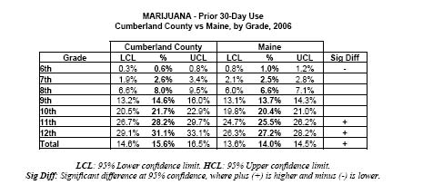

S

Statistically Significant higher rates of use in Cumb. Co


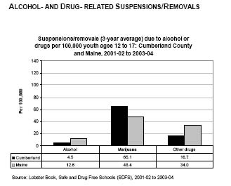

B
C
6TH 7TH 8TH 9TH 10TH 11TH 12TH MALE FEMALE T
N | 99.0 | 96.8 | 92.5 | 85.3 | 81.1 | 75.5 | 73.7 |  | 85.4 | 87.7 |  | 86.0
1-2 TIMES | 0.5 | 1.6 | 4.2 | 7.6 | 9.1 | 10.3 | 10.9 |  | 6.2 | 6.3 |  | 6.4
3-5 TIMES | 0.2 | 0.7 | 1.4 | 2.5 | 2.6 | 4.6 | 4.5 |  | 2.4 | 2.2 |  | 2.4
6-9 TIMES | 0.0 | 0.2 | 0.4 | 1.2 | 2.2 | 1.9 | 2.3 |  | 1.3 | 1.0 |  | 1.2
10 OR MORESource: Cumb. Co. MYDAUS 2006 | 0.3 | 0.7 | 1.4 | 3.5 | 5.0 | 7.8 | 8.6 |  | 4.7 | 2.8 |  | 4.0

students in CumCo have been drunk or high at school at least once in the past year

school on a moreconsistent basis


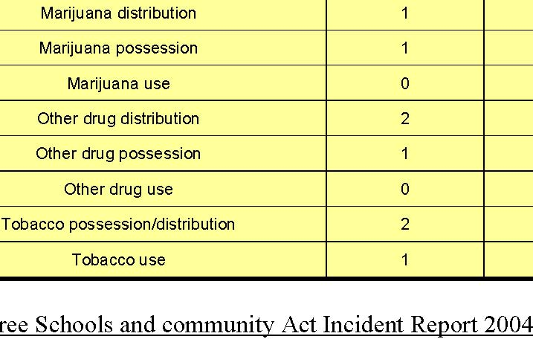
Ampersons who initiated nonmolder.Males genmhow Created from data in:Surveys on Drug Use and Health
0 | 81012 |  |  |  | ong adults aged 18 or older, | iona
Past
ersc
the risk of dependence or abuse fo
g use am17 in

for mast year wuthszers

mpared with those who initiated use at age 16 or ere higher aale vs male agedstimulants

ulants and les than males.:less

Source: Prescription Monitoring Program (OSA Website) County PMP (4th Quarter 04 - 3rd Quarter 05): Patients over the threshold for all scheduled drugs per 100,000
Somerset 129W
aldo 109.8Washington 80.6York
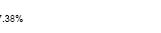
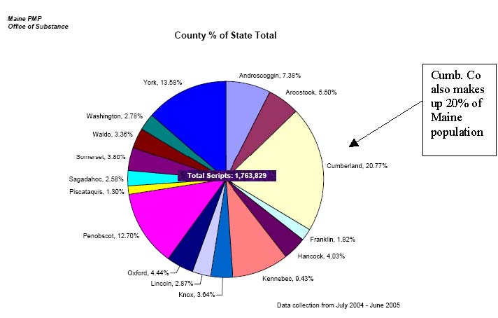
Source: Cu
m

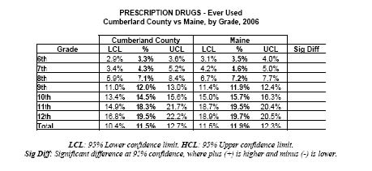
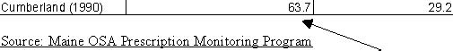

S

Nationally, prescproblem but we don’t have a lot of


In focus groups withithis study, perception
was that prescription drugs were safer
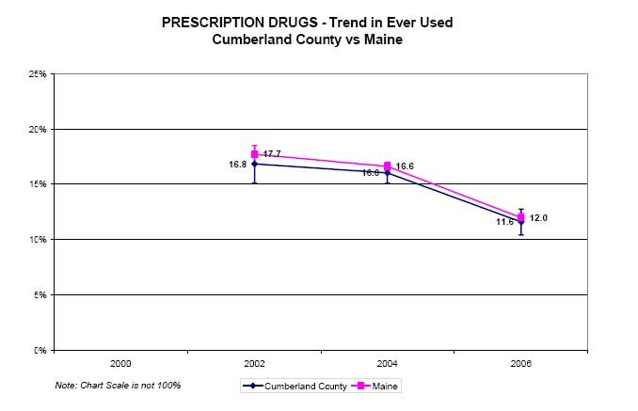
067.9Alcohol
Note: For prescription drugs and other drugs, there were too few cases for a reliable e
Source:
National P | ong You

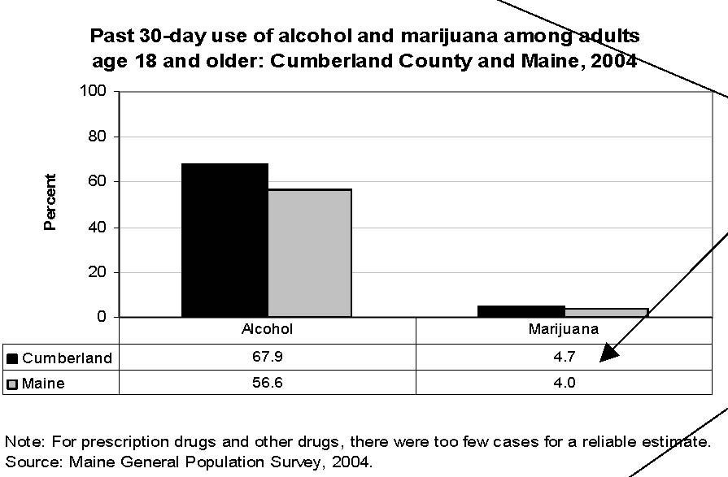
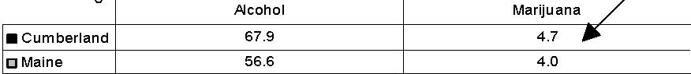
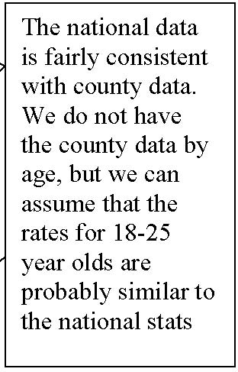
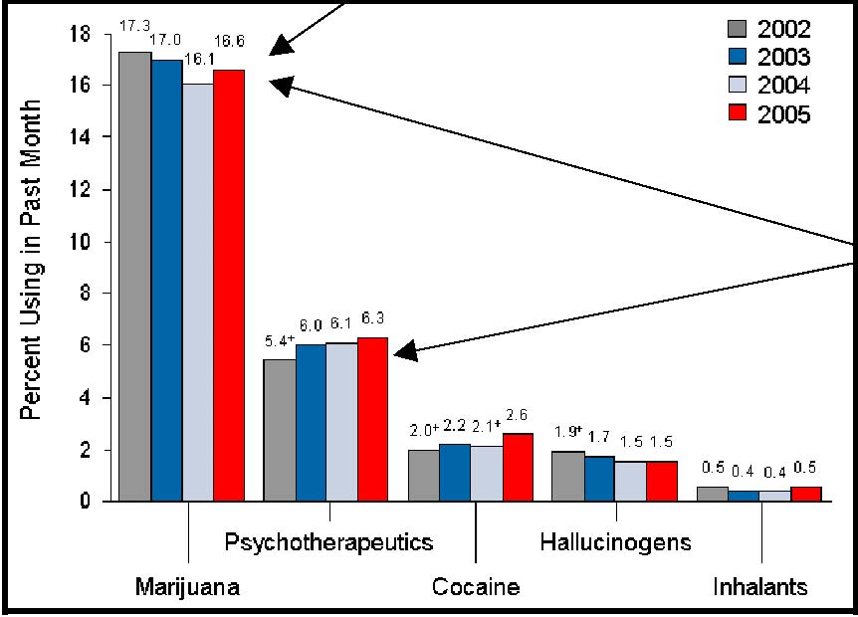
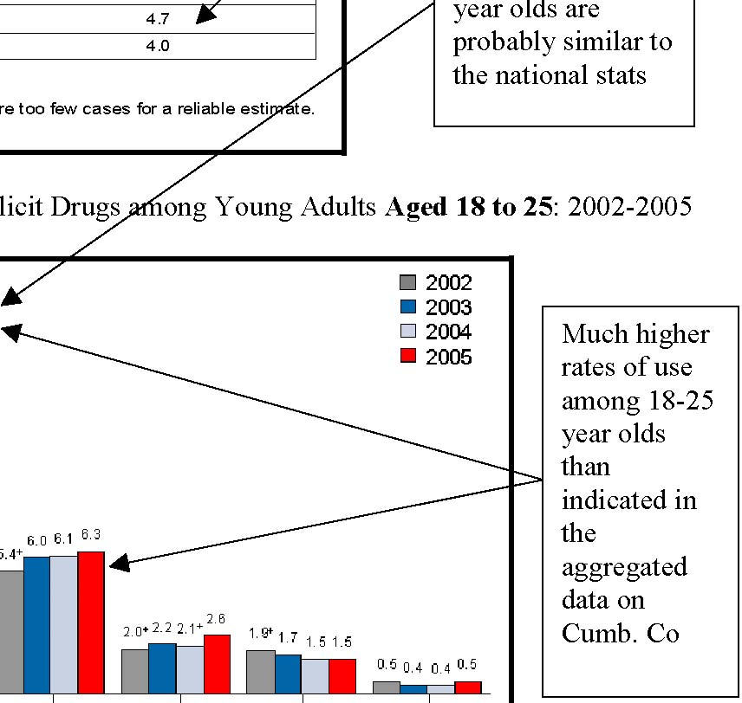


5: 2002-2005Much highrates

the Cu

Percent of adults aged 18 or older by employment status who are current illicit drug users, 2005 % of Unemployed who use % Employed part time who use % Employed Full time who use

thdrug users aged 18 or older in 2005, 12.9 m

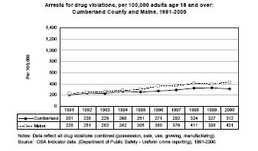
Type of drug involved in arrests of adults over 18 in Cumberland Co.,
2005

Methamphetmine2%N/A10%Pharm-Narcotic7%
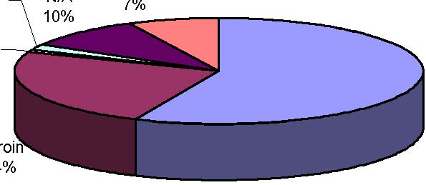
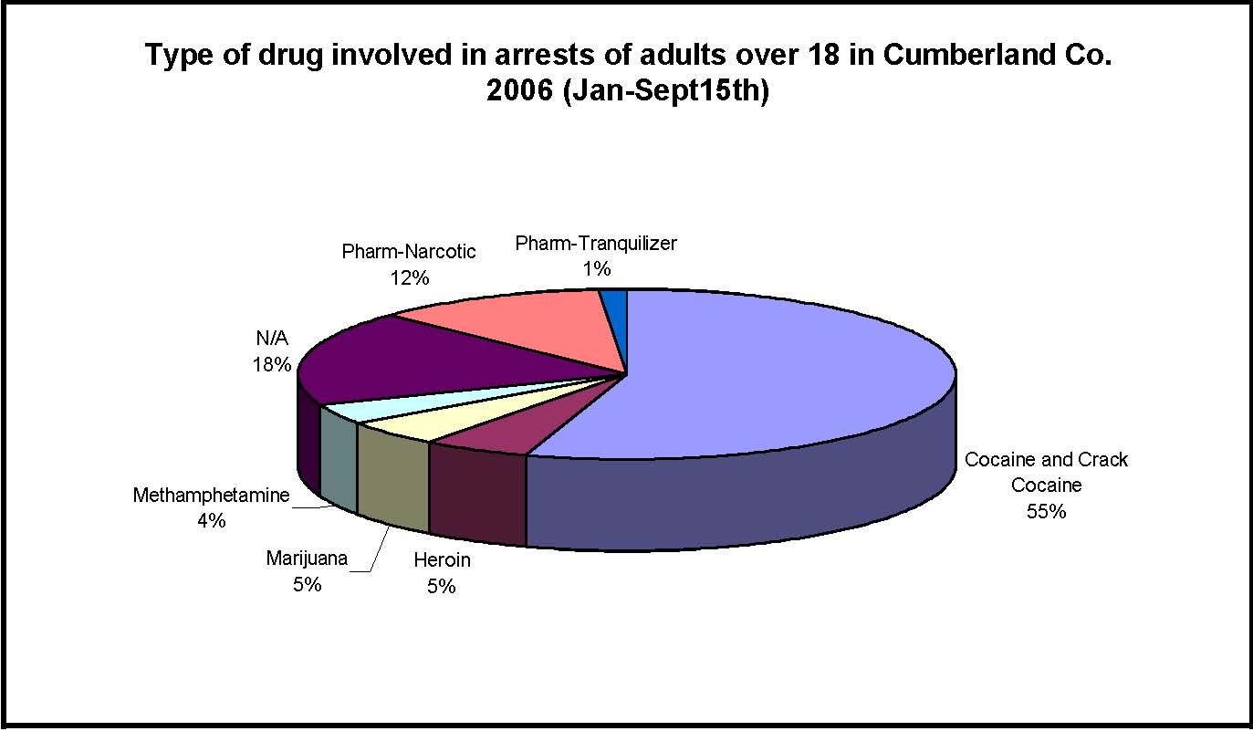
Source: Maine Drug-Related Mortality Patterns (1997-2005)
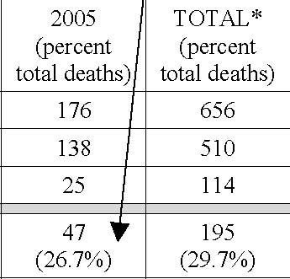

F

okes pot? Do they tend to be the same people?
4. Have you ever he | erm “ | rinki | hat d | ink t | ht mean?
many drink
Do you th
5. Do you think people y | ge beliet tost dange | rinking hs | oo
Make a continuum o | o m | rou | f alc
6. Looking at the contin | at | coh | m
7. Ho | hool get | hol?
8. Is prescription dru | rob | ur s

prescription drugs?
9. For people your age, what is the easiest substance to get? Make a continuum odifficult substance to get.

alcohol? top someone you know from
at schools keep peo | m usin
12. What messages are | tting fr
b. Do | ommu | e diffe
 |  | rugs mo
 |  | edia
13. What messages are youth getting from

estions r school? What about oth

you think sports contracts pot?

s the number one problem caused by drinking for peopl

15. What is the number one probl

- 16. What is the number one problem caused by misusing prescription drugs? If you wanted to talk with someone about alcohol or drugs, w
1
us Group Questions for Parents of High School Aged Children

1. Which substance concerns you the most?
2. Are there certain groups of people in your community for whom these sub

4

Focus Group Questions for people in recovery

1. Do you have any thoughts about why young

2. Do you think there are certain types of people who drink alcohol? Is there a particular type of person who smokes pot? D

3. Have you ever heard of the term “binge dri

Do you think many people your age engage in binge drinking?

Make a continuum of least to most dangerous types of alcohol.

5. Looking at the continuum, what kind of alcohol is used most often by people you know?

get.

7. What do you think is the most commonly used substance amongst people you know?

acquaintances or friends use drugs?

9. Amongst the people you know that have a problem with drugs and alcohol, at what age do you think most of them started drinking? Using drugs?

10. If you know people who abuse prescription drugs, how do you think they get it?

What messages do

a. Generally,do you think adults in your community when you were growing up thought thit was okay for youth to use as long as they us

16. What is the number one problem caused by
17. What would stop someone you know from drinking or using drugs?
- 18. If you could create a strategy to prevent youth from using alcohol and drugs, what would it be?

- us Group Questions for CCJ 18-25 year olds

1. Would you say that alcohol is a problem among your friends? What a

Appendix C: Foc

y Findings from Focus Groups
us Group Details:
Total Participants: ApproximA
Groups: • 4 youth groups • 1 parent group ( key leaders meetings were also made up of parents but results not listed here) • 1 18-25 year-old groups
• 2 adult groups, 18- 50 years old er Characteristics: • 1 all men
• 1 all women
• 2 suburban • 3
• 2 with people in recovery • 1 jail inmates

uth 12-18 (4 focus groups)
O
ics but there was some differences they
b
hlighting the areas of consensus.
W
one in any groups would identify one kind or person that drinks or smokes pot. Broad consensus
uth did not describe a consistent definition for “binge drinking”. They agreed that a danger
boys and girls use same drugs and alcohol?
M
- at is the least to most dangerous type of alcohol?
M


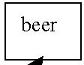
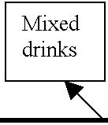
l used? k hard liquor, usually as mixed drinks. There is more access to it.

B

Where do youth get access to alcohol

Parents (stealing from or being provided by the parents), older lder.

o

Is prescription drug u

No Consensus th get prescription drugs?

Where do youConsensus that youth either got the prescription from
- n sarted to misuse it or a youth bought it from someone who had received it legitimately from
- cto.
- ats easiest to most difficult drug toups described somethin

Most of the youth gro

- weed

- y o youth use?

N

Stress, depression, addiction, p

because they look up to them” What messages are youth getting from adults in their community about drinking and smoking pot? No broad consensus. But here are some answers: • “Doesn’t matter what parents s

• From parents who don’t

• Parents who use are more accepting of use • Lots of youth said th

Media messages?

Very Broad Consensus that media glamorizes use. None of the groups had trouble coming up with lots of examples.
#1 problem associated with drinking for people y

our age? No broad consensus. The only answers that were said more than once were: Drinkin

getting caught, people getting violent

#1 problem associated with smoking pot?
pr

ciated

th mi


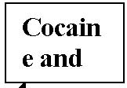
People in Recovery and/or past substance abusers:
We held 3 focus groups that included people who were in recovery or who were past substance abusers
Two were held at treatment facilities an
series of questions and below are some of the highlights from these conversations.

Why do young people start using alco
Family – geneti

“My parents weren’t around and didn’t have
family and work requirements made them unavailable.” “Adult drinking leads to the mindset that dinking is okay- when I grow up I’m going to drink” Who drink

Broad consensus that everyone can drink and ev

What is Binge Drinking and dangerous amounts of drinking?
e.
No consensus
Easiest substance to get access to?

Broad Consensus that
Most Commonly Used?
No consensus. They all talked about phases of drugs. Cocaine is more popular now but that heroin is also coming back in. On group
another group thought that people who were alcoholics were just as likely to use drugs as drugs a
were to use drugs.
- on people who abuse dugs and alcohol, when do you think most of
- adgreement! Drinking at 12, doing drugs by 14
- er do people get prescription drugs?
- adagreement that most people get Rx through
- t thy get it from someone who got it legitimately. It was also mentioned that people

parents.
Where do people commonly use drugs and alcohol? EVERYWHERE
When they were growing up, what messages did they get f
and using drugs? “Drugs are bad”
“Pot is okay”
“If it is controlled or supervised, than we can keep it safe” (for at drank and m
Most of the people in the recovery groups had parents tha did drugs with them
many people who said that their parents drank ord

Agreement that there was a dichotomy- people tell kiociated with drinking for people your
#1 problem ass

.

at dangest dangerment

ll agr least

What is
Death, addiction, jail, rehab, etc. These groups thou
talked about how they had seen these consequences come to fruition for themselves and many, many friends #1 problem associated with smoking pot for people your age?
N

#1 problem associated with misusing prescription drugs?
Consensus on: Overdose, death, using
Some other consequences mentioned were: stealing from friends, losing kids, jail, losing job, family and support system
What strategy would you create to prevent youth from using?

There were many strategies off
may be considered cool by youth, to go into schools and give them the r

glamorized version.
The other strategy with consensus was targeting parents and the family In one group we asked them who in their lives had talked to them about th

They said no one ever talked to them about their use, tha
no one expressed concern or offered support to them along the way.

Parents:
We held one f

many of the participants were parents
were of other parents in their community Below are some key themes aggregated
all the meetings about pa
Substances that are the biggest concern to parents? Many people were concerned about illicit drugs like cocaine, meth, and things they haven’t heard of. Some of the leaders
more worried about alcohol since it is more pervasive and causes more deaths and accide
drugs

#1 problem caused by underage drinking?
Everyone knows that drinking and driving is a serious consequence of underage drinking and everyone is very concerned about it. There was also consensus that parents are concerned about grades, academics, and the eff

What is the attitude of the adult community around
Consensus that thi
was consensus that many parents are in denial, “If I don’t see it and I don’t hear it, then it doesn’t exist” seems to be a prev
parental supervisi
the 2nd home i
teenagers.
Do a lot of adults use alcohol and drugs? Consensus that there were a lot of parents that drink and some that smoke pot and few that use other illicit drugs. Agreement that parents use made the abstinence message a hard sell for youth.

Appendix D: Key Leader Meeting Questions Key Lea
der Meeting Questions:
1. What role do families currently play in underage drinking and youth drug use? What ab
adults and high risk drinking?

2. How awa

re do you think parents are of the risk of underage drinking amdrinking among young adults? Why do you think this?
3. In your commu
nities, how effective is law enforcement in dealing with the issue of underage drinking? Why? How about other drugs?

4. How well do you think your community is preparing young p
school to high school, and high school to beyond?
5. What role are schools playing in underage drinking and drug use? (this can include school policies and practices, as well as school climate)

6. What role do retailers, local and national, play in
promoting high risk drinking to young people? What do you think most influences underage drinking and high risk drinking? 7.
In combating substance abuse, what is
8. What else would you like to see your community do to prevent substance abuse?
Appendix E: Key Leader Results
Key Leader Meeting Results
C
- ader Details:
K
•
community. Participants included: Teachers, substance abuse counselors, parents, police officersprevention providers, treatment providers, town council members, students, etc. Almost every town in Cumberland County was represen
In
ach meeting, we gave participants an overview of some of the data that we had collected thus far a w arrived at the priorities of concern (ie: high risk drinking among youth, high risk drinking amear-olds, etc). Then we asked them a serie
1w
at
h, organized by intervening variables or factors that cause substance abuse consequences or ption.

F
mily Climate: • Providing Place for parties Enabling and modeling behavior of drinking and using drugs
• Socially acceptable to drink Parents endorsing drinking so their child will be in the “cool” group
• Denial Factor
• Disposable income and allowances facilitates access

• Some communities are ad

• Protective factors need to be built up
• Facebook and
- • Kids know where they can access alcohol in the community • The community puts value on over-organization of teenager life “What happens at college stays at college”
- oo Climate:

• Lack of coach support of prevention efforts and school substance abuse contracts • Perception that “cool” kids or the top athletes will not get in trouble if they are caught using substances • School Substance abuse Contracts: are not consistently enforced and are very punitive (not enough education with the signing of the contract) • Parents d

• Lack of prev
- health class for ½ year
- • In high school there is less student engagement and more puni
- • 9th graders are trying to fit in and look to role
- • Lack of support for youth tha

- elpmental Transitions: Need to build up protective fac
- • Middle school
- lubricates that process
- • High expectations fo
- • Summer between 8th and 9th grade is a common time f
- • Also big initiation period between 5th and 6th
- • Age 22-25 is very stressful time after college and young adults are not prepare
- with stress. They get mixed messages
- forement:
- • Lack of Liquor enforcement agency is a real problem
- • Lack of resources for PDs Youth access to legal aid bas
- • Perception/ reality that there is no enforcement
- • Inconsistent enforcement Inconsistency on fines (cheaper to be cau
- • People don’t dramatically change by enforcement

• Parents don’t sup
- • Courts don’t back up enforcement
- • Probation system is all backed up and makes enforcement difficult
- es:
- • Youth know where to go to get alcohol
- • Drugs are often more easily accessible than alcohol to undera
- • Lack of carding enforcement
- • Access with parents or at home

Perception of Ris
- • Lack of risk knowledge for alcohol among parents and youth
- • Data doesn’t get shared to the community Youth and p
- :
- • Perception is that addressing the problem of advertising by alcoho
- • National chain stores advertising has a serious impact
- • TV has huge impact

- • Youth themselves
- • Youth run prevention programming
- • After-school programming
•

• Mentoring programs
- • Alternative activities
- • Wellness programs Skate parks
- • Positive Connections with adults
- ateople want to see in their communities:
- • Marketing and matching the planning of activities with what youth want Parents should be co-equals with educa

- Append
- g risk drinking among youth (12-17)
H

Consu
- 2006 MYDAUS D
- • 30% of 6-12th graders reported using Alcohol in the past 30 days
- • 15% of 6-12th graders reported
- th

• 31% of 12th gr
- Binge Drinking, Prior 2thth
6

- MYDAUS D

- Specific Community MYDAUS
- es ot necessarily reflect the

P

• 35% of high school students in Maine repor
- • Of the students that report alcohol use, about 50% report alcohol as the on
- • nine out of ten (86%) high school students in
- • nine out of ten (87%) of high school

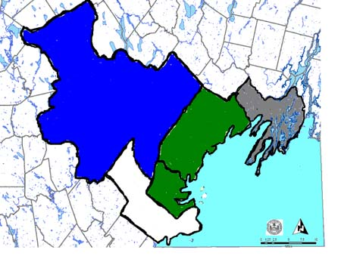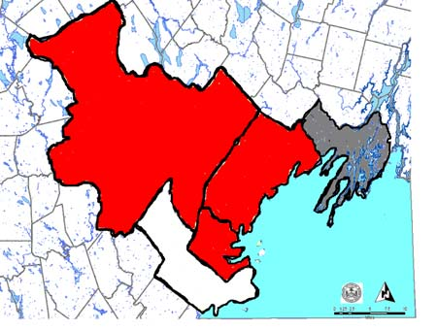
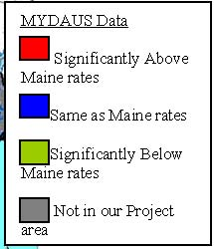
tive 15-17 year-olds reported doing more sexually thanaiser)
• In Maine, of currently sexually active high school studentdrugs before their last intercourse. (Maine YRBS 2005)

ttempted suicides among 15-24 year-olds were from
- ludng alcohol). (Maine Youth Suicide Prevention Program)
- ly lcohol use increases risk of dependence: 40% of people who used a
- enence diagnosis. (Surgeon General)
- deic Problems: Of Maine general education high school students wted behavio, 30% are removed due to drug-related acts (which include
p
2Developm

nt studies show that early alcoholent. (Surgeon general)
on the developing brain, including neurocognitive impairm
S
• Lack of upper class role models that do not drink • Lack of support for youth that don’t use
- orcement:
- • Perception among youth that they won’t get caught and if they do it’s not a big deal
- • Lack of resources for Police
- munity Climate: Lack of c

Access: • Parents don’t
• Drivers license and access to a car leads to freedom from parental oversight and easier accsubstances or places to use
• Parents hosting and
- elpmental Transitions: Middle school to high school is huge transition where kids are trying to fit in. Substanc
- • Summer between 8th and 9th grade is a common time for initiation with substances High expectations for youth that are not alw
- ed Risk: High perceived risk for drinking and driving but not for a
•

chool enforcemendrugs)

• Lack of prevention of substance abuse at schools • Lack of coach support of prevention efforts and scho
- rinking among young adults (1

High risk d
- nsumption:
- • In Maine in 2004, 28% of 18-25 year olds reported binge dri

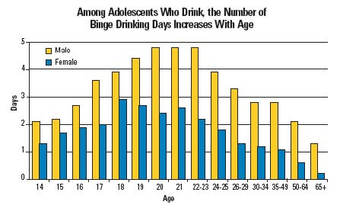
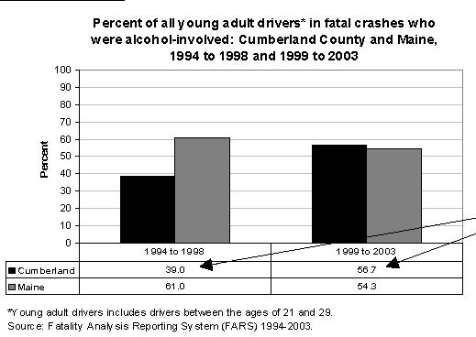
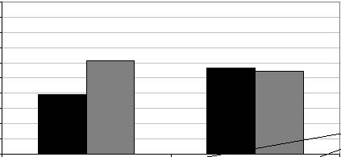
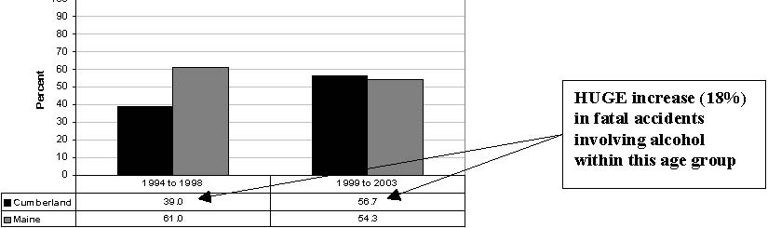
among college students • Among adults aged 18-30, heavy drinkers are five times as likely as n
least ten sex
- STDs, including HIV. (Kaiser) • Heavy drinkers between the ages of 18-25 were more than twice as likely to contract an STD in
- the past year than young adults who abstained from alcohol. (SAMHSA) Each year, 40,000 infants are affected by FASD (Fetal Alcohol Spectrum Disorders), the leading cause of mental retardation and birth defects. (National Organization on Fetal Alcohol Syndroion:

Data Source: Grant et al. 2004 (data
Intervening Va
Enforcement: • Campus security is

adies Night”)
- munity Climate: “What happens at colleg
- Most alcohol advertising is geared towards 18-25 year old population ed Risk:
- • Lack of information about: serving size, alcohol content, harm reduction strategies Now legal for some in this age group so perceived risk is reduced further

Developmental Transitions: • Age 22-25 is very stressful time after college and young adults are not prepared for how to deal
with

Presc
Consumption
- :
- 2006 MYDAUS Data for Cumberland County of 6-12th graders reported ever misusing prescrip

• 11.5%
- • Actually, the % of 6-12th graders who have ever used has gone down from 17% in 2002 to 11% in 2006 (statistically significant)

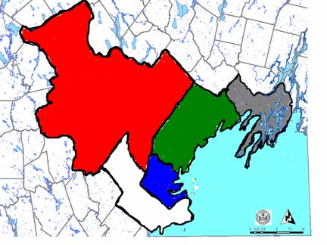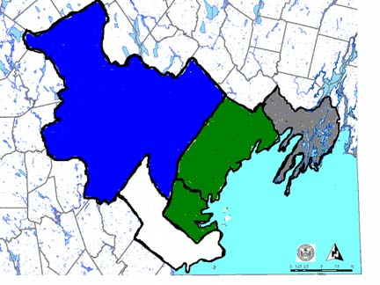
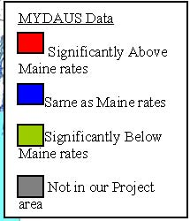
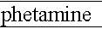
A

Source: SAMHSA,

2004. Overdose: Visits to emergency rooms arising from nonmedical use of prescription
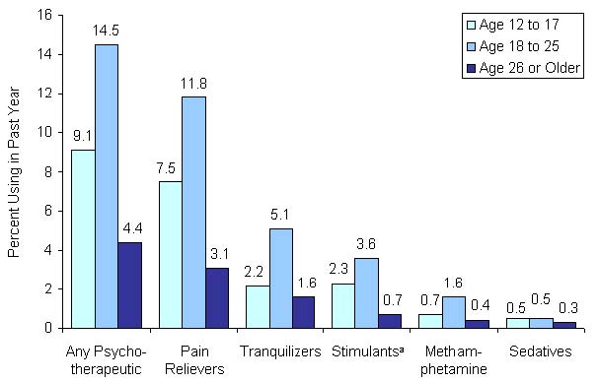
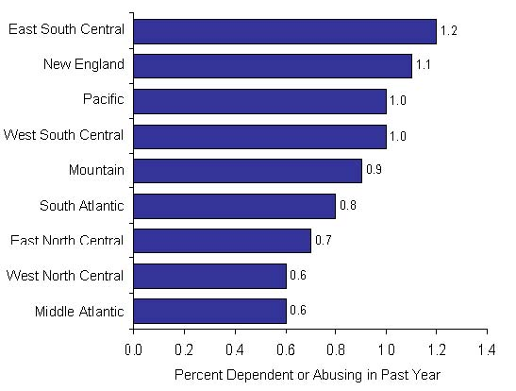

,

nnual Averages Based on 2002-2004
• Hard to detect by Police• OSA monitoring system may not detect who the abuser is, just the name of the person who has
C
• Ignorance and• General accep
Media • Med

• Promoting to Doctors, incentives from Rx companies help promote use of certain drugs Huge drug company lobbying Perceived Risk: • Low perceived risk because it is approved by do

Marijuana Use
Co
- nsumption:
- 2006 MYDAUS Data for Cumberland County 30% of 12th gradeth

• 16% of 6-
- Marijua
- th gade 9-12th grade

- MYDAUS Data

- area

- nsequences:

Academic Problems: Mariju
- ted incidents resulting in student removal in Ma

InAccess:

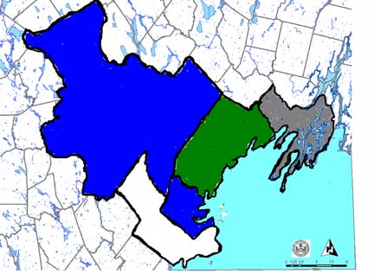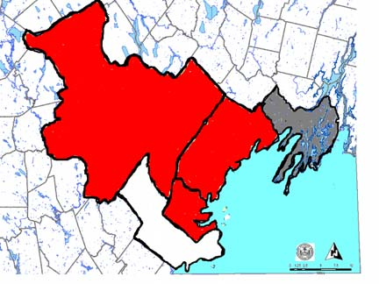
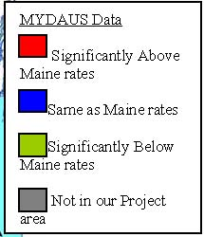

Perception that it is safer to drivDevelopmental Transitions:• Using pot to lubricate social
• Self-medicati
- cine/Crack Use

Consumption: Cume
- brland County: ic to Cocaine so we don’t have any local data on youth
- • MYDAUS does not ask questions specifcocaine use.

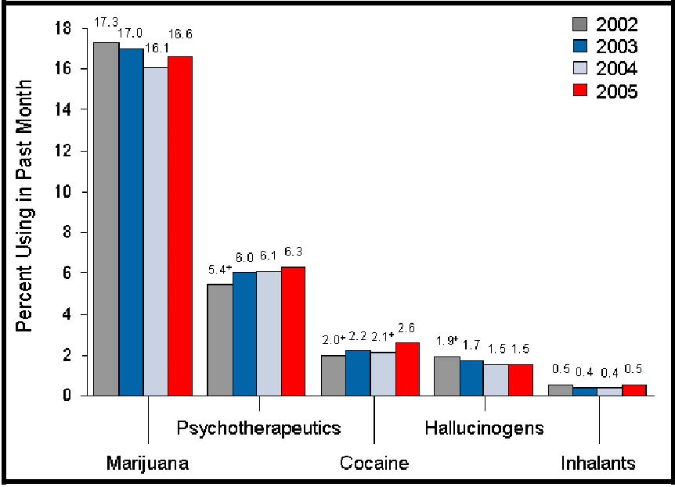

Consequences:
Drug Arrests: Cocai
in Cumberland CountyDeath:
- In 2005, 26.7% of all drug deaths occurred in Cumberland County (but only 20% of the ulation in Maine). (Maine Drug-Related Mortality Patterns (1997-2005) Cumberland County, ME)
- erening Variables: No key themes yet identified for Cocaine

Capacity Assessment for Substance Abuse Prevention Infrastructure Development
Cumberland County March 2007
Introduction
ck will be considered part of Sagadahoc County

Ita

resides within the borders of Cumberland County.
ng Group organized for this project in

nivorganizations, all of which conduct outreach
perspectives on subshan just youth, whi
t
Capacity Strengths Readiness

Cumberland County has recognized the need for SA prevention as part of a multi-faceted approach to reducing risky behaviors in youth ages 11-18 and has mobilized efforts across the county for this populatigroup. Considering SA prevention across all age and income populations is relatively new for this county, bthe need for a comprehensive approach has been identified.

Leadership Because of previous highly visible efforts to focus on substance abuse prevention for youth, interviewees feelthat most people know who the SAade a commitment to work and provide leadership for
m
three primary partner organizations. Cumberland County is willing to participate in and support a new regional structure in their county as recommended in the Public Health Workgroup report to the legislature. Because of the multiple organizationsand resources in this county there is a healthy tension and ongoing discussions among members of this projecas to who will be identified as the lead agency/organization/coalition for Cumberland County. Participation in
th
Planning
T
They have already done asses

Business Capacity PROP is the fiscal agent for this project and they have the full complement of established systems for budgeting, project reporting, and personnel management. PROP has contracted with Liz Blackwell-Moorfor facilitation of coalition meetings, facilitating and consulting for the strategic planning process, and to disseminate information to the wider group of participants.
S
This grantee has access to multiple experts within their county on substa

Research and Evaluation Methods This grantee has access to evaluation expertise from Glenwood Research through one of the particcoalitions. They also will be following the advice and guidelines of Hornby-Zeller staff. The grantee also intends to use the Prevention Centers of Excellence for needed
o
issemination
D
he grantee
T
Cumberland County. Historically this county has had good press coverage. The core project leadershipbe developing new methods of sharing the community assessment data on SA Prevention. Sustainability

This grantee bustainability.
s
obtaining grant funding. The new regional structure will most likely create an umbrella organization/agency that coordinates funding and through which all public health oriented funding to Cumberland County flows, including SA prevention.
A
Readiness & Internal County Linkages Historically Cumberland County has not collaborated with organizations and coalitions focusing on the college-age and senior populations on Substance Abuse Prevention. Both these populations will need to be
re
presentedthe lack of
th
e I-295 corridor: Yarmouth, Falmouth, Freeport and Cape Elizabeth. Contributing to this lack of participation has been a perceived negative consequence for schools if they call attention to substance abuseby students. Getting these schools and communities involved in this county-wide SA Preventi
id
a
h
A
n additional need isparticularly staff from

External Linkages The grantee seeks help accessing resources outside their county from other SPF-SIG grantees, the prevencenters, federal resources and from other states. York Count
coordinate their SPF-SIG planning efforts
in

S

A
seniors. Collection and Interpreting Data
T
analyzing their da
a
They are seeking assistance with templates and examples of data use agreements that can be used with school
T
local hospitals.

Cultural Competence This grantee has identified the need to include more representation from organizations that provide services for seniors, young adults (both college and non-college) on their coalition and in their planning group.
A
populations, including refugees and immigrant, that exist representation from these groups into the SA prevention

There is a need for data on the relationship
v
Readiness Rating The scale used for the rating was: not at all prepared, minimally prepared, partially prepared, very prepared and fully prepared.
1. Cumberland County is very prepared to create a county-wide readiness assessment. 2. Cumberland County is very prepared to develop a county-wide needs assessment. 3. Cumberland County is partially prepared to create a county
4. Cumberland C

Priority Areas of Technical Assistance 1. Getting mo

of people)

are non-college age)

oncluding Observations
C
Unlike many parts of Maine, Cumberland County’s wealth of human resources and organizational capagives them an advantage when developing a county
a
all these resources, so that the end result will be a focused strategic plan that can be easily accessed by
p
have the leadership to tackle this challenge but their efforts will require considerable collaboration with multiple commu
fi

