Maine’s Strategic Prevention Framework State Incentive Grant

Substance Consumption and Consequences

County Profile Supplement:
York County
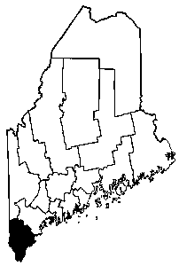

Prepared for:
Maine Office of Substance Abuse
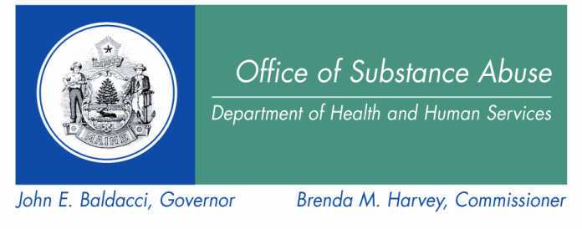

By:
Hornby Zeller Associates, Inc.
November 2009

Introduction

This document updates the original county profiles that were compiled for SPF SIG grantees in 2006. The County Profile is meant to accompany Maine’s Strategic Prevention Framework Guide to Evaluation and Planning and provides a starting point for answering some important questions. The following pages contain tables, charts and figures for York County (District 1) that come from a variety of sources, including: the Maine Youth Drug and Alcohol Survey (MYDAUS); the Behavioral Risk Factor Surveillance System (BRFSS); the Young Adult Drug and Alcohol Use Survey (YADAUS); the Fatality Analysis Report System (FARS); Uniform Crime Reports (UCR); and the Treatment Data System (TDS).

Census Quick Facts for York County and Maine: 2008
 | York | Maine
Population, 2008 estimate | 201,686 | 1,316,456
Population, percent change, April 1, 2000 to July 1, 2008 | 8.0% | 3.3%
Population estimates base (April 1) 2000 | 186,742 | 1,274,922
Persons under 5 years old, percent, 2008 | 5.3% | 5.4%
Persons under 18 years old, percent, 2008 | 21.6% | 20.9%
Persons 65 years old and over, percent, 2008 | 14.6% | 15.1%
Female persons, percent, 2008 | 51.2% | 51.2%
White persons, percent, 2008 (a) | 97.3% | 96.4%
Black persons, percent, 2008 (a) | 0.7% | 1.0%
American Indian and Alaska Native persons, percent, 2008 (a) | 0.3% | 0.6%
Asian persons, percent, 2008 (a) | 0.8% | 0.9%
Native Hawaiian and Other Pacific Islander, percent, 2008 (a) | -- | --
Persons reporting two or more races, percent, 2008 | 0.9% | 1.1%
Persons of Hispanic or Latino origin, percent, 2008 (b) | 1.2% | 1.3%
White persons not Hispanic, percent, 2008 | 96.1% | 95.3%
Housing units, 2008 | 105,113 | 700,480
Median household income, 2007 | $52,365 | $45,832
Persons below poverty, percent, 2007 | 8.2% | 12.2%
Land area, 2000 (square miles) | 990.92 | 30,861.55
Persons per square mile, 2000 | 188.4 | 41.3
SOURCE: US Census Bureau State & County QuickFacts.
- Includes persons reporting only one race.
Hispanics may be of any race, so also are included in applicable race categories.
Substance Consumption: Youth
Lifetime consumption patterns among 6th to 12th graders
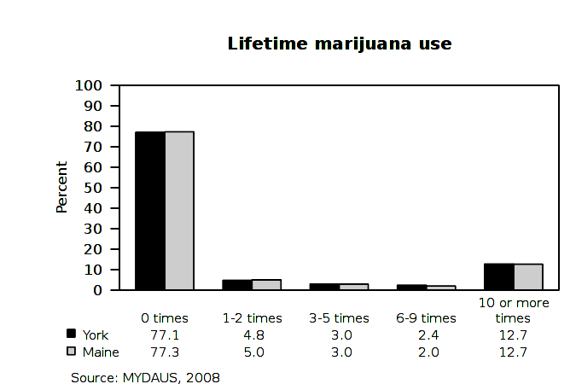
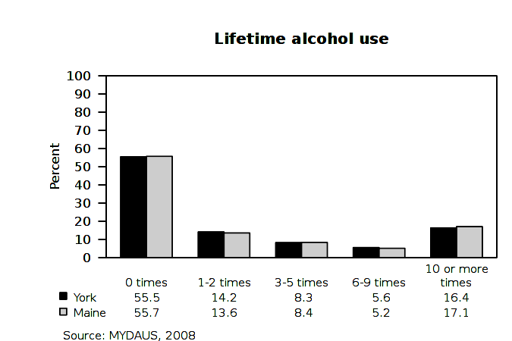
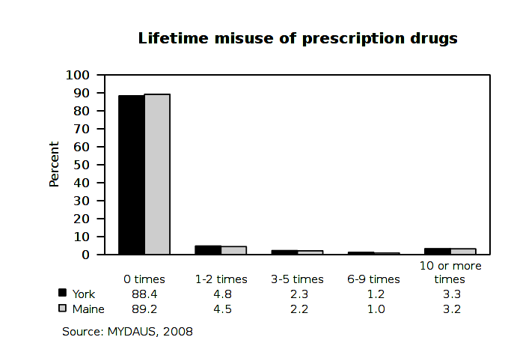

Substance Consumption: Youth
Lifetime consumption patterns among 6th to 12th graders, by grade
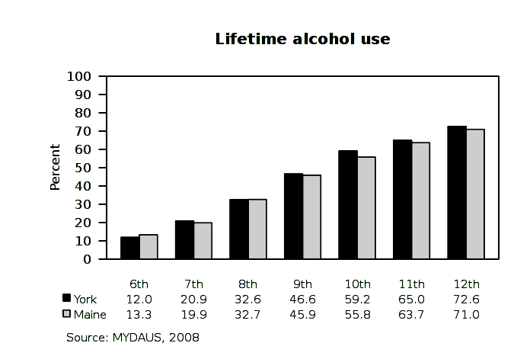
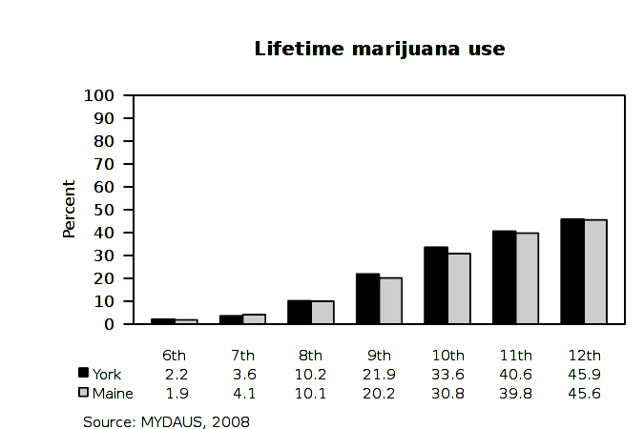
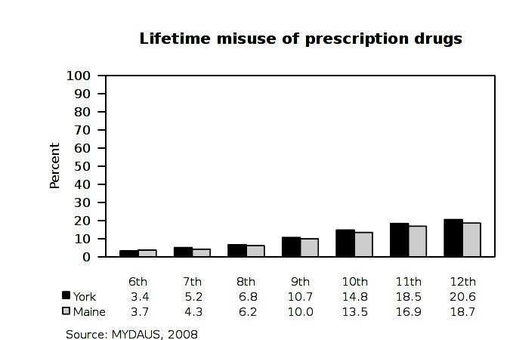

Substance Consumption: Youth
Previous 30-day consumption patterns among 6th to 12th graders
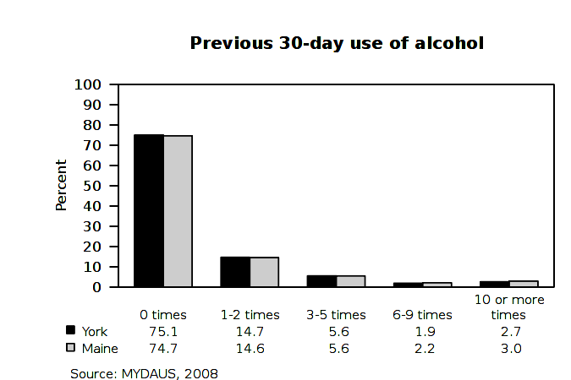
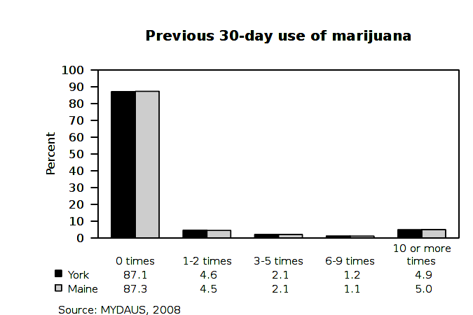
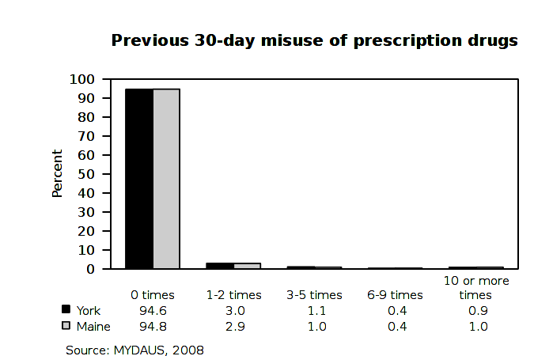

Substance Consumption: Youth
Previous 30-day consumption patterns among 6th to 12th graders, by grade
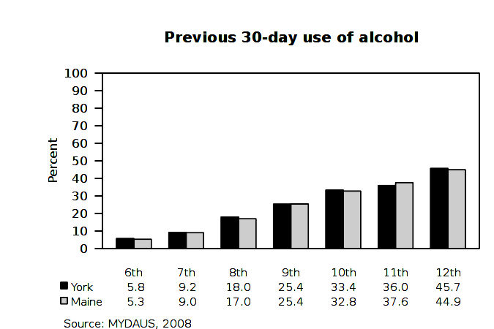
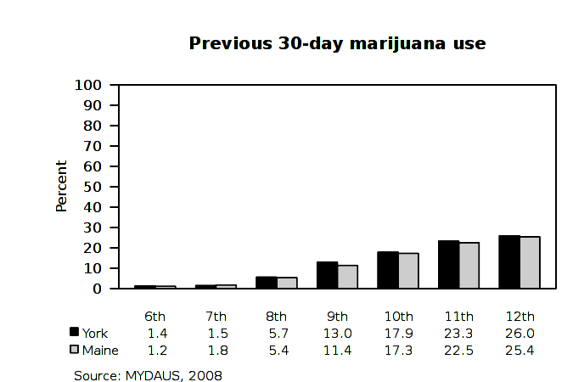
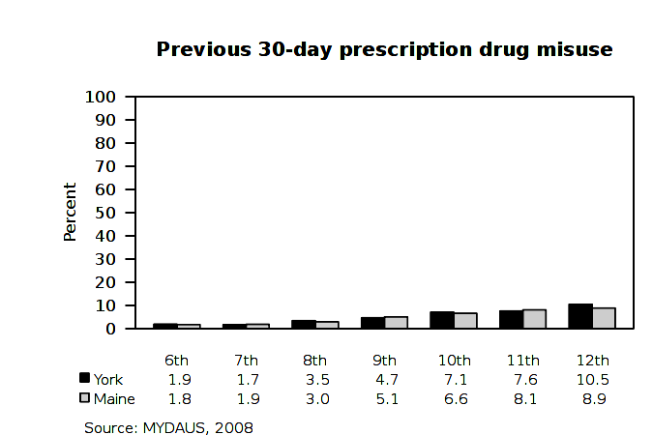

Substance Consumption: Youth
Binge Drinking among 6th to 12th graders Age First Tried Alcohol or Marijuana
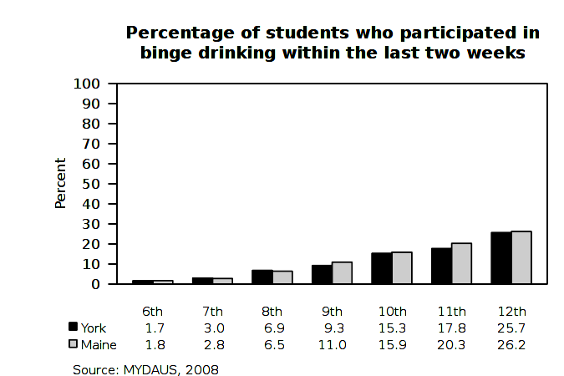
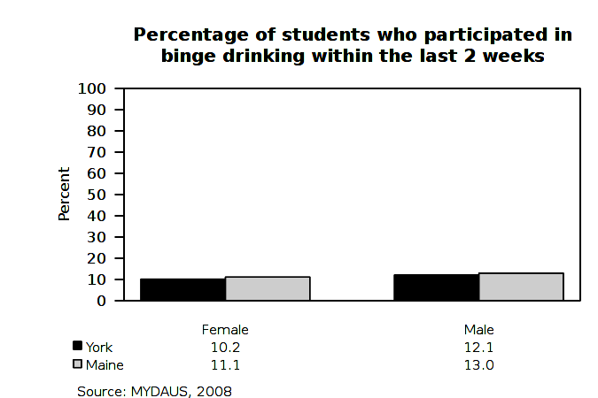
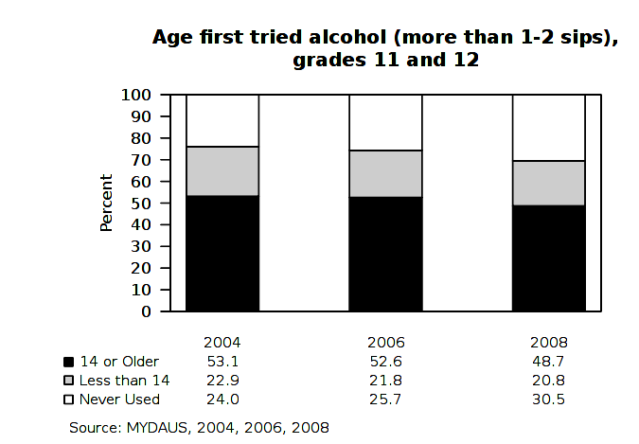
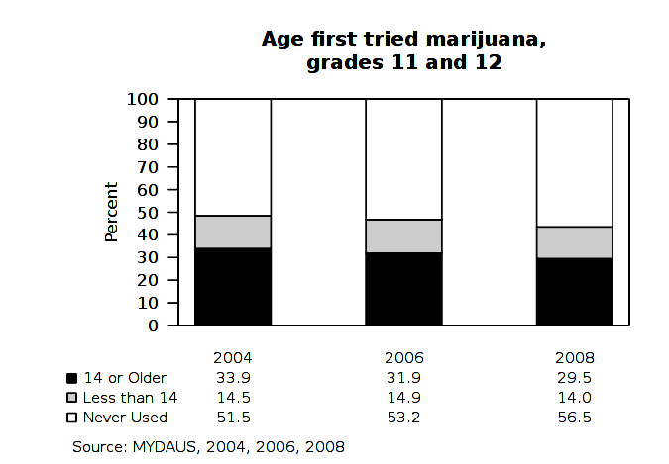

Substance Consumption: Youth
Perceptions on Ease of Access among 6th to 12th graders, by grade groups
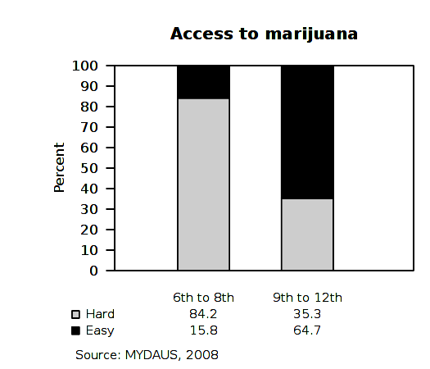

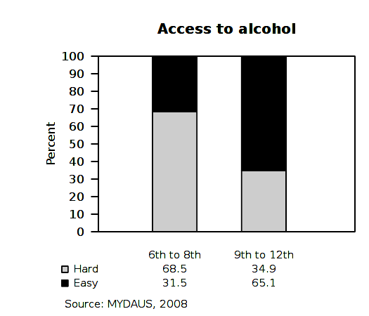
Substance Consumption: Youth
Perceptions that Use is Wrong among 6th to 12th graders, by grade groups
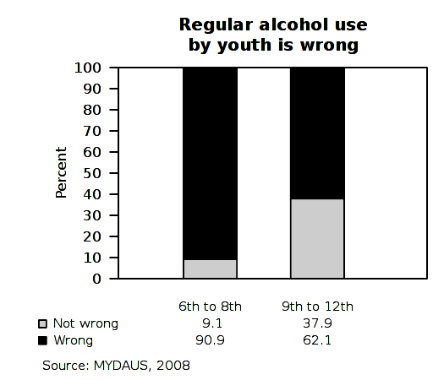
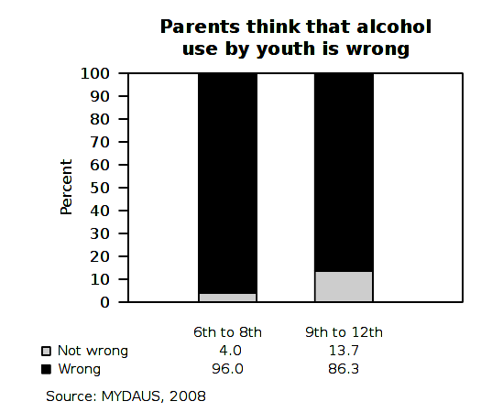
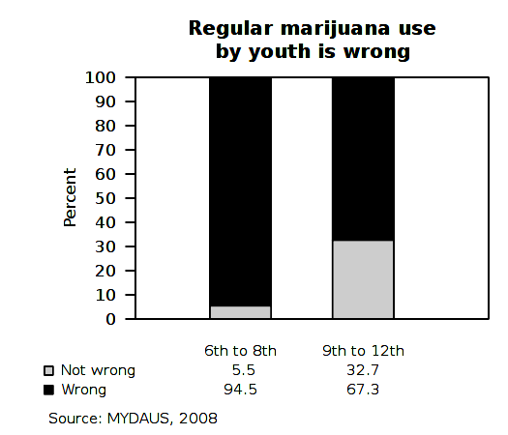
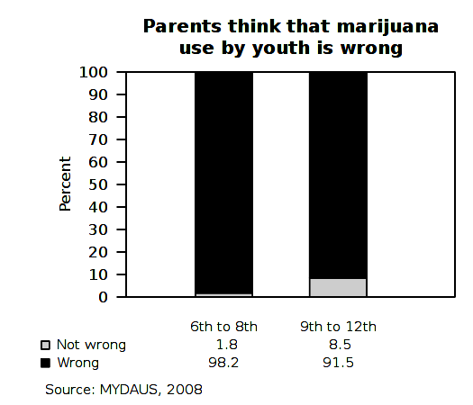
Substance Consumption: Youth
Perceptions of Getting Caught among 6th to 12th graders, by grade groups
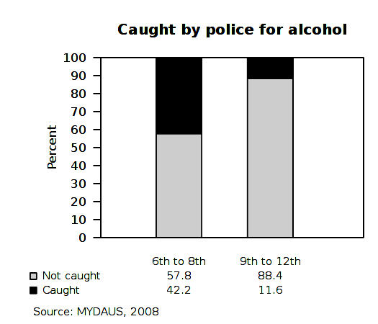
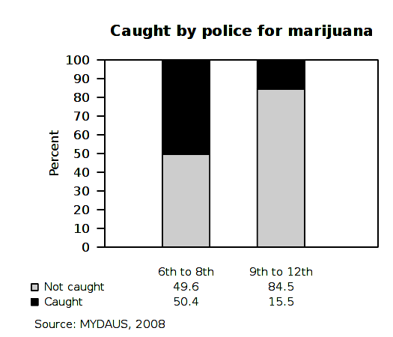
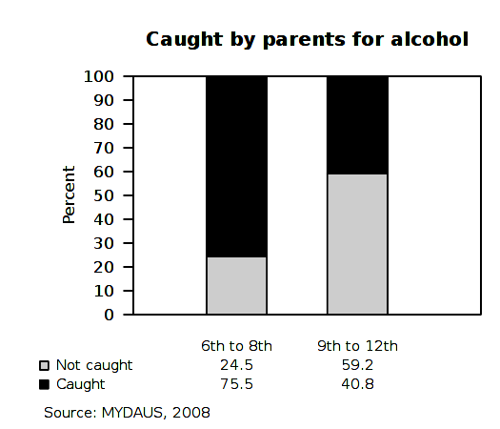

Substance Consumption: Youth
Perceptions of Harm from Use and Family Rules among 6th to 12th graders, by grade groups
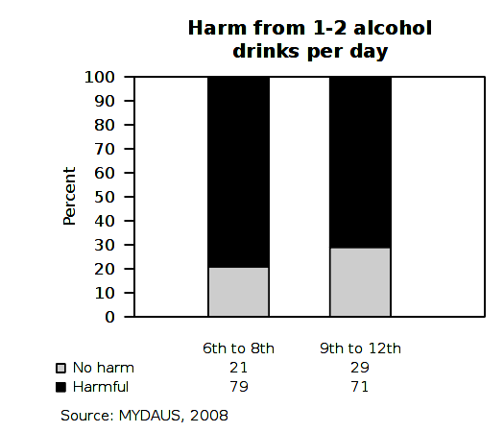
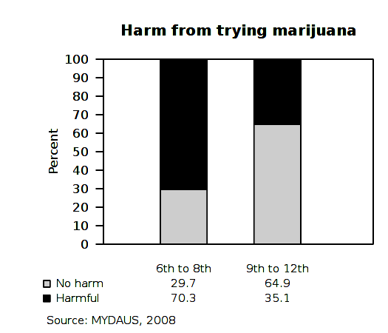
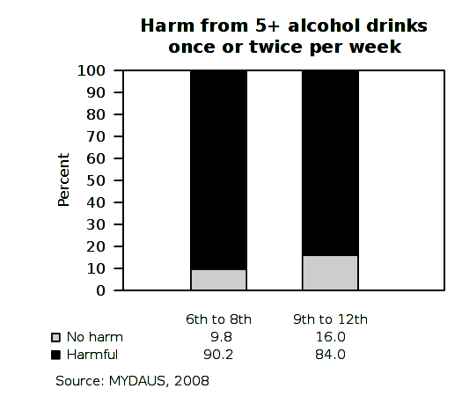
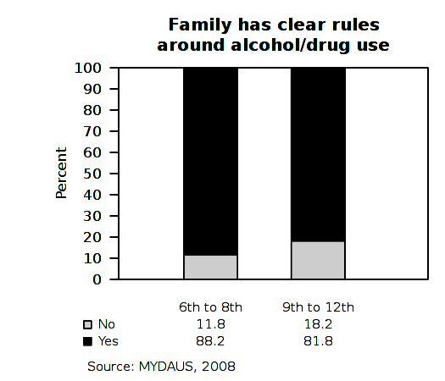
Substance Consumption: Youth
Consumption Trends: 2004 - 2008

Lifetime and Past Month Use, by Year | Lifetime |  |  | Past Month
YORK COUNTY | 2004 | 2006 | 2008 | 2004 | 2006 | 2008
Cigarettes | n/a | n/a | n/a | 12.8% | 12.5% | 12.1%
Alcohol | 49.4% | 46.2% | 44.5% | 28.2% | 28.0% | 24.9%
Marijuana | 24.8% | 22.8% | 22.9% | 13.0% | 12.5% | 12.9%
Hallucinogens | 4.0% | 4.0% | 4.1% | 1.8% | 1.7% | 1.5%
Cocaine | 4.6% | 4.2% | 3.7% | 1.9% | 1.7% | 1.5%
Ecstasy | 4.1% | 3.3% | 2.7% | 1.2% | 1.2% | 0.9%
Inhalants | 12.8% | 11.9% | 11.1% | 5.1% | 5.2% | 4.0%
Stimulants | 3.3% | 3.4% | 2.5% | 1.4% | 1.5% | 1.1%
Heroin | 1.8% | 1.7% | 1.4% | 0.8% | 0.8% | 0.7%
Prescription Drugs | 17.4% | 12.4% | 11.6% | 7.7% | 6.5% | 5.4%
Other Illegal Drugs | 10.9% | 10.4% | 9.4% | 5.7% | 5.7% | 4.9%
Binge Drinking (Past 2 Weeks) | n/a | n/a | n/a | 14.0% | 13.5% | 11.5%
SOURCE: MYDAUS 2004-2008. All percentages represent the proportion of students who indicated "Yes".

Substance Consumption: Youth
Trends for Intervening Variables and Contributing Factors: 2004 - 2008

Intervening Variables, by grade groups and year | 6th to 8th |  |  | 9th to 12th
YORK COUNTY | 2004 | 2006 | 2008 | 2004 | 2006 | 2008
Access to alcohol is easy | 31.2% | 30.1% | 31.5% | 69.0% | 66.5% | 65.1%
Access to other drugs is easy | 8.6% | 8.0% | 7.6% | 25.9% | 22.6% | 20.1%
Access to marijuana is easy | 19.7% | 16.6% | 15.8% | 71.6% | 68.5% | 64.7%
Would be caught by police (alcohol) | 42.4% | 43.1% | 42.2% | 10.2% | 10.3% | 11.6%
Would be caught by police (marijuana) | 53.1% | 52.4% | 50.4% | 15.4% | 14.7% | 15.5%
Would be caught by parents (alcohol) | 74.9% | 76.1% | 75.5% | 36.8% | 38.4% | 40.8%
Consuming 1-2 alcohol drinks per day is harmful | 75.0% | 77.3% | 79.0% | 68.0% | 69.0% | 71.0%
Consuming 5+ alcohol drinks once or twice per week is harmful | n/a | 88.8% | 90.2% | n/a | 80.8% | 84.0%
Trying marijuana is harmful | 68.3% | 69.2% | 70.3% | 36.3% | 35.7% | 35.1%
Regularly smoking marijuana is harmful | 90.3% | 89.9% | 90.8% | 72.6% | 71.6% | 69.6%
Family has clear rules around alcohol/drug use | 88.6% | 88.8% | 88.2% | 80.4% | 80.4% | 81.8%
Regular alcohol use by youth is wrong | 88.6% | 89.1% | 90.9% | 55.9% | 56.1% | 62.1%
Regular marijuana use by youth is wrong | 93.2% | 93.3% | 94.5% | 65.9% | 66.0% | 67.3%
Other drug use by youth is wrong | 97.3% | 96.8% | 98.0% | 90.8% | 90.7% | 91.9%
Parents think regular alcohol use by youth is wrong | 94.9% | 95.9% | 96.0% | 83.4% | 83.1% | 86.3%
Parents think regular marijuana use by youth is wrong | 97.8% | 98.3% | 98.2% | 91.7% | 90.7% | 91.5%
Community thinks regular alcohol use by youth is wrong | 95.2% | 94.8% | 95.9% | 84.2% | 81.6% | 81.6%
Community thinks regular marijuana use by youth is wrong | 89.0% | 88.8% | 90.2% | 71.4% | 67.6% | 71.4%
SOURCE: MYDAUS 2004-2008. All percentages represent the proportion of students who indicated "Yes".

Substance Consumption: Adults
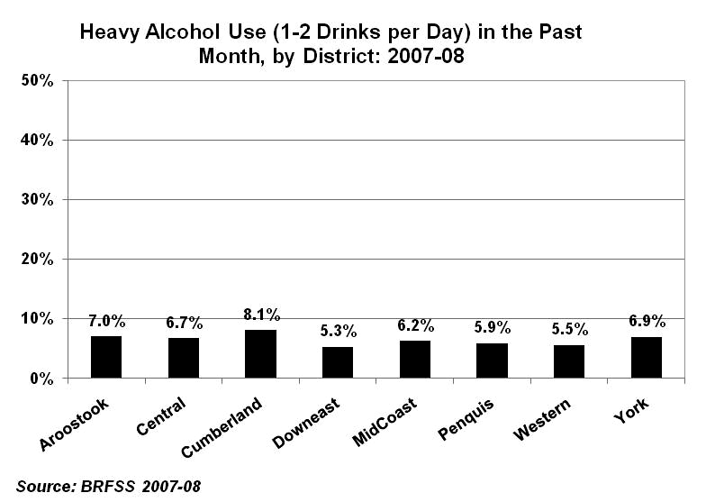
Any Alcohol, Heavy Drinking and Binge Drinking
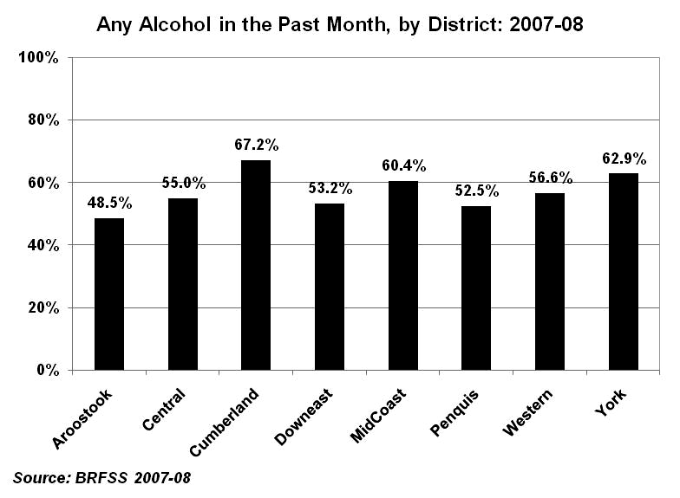
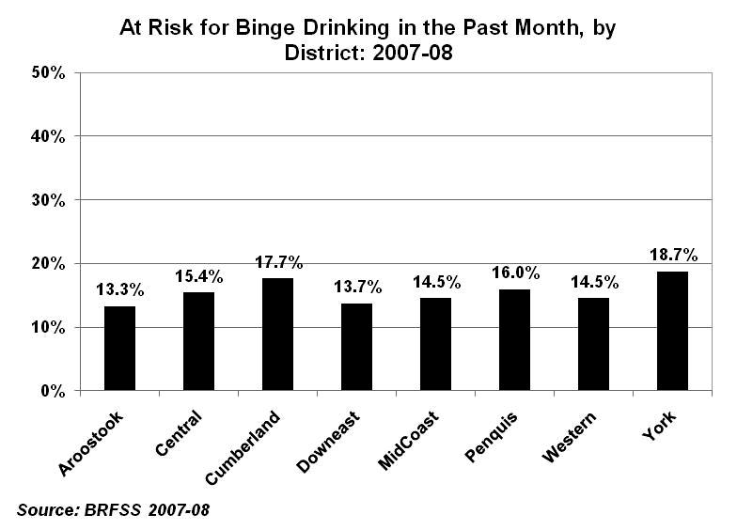
Substance Consumption: Adults
Alcohol and Drug Use, by District
 | Maine |  | York (1) |  | Cumberland (2) |  | Western (3) |  | MidCoast (4) |  | Central (5) |  | Peqnuis (6) |  | Downeast (7) |  | Aroostook (8)
 | (N=722) |  | (N=45) |  | (N=45) |  | (N=134) |  | (N=66) |  | (N=260) |  | (N=81) |  | (N=36) |  | (N=55)
 | # | % | # | % | # | % | # | % | # | % | # | % | # | % | # | % | # | %
Any use in Past Year
Alcohol | 583 | 80.7% | 36 | 80.0% | 41 | 91.1% | 100 | 74.6% | 55 | 83.3% | 220 | 84.6% | 65 | 80.2% | 26 | 72.2% | 40 | 72.7%
Marijuana | 270 | 38.0% | 24 | 54.5% | 24 | 53.3% | 45 | 33.8% | 20 | 30.8% | 108 | 42.5% | 24 | 29.6% | 12 | 35.3% | 13 | 23.6%
Painkillers or tranquilizers | 118 | 16.6% | 12 | 27.3% | 10 | 22.2% | 25 | 18.8% | 11 | 17.2% | 34 | 13.4% | 10 | 12.3% | 7 | 20.0% | 9 | 16.4%
Over the counter | 33 | 4.7% | 3 | 7.0% | 4 | 8.9% | 3 | 2.3% | 7 | 11.1% | 9 | 3.6% | 2 | 2.5% | 1 | 2.9% | 4 | 7.4%
Any of the above | 600 | 83.1% | 37 | 82.2% | 41 | 91.1% | 104 | 77.6% | 55 | 83.3% | 227 | 87.3% | 66 | 81.5% | 28 | 77.8% | 42 | 76.4%
Any use in Past Month
Alcohol | 490 | 68.2% | 33 | 73.3% | 40 | 88.9% | 77 | 57.5% | 47 | 71.2% | 184 | 71.0% | 55 | 67.9% | 20 | 55.6% | 34 | 61.8%
Marijuana | 197 | 27.7% | 18 | 40.9% | 17 | 37.8% | 35 | 26.3% | 16 | 24.6% | 77 | 30.3% | 18 | 22.2% | 7 | 20.6% | 9 | 16.4%
Painkillers or tranquilizers | 60 | 8.4% | 5 | 11.4% | 7 | 15.6% | 9 | 6.8% | 5 | 7.8% | 19 | 7.5% | 7 | 8.6% | 4 | 11.4% | 4 | 7.3%
Over the counter | 15 | 2.1% | - | - | 2 | 4.4% | 2 | 1.5% | 3 | 4.8% | 4 | 1.6% | - | - | 1 | 2.9% | 3 | 5.6%
Any of the above | 511 | 70.8% | 35 | 77.8% | 40 | 88.9% | 82 | 61.2% | 48 | 72.7% | 193 | 74.2% | 57 | 70.4% | 22 | 61.1% | 34 | 61.8%
Average number of alcoholic drinks consumed on weekdays
None | 557 | 86.1% | 33 | 80.5% | 32 | 82.1% | 106 | 87.6% | 49 | 84.5% | 204 | 89.1% | 59 | 79.7% | 28 | 82.4% | 46 | 90.2%
1-2 drinks | 69 | 10.7% | 4 | 9.8% | 5 | 12.8% | 15 | 12.4% | 5 | 8.6% | 18 | 7.9% | 12 | 16.2% | 5 | 14.7% | 5 | 9.8%
5 or more drinks | 21 | 3.2% | 4 | 9.8% | 2 | 5.1% | - | - | 4 | 6.9% | 6 | 3.1% | 3 | 4.1% | 1 | 2.9% | - | -
Average number of alcoholic drinks consumed on weeknights
None | 436 | 65.8% | 26 | 61.9% | 12 | 28.6% | 93 | 77.5% | 34 | 58.6% | 156 | 65.3% | 53 | 69.7% | 26 | 74.3% | 36 | 70.6%
1-2 drinks | 195 | 29.4% | 12 | 28.6% | 28 | 66.7% | 25 | 20.8% | 21 | 36.2% | 67 | 28.0% | 20 | 26.3% | 9 | 25.7% | 13 | 25.5%
5 or more drinks | 32 | 4.8% | 4 | 9.5% | 2 | 4.8% | 2 | 1.7% | 3 | 5.2% | 15 | 6.7% | 3 | 3.9% | 0 | 0.0% | 2 | 3.9%
Average number of alcoholic drinks consumed on weekends
None | 222 | 32.5% | 15 | 34.9% | 5 | 11.9% | 53 | 43.1% | 19 | 30.2% | 67 | 27.1% | 26 | 32.9% | 14 | 40.0% | 23 | 45.1%
1-2 drinks | 245 | 35.9% | 14 | 32.6% | 12 | 28.6% | 42 | 34.1% | 27 | 42.9% | 87 | 35.2% | 33 | 41.8% | 14 | 40.0% | 16 | 31.4%
5 or more drinks | 216 | 31.6% | 14 | 32.6% | 25 | 59.5% | 28 | 22.8% | 15 | 23.8% | 93 | 37.7% | 20 | 25.3% | 7 | 20.0% | 12 | 23.5%
Source: YADAUS 2008
Substance Consumption: Adult
Intervening Variables and Contributing Factors (Access and Enforcement), by District
 | Maine |  | York (1) |  |  |  | Cumberland (2) |  |  |  | Western (3) |  |  |  | MidCoast (4) |  |  |  | Central (5) |  |  |  | Peqnuis (6) |  |  |  | Downeast (7) |  |  |  | Aroostook (8)
 | (N=722) |  | (N=45) |  |  |  | (N=45) |  |  |  | (N=134) |  |  |  | (N=66) |  |  |  | (N=260) |  |  |  | (N=81) |  |  |  | (N=36) |  |  |  | (N=55)
 | # | % | # | % |  | # |  | % |  | # |  | % |  | # |  | % |  | # |  | % |  | # |  | % |  | # |  | % |  | # |  | %
Access to Alcohol (Under 21)
Easy | 228 | 82.0% | 14 |  | 82.4% |  | 15 |  | 93.8% |  | 37 |  | 71.2% |  | 26 |  | 89.7% |  | 90 |  | 81.8% |  | 21 |  | 84.0% |  | 10 |  | 90.9% |  | 15 |  | 83.3%
Hard | 50 | 12.0% | 3 |  | 17.6% |  | 1 |  | 6.3% |  | 15 |  | 28.8% |  | 3 |  | 10.3% |  | 20 |  | 18.2% |  | 4 |  | 16.0% |  | 1 |  | 9.1% |  | 3 |  | 16.7%
Access to Marijuana
Easy | 453 | 64.3% | 30 |  | 69.8% |  | 36 |  | 80.0% |  | 78 |  | 58.6% |  | 40 |  | 61.5% |  | 166 |  | 66.1% |  | 45 |  | 57.0% |  | 26 |  | 72.2% |  | 32 |  | 60.4%
Hard | 252 | 35.7% | 13 |  | 30.2% |  | 9 |  | 20.0% |  | 55 |  | 41.4% |  | 25 |  | 38.5% |  | 85 |  | 33.9% |  | 34 |  | 43.0% |  | 10 |  | 27.8% |  | 21 |  | 39.6%
Access to Rx Drugs
Easy | 299 | 42.4% | 22 |  | 51.2% |  | 22 |  | 51.1% |  | 59 |  | 44.4% |  | 26 |  | 40.0% |  | 98 |  | 38.9% |  | 34 |  | 43.0% |  | 17 |  | 47.2% |  | 21 |  | 39.6%
Hard | 407 | 57.6% | 21 |  | 48.8% |  | 23 |  | 48.9% |  | 74 |  | 55.6% |  | 39 |  | 60.0% |  | 154 |  | 61.1% |  | 45 |  | 57.0% |  | 19 |  | 52.8% |  | 32 |  | 60.4%
Do the bars, taverns and/or restaurants near you offer specials on alcohol?
Yes | 303 | 42.9% | 21 |  | 50.0% |  | 22 |  | 50.0% |  | 47 |  | 35.3% |  | 27 |  | 42.9% |  | 100 |  | 39.4% |  | 38 |  | 47.5% |  | 16 |  | 45.7% |  | 32 |  | 58.2%
No | 76 | 10.8% | 5 |  | 11.9% |  | 4 |  | 9.1% |  | 18 |  | 13.5% |  | 8 |  | 12.7% |  | 21 |  | 8.3% |  | 11 |  | 13.8% |  | 5 |  | 14.3% |  | 4 |  | 7.3%
Unsure | 327 | 46.3% | 16 |  | 38.1% |  | 18 |  | 40.9% |  | 68 |  | 51.1% |  | 28 |  | 44.4% |  | 133 |  | 52.4% |  | 31 |  | 38.8% |  | 14 |  | 40.0% |  | 19 |  | 34.5%
How often do you go to one of these establishments because of drink specials
Never | 539 | 76.8% | 33 |  | 76.7% |  | 25 |  | 59.5% |  | 105 |  | 79.5% |  | 54 |  | 83.1% |  | 197 |  | 78.5% |  | 58 |  | 73.4% |  | 28 |  | 80.0% |  | 39 |  | 70.9%
Rarely | 101 | 14.4% | 5 |  | 11.6% |  | 12 |  | 28.6% |  | 18 |  | 13.6% |  | 5 |  | 7.7% |  | 35 |  | 13.9% |  | 11 |  | 13.9% |  | 5 |  | 14.3% |  | 10 |  | 18.2%
Occasionally | 45 | 6.4% | 3 |  | 7.0% |  | 4 |  | 9.5% |  | 7 |  | 5.3% |  | 3 |  | 4.6% |  | 13 |  | 5.2% |  | 9 |  | 11.4% |  | 2 |  | 5.7% |  | 4 |  | 7.3%
Frequently | 17 | 2.4% | 2 |  | 4.7% |  | 1 |  | 2.4% |  | 2 |  | 1.5% |  | 3 |  | 4.6% |  | 6 |  | 2.4% |  | 1 |  | 1.3% |  | - |  | - |  | 2 |  | 3.6%
Do you believe your local police department enforces alcohol laws and policies?
Yes | 416 | 58.5% | 30 |  | 69.8% |  | 27 |  | 61.4% |  | 73 |  | 54.5% |  | 41 |  | 63.1% |  | 152 |  | 59.1% |  | 46 |  | 59.0% |  | 16 |  | 45.7% |  | 31 |  | 56.4%
No | 85 | 12.0% | 3 |  | 7.0% |  | 5 |  | 11.4% |  | 18 |  | 13.4% |  | 5 |  | 7.7% |  | 31 |  | 12.1% |  | 9 |  | 11.5% |  | 7 |  | 20.0% |  | 7 |  | 12.7%
Unsure | 210 | 29.5% | 10 |  | 23.3% |  | 12 |  | 27.3% |  | 43 |  | 32.1% |  | 19 |  | 29.2% |  | 74 |  | 28.8% |  | 23 |  | 29.5% |  | 12 |  | 34.3% |  | 17 |  | 30.9%
How willing are you to provide alcohol to someone under 21 years of age?
Willing | 108 | 15.5% | 9 |  | 20.9% |  | 11 |  | 25.6% |  | 14 |  | 10.5% |  | 7 |  | 10.9% |  | 52 |  | 21.0% |  | 10 |  | 12.7% |  | 4 |  | 11.4% |  | 1 |  | 1.9%
Not willing | 492 | 70.4% | 23 |  | 53.5% |  | 23 |  | 53.5% |  | 107 |  | 80.5% |  | 42 |  | 65.6% |  | 156 |  | 62.9% |  | 62 |  | 78.5% |  | 28 |  | 80.0% |  | 51 |  | 94.4%
Unsure | 99 | 14.2% | 11 |  | 25.6% |  | 9 |  | 20.9% |  | 12 |  | 9.0% |  | 15 |  | 23.4% |  | 40 |  | 16.1% |  | 7 |  | 8.9% |  | 3 |  | 8.6% |  | 2 |  | 3.7%
How likely do you think someone from your town will face legal consequences if they served or provided alcohol to a minor?
Likely | 447 | 63.2% | 31 |  | 72.1% |  | 26 |  | 59.1% |  | 79 |  | 59.8% |  | 50 |  | 76.9% |  | 153 |  | 60.0% |  | 53 |  | 67.9% |  | 21 |  | 60.0% |  | 34 |  | 61.8%
Not likely | 163 | 23.1% | 7 |  | 16.3% |  | 13 |  | 29.5% |  | 31 |  | 23.5% |  | 12 |  | 18.5% |  | 60 |  | 23.5% |  | 17 |  | 21.8% |  | 9 |  | 25.7% |  | 14 |  | 25.5%
Unsure | 97 | 13.7% | 5 |  | 11.6% |  | 5 |  | 11.4% |  | 22 |  | 16.7% |  | 3 |  | 4.6% |  | 42 |  | 16.5% |  | 8 |  | 10.3% |  | 5 |  | 14.3% |  | 7 |  | 12.7%
Source: YADAUS 2008
Substance Consumption: Adult
Intervening Variables and Contributing Factors (Risk of Harm and Employment), by District
 | Maine |  | York (1) |  | Cumberland (2) |  | Western (3) |  | MidCoast (4) |  | Central (5) |  | Peqnuis (6) |  | Downeast (7) |  | Aroostook (8)
 | (N=722) |  | (N=45) |  | (N=45) |  | (N=134) |  | (N=66) |  | (N=260) |  | (N=81) |  | (N=36) |  | (N=55)
 | # | % | # | % | # | % | # | % | # | % | # | % | # | % | # | % | # | %
Harm from drinking 1-2 alcoholic drinks a few times a week
Harmful | 178 | 25.2% | 15 | 34.9% | 4 | 9.3% | 41 | 30.8% | 14 | 21.5% | 49 | 19.3% | 24 | 30.4% | 11 | 31.4% | 20 | 36.4%
Not harmful | 529 | 74.8% | 28 | 65.1% | 39 | 90.7% | 92 | 69.2% | 51 | 78.5% | 205 | 80.7% | 55 | 69.6% | 24 | 68.6% | 35 | 63.6%
Harm from drinking 5 or more alcoholic drinks in one sitting
Harmful | 513 | 72.2% | 33 | 76.7% | 25 | 56.8% | 96 | 71.6% | 51 | 78.5% | 181 | 71.0% | 57 | 71.3% | 27 | 77.1% | 43 | 78.2%
Not harmful | 198 | 27.8% | 10 | 23.3% | 19 | 43.2% | 38 | 28.4% | 14 | 21.5% | 74 | 29.0% | 23 | 28.8% | 8 | 22.9% | 12 | 21.8%
Harm from using prescription drugs in order to get high
Harmful | 619 | 88.7% | 36 | 90.0% | 37 | 86.0% | 114 | 86.4% | 57 | 93.4% | 221 | 87.7% | 71 | 88.8% | 33 | 94.3% | 50 | 90.9%
Not harmful | 79 | 11.3% | 4 | 10.0% | 6 | 14.0% | 18 | 13.6% | 4 | 6.6% | 31 | 12.3% | 9 | 11.3% | 2 | 5.7% | 5 | 9.1%
Harm from trying marijuana once or twice
Harmful | 184 | 26.1% | 9 | 20.9% | 7 | 16.3% | 41 | 30.6% | 14 | 22.2% | 43 | 17.0% | 32 | 40.5% | 14 | 40.0% | 24 | 43.6%
Not harmful | 521 | 73.9% | 34 | 79.1% | 36 | 83.7% | 93 | 69.4% | 49 | 77.8% | 210 | 83.0% | 47 | 59.5% | 21 | 60.0% | 31 | 56.4%
Harm from smoking marijuana regularly
Harmful | 448 | 63.3% | 22 | 52.4% | 23 | 52.3% | 87 | 65.4% | 43 | 66.2% | 153 | 60.2% | 54 | 67.5% | 25 | 71.4% | 41 | 74.5%
Not harmful | 260 | 36.7% | 20 | 47.6% | 21 | 47.7% | 46 | 34.6% | 22 | 33.8% | 101 | 39.8% | 26 | 32.5% | 10 | 28.6% | 14 | 25.5%
To your knowledge, does your employer have an alcohol and/or drug policy? (Among those employed)
Yes | 346 | 61.0% | 22 | 64.7% | 15 | 37.5% | 61 | 61.6% | 34 | 59.6% | 119 | 62.3% | 46 | 65.7% | 23 | 76.7% | 26 | 56.5%
No | 73 | 12.9% | 2 | 5.9% | 5 | 12.5% | 18 | 18.2% | 7 | 12.3% | 20 | 10.5% | 13 | 18.6% | 2 | 6.7% | 6 | 13.0%
Unsure | 148 | 26.1% | 10 | 29.4% | 20 | 50.0% | 20 | 20.0% | 16 | 28.1% | 52 | 27.2% | 11 | 15.7% | 5 | 16.7% | 14 | 30.4%
Source: YADAUS 2008
Consequences of Substance Use
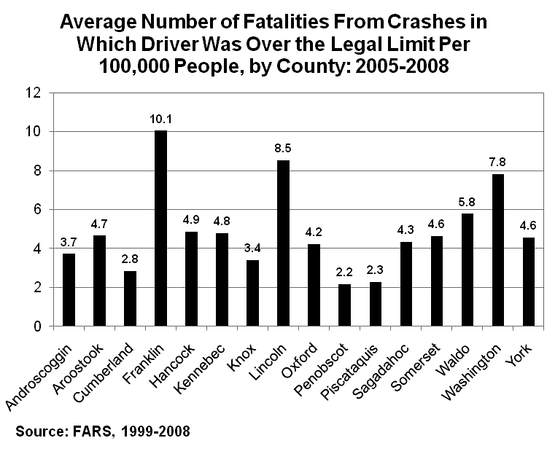
Crash Fatalities and Crime
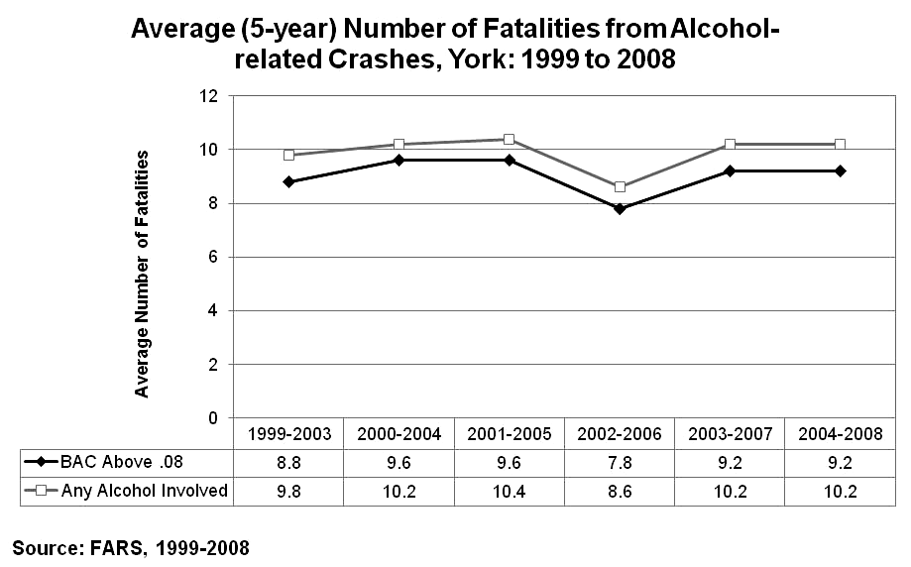

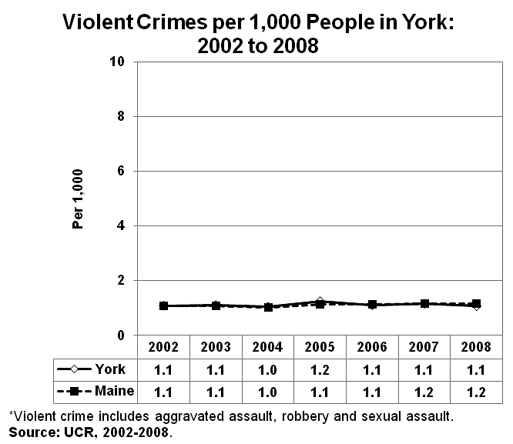
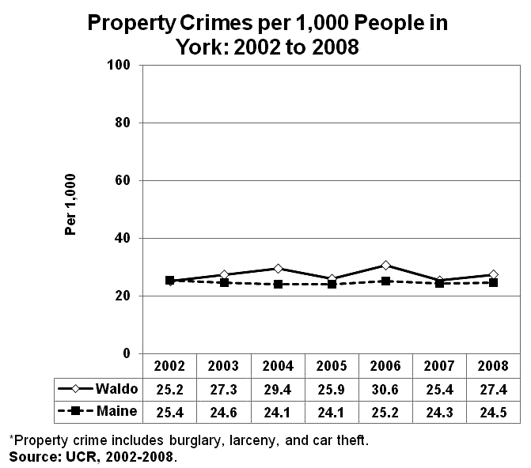

Consequences of Substance Use
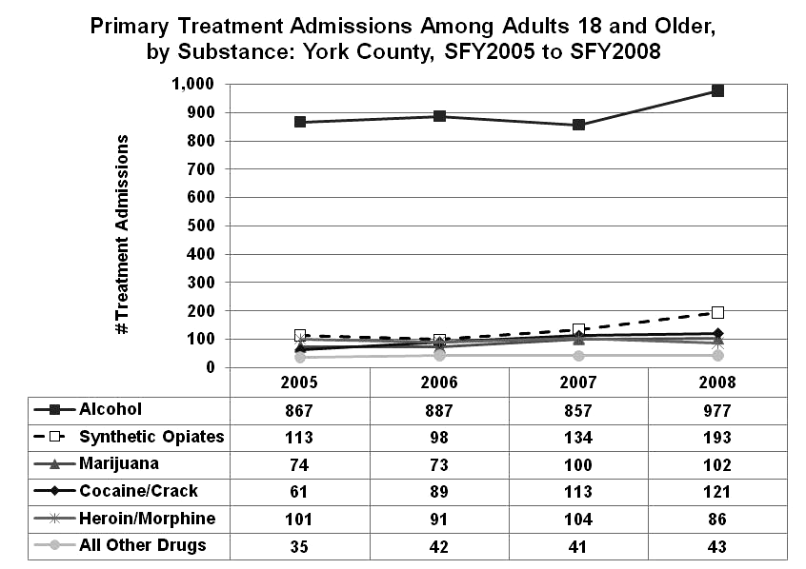
Treatment for Substance Abuse
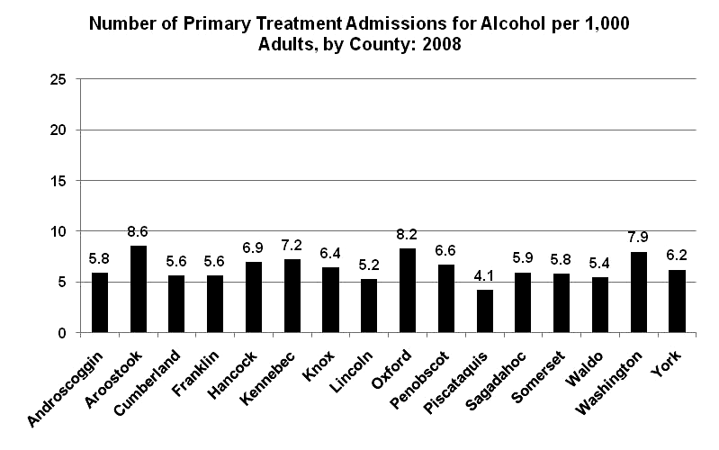

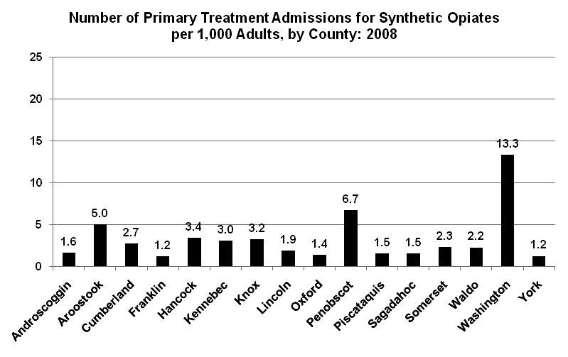
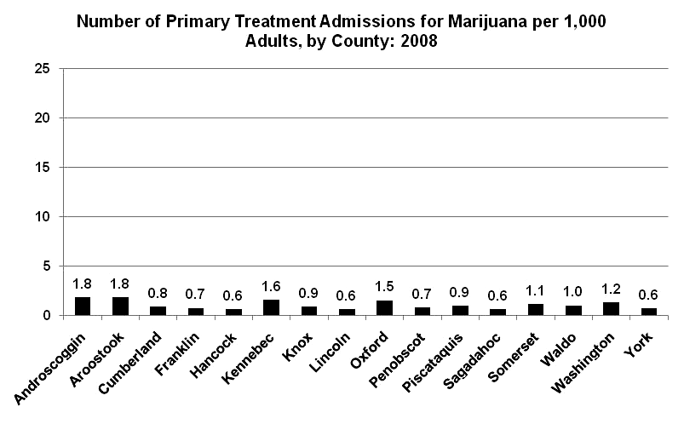

SOURCE: TDS. These charts represent the primary substance for which an individual was admitted; some individuals may use more than one substance.
Explanation of Terms Used in the Profile

Alcohol-related is a fatal crash in which a driver was alcohol involved.

Binge drinking for adults is defined as 5 or more alcoholic beverages for men in one occasion, and 4 or more alcoholic beverages for women in one occasion. For youth, there is no distinction between gender and binge drinking is defined as 5 or more alcohol beverages in one occasion.

Heavy use of alcohol for adults is defined more than one drink per day for women or two drinks per day for men and is considered a public health concern by the U.S. Centers for Disease Control and Prevention.

Lifetime use of a substance refers to whether a person has ever used the substance, even once.

Misuse of prescription drugs, for youth, means that a student used a pharmaceutical that was not specifically prescribed by a doctor. For adults, misuse means that a person used painkillers or tranquillizers in order to get high.

Previous 30-day use refers to whether the person used the substance within the 30-day period prior to the administration of the survey.

Property crime includes burglary, larceny and car theft. These crimes frequently are committed in order to obtain money to purchase drugs. Drug-attribution rates for property crime range from approximately seven percent for motor vehicle theft to 30 percent for burglary and larceny, although this may vary by geographic region. Reported property crimes are an under report of the total number of actual crimes.

Rate per 1,000/100,000 reflects a special kind of ratio that indicates the frequency with which an event occurs in a defined population over a period of time. The components of a rate include the number of incidents (e.g., number of arrests) and the population in question. Performing this calculation helps make the total number of incidents within a small county comparable to the total number of incidents found in a larger one.

Violent crime includes aggravated assault, robbery and sexual assault. Violence is often associated with alcohol and drinking on the part of the victim or a perpetrator can increase the risk of assaults and assault-related injuries. Approximately 23 percent of sexual assaults, 30 percent of physical assaults, and 3 percent of robberies are attributable to alcohol although this may vary by geographic region. Reported violent crimes are an under report of the total number of actual violent crimes.

Treatment admission reporting is required for publicly funded treatment facilities, although some private facilities report voluntarily. The data included here includes all admissions by the primary substance for which the individual sought treatment; some individuals may receive treatment for abusing more than one substance. The data do not distinguish whether a person returned more than once in the same year.

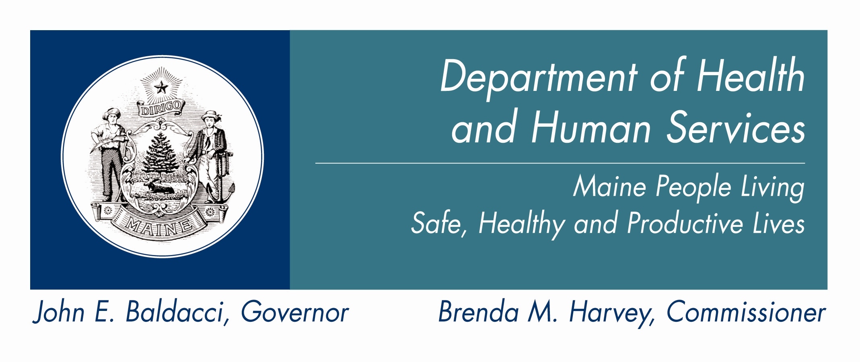
The Department of Health and Human Services does not discriminate on the basis of disability, race, color, creed, gender, sexual orientation, age or national origin in admission or access to or operations of its programs, services, or activities, or its hiring or employment practices. This notice is provided as required by Title II of the Americans with Disabilities Act of 1990 and in accordance with the Civil Rights Act of 1964 as amended, Section 504 of the Rehabilitation Act of 1973 as amended, the Age Discrimination Act of 1975, Title IX of the Education Amendments of 1972 and the Maine Human Rights Act. Questions, concerns, complaints or requests for additional information regarding the ADA may be forwarded to DHHS ADA Compliance/EEO Coordinator, SHS #11, Augusta, ME 04333; (207) 287-4289 (V) or (207) 287-3488 (V), TTY: 800-606-0215. Individuals who need auxiliary aids or services for effective communication in programs and services of DHHS are invited to make their needs and preferences known to the ADA Compliance/EEO Coordinator. This information is available in alternate formats upon request.

Caring. Responsive. Well-Managed.
We Are DHHS.

