Map # 16 depicts the coverage area by township of the One Maine Partnerships. Population is based on township level of measurement.
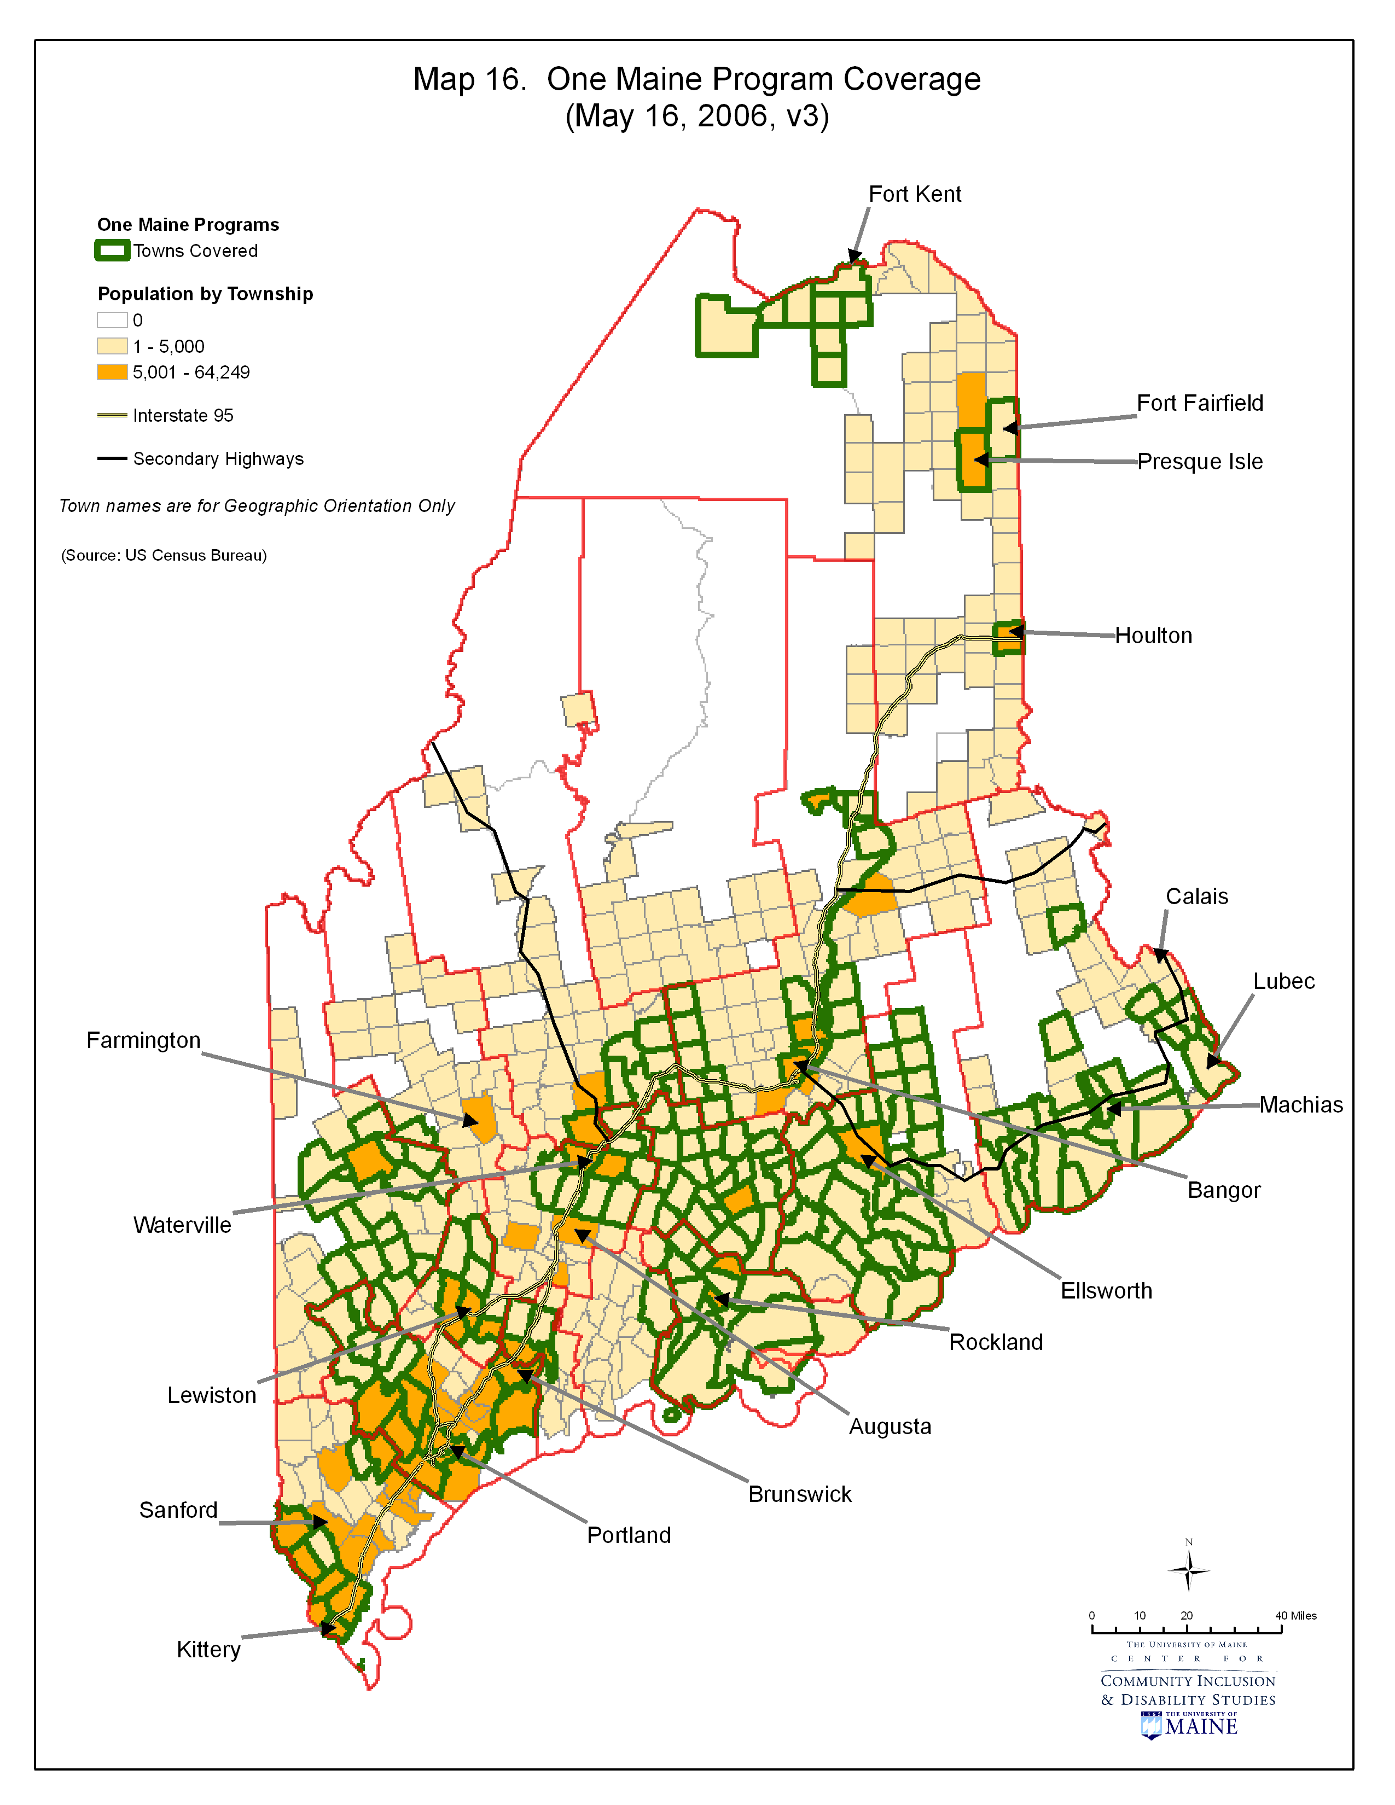
Map # 17 depicts the coverage area by township of the Healthy Maine Partnership Programs. Population is based on township level of measurement.
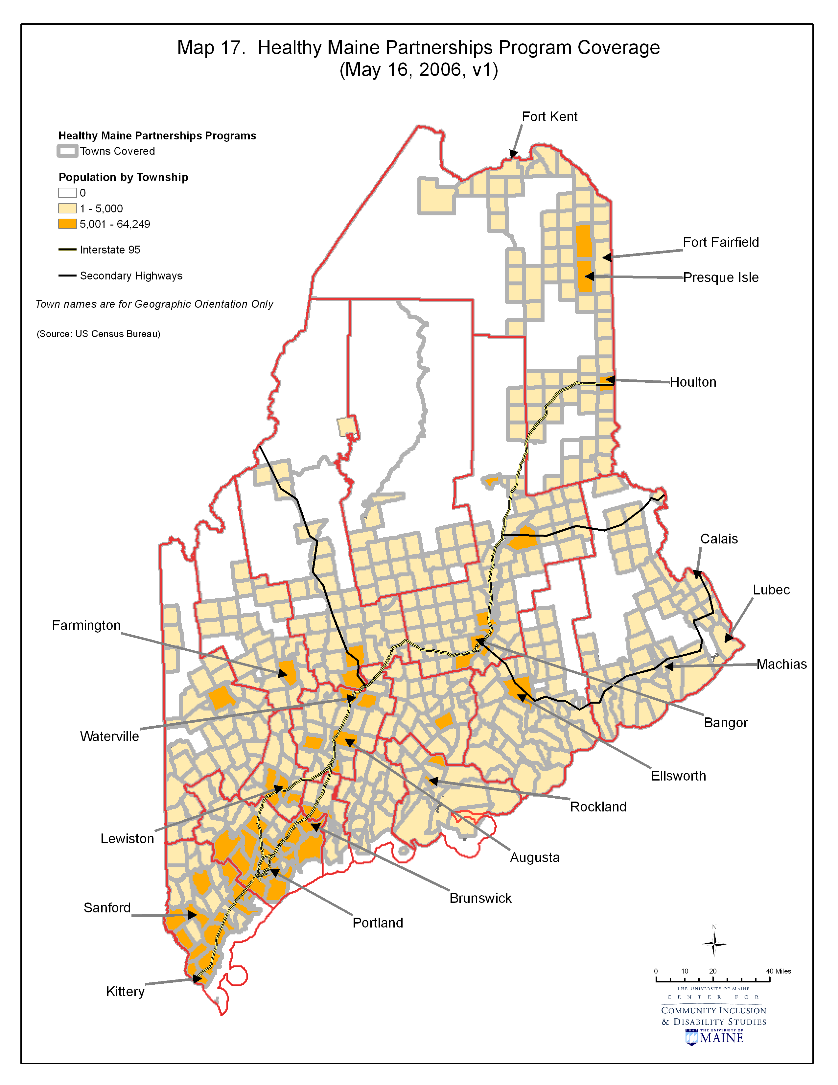
Map # 18 depicts the coverage area by township of the Healthy Communities Program. Population is based on township level of measurement.
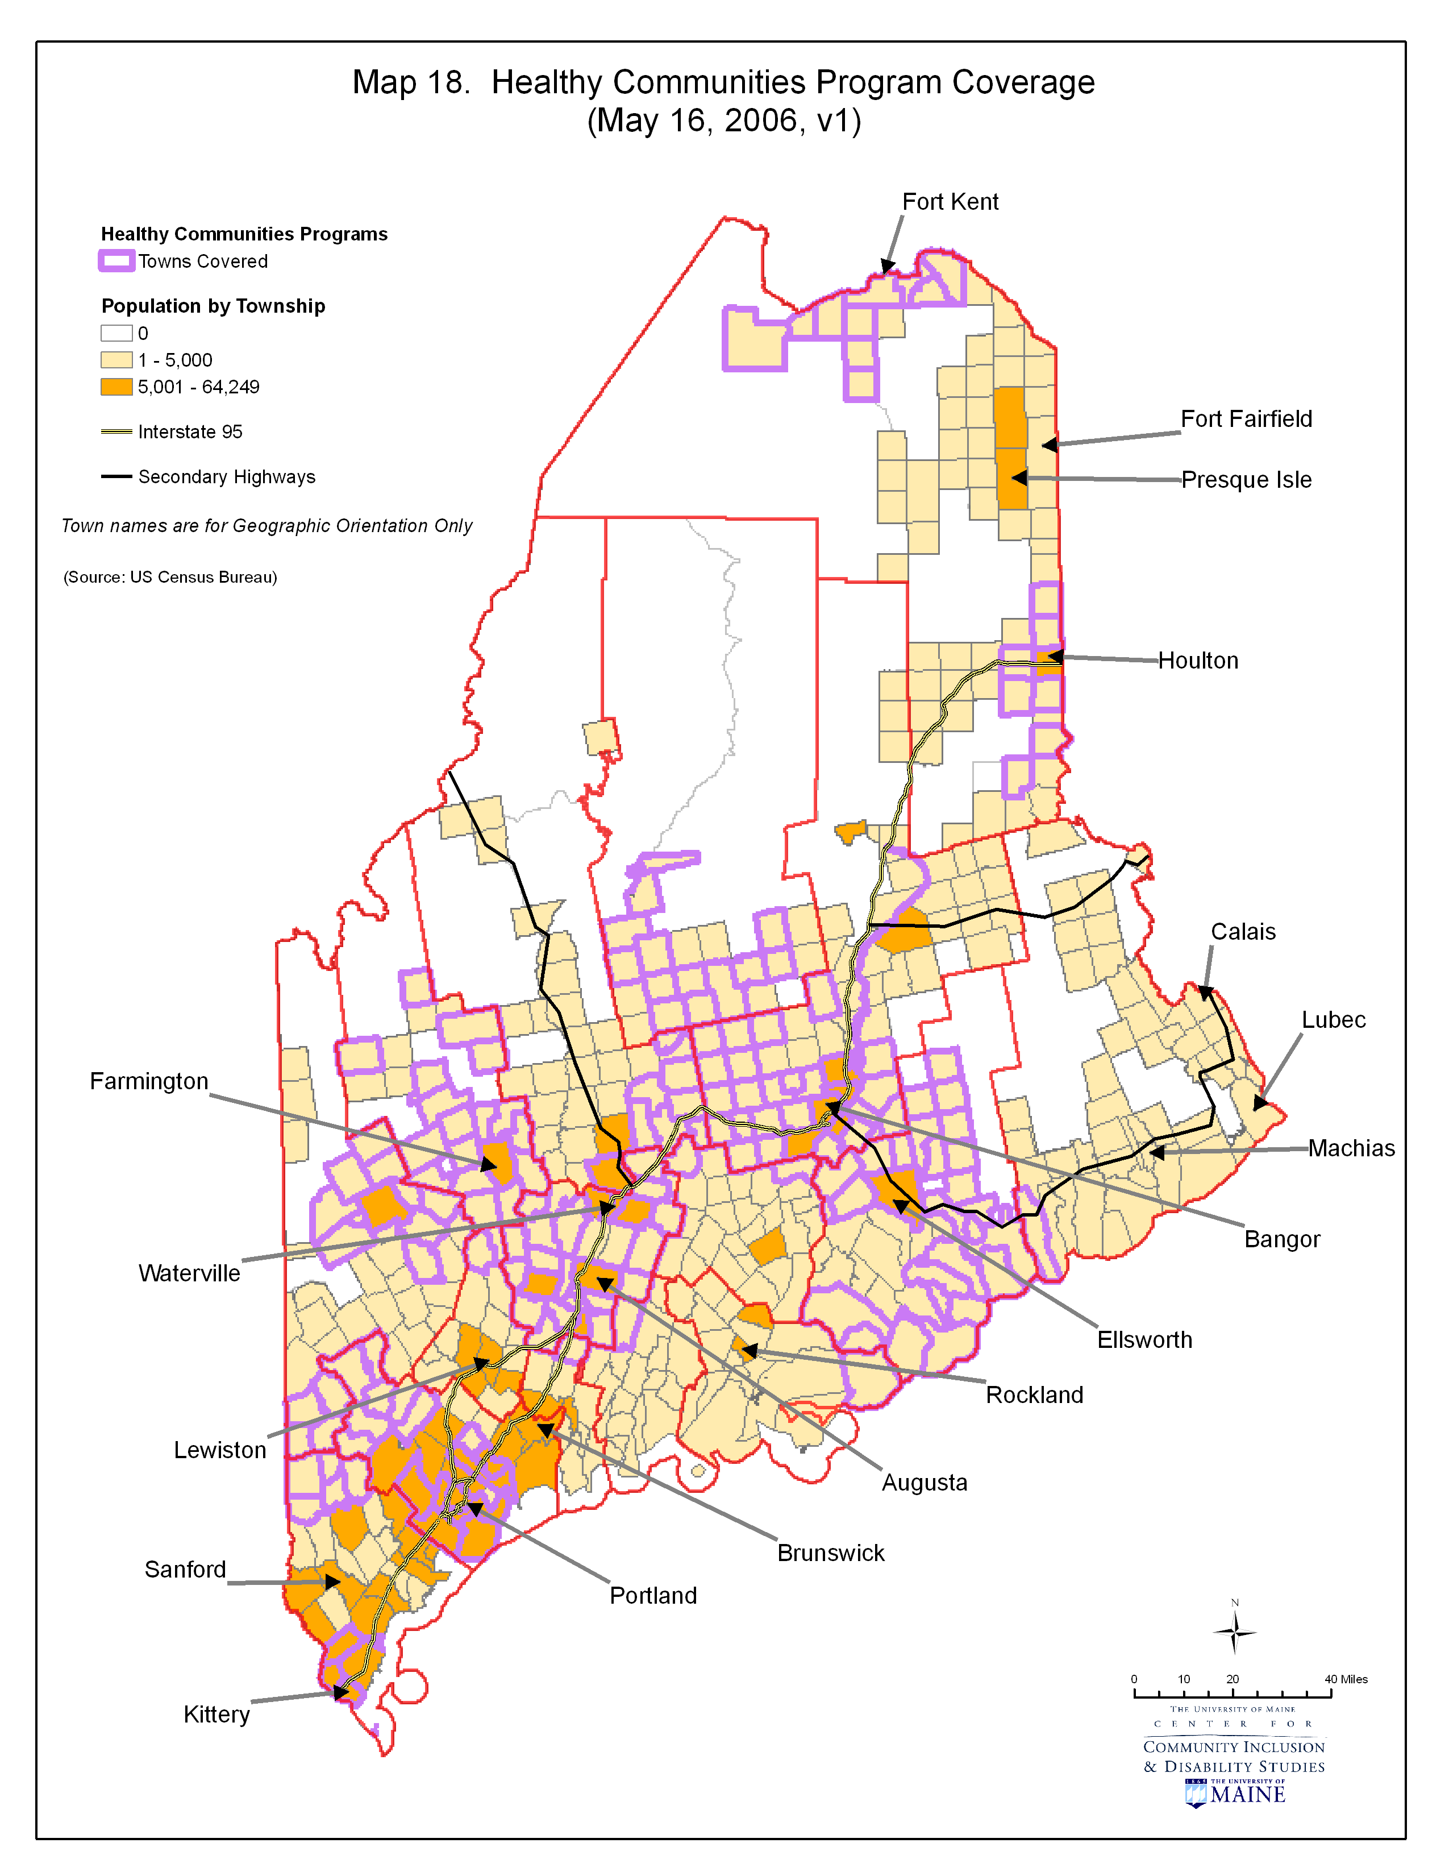
Map # 19 depicts the coverage area by township of the Communities for Children and Youth Program. Population is based on township level of measurement.

