Map #4 reports the percentage of reported binge drinking by county and population density and minor civil divisions. Statistics for reported binge drinking are derived from valid percentages from the MYDAUS data, 2004. The key depicts the meaning of shapes, color scheme and lines. Towns and cities are included for geographic orientation only.
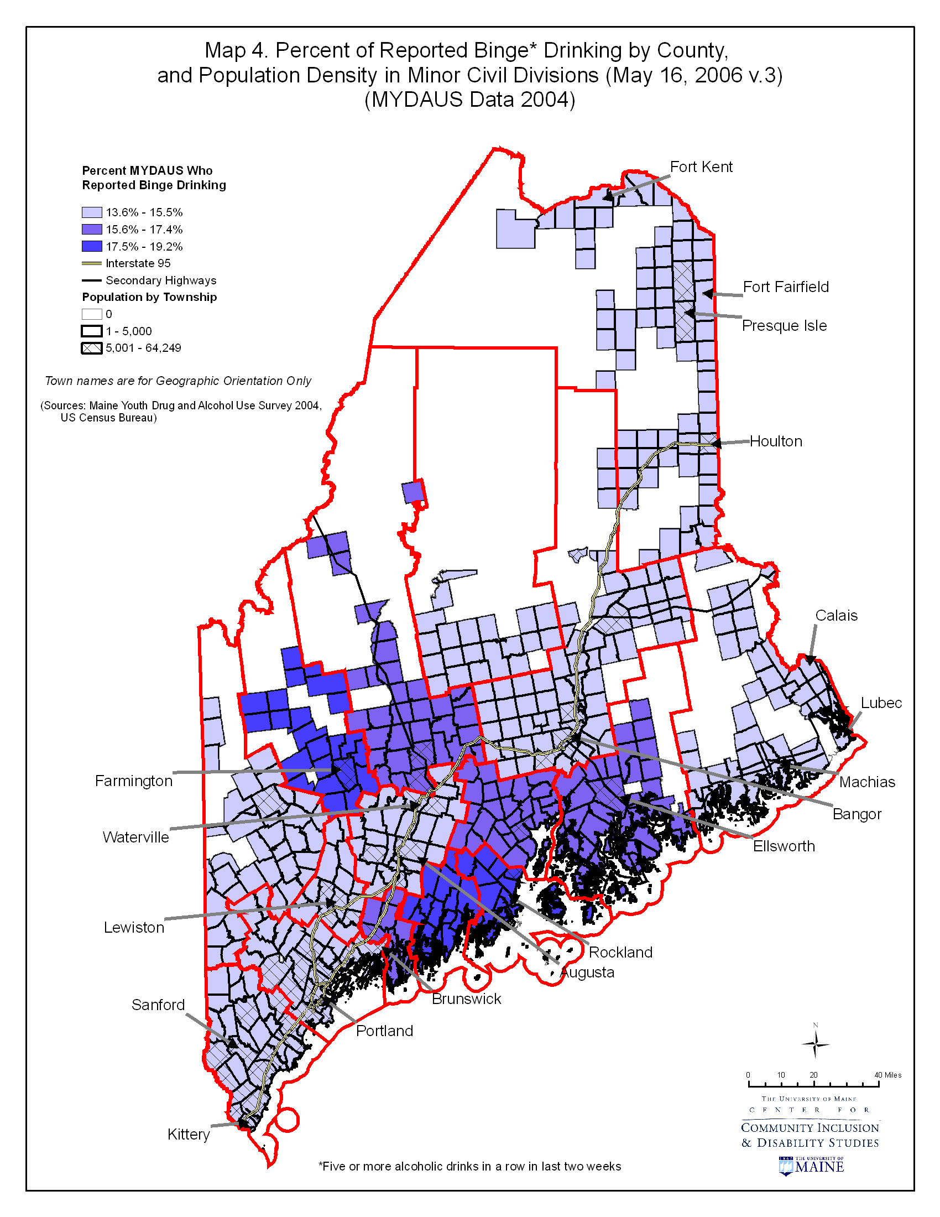

Map #5 presents the relationship between binge drinking by county (as measured by valid percentage of reported binge drinking from the MYDAUS data, 2004) and prevention infrastructure, measured as number of primary programs by minor civil division. The key depicts the meaning of shapes, color scheme and lines. Towns and cities are included for geographic orientation only.
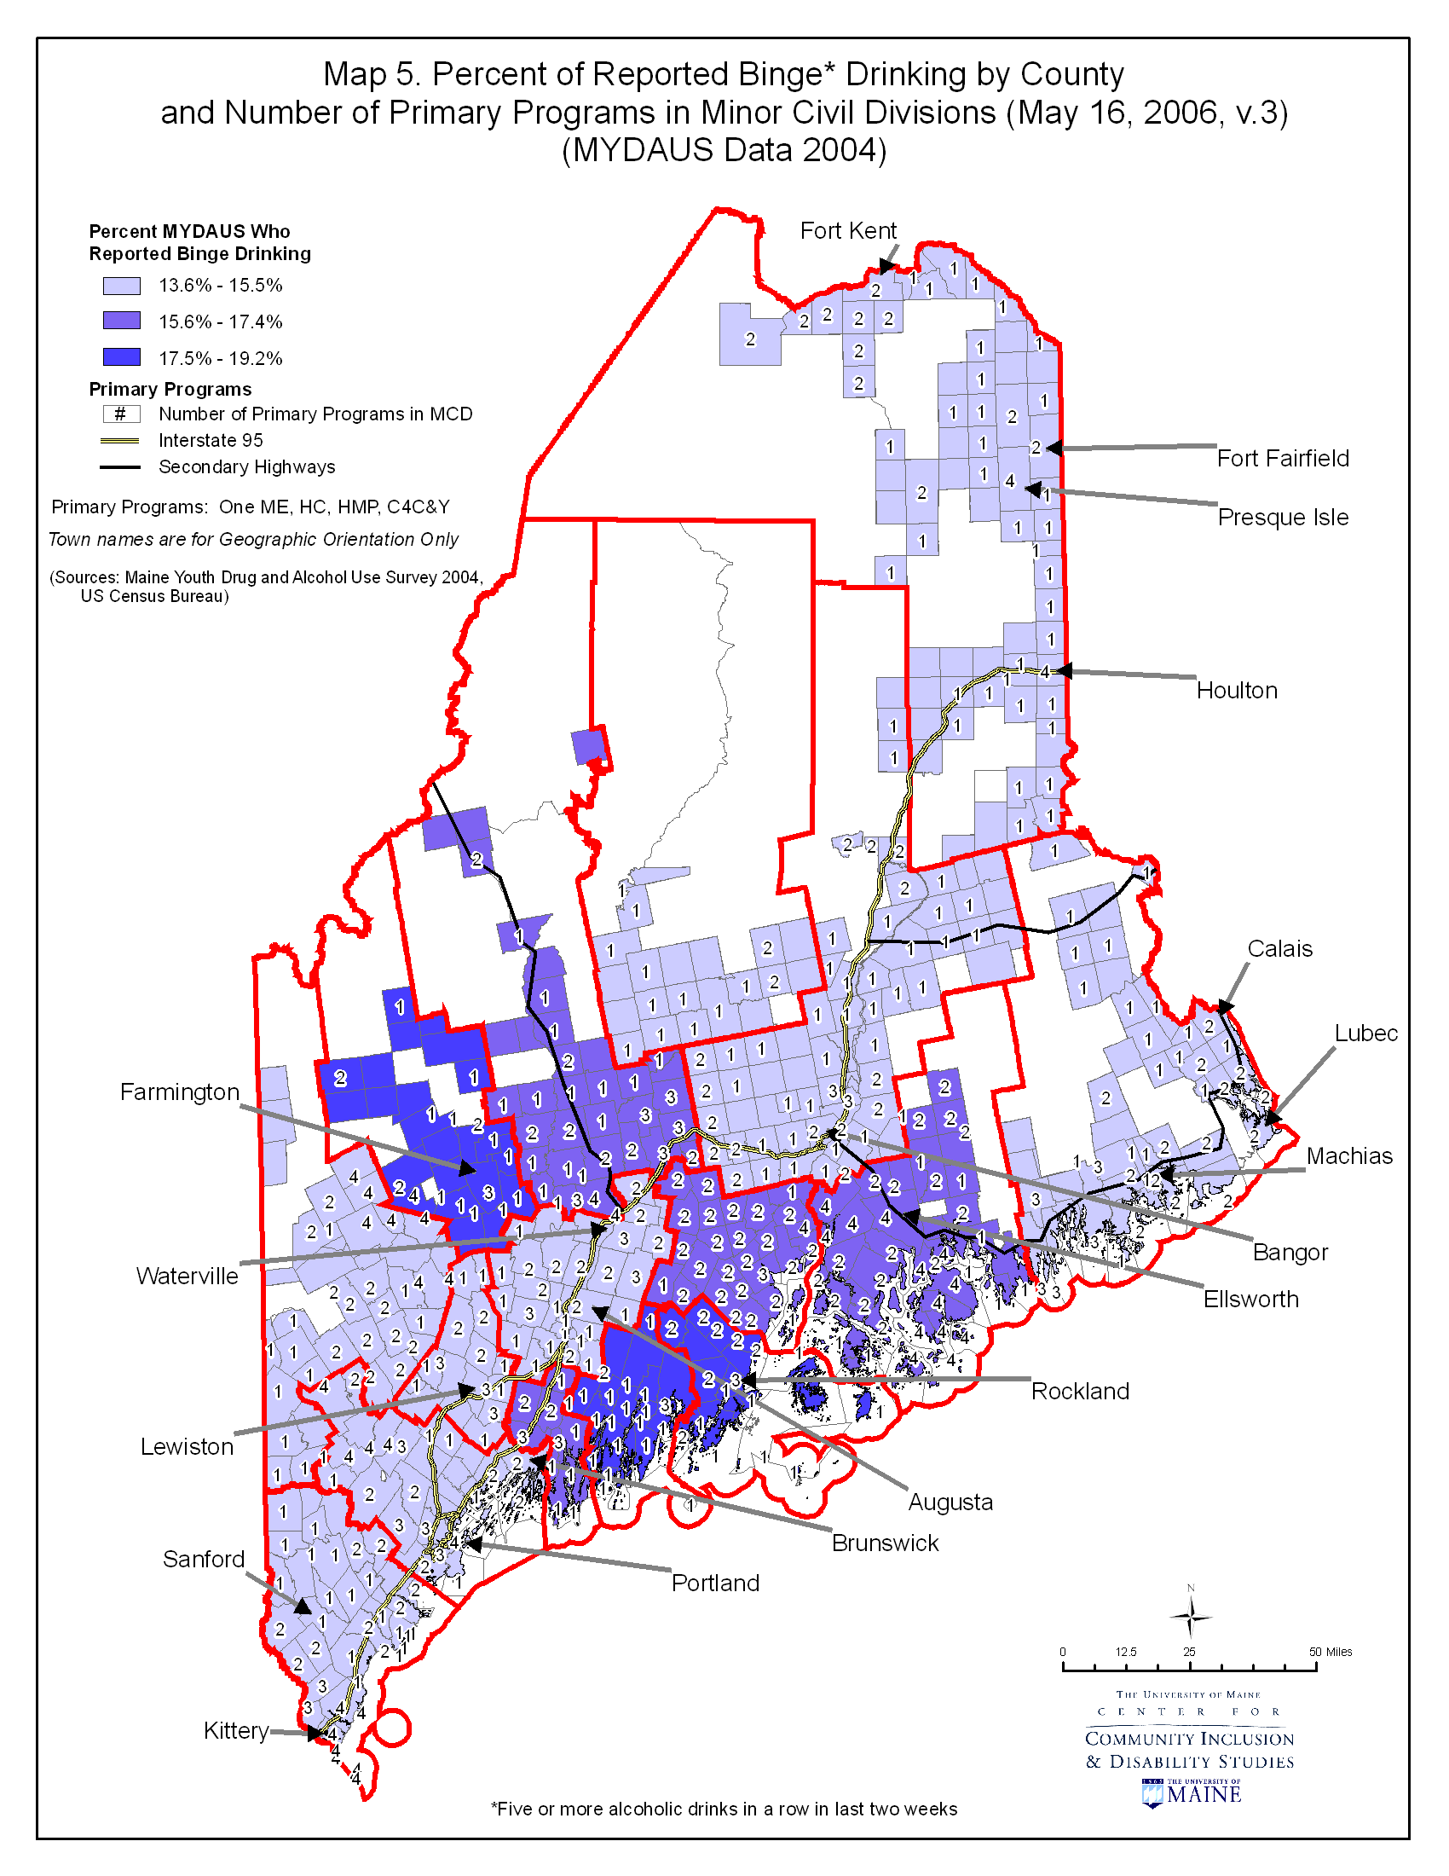

Map #6 presents the relationship between reported alcohol use during the last 30 days by county (as measured by valid percentage of reported alcohol use from the MYDAUS data, 2004) and population density by block group. As noted in the definitions below, census blocks are the smallest level of measurement, and thus population density is depicted in this map differently than in Maps #2 and #4. The key depicts the meaning of shapes, color scheme and lines. Towns and cities are included for geographic orientation only.
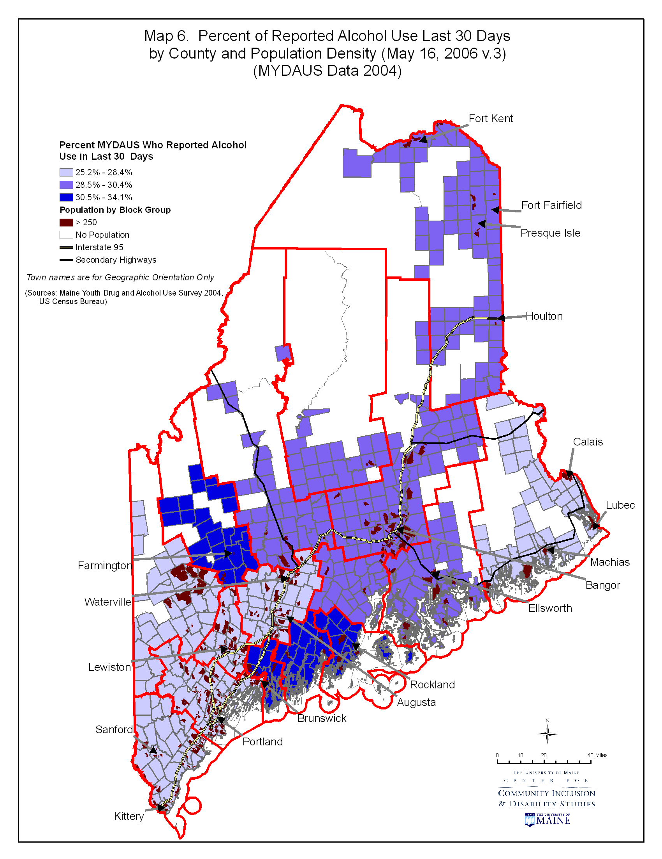
Map #7 presents the relationship between alcohol use during the past 30 days by county (as measured by valid percentage of reported alcohol use from the MYDAUS data, 2004) and prevention infrastructure, measured as number of total programs by minor civil division. The key depicts the meaning of shapes, color scheme and lines. Towns and cities are included for geographic orientation only.

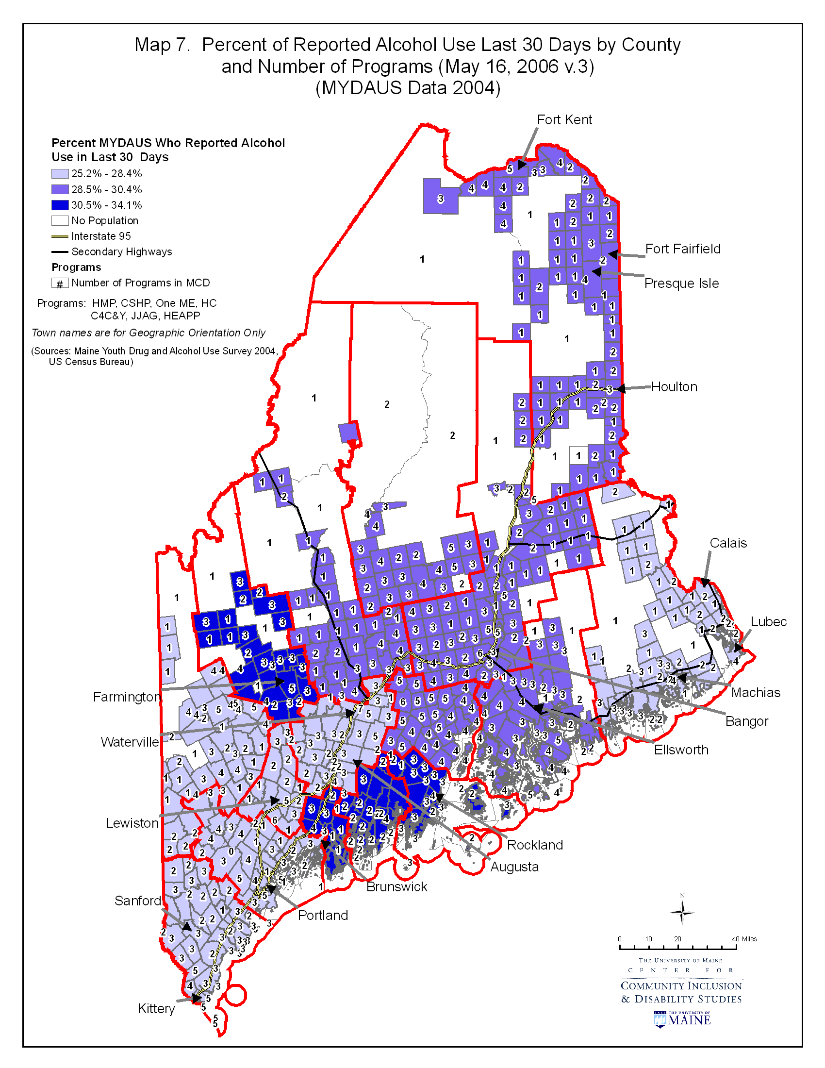
Map #8 presents the relationship between reported marijuana use during the last 30 days by county (as measured by valid percentage of reported marijuana use from the MYDAUS data, 2004) and population density by block group. As noted in the definitions below, census blocks are the smallest level of measurement, and thus population density is depicted in this map differently than in Maps #2 and #4. The key depicts the meaning of shapes, color scheme and lines. Towns and cities are included for geographic orientation only.

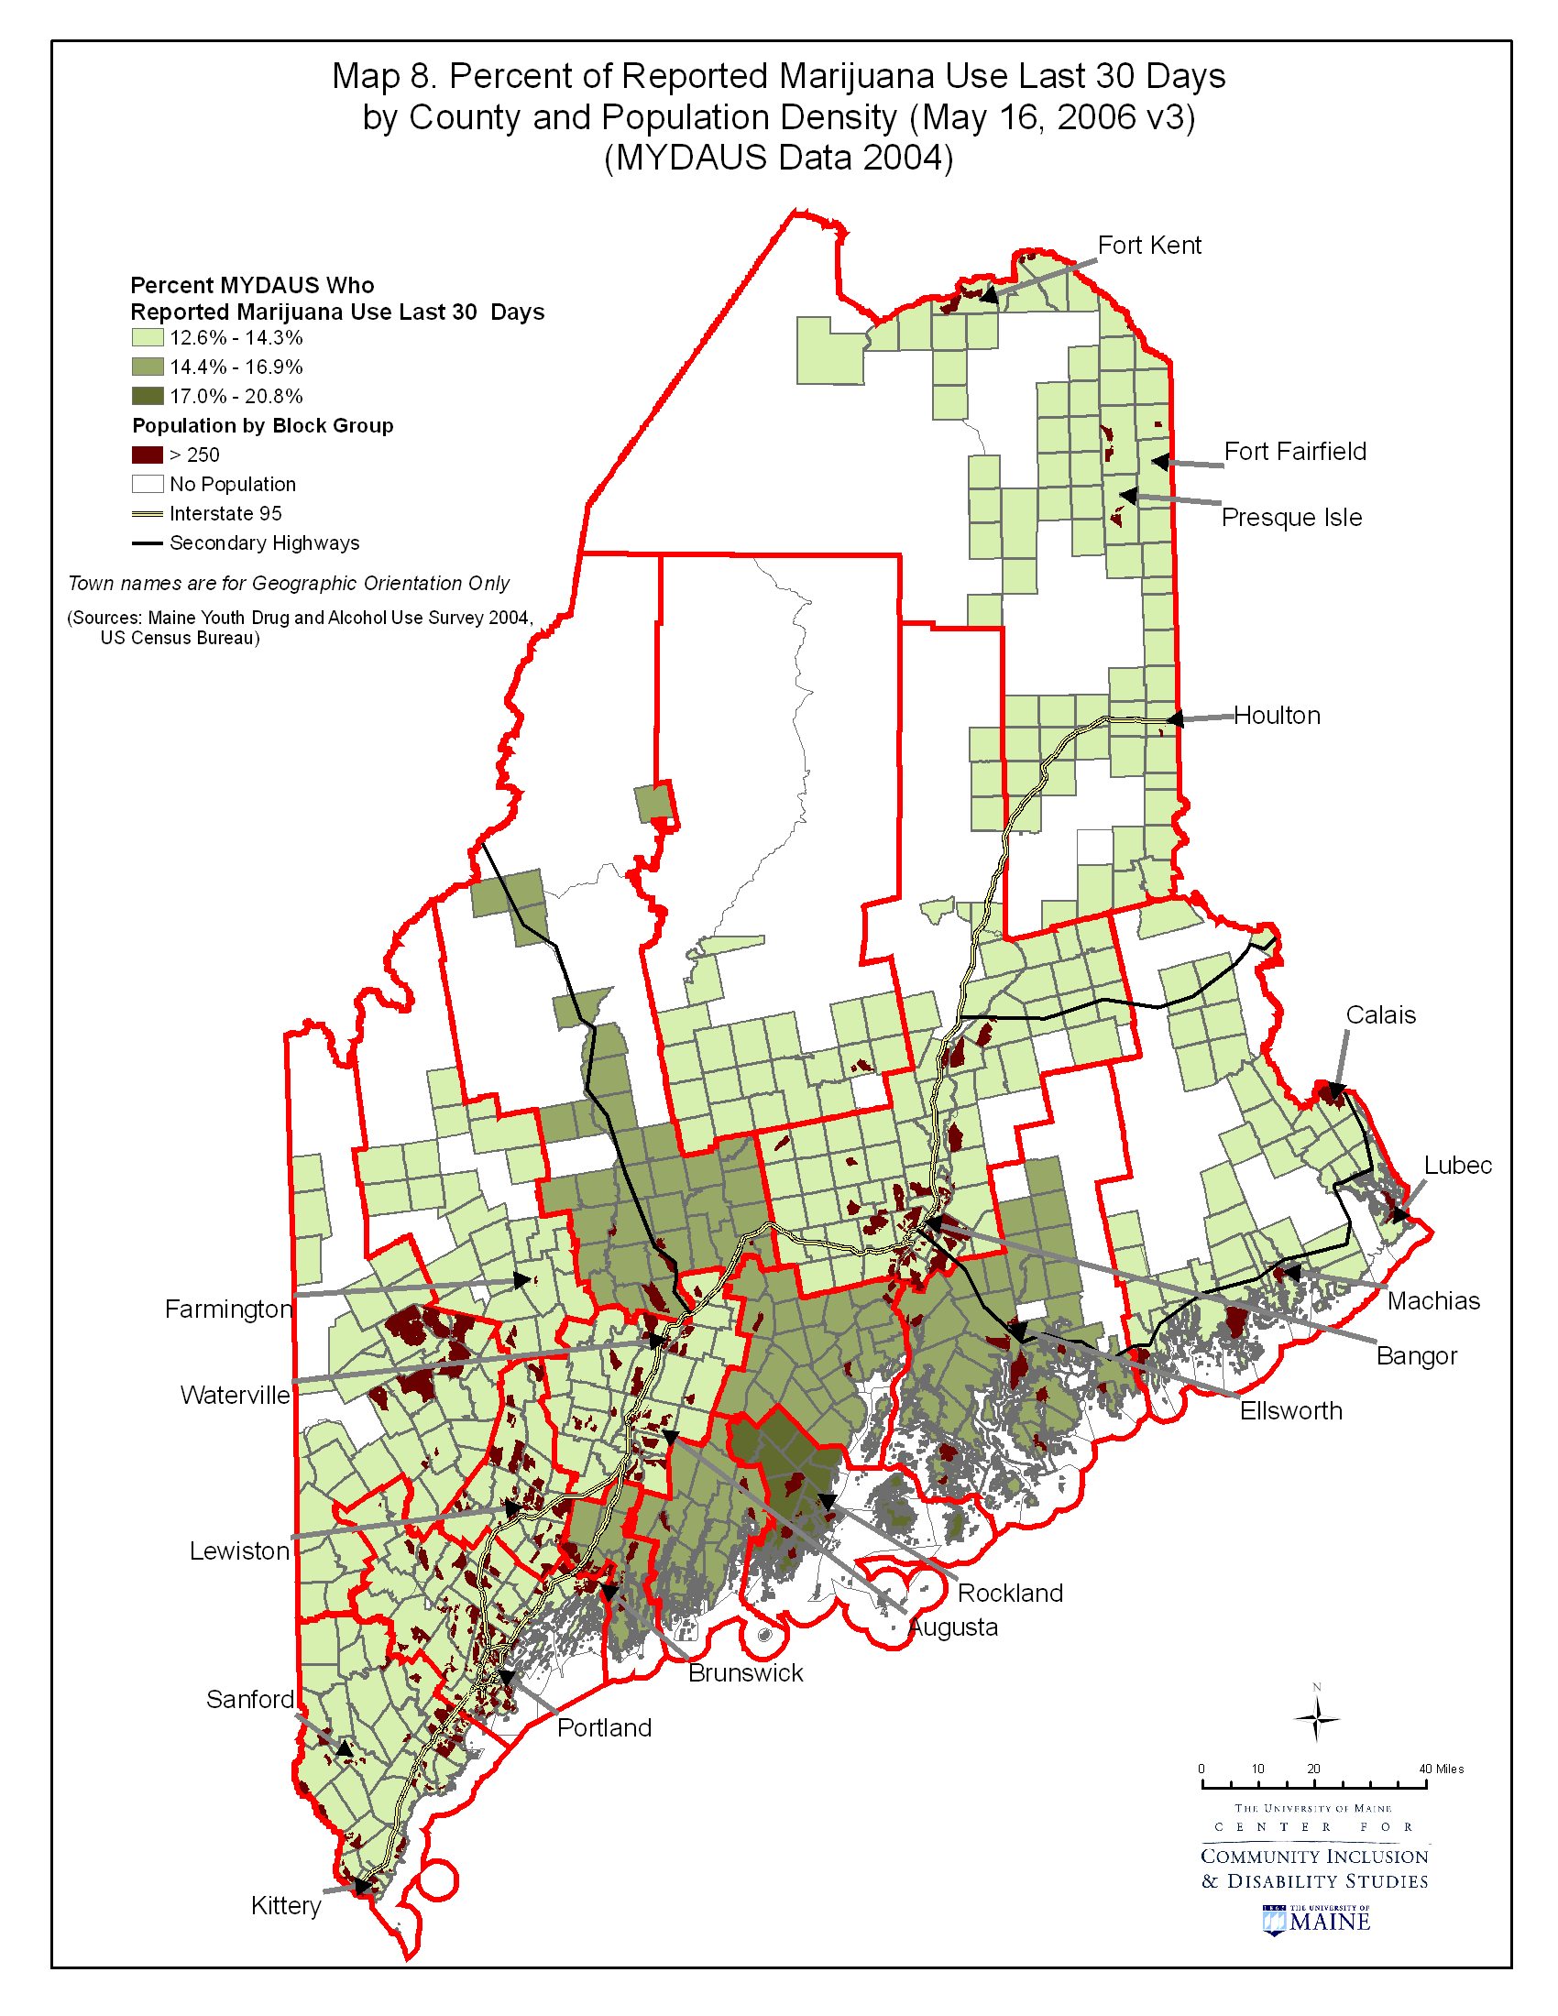
Map #9 presents the relationship between marijuana use during the past 30 days by county (as measured by valid percentage of reported marijuana use from the MYDAUS data, 2004) and prevention infrastructure, measured as number of total programs by minor civil division. The key depicts the meaning of shapes, color scheme and lines. Towns and cities are included for geographic orientation only.
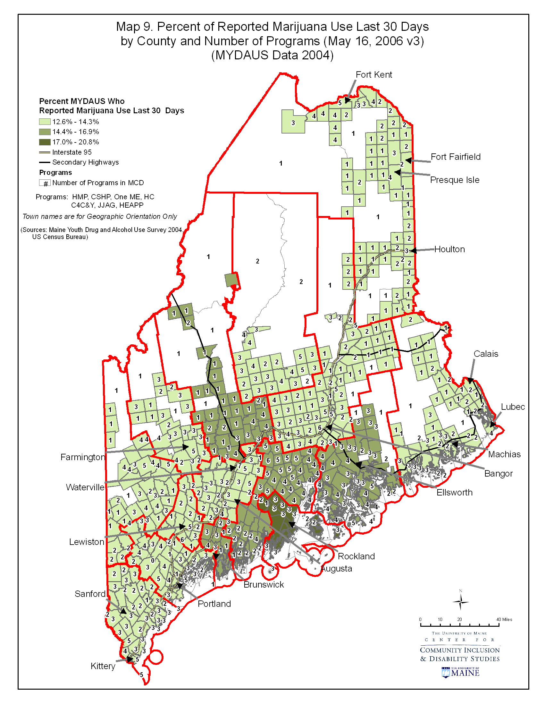

Map #10 presents the relationship between reported huffing during the last 30 days by county (as measured by valid percentage of reported huffing from the MYDAUS data, 2004) and population density by block group. As noted in the definitions below, census blocks are the smallest level of measurement, and thus population density is depicted in this map differently than in Maps #2 and #4. The key depicts the meaning of shapes, color scheme and lines. Towns and cities are included for geographic orientation only.
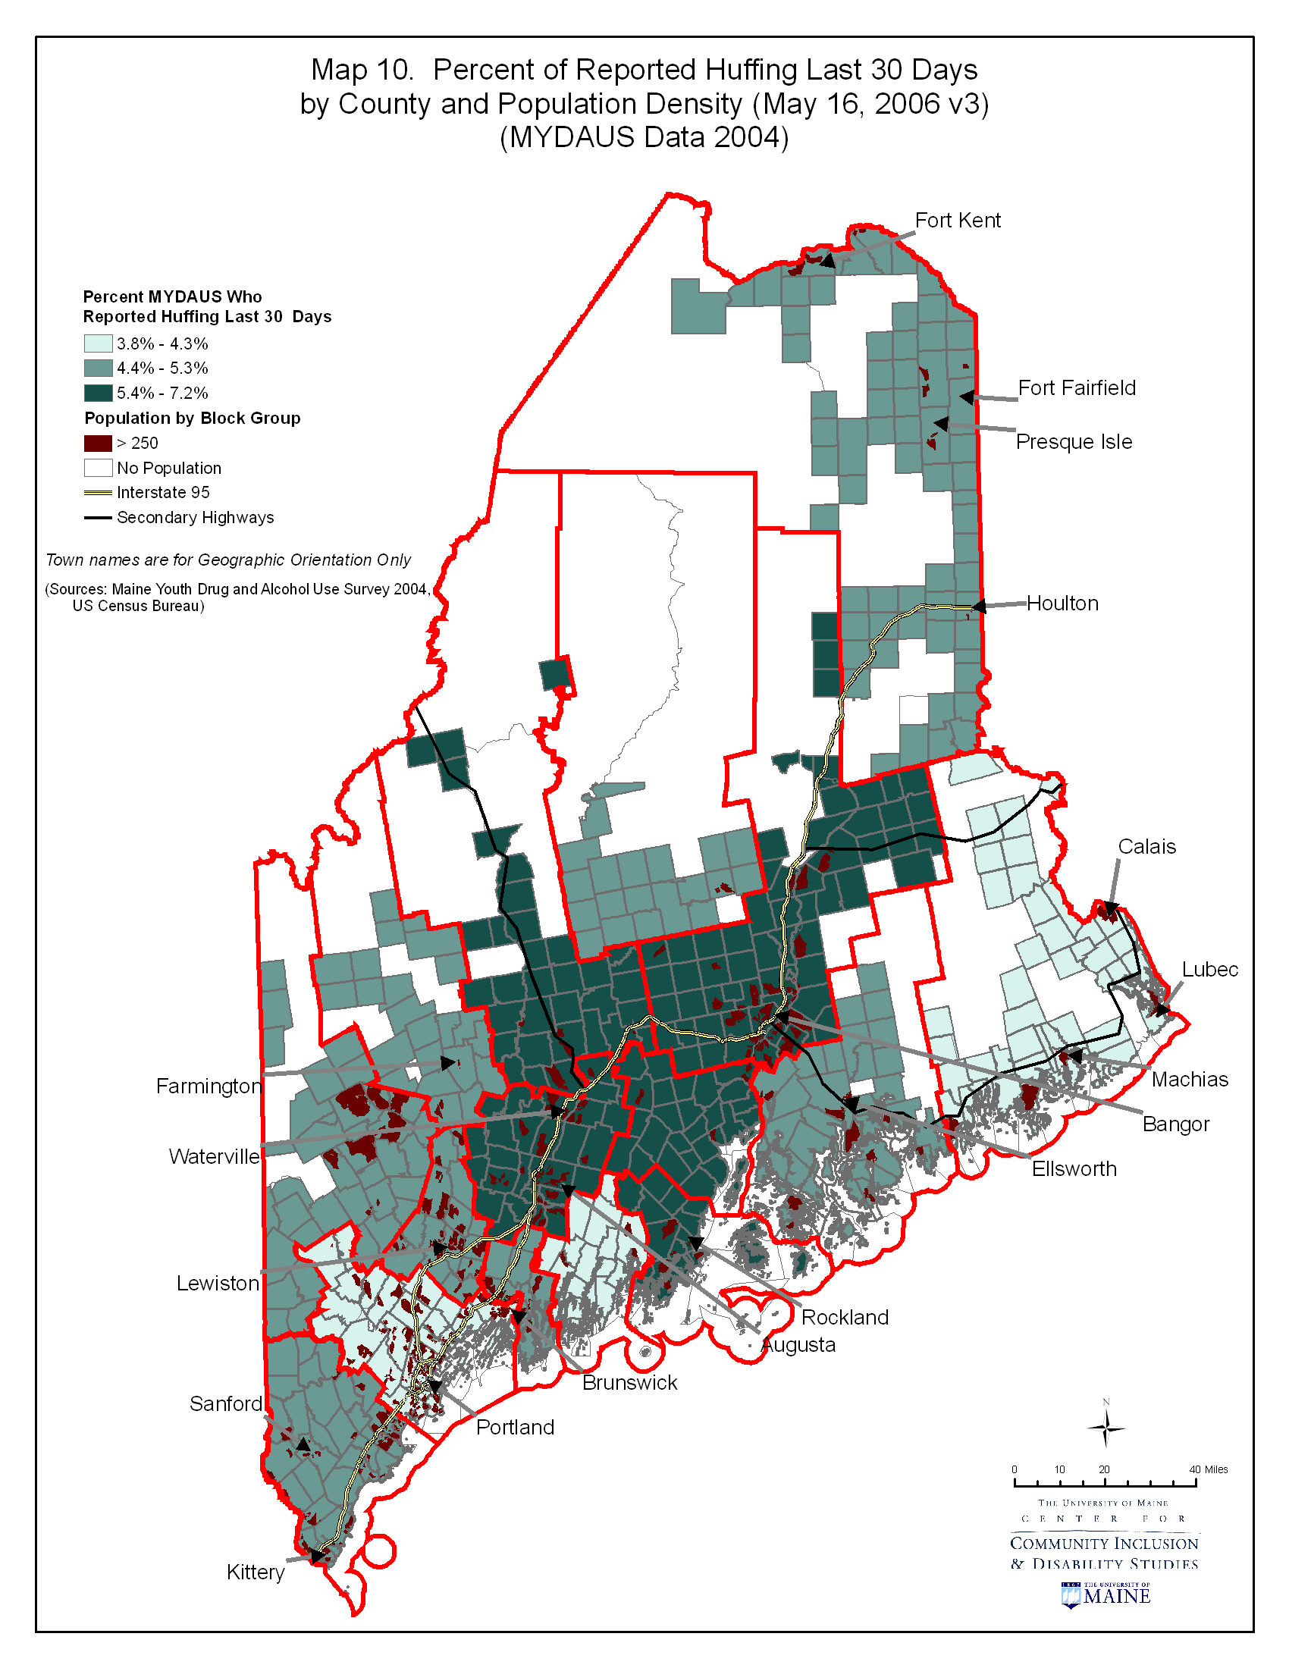

Map #11 presents the relationship between huffing during the past 30 days by county (as measured by valid percentage of reported huffing from the MYDAUS data, 2004) and prevention infrastructure, measured as number of total programs by minor civil division. The key depicts the meaning of shapes, color scheme and lines. Towns and cities are included for geographic orientation only.
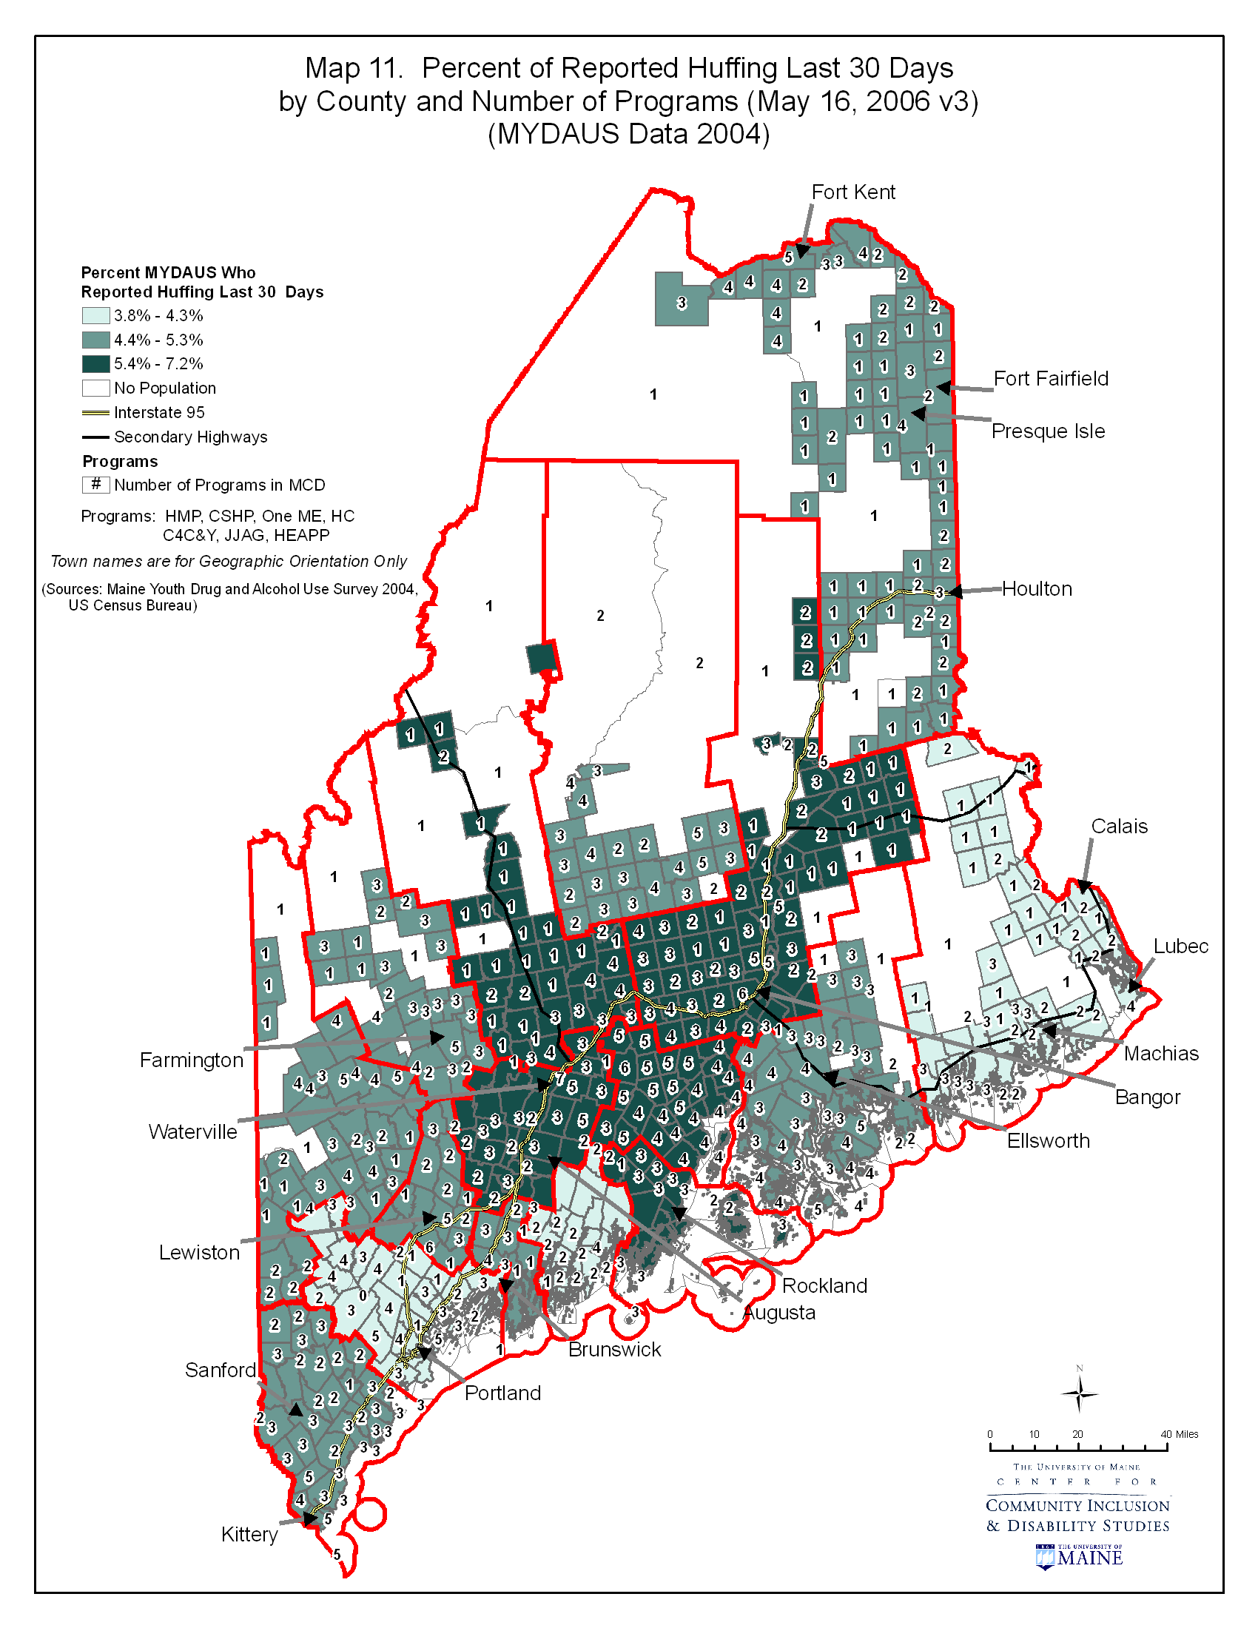

Map #12 presents the relationship between reported illicit prescription use during the last 30 days by county (as measured by valid percentage of reported illicit prescription use from the MYDAUS data, 2004) and population density by block group. As noted in the definitions below, census blocks are the smallest level of measurement, and thus population density is depicted in this map differently than in Maps #2 and #4. The key depicts the meaning of shapes, color scheme and lines. Towns and cities are included for geographic orientation only.
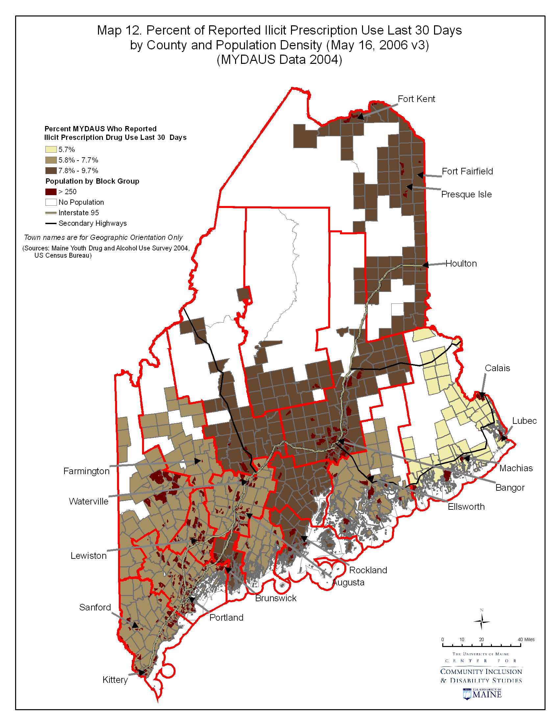
Map #13 presents the relationship between illicit prescription use during the past 30 days by county (as measured by valid percentage of reported illicit prescription use from the MYDAUS data, 2004) and prevention infrastructure, measured as number of total programs by minor civil division. The key depicts the meaning of shapes, color scheme and lines. Towns and cities are included for geographic orientation only.
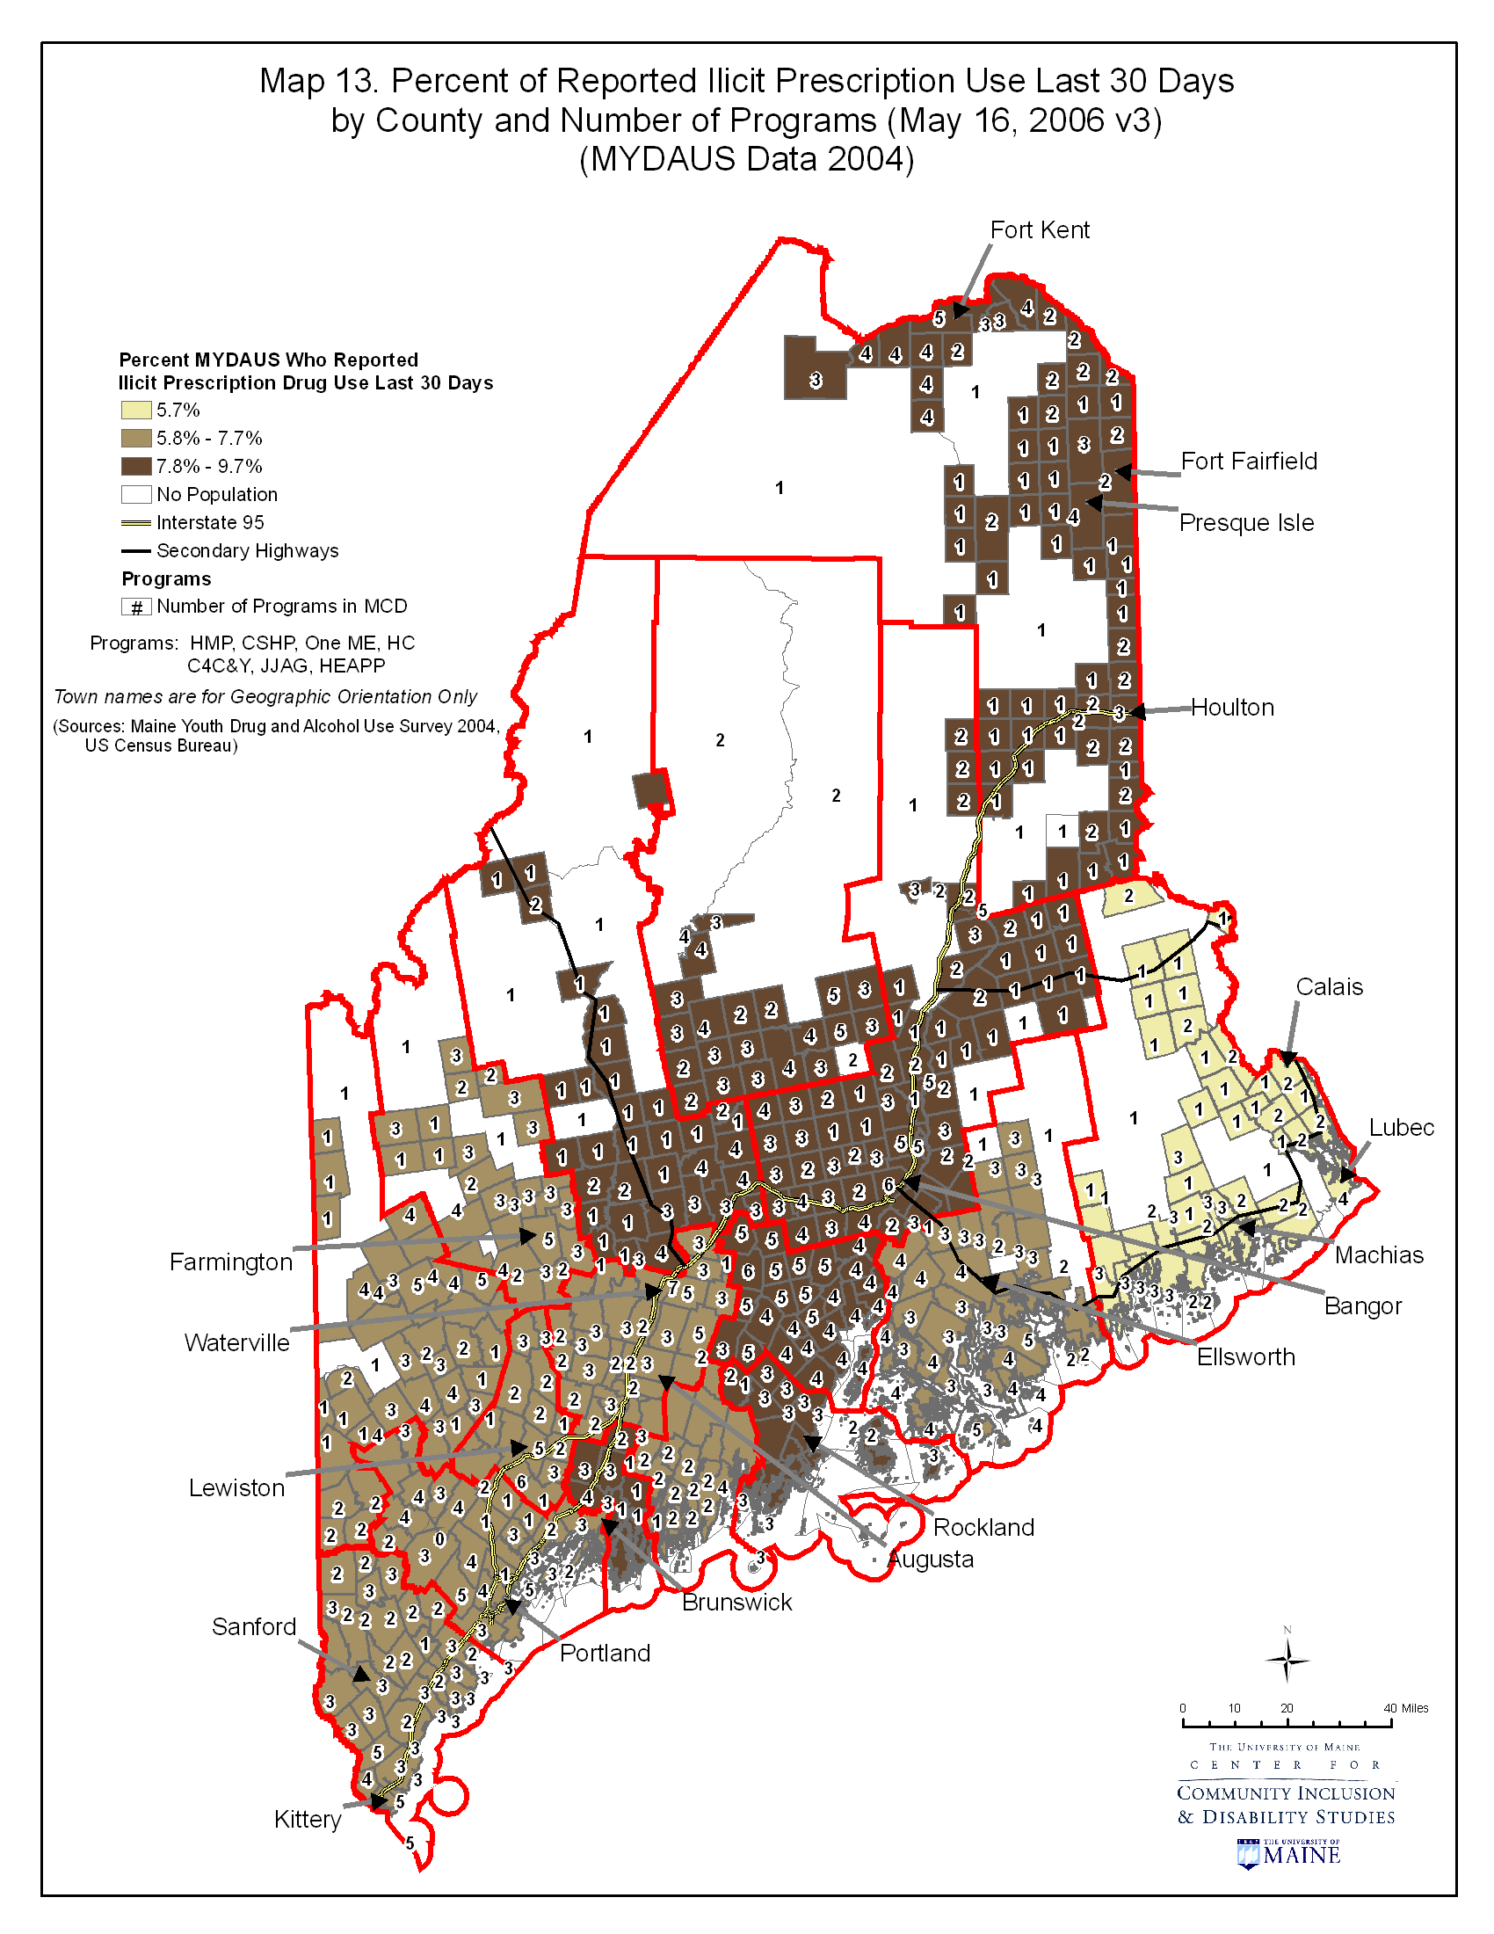

Map #14 presents the relationship between reported other illicit drug use during the last 30 days by county (as measured by valid percentage of reported other illicit drug use from the MYDAUS data, 2004) and population density by block group. As noted in the definitions below, census blocks are the smallest level of measurement, and thus population density is depicted in this map differently than in Maps #2 and #4. The key depicts the meaning of shapes, color scheme and lines. Towns and cities are included for geographic orientation only.
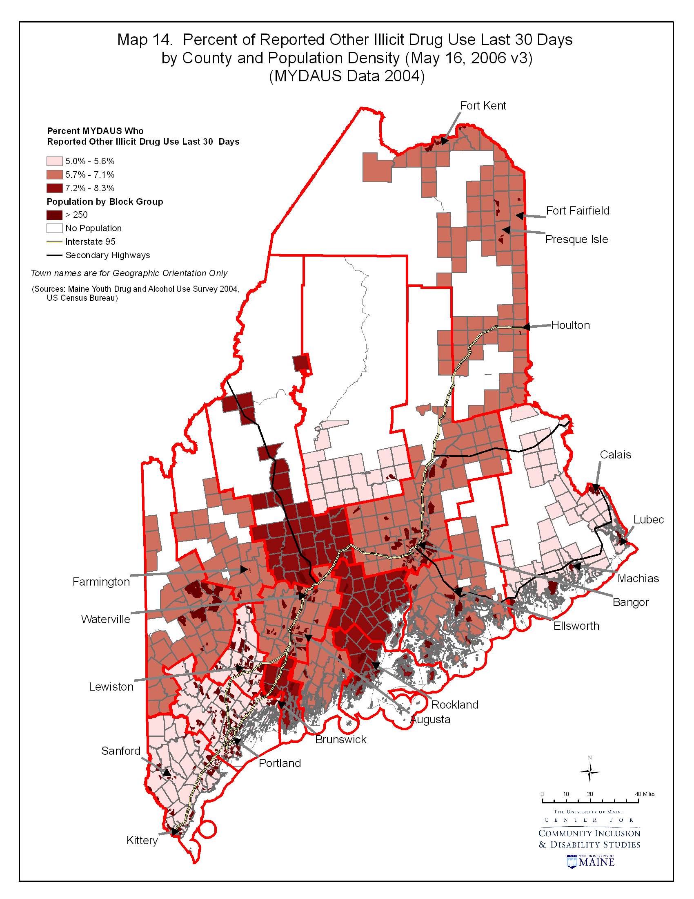
Map #15 presents the relationship between other illicit drug use during the past 30 days by county (as measured by valid percentage of reported other illicit drug use from the MYDAUS data, 2004) and prevention infrastructure, measured as number of total programs by minor civil division. The key depicts the meaning of shapes, color scheme and lines. Towns and cities are included for geographic orientation only.
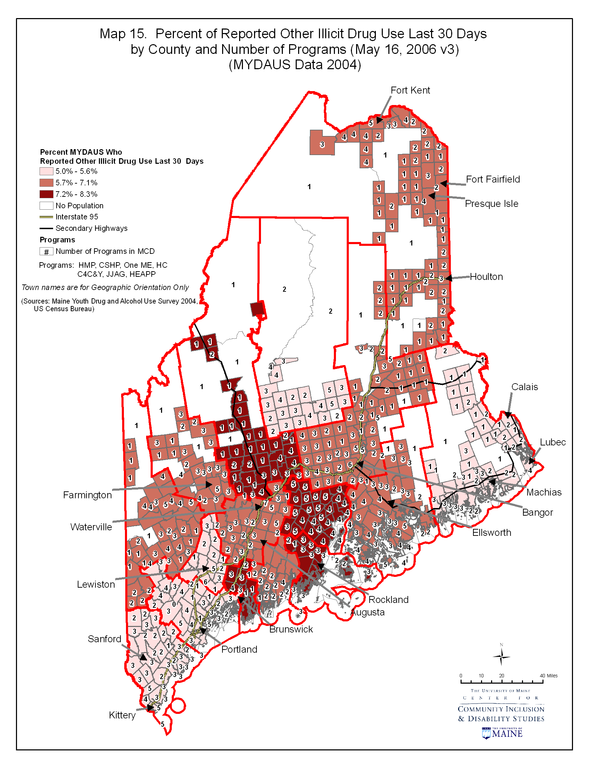

Definitions
Census blocks: the smallest geographic area for which the Bureau of the Census collects and tabulates decennial census data, formed by streets, roads, railroads, streams and other bodies of water, other visible physical and cultural features, and the legal boundaries shown on Census Bureau maps. (www.census.gov/geo/www/GARM/Ch11GARM.pdf)

Valid percentage; the percentage of the total number of respondents for each item.(Depoy, E. and Gitlin, L. ( 2005) Introduction to research. St Louis, MO: Mosby.)

Minor civil divisions: the primary political or administrative divisions of a county. MCDs represent many different kinds of legal entities with a wide variety of governmental and/or administrative functions. MCDs include, among others, American Indian reservations, assessment districts, boroughs, precincts, towns, and townships. (www.library.wisc.edu/guides/govdocs/census/geog.htm)

