Alcohol Pricing & Promotions:
Protect Your Business


FAQ’s for Maine Liquor Licensees
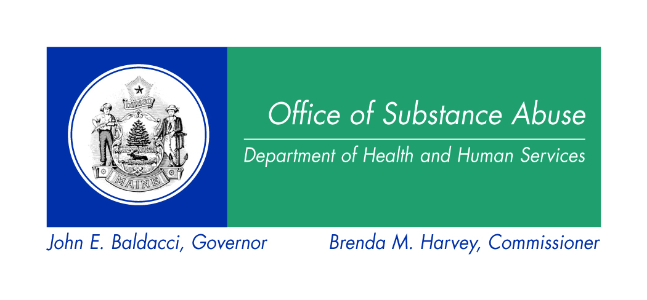
Alcohol Pricing & Promotions:
Protect Your Business
FAQ’s for Maine Liquor Licensees

Low alcohol prices and special promotions are sometimes used to boost product sales and brand loyalty. But they also reduce your profit margin—and they open your business up to costly penalties and lawsuits. The information below will help you decide for yourself: Is it worth the risk?
Q: WHY ARE ALCOHOL PROMOTIONS A PROBLEM?

- They increase your risk of administrative violations. Licensees must make sure that they follow administrative regulations related to their liquor license (see page 3). Failure to follow these regulations could result in fines and/or license suspensions that will hurt your bottom line.
MAINE LIQUOR LIABILITY ACT
Summary: The Maine Liquor Liability Act provides a way to pay for the cost of damages that result from alcohol related incidents. Anyone who sells, gives, or otherwise provides liquor to an individual, whether they hold a Maine Liquor License or not, can be sued for negligent or reckless conduct—for up to $350,000 in damages plus medical expenses.

ADMINISTRATIVE VIOLATION: Sale or Service to Visibly Intoxicated Persons*
Summary: A licensee or licensee’s employee or agent may not sell, furnish, give, serve, or permit to be served liquor to a person who is visibly intoxicated.

For more information on applicable Liquor Laws, see page 3.

*A visibly intoxicated person (VIP) is someone who shows the signs of intoxication: swaying or being “tipsy” while standing or walking, severely slurred speech, strong smell of intoxicants on the breath, argumentative, combative, incoherent speech, and/or other signs.
- They present liability issues that may result in lawsuits and higher insurance costs. If the price per drink is lower, people tend to drink more than they normally would. If they become drunk, you could be opening your business up to being sued for damages under the Maine Liquor Liability Act.
- They may attract undesirable customers. Aggressive pricing and promotions could do more than eat into your short-term profits; they could also attract very price-sensitive patrons who won’t have any loyalty to your business. These are customers who are simply looking for a cheaper way to get drunk.
- They can make your business seem unappealing. Cheap prices can affect how the public views your business, making people wonder about the quality of your establishment. Lower prices may also result in patrons drinking to the point that they cause damage to your establishment—or worse, they may drive away other paying customers.
- They compromise public safety. Many studies have shown that alcohol-related problems go down when alcohol prices are raised. These problems include motor vehicle fatalities, robberies, rapes, sexually transmitted diseases, and child abuse.^{i} Other studies show that low alcohol prices and promotions may be especially problematic for younger drinkers:
- Binge drinking*. Young adults engage in higher-risk drinking when alcohol is available for low prices and in large quantities.^{ii} And 18-25 is already the age group at highest-risk for binge drinking and heavy drinking.^{iii} This is the kind of drinking that can set up your business for all kinds of problems.
- Impaired driving deaths. Young adults are also the age group most likely to drive under the influence of alcohol or die in an alcohol-related vehicle crash.^{iv} Offering cheap liquor can result in customers drinking more alcohol for the same amount of money, resulting in greater intoxication—which opens up your business to greater liability.
- Assaults & victimizations. Young adults are at high risk for sexual assault and date rape.^{v} Studies have found that alcohol-involved sexual assaults tend to occur among young adults who know each other only casually and spend time together at a party or a bar.^{vi} Other alcohol-related crimes include robberies and child abuse.^{vii}

Q: WHAT PRICING OR PROMOTIONS PRACTICES ARE AGAINST MAINE LAW?

Maine liquor licensees must make sure that none of their employees and/or agents break any laws or administrative regulations regarding the sale and pricing of alcohol. While this is not a complete list, below are some Maine Liquor Laws that licensees should pay special attention.
- DON’T offer or deliver any free liquor to any person or group of persons. Note: This includes BOGO (“buy one, get one”) promotions.
- DON’T sell, offer to sell or deliver to any person or group of persons an unlimited number of drinks for a fixed price, except at private functions not open to the public.
- DON’T encourage or permit, on the licensed premises, any game or contest that involves drinking or the awarding of drinks as prizes.
- DON’T engage in any other practice that encourages customers to drink to excess.

A summary of other related liquor laws is included on page 3. If you have questions about Maine Liquor Law, please refer to Title 28-A or contact the Liquor Licensing and Compliance Division at the Department of Public Safety: http://www.maine.gov/dps/liqr/index.html.

Q: WHAT ELSE CAN I DO TO PROTECT MY BUSINESS FROM THE LIABILITY OF ALCOHOL PROMOTIONS?

- DO sell alcohol for more than the wholesaler charged you for it.
- DON’T list prices in advertisements or promotions.
- DO offer non-alcoholic beverages at the same (or lower) price as alcoholic ones.
- DO consider the costs and benefits of any special promotion before deciding to do it.

Q: HOW CAN I COMPETE WITH OTHER BUSINESSES THAT CONTINUE TO USE LOW PRICING AND PROMOTIONS?

Talk with your fellow business owners and managers. Try to agree on a joint code of responsible retailing practices so that you’re not undercutting each other. Responsible business practices help to protect your bottom line. Irresponsible operators will always be at higher risk for costly fines, non-renewal of liquor licenses, and liability under the Maine Liquor Liability Act—all of which can ruin any profit margin.

* Binge drinking is defined as 4 or more drinks for women and 5 or more drinks for men in one occasion.
For more suggestions on best practices, please call the Office of Substance Abuse at (207) 287-8900 or email osa.ircosa@maine.gov. You can also contact your local Healthy Maine Partnership for more help. Find out who yours is at: healthymainepartnerships.org For a list of references cited or an electronic copy of this document, go to: www.maineosa.org/prevention/community/licensee/pricepromo.htm

Alcohol Pricing & Promotions: Applicable Liquor Laws
If you have questions, please refer to Title 28-A or contact the Liquor Licensing and Compliance Division: http://www.maine.gov/dps/liqr/index.html.

Chapter 29 § 709: Prohibition of certain practices
1. Certain practices prohibited. The following practices are prohibited:
A. No licensee or employee or agent of a licensee may:
1. Offer or deliver any free liquor to any person or group of persons
2. Deliver more than 2 drinks containing spirits, a carafe containing more than one liter or 33.8 ounces of wine, or any serving or pitcher containing more than one liter or 33.8 ounces of malt liquor, to one person at one time;
3. Sell, offer to sell or deliver to any person or group of persons an unlimited number of drinks for a fixed price, except at private functions not open to the public.
4. Encourage or permit, on the licensed premises, any game or contest that involves drinking or the awarding of drinks as prizes.

Chapter 29 § 708-A: In-pack sweepstakes, contests and games
Notwithstanding any provision of law to the contrary, a certificate of approval holder, wholesale licensee or retail licensee may offer sweepstakes, games and contests inside packages of alcoholic beverages, if that offer is not contingent on the purchase of an alcoholic beverage.

Rule 7.9 – No advertising of liquor shall contain any subject matter relating to contests or prizes that require the purchase of or the awarding of any alcoholic beverage.

Rule 7.4 – No advertisement of liquor shall contain either subject matter or illustrations inducing minors or immature persons to drink, nor shall depict any person in the act of drinking liquor.

Chapter 29 § 710: Advertising Signs
1. Advertising outside of licensed premises. A person, except wholesale licensees and certificate of approval holders, may not advertise or permit to be advertised, by more than one sign, on the outside of any licensed premises, or on any building, ground or premises under that person’s control or contiguous or adjacent to the licensed premises:
A. The fact that the licensee has liquor or any brand of liquor for sale;
B. The price at which liquor is sold by the licensee; or
C. Any other advertisement that indicates any reference to liquor.

2. Advertising inside the licensed premises. A licensee may display no more than one sign inside the licensed premises, where it may be seen from the outside, advertising the fact that the licensee has liquor for sale. The sign may not be more than 750 square inches in total area.

3. Exception. Subsection 1 does not prohibit the display of signs advertising sponsorship of specific sporting events and cultural events or sponsorship of a transportation system for transporting the public as long as the signs are not displayed on a licensed establishment as defined in section 2, subsection 15. Signs on a licensed establishment advertising sponsorship maybe displayed with prior bureau approval.

