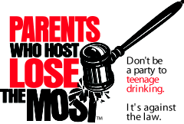

- It is illegal to host or allow teen drinking parties in your home or camp.

- You can be ARRESTED with furnishing alcohol to a minor or allowing a minor other than your own child to drink in your home or camp. Both crimes carry penalties of up to 1 year in jail and up to a $2,000 fine.

  - If someone is injured or killed as a result of the alcohol you supplied, you could be charged with a FELONY.
You can be SUED. If you allow minors to consume alcohol in your home or camp, your homeowner’s insurance policy may not provide adequate protection when serious injury occurs. You could be HELD RESPONSIBLE if injury occurs on or away from your premises (EVEN IF YOU ARE NOT HOME). You can PREVENT TRADEGIES by stopping teenage drinking.

Is your HOME, your FREEDOM and your REPUTATION really worth the RISK?

Make the call to local law enforcement if you suspect underage drinking taking place in your community.

Project Unite!
Healthy Androscoggin,
207.795.5990 or www.healthyandroscoggin.org
Drug-Free Communities Support Program
Maine Office of Substance Abuse, DHHS

“Parents Who Host, Lose the Most,”
was developed by and is a project of Drug-Free Action Alliance.

