IMPLEMENTING A SUPPLEMENTAL FLUORIDE PROGRAM IN A
PRIMARY MEDICAL CARE SETTING:
CRITICAL SUCCESS FACTORS

Strong Physician Commitment: All physicians within the practice setting must demonstrate strong commitment to the program. The physicians must not simply endorse the concept, but must be dedicated to improving the oral health of the children seen within the practice and serve as program champions. Ideally, the program should be physician-initiated. As a program champion, each physician must assume the responsibility of ensuring that every child has an oral examination and is provided an appropriate fluoride regimen at the appropriate time and that the child’s caregivers are provided with basic oral health information and anticipatory guidance. Such a regimen will include the use of fluoride toothpaste, fluoride supplements, and fluoride varnish applications as appropriate for the individual child. This may entail examining and modifying existing patient care practices, scheduling, and processes within the practice to accommodate the incorporation of the program into child care visits.

Essential Component of a Health Professional’s Practice: While the program may be provided in total by a single type of health professional, such as a nurse practitioner, or subdivided and allocated to different health professionals, individual health providers must take responsibility for incorporating their aspect of the program into the scope of their practice and believe that failure to do so on a patient-by-patient basis results in poor quality care. Regardless of whether it is the physicians, nurse practitioners, nurses, medical assistants, or other health care providers in the practice, the health professional or professionals must perceive that an oral examination and the implementation of an appropriate fluoride regimen, along with caregiver education and guidance, is an essential part of their patient care practice. The program should not be perceived simply as another thing to do that can be eliminated if a practice gets busy or is short-staffed.

A Culture that Values Oral Health: Every employee within the practice must value the importance of good oral health, not only for patients but also for themselves. It is important to address any dental phobias that staff may have and how their attitudes, fears, and misconceptions may be transferred, even inadvertently, to patients and their families. Establishing a culture based on teeth and gums being as important as every other body part helps to ensure that patients receive appropriate oral health care, and also communicates to parents and caregivers that good oral health is a vital part of one’s overall health. In this environment, parents and caregivers are more likely to be willing to participate in the program, adopt good oral health behaviors for their children as well as themselves, and comply with patient referrals to a dentist.

Integration into Existing Patient Care Processes: The conduct of the oral exam; the implementation of the fluoride regimen; the provision of anticipatory guidance; and the collection of the necessary informed consent, patient information, and documentation must be well-integrated into the practice’s patient care processes. Because these are activities being added into an already busy practice, they must be efficiently and effectively incorporated into existing policies and procedures. Failure to do so will result in the activities either not being performed routinely or being conducted in a less than high quality manner. This integration requires a careful examination of the practice’s patient flow patterns and a modification of those patterns to adopt the added responsibilities. This may also include examining current staff roles, as well as practice act regulations, regarding staff responsibilities, use of standing orders, and dental referral policies and practices. In addition, decisions must be made regarding the location of supplies needed for the program as well as the flow and processing of the required information.

Program Coordinator: A staff member should be designated as the coordinator for the program. This person should be responsible for working with other staff in developing and implementing the plan for integrating the program into the practice, making parents and caregivers aware of the program and addressing their questions and concerns, and addressing operational issues that arise. Most importantly, the program coordinator should monitor the implementation of all aspects of the program and establish quality control and improvement policies and procedures.

Appropriate Staff Training: Staff must be appropriately trained to provide the necessary anticipatory guidance to parents and caregivers regarding good oral health behaviors, conduct the oral health examination on the child and correctly identify and document any oral health problems, correctly apply fluoride varnish to the child’s teeth and/or prescribe a fluoride supplement as appropriate, address any parent or caregiver questions or concerns, and make the appropriate dental referral decisions. In addition, staff should receive training on how to handle situations when the child is uncooperative or crying. Training should include both observation and practice, and should be peer-led if possible (e.g., a dentist or physician training physicians). The trainer should be available for follow-up questions and technical assistance (via phone or site visit), especially in the early stages of implementation. Follow-up training sessions are important for any new staff members, and can be an effective way of re-energizing or engaging existing providers.

Effective Referral System: Because oral health problems may be identified that are beyond the practitioner’s scope of practice, an effective system must be established to refer patients to the dental community. The implementation of the program in the practice must have the support of the local dental community and members of that community must be willing to accept referrals of (a) young children and (b) children with the particular type of payment source. If not currently available, the practice may have to generate a list of dentists willing to accept referrals. Secondly, procedures must be established to correctly identify when a referral may be necessary and make the referral decision, make or assist the parents/caregivers in obtaining a referral appointment, communicate the necessary information to the referral dentist, and follow-up with the dentist and/or parents/caregivers to ensure that the child was seen by the dentist and determine the nature of any follow-up care. In addition, appropriate staff must educate parents/caregivers regarding the importance of the referral to ensure compliance with the referral decision and serve as a liaison if problems arise with completing the referral.

Efficient Data Collection Systems: A system for recording the clinical findings of the oral health examination, the application of fluoride varnish or prescription of a fluoride supplement, and the anticipatory guidance provided to parents and caregivers must be effectively integrated into existing documentation policies and procedures to minimize data collection burden on staff, while providing the necessary data for continuity of oral health care. Any additional data collection efforts established for evaluation purposes, which is an important component for on-going program quality monitoring and improvement, must also be designed to minimize staff and parent/caregiver burden as well as be culturally sensitive. Procedures should be established for not only the collection of evaluation data, but also the processing, analysis, and review of the data to provide timely feedback on the level of success of the program and areas of potential improvement.

Adequate Reimbursement: Continued integration of a supplemental fluoride program, and in particular one including fluoride varnish, requires that health care professionals be adequately reimbursed for the additional care being provided. Although an important component of overall health care, the application of fluoride varnish requires additional staff time and resources for which third-party payers may not currently reimburse non-dental health providers. Thus, efforts must be undertaken to document the time and resources associated with a fluoride varnish program and demonstrate to third-party payers the need for additional reimbursement.

Parent/Caregiver Consent: The procedures for obtaining informed consent from parents/ caregivers must be established to minimize staff burden and care delays, while ensuring that informed consent is obtained in a complete and correct manner. This includes having consent materials that are culturally sensitive and provided in a manner consistent with the functional health literacy of the parents/caregivers. Parents/ caregivers must be made aware of the supplemental fluoride program within the practice and the benefits, as well as the risks, of the program to the child’s oral health status. Unless parents/caregivers view the appropriate fluoride regimen as safe and beneficial, they will be unwilling to participate in the program and comply with instructions regarding supplements and/or post-application for fluoride varnish.

Culturally Competent Care
Staff should be aware that different cultures may place different value on the importance of oral health care, and many parents/caregivers will need help understanding why oral health is a key component of overall health, and why it is important to comply with hygiene instructions and referrals to community dentists. All information about the program and any forms should be provided to parents/caregivers in a culturally competent manner consistent with their functional health literacy.

A Learning Environment
Perhaps the most important success factor is having a practice environment that embraces learning and continuous program improvement. Each practice setting has its own set of unique strengths and challenges that will influence the successful implementation of the fluoride varnish program. It is helpful to have an organizational culture that values learning from mistakes, testing different approaches and solutions, and identifying ways to improve the program’s effectiveness and impact.

Adapted with permission (2008) by the Association of State & Territorial Dental Directors Fluorides Committee for distribution from a document prepared for the Anthem Foundation of Ohio by:
Robert L. Ludke, Ph.D.
Professor of Family Medicine and Senior Research Scientist
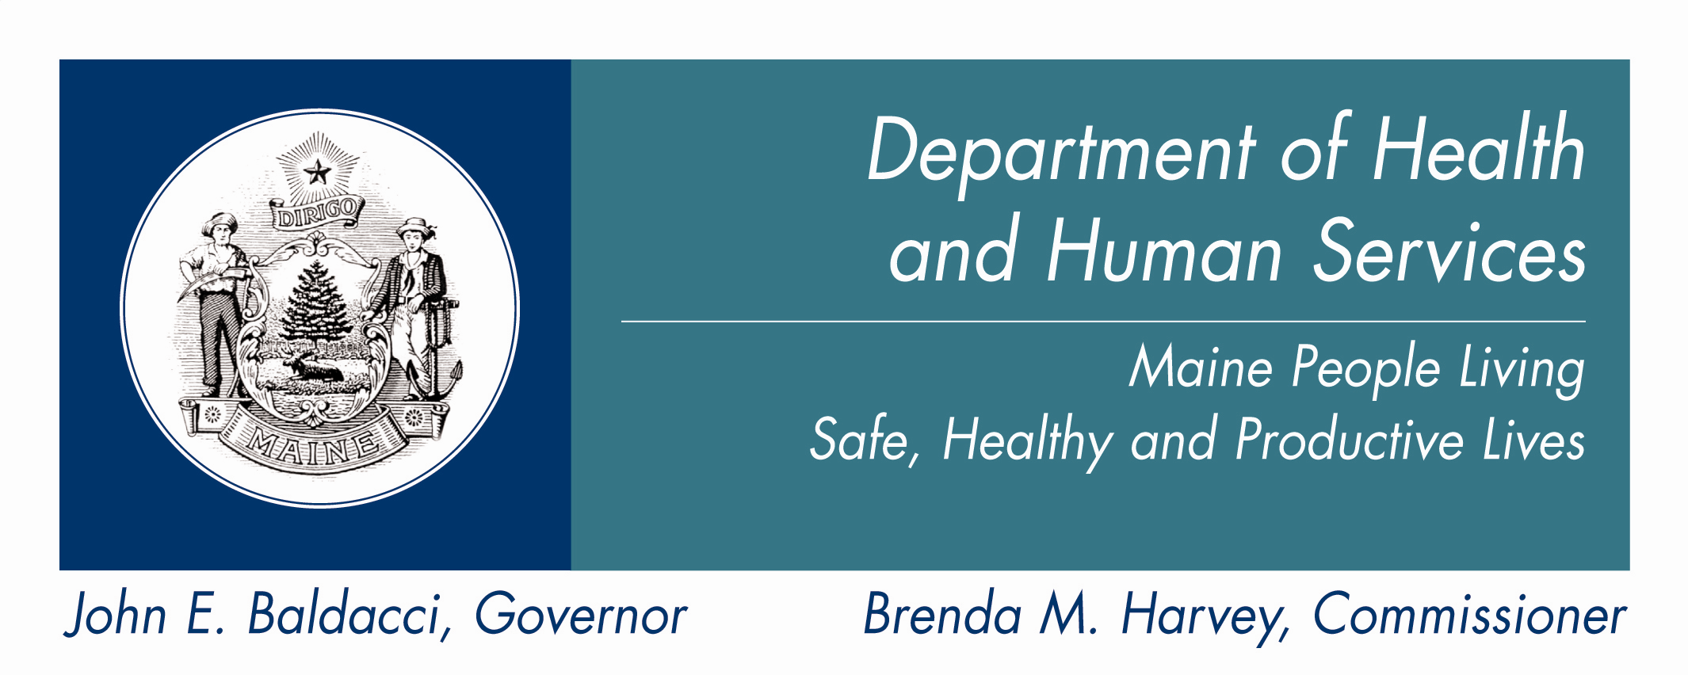
Institute for the Study of Health, University of Cincinnati
PO Box 670840
Cincinnati, Ohio 45267-0840
Phone: (513) 558-2757
Fax: (513) 558-2744
E-mail: Robert.Ludke@uc.edu

