Meth Mouth

The use and production of methamphetamine, a strong stimulant drug, has become a huge problem in the United States. The popularity of this drug is that it is cheap, easy to make and the high lasts longer (12 hours versus one hour for cocaine). Some of the street names for Methamphetamine are Crank, Speed, Fire, Glass Crystal, Quartz, and Meth. Methamphetamine can be snorted, smoked, injected, and taken orally.

A common sign of meth abuse is extreme tooth decay, which has created the term Meth Mouth. Methamphetamine users have black or stained and rotting teeth. Most often these teeth cannot be saved. There are several factors in the use of methamphetamines cause destruction to the oral cavity:

- The “Buzz” from meth last about 12 hours, during the “buzz” the user will crave sugary substances, like soda and candy.

- Methamphetamine users usually will clench or grind their teeth. This will cause severe wear on the dentition.

- Methamphetamines may cause “xerostomia” or “dry mouth”.

- The user will not brush or floss their teeth for several days. This often leads to dental disease.

- The acidic content of the drug will damage the teeth. Ingredients include battery acid, fertilizers, and household cleaning agents.

Meth Mouth Symptoms:

- Dry Mouth – Saliva acts as a buffer in the mouth against acidic substances that we may eat or drink. The average person creates about one liter of saliva a day. When saliva production is reduced, the number of oral bacteria can increase. Methamphetamines dry out the salivary glands. When we do not have enough saliva, the acid content in our mouth will start to destroy the enamel on the teeth. Eventually this will lead to cavities.

- Cracked Teeth – Methamphetamine can make the user feel anxious, hyper, or nervous, so they will clench or grind their teeth. You may see severe wear patterns on their teeth. Sometimes even biting or chewing soft foods, like mashed potatoes will cause their teeth to break. Meth users will suck on lollipops or pacifiers to help keep them from grinding.

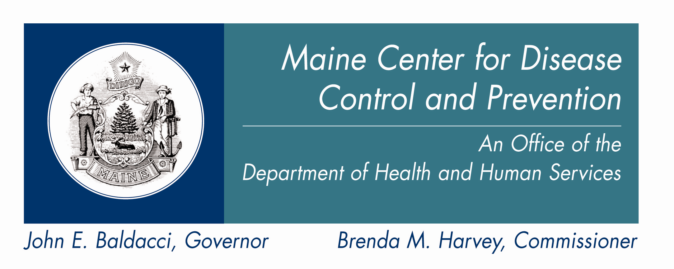

- Tooth Decay – Meth users crave beverages high in sugar while they are “high” mainly because they experience dry mouth. The bacteria that feed on the sugars in the mouth will secrete acid, which can lead to more tooth destruction. With meth users tooth decay will start at the gum line, and eventually spread through out the tooth. The front teeth are usually destroyed first.

- Gum Disease – Methamphetamine users do not seek out regular dental treatment. Lack of oral health care can contribute to periodontal disease (destruction of the bone that supports the teeth). Teeth and gums need blood to stay healthy. Methamphetamines cause the vessels that supply blood to oral tissues to shrink in size. A reduction in blood flow will cause the tissues to break down. Over time the blood flow can not recover and the tissue will become necrotic.

- Lesions – Users who smoke meth present with lesions and or/burns on their lips, gingival, inside cheeks or hard palate. Users who snort may present burns in the back of their throats. Meth use decreases a person’s ability to fight infection and heal after injury.

- Deferred pain – The meth user not experience the pain to be expected from such extensive decay because meth can block or lessen the effects of dental pain. The patient may use their extensive decay to try obtain prescription pain medications.

Meth’s other effects on the body:

- Stroke- due to the damage of the blood vessels
- Liver damage- due to chemicals involved in making the drug
- Increase in body temperature, which can cause brain damage
- The body’s immune system becomes weak and the user is unable to fight off infections.
- Death

Photos of meth mouth

First stage of meth mouth

- Signs of cavities
- Bad breath
- Gum tissue appears red and swollen

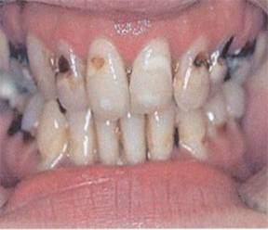
Second Stage of meth mouth

- Dental lesions may be present on the lips
- Gum tissue starts to recede
- Tooth cavities are getting worse

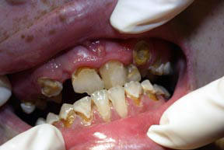

Third stage of meth mouth

- Teeth have decayed down to the gum line
- There will be missing teeth
- Dental lesions will be more apparent

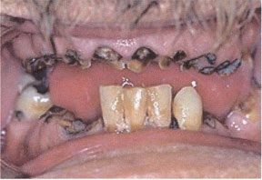

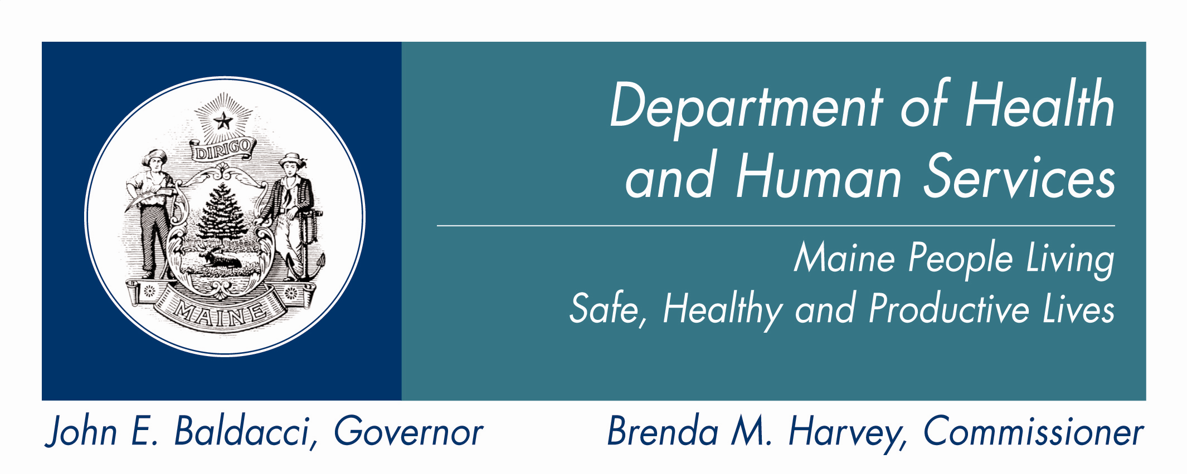

DHHS
Non-Discrimination Notice

The Department of Health and Human Services (DHHS) does not discriminate on the basis of disability, race, color, creed, gender, sexual orientation, age, or national origin, in admission to, access to, or operations of its programs, services, or activities, or its hiring or employment practices. This notice is provided as required by Title II of the Americans with Disabilities Act of 1990 and in accordance with the Civil Rights Act of 1964 as amended, Section 504 of the Rehabilitation Act of 1973, as amended, the Age Discrimination Act of 1975, Title IX of the Education Amendments of 1972 and the Maine Human Rights Act and Executive Order Regarding State of Maine Contracts for Services. Questions, concerns, complaints or requests for additional information regarding the ADA may be forwarded to DHHS’ ADA Compliance/EEO Coordinators, 11 State House Station – 221 State Street, Augusta, Maine 04333, 207-287-4289 (V), 207-287-3488 (V), 1-800-606-0215 (TTY). Individuals who need auxiliary aids for effective communication in program and services of DHHS are invited to make their needs and preferences known to the ADA Compliance/EEO Coordinators. This notice is available in alternate formats, upon request.

Caring…Responsive…Well-Managed
We Are DHHS.

