**Dental Sealants**

**Help Prevent Tooth Decay**

Help your child’s teeth last a lifetime.



**1)** Dental sealants protect teeth. **2)** Getting sealants is easy. **3)** Sealants help you save money.

**Dental sealants protect your child’s teeth from decay.**

Sealants are a thin, plastic coating put on the chewing surface of the back teeth (molars). The chewing surfaces of the back teeth are rough and uneven with small pits and grooves.

MCj02153570000[1]

A toothbrush can’t reach into these pits to brush away the food and germs that get trapped in the pits.

Sealants fill the pits and grooves and make the surfaces smooth. They keep out the foods and germs that cause decay. Once decay starts in a tooth, it has to be cleaned out by drilling. Then the tooth has to be filled. A sealant is put on a tooth before decay ever starts.

**Children should get sealants on their permanent molars as soon as the teeth come in.**

The first permanent molars usually come in when a child is between the ages of 5 and 7. The second permanent molars usually come in between the ages of 11 and 14.

Other teeth with pits and grooves might need sealants. Sealants can last up to 10 years without resealing.

**over**

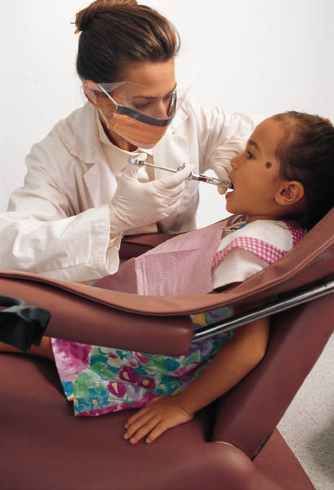

**Getting sealants is easy.**

The dentist or hygienist:

* Cleans the tooth.
* Dabs it with a special solution to help the sealant stick.
* Puts on the sealant. It gets hard in less than a minute.

**Getting sealants doesn’t hurt.**

No shots. No drilling. The tooth stays whole and strong. Your child won’t feel the sealants because they are very thin. They won’t show when your child talks or smiles.

**Sealants help you save money.**

The cost of a sealant may vary, but a sealant costs a lot less than a filling. If you have dental insurance, it may pay for some sealants.



The MaineCare Program **does** pay for sealants.

Sealants help you save money because they protect teeth from decay. In the long run, you and your child will spend less on fillings, crowns or caps. And a healthy mouth means better health in general.

**DHHS**

**Non-Discrimination Notice**

The Department of Health and Human Services (DHHS) does not discriminate on the basis of disability, race, color, creed, gender, sexual orientation, age, or national origin, in admission to, access to, or operations of its programs, services, or activities, or its hiring or employment practices. This notice is provided as required by Title II of the Americans with Disabilities Act of 1990 and in accordance with the Civil Rights Act of 1964 as amended, Section 504 of the Rehabilitation Act of 1973, as amended, the Age Discrimination Act of 1975, Title IX of the Education Amendments of 1972 and the Maine Human Rights Act and Executive Order Regarding State of Maine Contracts for Services. Questions, concerns, complaints or requests for additional information regarding the ADA may be forwarded to DHHS’ ADA Compliance/EEO Coordinators, 11 State House Station – 221 State Street, Augusta, Maine 04333, 207-287-4289 (V), 207-287-3488 (V), **TTY users call Maine relay 711**. Individuals who need auxiliary aids for effective communication in program and services of DHHS are invited to make their needs and preferences known to the ADA Compliance/EEO Coordinators. This notice is available in alternate formats, upon request.

**To order additional copies of this publication, or if you have questions about the content, please call:**  the Oral Health Program at 207-287-3121, TTY users call Maine relay 711.

Revised 07/2013