Virtual Engagement Guide

Introduction
As a result of COVID-19, and in adherence with guidelines and recommendations set forth by the CDC and Maine’s Office of the Governor at the time our engagement planning was taking place, Mainstream Community Forums supported by the MSCHNA will be conducted virtually.

Virtual Forum Responsibilities/To-Dos by Role
When hosting a virtual forum, be sure to assign and/or recruit people who are able to take on the following roles to perform the associated tasks during your event.

Role | Tasks
Meeting Host | In session:  - Start the meeting; allow participants in from waiting room; mute all participants upon entry; turn on closed captioning; start recording  - Move participants, Facilitator(s), and Scribe(s) into Breakout rooms and back into plenary session  - Keep time during Breakout sessions; send time warnings to Breakout Facilitators one minute prior to the end of each activity and the end of the breakout session.
Lead Facilitator | Prior to session:  - Distribute Run of Show and Breakout Discussion Worksheets to Breakout Facilitators, Breakout Scribes, and Local Planning Committee prior to the start of the session  - Attend Meeting Prep session 30 minutes prior to the start of official meeting time; Conduct roll call and materials check  In first plenary session:  - Share screen to show PowerPoint presentation; advance slides throughout event  - Present key data findings  In the reconvened plenary session:  - Screen share the Mentimeter poll results to display top Priority Health Topic areas from the session  - Share link to Participant Feedback Form in chat box
Technical Support | - Monitor chat; answer any tech questions
Local Planning Committee Member(s) | Prior to session:  - Promote event and share link to the Participant Registration Form or Zoom registration link to recruit participants  - Identify Breakout Facilitator(s) and Scribe(s) for the session  - Print Run of Show document, if possible  In first plenary session:  - Welcome participants to the session  - Provide basic guidelines for Zoom (e.g., mute, video on/off, chat, hand raise, etc.) and ask people to practice. Remind participants to remain muted unless in breakout rooms.  - Provide an overview of County CHNA priorities and activities from last assessment (this occurs after leadership remarks)  In the reconvened plenary session:  - Thank participants for their time and insight  - Discuss next steps in the CHNA process
Local Leadership | - Provide remarks
Breakout Facilitator(s) | Prior to session:  - Attend Facilitation Training  - Print Run of Show if possible (found in Maine Shared CHNA Community Engagement SmartSheet)  - Download and open Breakout Discussion Worksheet (can be found in Maine Shared CHNA Community Engagement SmartSheet)  - Create a free Ideaboardz, and set up their board as described below. Instructions on how to do this will be provided during trainings and reviewed during meeting set up.  - Be sure you can access email in case you need to email polling results to Lead Facilitator—contacts available at top of Run of Show and Breakout Discussion Worksheet.  In Breakout rooms:  - Facilitate introductions and icebreaker  - Lay out ground rules for the meeting  - Review the breakout session process/materials (see Breakout Discussion Worksheet)  - Question 1: Lead data discussion (see Breakout Discussion Worksheet)  - Question 2: Provide link to Indicators Survey in the chat. Lead discussion (see Breakout Discussion Worksheet)  - Question 3: Provide link to Mentimeter poll in the chat. Lead discussion (see Breakout Discussion Worksheet)  - Question 4: Share link to Ideaboardz in the chat and facilitate exercise. (see Breakout Discussion Worksheet)  - After Ideaboardz exercise and breakout discussion session is complete, export the Ideaboardz to PDF and email it to your Scribe. (see directions in Breakout Discussion Worksheet).  - Download the group chat as back up.
Breakout Scribe(s) | Prior to session:  - Attend Facilitation Training  - Print Run of Show document found in Maine Shared CHNA Community Engagement SmartSheet  - Download and open Breakout Discussion Worksheet for virtual events, found in this Guide or on the Maine Shared CHNA Events page.  - Have pen and paper handy just in case it is needed.  In Breakout rooms:  - Take Breakout Session notes in the Breakout Discussion Worksheet  - Monitor chat in Breakout Sessions  - Export and save the Breakout Group chat at the end of the Breakout Discussion (see directions in Breakout Discussion Worksheet)  - Gather the chat discussion, your Breakout Discussion Worksheet, and your facilitator’s Ideaboardz PDF and email to the Lead Facilitator (see contact information in Run of Show) at the conclusion of your event.

Virtual Event Best Practices
Follow these tips to make the most of this experience for you and your audience:

Internet speed: Try turning off all other devices that share your wifi signal such as phones, tablets, Alexa, or other devices. If possible, use a hardwire connection right to your modem.
Computer: Start up your computer early to allow for any updates that may need to process. Close any other applications running in the background that may slow down your computer.
Lighting: Bright and even that lights up your face. Avoid back lighting that makes you appear as a silhouette.
Background: Plain backgrounds are less distracting. If choosing virtual backgrounds, blurry is best. Blank walls work well, too.
Clothing: Solids work best. Avoid stripes, polka-dots, checked, or other patterns. Try to choose colors that contrast with your background.
Eye contact: Try your best to line up your computer camera so that the video frames your shoulders and leaves a little extra room above your head. Try to look directly at the webcam rather than the screen when you are speaking.
Noise: Mute if you are not an active speaker. Try to find a quiet space away from dogs, babies, lawnmowers, etc.
Breathe: Taking deep breaths and purposely slow down your speech. When you relax, so will your audience.

Virtual Event Tools and Resources
Event Registration:
- Use this Participant Registration Link to advertise all Mainstream Community Forums
- Zoom Registration links for individual Community Sponsored Events can be found in the Community Engagement SmartSheet and on the Maine Shared CHNA Event page.
- Those wishing to hold events in addition to a Mainstream Community Forums or a Community Sponsored Events are responsible for creating their own Zoom registration link. MSCHNA program manager can provide assistance in setting these up.

Registration Confirmations:
- Registration confirmation emails will automatically generate from the Zoom platform to the email supplied by registrants. These confirmation emails will include a reminder for the date and time of the event, a Zoom link to join the event, and a link to the Maine Shared CHNA Events page. Local hosts are strongly encouraged to include a link to this page in all subsequent reminder emails. Remind registrants to review the Data Health Profiles and Interactive Data Portal and the Health Priority Handout prior to your event.
- Should local hosts send their own reminder emails as well, include the same information as outlined above.

PowerPoints:
- Can be found in the Community Engagement SmartSheet and on the Maine Shared CHNA Events page.
- Developed in collaboration with local planning teams, Maine Shared CHNA data analysis vendor, and communications vendor
- In order to ensure version control and accuracy in production trafficking, the communications vendor will use the Maine Shared CHNA SmartSheet to send versions of the PPTs to local planning teams for review.
- Final PowerPoints will be posted on the Maine Shared CHNA website. All previous versions will be removed from the SmartSheet to avoid confusion.

Breakout Discussion Worksheet (formerly the Table Facilitator’s Guide):
- Can be found on the Maine Shared CHNA Resources page.
- Will be posted on SmartSheet for each Mainstream Community Forum and Community Sponsored Event; will also be emailed directly to Local Planning Committee point-person, Breakout Facilitator(s), and Scribe(s) for each session
- This is the more detailed discussion guide for Breakout Facilitator. It contains links to the Indicators Survey, Mentimeter, Ideaboardz. Scribes are encouraged to use the note-taking space provided in the worksheet during the event.

Priority Handout
- Can be found on the Maine Shared CHNA Resources page.
- Will be posted on the Maine Shared CHNA website and the Community Engagement SmartSheet
- Event registration and reminder emails will encourage participants to have this open on their computer, or printed, if possible, for use during the session. Facilitator will remind participants of this at the beginning of the event.
- Participants will be provided a link to the Indicators Survey when asked to identify indicators that concern them most

Indicators Survey
- Used to collect information on which indicators concern the community most
- Same link will be used for all events
- Link will be included in the Run of Show and Breakout Discussion Worksheet, and can be found in the Community Engagement SmartSheet

Mentimeter
- Used as the final health priority activity
- An individual link will be created for each event
- Link to each event’s Mentimeter will be posted in the Run of Show, Breakout Discussion Worksheet, and can be found in the Community Engagement SmartSheet

Ideaboardz:
- Used to collect information on community gaps and barriers or resources and assets. Each Breakout Facilitator needs to create a free Ideaboardz page prior to the event (you do not need to Login to do this). This tool will be used during the “sticky note” exercise. A review of this tool will be provided during the Facilitation Training Sessions. Once they have created an account, each Breakout Facilitator should:

- Click “Create” to create the Board for the session as shown in the first column to the right.  - After creating the Board, fill out the form as seen in the second column to the right. In the Format field, choose “2 sections” in the drop-down menu. The Facilitator should then fill out the subsequent Section Title lines as “Gaps/Barriers” and “Resources/Assets.”  - Click “Create.” You have now created the Board that will be used for the Sticky Note Exercise portion of the breakout discussion. Note that you will need to copy & paste the link to this Board to your breakout group participants (in the drop-down chat box) when it is time to do this exercise. | 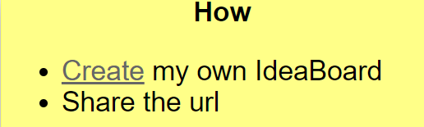 | 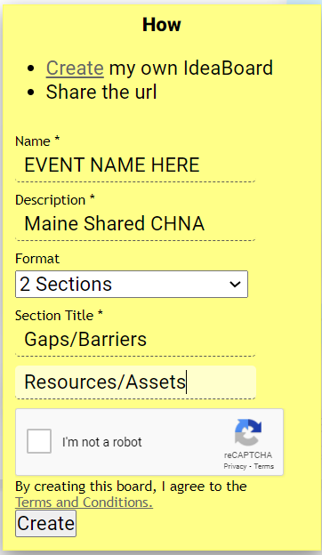
When finished, your Ideaboardz should look like this:

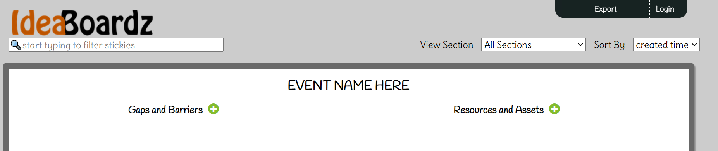

Participant Feedback Form
- Used to collect participant’s impression of the event and any additional information they may wish to share
- This is a single centralized SurveyMonkey created for use in all events
- Participant Feedback Form link available on the Run of Show and in the Community Engagement SmartSheet
- Provided link in the chat box at the end of your event and in follow up emails sent either by Local Planning Committee members (for Mainstream Forums) or community host (for Community Sponsored Events).

Immediately following your event
Post Event Checklist:
Breakout Room Facilitator | Scribe
At Conclusion of Breakout Session:
- Download Ideaboardz as a PDF  - Download chat (as backup) | - Download Chat & save on desktop  - Save Breakout Discussion Worksheet (BDW)on desktop  - Look Ideaboardz PFD in your inbox
Send Document to: | Send all three documents to:
Scribe | Lead facilitator
Host/Local planning team | Lead Facilitator
Within 24 hours of Event:
- Email link to the Participant Feedback Form 1 day and 1 week post event. | - Complete the CORT  - Upload Chat, BDW, Ideaboardz, and Mentimeter results to SmartSheet  - Update the Vote Tallying Tool  - Send recording of event to info@mainechna.org
Contact information for Breakout Room Facilitators, Scribes, Local Host or Planning Teams, and Lead Facilitators can be found on the top of the Run of Show for your event.

To update the Vote Tallying Tool (to be completed by Lead Facilitator):
- Make a note in the Comments Box you have downloaded the Tool.
- Download the most recent version from the SmartSheet.
- Update the document with the results of your event
- Upload the Vote Tallying Tool back to the SmartSheet.
- Make a note in the comments box that you have uploaded the Tool again.

