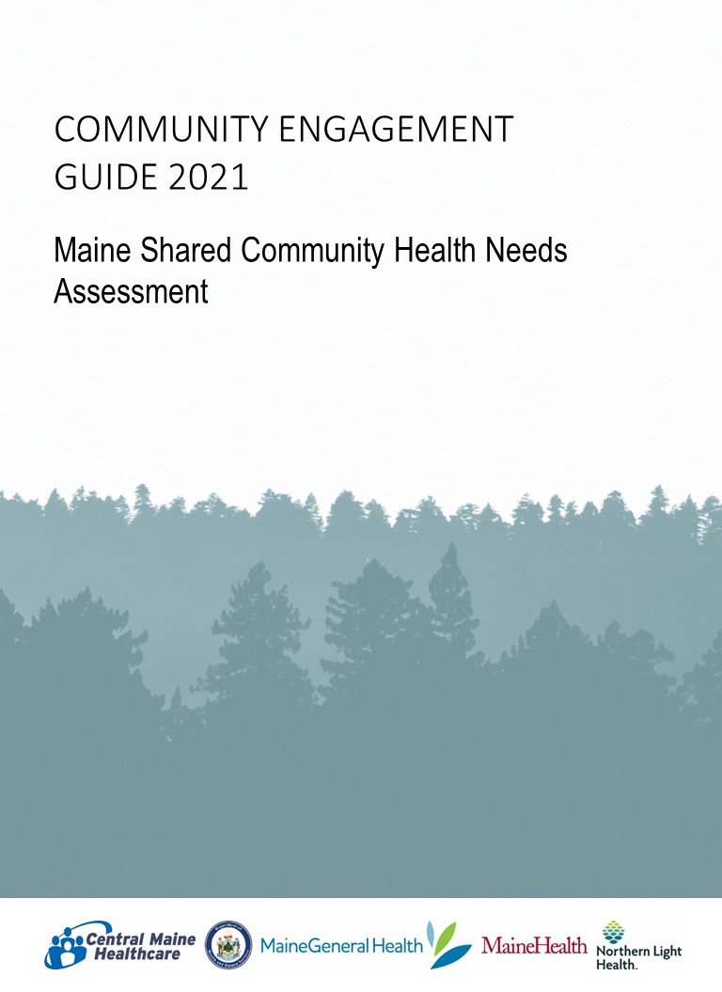

Table of Contents
Overview 4
Governance Structure 5
Maine Shared CHNA Process 6
Maine Shared CHNA Timeline 6
Major Milestones 7
IRS-PHAB Requirements 7
Data Health Profiles 9
COMMUNITY ENGAGEMENT 10
Choosing the right tool for the job 11
Virtual Engagement Guide 12
Mainstream Community Forums (in-person events) 27
Additional Engagement Options 33
Oral Survey 33
Focus Groups 33
Key Stakeholder Interviews 34
Handouts, Worksheets, and Other Meeting Materials 36
Reporting the Results 53
Post Event Checklist (virtual events) 53
Post Event Checklist (in-person) 54
Community Outreach Reporting Tool 55
Key Stakeholder Interview Reporting Tool 58
Communication 59
Save the Date Template 59
Event Invitation Template for Email 60
Press Release Template: Forum Announcement/Invite 61
Community Health Needs Assessment Reports 62
Public Health Improvement Planning 62

Overview
Vision: The Maine Shared Community Health Needs Assessment helps to turn data into action so that Maine will become the healthiest state in the US.

Mission: The Maine Shared Community Health Needs Assessment is a dynamic public private partnership that
- Creates Shared Community Health Needs Assessment Reports,
- Engages and activates communities, and
- Supports data-driven health improvements for Maine people.

This guide was designed to assist local planning committees in their efforts conducting a community engagement process for the Maine Shared Community Health Needs Assessment (Maine Shared CHNA). The Maine Shared CHNA is a unique public-private statewide collaboration between Central Maine Healthcare (CMHC), Maine Center for Disease Control and Prevention of the Maine Department of Health and Human Services (Maine CDC), MaineGeneral Health (MGH), MaineHealth (MH), and Northern Light Health (NLH).

The purpose and goals of the health needs assessment process is to:
- Describe populations and their overall health status.
- Identify the significant health needs of the community.
- Identify contributing factors to poor health.
- Provide a systematic collection and analysis of data and information to be used as a basis for comparison between regions and sound decision-making and action planning.
- Provide a description of the resources potentially available to address the identified significant health needs.
- Include a description of actions taken as a result of the immediately concluded CHNA process.
- Solicit and take into account input received from persons who represent the broad interests of that community, including those with special knowledge of, or expertise in, public health. This includes state, local, tribal, and or regional governmental public health department as well as members of medically underserved, low-income, and minority populations or individuals or organizations serving or representing the interests of such populations in order to gather data on health inequities and their contributing factors.
- Provide a platform to educate and mobilize communities.

The CHNA will then be documented in a written report and broadly shared in the coming years for use by policymakers, non-profits, businesses, academics, and other community partners.

The CHNA is the primary source for healthcare’s Implementation Strategies and the State of Maine’s Public Health Accreditation Board (PHAB) requirements.

Governance Structure
The Steering Committee is composed of members from the Maine Shared CHNA collaborative. This group provides stewardship and oversight of the project. The Steering Committee ultimately approves the work produced by the Metrics Committee and the Community Engagement Committee. The Program Manager reports to the Steering Committee.

The Metrics Committee
- Creates a common set of population/community health indicators
- Produces a preliminary data analysis plan
- Identifies processes for regularly reviewing indicators to stay abreast of research
- Makes recommendations for annual data-related activities and projected costs associated with recommendations.

The Health Equity/Community Engagement Committee
- Ensures an equitable, inclusive and robust community engagement process
- Coordinates resources (staff time, data collection activities, outreach efforts, etc.,) used in conducting local outreach
- Hosts local community engagement activities
- Assists in collecting information on local participants

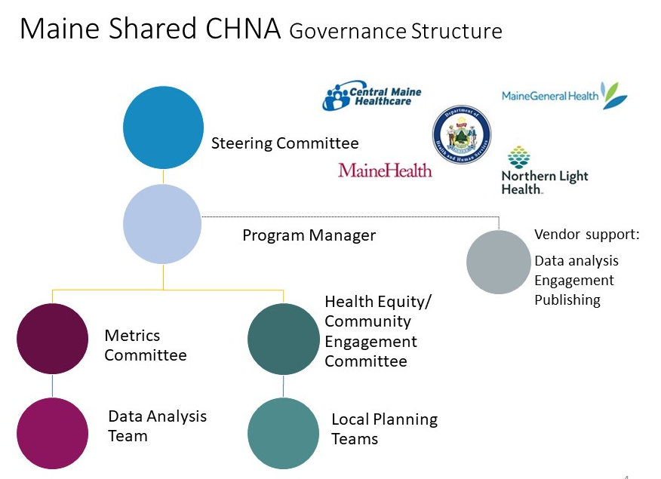

Maine Shared CHNA Process
The Maine Shared CHNA process consists of four major elements:
- Data Health Profiles
- Community Engagement
- CHNA Reports
- Health Improvement Strategies and Plans

Maine Shared CHNA Timeline
Overall multi-year Maine Shared CHNA Timeline:
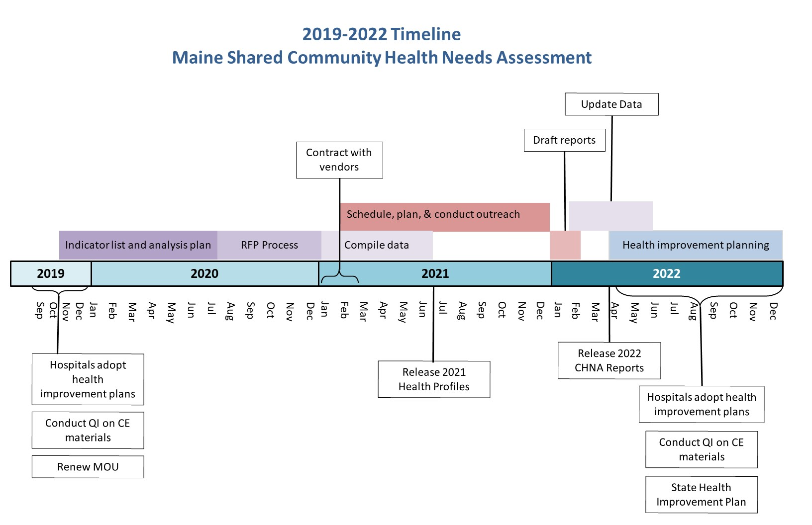

Major Milestones
2021
Jan-Feb |  | Data Analysis and Engagement Vendors for 2021 CHNA process in place
 |  | Data analyses work group convenes
 |  | Local community engagement co-chairs meet
 |  | Begin to create forum schedule; coordinate with shared facilitator
Mar |  | Community Engagement Summit to review process; release Community Engagement Guide
 |  | Confirm ability access proposed online tools for virtual engagement
May |  | Approve visualization criteria used to choose data for PPTs and HE data sheets
 |  | Communications vendor in place
June |  | Data analyses complete by 6/30
July |  | Begin visualization selection for PPTs & HE data sheets
Aug |  | Data visualization selection process complete for all PPTs and HE data sheets
 |  | All Data Profiles published; Breakout Facilitator training & technical assistance begins
If holding events in:
Sept | Oct |  | Nov | Task
then in:
Mar | Apr |  | May | Local teams’ first meeting
 |  |  |  | Prepare local outreach budget & identify source of support (if need be)
 |  |  |  | Review purpose and goals for forums with team
Apr | May |  | Jun | First draft forum agenda
 |  |  |  | Draft attendee contact list and marketing plan
 |  |  |  | Create recruitment plan for breakout facilitators and scribes
May | Jun |  | Jul | Send 1st Save the Date notices w/location/date/time, link to mainechna.org
 |  |  |  | Registration links posted
 |  |  |  | Finalized county-level forum and community presentations schedule released
 |  |  |  | Begin posting all forum locations, dates, and times to website
 |  |  |  | Schedule/invite leadership to forums
 |  |  |  | Revise forum agenda
 |  |  |  | Draft handouts/online documents-e.g., previous CHNA updates, local partner materials
 |  |  |  | Recruit breakout facilitators and scribes (more than you need)
Jun | Jul |  | Aug | Send 2nd Save the Date notices w/location/date/time
 |  |  |  | Final handouts/online documents-e.g., previous CHNA updates, local partner materials
 |  |  |  | Recruit breakout facilitators and scribes (more than you need)
Jul | Aug |  | Sept | Registration opens, send 1st invite with location/date/time and registration
 |  |  |  | Draft local slides (progress health improvement plans, speakers, etc.)
 |  |  |  | Confirm leadership availability
 |  |  |  | Recruit breakout facilitators and scribes (more than you need)
Aug | Sept |  | Oct | Resend registration with links to data and data overview located on mainechna.org
 |  |  |  | Finalize handouts, speakers’ comments, roles, & presentations
 |  |  |  | Training and technical assistance on use of virtual platform
 |  |  |  | Finalize local slides (agenda, progress on health improvement plans, speakers, etc.)
 |  |  |  | Begin targeted outreach as needed
Sept | Oct |  | Nov | Send final reminders with location/date/time/data reports/registration links
 |  |  |  | Develop online attendee packets (print and collate for in-person events)
 |  |  |  | Confirm technology needs are met and partners ability to access online tools
 |  |  |  | Have electronic or print version of the registration attendance sheet available
 |  |  |  | Print sign-in sheet for walk-ins (if having in-person)
Oct | Nov |  | Dec | Upload follow-up materials
 |  |  |  | Review initial results of qualitative data analysis for your area
2022
 |  |  |  | Review near final reports. Reports to be released on or about April 1, 2022.

IRS-PHAB Requirements
The Maine Shared Community Health Needs Assessment (CHNA) is a unique community health collaborative that dates back to 2007. From the beginning, the Maine Shared CHNA collaborative recognized the value of banding together to assess our communities and share findings to improve our health. Today, this process also meets accreditation and legal obligations. Public health departments (i.e.: the Maine CDC, and the City of Portland) are guided by requirements from the Public Health Accreditation Board (PHAB). Hospitals are guided by the Internal Revenue Service (IRS) guidelines as set forth by the Affordable Care Act. Below is a list of common requirements that inform the Maine Shared CHNA:

Timing | At least every 3 years. This is the 4th triennial effort (2010, 2015-2016, 2018-2019, and now 2021-2022).
Collaboration | Highly encouraged by both the PHAB and IRS
Service Area | This combined effort involves the entire state. This includes hospital service areas as well as Public Health Districts.
Partners | Must include input from:  - Public Health professionals  - Government  - Public Health department staff  - Medically underserved or organizations who serve them  - Low income population or organizations who serve them  - Minority populations or organizations who serve them
Requirements | - Assess and prioritize top health issues  - Compile potential community resources to address health priorities  - Lists gaps and or barriers to overcoming identified health priorities  - Describe the local challenges in the social determinants of health  - Describe the health surveillance system (PHAB)  - Include description and examples of how data is being used (PHAB)  - Collect comments of previously adopted health improvement plans
Process | Largely undefined on how to gather community input
Documentation | - Meeting minutes, emails, website or other documentation used to collect data and information.  - Description of criteria used to identify health priorities and resources  - Description of which model or framework was used
Data | - Describe process of identifying data sources, methodology and analysis.  - Must include ‘context for the population’ such as census, employment, income, education, voter registration, transportation, parks, housing stock, home values, etc.  - Must include primary data collection through either surveys, focus groups, interviews, or talking circles, for example.
Final Product | - For IRS: written report adopted by a hospital board  - For PHAB: Description of how results are to be shared and used; ongoing monitoring and updating of data  - For both: opportunity for public comment
Follow-up | - Hospitals use final reports to develop Community Health Improvement Plans  - The State of Maine and other health departments use final reports to develop the State Health Improvement Plan.

Data Health Profiles
There will be 16 County Health Profiles, 5 multi-county Public Health District Profiles and 1 Statewide Health Profile, and 3 Urban Profiles: Portland, Lewiston/Auburn, and Bangor. The Health Profiles consist of key demographics as well as data on 210 health indicators, whenever available and by design. County Health Profiles will be released prior to the first community forum to facilitate the distribution to our community partners prior to meeting.
In addition to County and City Data Health Profiles, Health Equity Data Sheets have been compiled. Data has been chosen in collaboration with members of the Maine Shared CHNA Health Equity Work Group to raise awareness on health disparities experienced by various communities across our state.

Profile distribution relies upon the outreach and promotional efforts of our community partners. Leveraging organizational e-newsletters, email distribution lists, and contact lists will ensure that our community partners are informed.

Health Profiles will be posted on the Maine Shared CHNA website: (www.mainechna.org). This website also hosts an interactive data portal.

COMMUNITY ENGAGEMENT
Between September and December 2021, local planning committees will host forums and conduct other community outreach to ensure feedback from those who represent the broad interests of the community, including but not limited to the medically underserved, low-income, those who experience health disparities, or minority populations.
The purpose of these activities is to collect the following data:

- Community identified health priorities
- Gaps/barriers which must be overcome to address each priority
- Resources/assets potentially available to address each priority

These data must be collected from state, local, tribal, or regional governmental public health department representative, members of medically underserved, low-income, and minority populations or their representatives.

Representation can be in the form of either organizations who work with these populations or individuals with lived experience. Aside from hosting forums, other means of gathering community feedback could include community group presentations, focus groups, key stakeholder interviews, or surveys.

This Guide provides detailed steps on those activities that are supported by the Maine Shared Community Health Needs Assessment Collaborative: Community Sponsored Events and Forums. Additional guidance on conducting focus groups or key stakeholder interviews is provided as a resource for those interested in pursuing those activities. Please consult with the Maine Shared CHNA program manager should you wish to include those findings in your final county CHNA reports, as capacity to include additional data is limited.

Choosing the right tool for the job

Health Equity
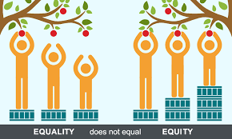
As the graphic above depicts, a single outreach method may not work in every community. The graphic below provides a reference to MSCHNA supported outreach Descriptions of these methods are included on the following pages. See the Section: Additional Engagement Options for additional methods you may wish to employ on your own in your community.

Outreach Methods
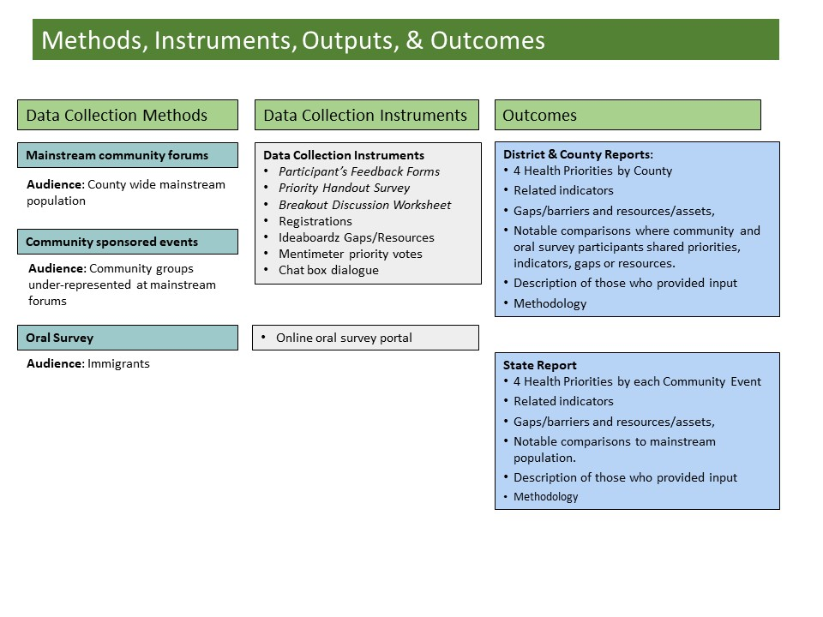

Virtual Engagement Guide

Introduction
As a result of COVID-19, and in adherence with guidelines and recommendations set forth by the CDC and Maine’s Office of the Governor at the time our engagement planning was taking place, Mainstream Community Forums supported by the MSCHNA will be conducted virtually.

Virtual Forum Responsibilities/To-Dos by Role
When hosting a virtual forum, be sure to assign and/or recruit people who are able to take on the following roles to perform the associated tasks during your event.

Role | Tasks
Meeting Host | In session:  - Start the meeting; allow participants in from waiting room; mute all participants upon entry; turn on closed captioning; start recording  - Move participants, Facilitator(s), and Scribe(s) into Breakout rooms and back into plenary session  - Keep time during Breakout sessions; send time warnings to Breakout Facilitators one minute prior to the end of each activity and the end of the breakout session.
Lead Facilitator | Prior to session:  - Distribute Run of Show and Breakout Discussion Worksheets to Breakout Facilitators, Breakout Scribes, and Local Planning Committee prior to the start of the session  - Attend Meeting Prep session 30 minutes prior to the start of official meeting time; Conduct roll call and materials check  In first plenary session:  - Share screen to show PowerPoint presentation; advance slides throughout event  - Present key data findings  In the reconvened plenary session:  - Screen share the Mentimeter poll results to display top Priority Health Topic areas from the session  - Share link to Participant Feedback Form in chat box
Technical Support | - Monitor chat; answer any tech questions
Local Planning Committee Member(s) | Prior to session:  - Promote event and share link to the Participant Registration Form or Zoom registration link to recruit participants  - Identify Breakout Facilitator(s) and Scribe(s) for the session  - Print Run of Show document, if possible  In first plenary session:  - Welcome participants to the session  - Provide basic guidelines for Zoom (e.g., mute, video on/off, chat, hand raise, etc.) and ask people to practice. Remind participants to remain muted unless in breakout rooms.  - Provide an overview of County CHNA priorities and activities from last assessment (this occurs after leadership remarks)  In the reconvened plenary session:  - Thank participants for their time and insight  - Discuss next steps in the CHNA process
Local Leadership | - Provide remarks
Breakout Facilitator(s) | Prior to session:  - Attend Facilitation Training  - Print Run of Show if possible (found in Maine Shared CHNA Community Engagement SmartSheet)  - Download and open Breakout Discussion Worksheet (can be found in Maine Shared CHNA Community Engagement SmartSheet)  - Create a free Ideaboardz, and set up their board as described below. Instructions on how to do this will be provided during trainings and reviewed during meeting set up.  In Breakout rooms:  - Facilitate introductions and icebreaker  - Lay out ground rules for the meeting  - Review the breakout session process/materials (see Breakout Discussion Worksheet)  - Question 1: Lead data discussion (see Breakout Discussion Worksheet)  - Question 2: Provide link to Indicators Survey in the chat. Lead discussion (see Breakout Discussion Worksheet)  - Question 3: Provide link to Mentimeter poll in the chat. Lead discussion (see Breakout Discussion Worksheet)  - Question 4: Share link to Ideaboardz in the chat and facilitate exercise. (see Breakout Discussion Worksheet)  - After Ideaboardz exercise and breakout discussion session is complete, export the Ideaboardz to PDF and email it to your Scribe. (see directions in Breakout Discussion Worksheet).  - Download the group chat as back up.
Breakout Scribe(s) | Prior to session:  - Attend Facilitation Training  - Print Run of Show document found in Maine Shared CHNA Community Engagement SmartSheet  - Download and open Breakout Discussion Worksheet for virtual events, found in this Guide or on the Maine Shared CHNA Events page.  In Breakout rooms:  - Take Breakout Session notes in the Breakout Discussion Worksheet  - Monitor chat in Breakout Sessions  - Export and save the Breakout Group chat at the end of the Breakout Discussion (see directions in Breakout Discussion Worksheet)  - Gather the chat discussion, your Breakout Discussion Worksheet, and your facilitator’s Ideaboardz PDF and email to the Lead Facilitator (see contact information in Run of Show) at the conclusion of your event.

Virtual Event Best Practices
Follow these tips to make the most of this experience for you and your audience:

Internet speed: Try turning off all other devices that share your wifi signal such as phones, tablets, Alexa, or other devices. If possible, use a hardwire connection right to your modem.
Computer: Start up your computer early to allow for any updates that may need to process. Close any other applications running in the background that may slow down your computer.
Lighting: Bright and even that lights up your face. Avoid back lighting that makes you appear as a silhouette.
Background: Plain backgrounds are less distracting. If choosing virtual backgrounds, blurry is best. Blank walls work well, too.
Clothing: Solids work best. Avoid stripes, polka-dots, checked, or other patterns. Try to choose colors that contrast with your background.
Eye contact: Try your best to line up your computer camera so that the video frames your shoulders and leaves a little extra room above your head. Try to look directly at the webcam rather than the screen when you are speaking.
Noise: Mute if you are not an active speaker. Try to find a quiet space away from dogs, babies, lawnmowers, etc.
Breathe: Taking deep breaths and purposely slow down your speech. When you relax, so will your audience.

Virtual Event Tools and Resources
Event Registration:
- Use this Participant Registration Link to advertise all Mainstream Community Forums
- Zoom Registration links for individual Community Sponsored Events can be found in the Community Engagement SmartSheet and on the Maine Shared CHNA Event page.
- Those wishing to hold events in addition to a Mainstream Community Forums or a Community Sponsored Events are responsible for creating their own Zoom registration link. MSCHNA program manager can provide assistance in setting these up.

Registration Confirmations:
- Registration confirmation emails will automatically generate from the Zoom platform to the email supplied by registrants. These confirmation emails will include a reminder for the date and time of the event, a Zoom link to join the event, and a link to the Maine Shared CHNA Events page. Local hosts are strongly encouraged to include a link to this page in all subsequent reminder emails. Remind registrants to review the Data Health Profiles and Interactive Data Portal and the Health Priority Handout prior to your event.
- Should local hosts send their own reminder emails as well, include the same information as outlined above.

PowerPoints:
- Can be found in the Community Engagement SmartSheet and on the Maine Shared CHNA Events page.
- Developed in collaboration with local planning teams, Maine Shared CHNA data analysis vendor, and communications vendor
- In order to ensure version control and accuracy in production trafficking, the communications vendor will use the Maine Shared CHNA SmartSheet to send versions of the PPTs to local planning teams for review.
- Final PowerPoints will be posted on the Maine Shared CHNA website. All previous versions will be removed from the SmartSheet to avoid confusion.

Breakout Discussion Worksheet (formerly the Table Facilitator’s Guide):
- Can be found in this Guide or on the Maine Shared CHNA Resources page.
- Will be posted on SmartSheet for each Mainstream Community Forum and Community Sponsored Event; will also be emailed directly to Local Planning Committee point-person, Breakout Facilitator(s), and Scribe(s) for each session
- This is the more detailed discussion guide for Breakout Facilitator. It contains links to the Indicators Survey, Mentimeter, Ideaboardz. Scribes are encouraged to use the note-taking space provided in the worksheet during the event.

Priority Handout
- Can be found in this Guide or on the Maine Shared CHNA Events page.
- Will be posted on the Maine Shared CHNA website and the Community Engagement SmartSheet
- Event registration and reminder emails will encourage participants to have this open on their computer, or printed, if possible, for use during the session. Facilitator will remind participants of this at the beginning of the event.
- Participants will be provided a link to the Indicators Survey when asked to identify indicators that concern them most

Indicators Survey
- Used to collect information on which indicators concern the community most
- Same link will be used for all events
- Link will be included in the Run of Show and Breakout Discussion Worksheet, and can be found in the Community Engagement SmartSheet

Mentimeter
- Used as the final health priority activity
- An individual link will be created for each event
- Link to each event’s Mentimeter will be posted in the Run of Show, Breakout Discussion Worksheet, and can be found in the Community Engagement SmartSheet

Ideaboardz:
- Used to collect information on community gaps and barriers or resources and assets. Each Breakout Facilitator needs to create a free Ideaboardz page prior to the event (you do not need to Login to do this). This tool will be used during the “sticky note” exercise. A review of this tool will be provided during the Facilitation Training Sessions. Once they have created an account, each Breakout Facilitator should:

- Click “Create” to create the Board for the session as shown in the first column to the right.  - After creating the Board, fill out the form as seen in the second column to the right. In the Format field, choose “2 sections” in the drop-down menu. The Facilitator should then fill out the subsequent Section Title lines as “Gaps/Barriers” and “Resources/Assets.”  - Click “Create.” You have now created the Board that will be used for the Sticky Note Exercise portion of the breakout discussion. Note that you will need to copy & paste the link to this Board to your breakout group participants (in the drop-down chat box) when it is time to do this exercise. | 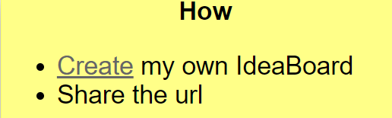 | 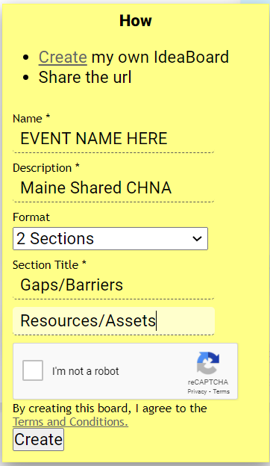
When finished, your Ideaboardz should look like this:

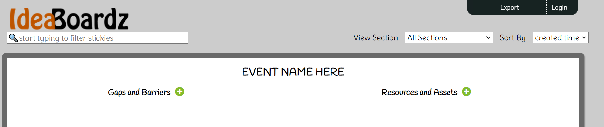

Participant Feedback Form
- Used to collect participant’s impression of the event and any additional information they may wish to share
- This is a single centralized SurveyMonkey created for use in all events
- Participant Feedback Form link available on the Run of Show and in the Community Engagement SmartSheet
- Provided link in the chat box at the end of your event and in follow up emails sent either by Local Planning Committee members (for Mainstream Forums) or community host (for Community Sponsored Events).
- Will be posted on the Maine Shared CHNA Events page.

Immediately following your event
Post Event Checklist:
Breakout Room Facilitator | Scribe
At Conclusion of Breakout Session:
- Download Ideaboardz as a PDF  - Download chat (as backup) | - Download Chat & save on desktop  - Save Breakout Discussion Worksheet (BDW)on desktop  - Look Ideaboardz PFD in your inbox
Send Document to: | Send all three documents to:
Scribe | Lead facilitator
Host/Local planning team | Lead Facilitator
Within 24 hours of Event:
- Email link to the Participant Feedback Form 1 day and 1 week post event. | - Complete the CORT  - Upload Chat, BDW, Ideaboardz, and Mentimeter results to SmartSheet  - Update the Vote Tallying Tool  - Send recording of event to info@mainechna.org
Contact information for Breakout Room Facilitators, Scribes, Local Host or Planning Teams, and Lead Facilitators can be found on the top of the Run of Show for your event.

To update the Vote Tallying Tool:
- Make a note in the Comments Box you have downloaded the Tool.
- Download the most recent version from the SmartSheet.
- Update the document with the results of your event
- Upload the Vote Tallying Tool back to the SmartSheet.
- Make a note in the comments box that you have uploaded the Tool again.

Event Preparation Checklist for Virtual Events
- For Mainstream Community Forums use the link to the Participant Registration Form to advertise the event. (See the Virtual Outreach section in this Community Engagement Guide for further guidance on advertising your event). This singular meeting link will be used for all Mainstream Community Forums. This brief Survey Monkey form directs Participants to their chosen County’s Zoom forum registration link.

For Community Sponsored Events JSI will create a unique Zoom registration link for each event and will forward links to the event’s host.

For additional events, local planning teams will be responsible for creating their own Zoom link for meetings. Please contact Panos Smyrnios (panos_smyrnios@jsi.com) if you need assistance in creating this registration. Please note: Local teams must add details of these events (event title, contact, time, date, and upload event materials) into the Community Engagement Smart sheet so that JSI can include this data in their qualitative analysis.
Responsibility: JSI will be responsible for creation and maintenance of the Participant Registration Form and Zoom registration links for Mainstream Community Forums Community Sponsored Events. These links will be based on the information (event date, time) in the SmartSheet.

- Determine the Meeting Host. Meeting Host will be responsible for starting the meeting, managing the meeting’s “waiting room,” recording the event, and keeping time.
Responsibility: For Mainstream Community Forums, JSI will act as the Meeting Host during virtual events. For Community Sponsored Events, JSI will support the Meeting Host as they take primary responsibility for these tasks. Hosts for Community Sponsored Events must coordinate with JSI (email Panos Smyrnios, panos_smyrnios@jsi.com). JSI will set up the Zoom meeting and assign local hosts as Hosts or Co-Hosts for their event.

- Identify one individual to monitor the chat box. Participants will be encouraged to utilize the chat box if any technical issues arise.
Responsibility: For Mainstream Community Forums, JSI will monitor the chat box and be responsible for addressing technical issues. For Community Sponsored Events, hosts should identify an individual to monitor the chat prior to the start of the event.

- Identify a Lead Facilitator. The Lead Facilitator will be responsible for screen sharing, advancing slides, presenting key findings from the data, and sharing the total vote tally of Priority Health Topic Areas.
Responsibility: For Mainstream Community Forums, JSI will act as the Lead Facilitator. For Community Sponsored Events, the Lead Facilitator will be a member of the community. If needed, JSI will facilitate the data presentation at Community Sponsored Events.

- Identify Local Leadership. It is recommended that organizational leadership provide opening remarks at all events.
Responsibility: For Mainstream Community Forums and Community Sponsored Events, leadership from the host organization should provide opening remarks.

- Estimate number of attendees. The number of registered participants will be known prior to the start of the event. This will assist in recruiting an adequate number of Breakout Facilitators and Scribes for breakout discussions.
Responsibility: JSI will post the number of registered participants for each event into the Community Engagement SmartSheet each Monday by 12:00 PM EST for both Mainstream Community Forums and Community Sponsored Events.

- Identify/Recruit Breakout Facilitator(s) and Scribes and attend a Facilitation Training Session. The ideal number of breakout participants is five.
  - Responsibility: Local Planning Committees must post a document in an Excel document named Volunteer Contacts with columns labeled:
    - Event | Name | Email Address
      - Event = the county in which the event will take place or the community
      - Name = The volunteer's first and last name
      - Email Address = the email address to which JSI will send the training link and materials.
Attach the document in the row for your event using the 'attach' column, which is to the left of the comment box.

  - The number of Facilitators and Scribes are based on the number of registered participants for each event. For example, if you have 30 registered participants, you will need up to 6 Breakout Facilitators and 6 Scribes. Group sizes can be adjusted depending on availability of Facilitators and Scribes. Given that almost all events will be virtual, one source of Breakout Facilitators and Scribes can be individuals who are performing these tasks for other events.

  - Facilitator and Scribe contact information, along with the Local Lead contact information found in the SmartSheet, will be used to send information about Facilitation Training Sessions. These sessions will be recorded and posted to the Community Engagement SmartSheet.

- Create and distribute “Run-of-Show” Document:
The document will be distributed to Local Planning Committee members, Local Facilitator(s), and Scribe(s) in order to provide a comprehensive guide to how each event will unfold. See the table called “Additional Virtual Forum Responsibilities/To-Dos by Role.” You may wish to use the job descriptions in the beginning of this section to recruit Facilitators and Scribes.
  - Responsibility: For Mainstream Community Forums, JSI will create and distribute this document at least 1 week prior to the date of each event. A template will be provided to the hosts and facilitators of the Community Sponsored Events to fill out with support from the Maine Shared CHNA program manager or local planning teams.

- Email meeting reminders and meeting materials to participants. Meeting reminders should be sent to registered participants twice: one week before the meeting date, and the day before the meeting. A link to the Maine Shared CHNA Events page should be included in both emails.
  - Responsibility: JSI will send these reminders and materials to the registrants for the Mainstream Community Forums. Hosts and facilitators will send these reminders and materials for Community Sponsored Events with support from either the Maine Shared CHNA Program Manager or local planning team.
Training session dates and times:
    - August 23, 3:00-5:00 (for September cohort)
    - September15, 3:00-5:00 (for October cohort)
    - October 20, 3:00-5:00 (for November cohort)

Run-of-Show Template
Session name, date, and time: _________________________
Indicators Survey link: https://www.surveymonkey.com/r/YV82R9Q
Mentimeter link: Entered by JSI prior to event
Ideaboardz link: https://ideaboardz.com/ (for setting up your own board)
Participant Feedback Form: https://www.surveymonkey.com/r/NJN82CY
 | Name | Role/Responsibility | Contact Info
JSI Team | Corina Pinto | Lead Facilitator | Corina_pinto@jsi.com
 | Panos Smyrnios | Meeting Host | Panos_smyrnios@jsi.com
 | Madison MacLean | Tech Support | Madison_maclean@jsi.com
Local Team | Mindy Smith | Local Planning Team – Main Contact | Mindy_smith@mail.com
 | Dr. Maria Gomez | Local Leadership – President of Hospital | Dr_gomez@mail.com
 | Samuel | Breakout Facilitator 1 | samcoleman@mail.com
 | Justin | Scribe 1 | justin@mail.com
 | Taylor | Breakout Facilitator 2 | taylor@mail.com
 | Abdul | Scribe 2 | abdul@mail.com
 | Chrissy | Breakout Facilitator 3 | chrissy@mail.com
 | Anh | Scribe 3 | anh@mail.com
Other | Jo Morrissey | Observer | jo@maine.com

What | Where | Time | Speaker | Presentation | Staff | Tasks | Zoom Activity
Meeting Prep | Zoom | 30 minutes before meeting start time | Lead Facilitator | N/A | Local Planning Committee Member(s), Breakout Facilitators, Breakout Scribes  Lead Facilitator & Meeting Host  Local Leadership | - Join Zoom 30 minutes prior to scheduled meeting start time  - Participate in roll call/materials check  - Answer any outstanding questions  - Check to ensure PPT is in slideshow mode.  - Facilitate roll call/materials check for each Scribe:  - Do you have your Breakout Discussion Worksheet open?  - Reminder to monitor chat for discussion  - Reminder to download Zoom chat prior to the end of the Breakout Session,  - Facilitate roll call/materials check for each Breakout Facilitator:  - Do you have your Breakout Discussion Worksheet open?  - Reminder that links to Indicator Survey and Mentimeter are in the Breakout Discussion Worksheet and Run of Show  - Have you created your Ideaboardz?  - Answer questions as needed  - Meeting Host must enable the Lead Facilitator and all Breakout Scribes to share their screen  Log on 15 minutes prior to the official meeting start time | None
Starting the meeting | Zoom | 10 Minutes Prior | N/A | From PowerPoint presentation | Meeting Host  Lead Facilitator | - Start the meeting  - Allow participants in from meeting room  - Mute all participants upon entry  - Enable closed captions  - Start recording  Share screen to show PowerPoint presentation.  Ask participants to add their names to the chat box. Ask random, welcoming questions about the weather, sports, local trivia to make people feel welcome and at ease. | None
Welcome | Main Zoom Room | 5 mins | Local Planning Committee Member(s) | From PowerPoint Presentation | Local Planning Committee Member(s)  Meeting Host  Lead Facilitator  Tech Support | - Welcome participants to the session  - Provide session ground rules and basic guidelines for using Zoom (e.g., chat and participants; open and close these features, hand raise, mute, video, etc.) and ask people to practice.  - Remind participants to mute in plenary session.  - Tell participants who they can chat to for tech support (see Run of Show for Tech Support staff’s name)  Continue to monitor and allow people in from waiting room  Share screen to show PowerPoint presentation, advance slides  Monitor chat for tech questions | Ask participants to practice typing in the chat, turning video on and off, raising hand
Leadership Message | Main Zoom Room | 5 mins | Local Leadership | From PowerPoint Presentation | Local Leadership  Lead Facilitator  Tech Support | Local leadership remarks  Share screen to show PowerPoint presentation, advance slides  Monitor chat for tech questions | None
Review of previous CHNA priorities and activities | Main Zoom Room | 10 mins | Local Planning Committee Member(s) | From PowerPoint Presentation | Local Planning Committee Member(s)  Lead Facilitator  Tech Support | Provide an overview of County CHNA priorities and activities from 2019  Share screen to show PowerPoint presentation, advance slides  Monitor chat for tech questions | None
Present Key Data Findings | Main Zoom Room | 25 mins | Lead Facilitator | From PowerPoint presentation | Lead Facilitator  Tech Support | Share screen to show PowerPoint presentation; present key data findings; advance slides  Monitor chat for tech questions | None
Move to Breakout Rooms | Main Room to Breakout  Rooms | N/A | Lead Facilitator |  | Meeting Host | - Stop recording  - Move participants, Facilitator(s), and Scribe(s) into Breakout rooms | None
MOVE PARTICIPANTS TO BREAKOUT SESSION; 3 MINUTE BREAK
While in Breakout Sessions, Meeting Host will keep time. They will message Breakout Facilitators with a 1 minute warning of when to wrap up each activity, and a 2 minute warning of when Breakout Session will end.
Ground Rules and Introductions | Breakout  Room | 5 min | Breakout Facilitator | None | Breakout Facilitator  Breakout Scribe | - Introductions & ice breaker (see Breakout Discussion Worksheet)  - Ground rules  - Review the process/materials  - Prepare to take notes in the Breakout Discussion Worksheet. An MS Word version of this worksheet will be available on the Maine Shared CHNA Resources page. (JSI will send this worksheet to Facilitators and Scribes prior to Mainstream Community Forums)  - Monitor chat while Facilitator leads discussion | Introductions and ice breaker
QUESTION 1: Data Discussion | Breakout  Room | 5 min | Breakout Facilitator | None | Breakout Facilitator  Breakout Scribe  Meeting Host | Lead data discussion (see Breakout Discussion Worksheet)  Take notes within Breakout Discussion Worksheet  Send chat to Breakout Facilitators when there is 1 minute left for Question 1 | Participate in discussion
QUESTION 2: Choose Indicators | Breakout  Room | 10 min | Breakout Facilitator | None | Breakout Facilitator  Breakout Scribe  Meeting Host | - Provide link to Indicator Survey. Link is also included in Breakout Discussion Worksheet, Run of Show, and ME CHNA Community Engagement SmartSheet. Participants will choose as many indicators as they’d like  - Lead discussion (see Breakout Discussion Worksheet)  Log notes from discussion and indicators activity in the Breakout Discussion Worksheet  Send chat to Breakout Facilitators when there is 1 minute left for Question 2 | Individuals will follow SurveyMonkey link to log their top Indicators
QUESTION 3: Choose Priority Health Topic Areas | Breakout Room | 10 min | Breakout Facilitator | N/A | Breakout Facilitator  Breakout Scribe  Meeting Host | - Put link to Mentimeter poll in the Chat. Link will be created by JSI and will be on the Breakout Discussion Worksheet and Run of Show. The Mentimeter provides opportunity for participants to choose their top 4 Priority Health Topic areas  - Lead discussion (see Breakout Discussion worksheet)  - Also, submit your Indicator Survey now  Log notes from discussion in the Breakout Discussion Worksheet  Send chat to Breakout Facilitators when there is 1 minute left for Question 3 | Individuals take Mentimeter poll to log their top 4 Priority Health Topic Areas  NOTE: In the event that participants are unable to use Mentimeter, ask them to use the chat box to vote for their top 4 Priority Health Topic areas.
QUESTION4: Sticky Note Exercise | Breakout  Room | 10 min | Breakout Facilitator | Ideaboardz | Breakout Facilitator  Breakout Scribe | - Explain and demonstrate the Ideaboardz activity. (See Breakout Discussion worksheet)  - Answer any questions  - Then share link to Ideaboardz in the chat box;  - At the conclusion of the breakout session, export the Ideaboardz to PDF. Email the PDF to your Scribe  - Record any discussion that occurs in the Breakout Discussion Worksheet | Add Gaps/Barriers and Resources/Assets to for each of their chosen Priority Health Topic areas  NOTE: In the event that participants are unable to use Ideaboardz, ask them to use the chat box to list assets and gaps/barriers for each of their chosen priority areas
Wrap Up | Breakout Room | 5 min | Breakout Facilitator | None | Breakout Facilitator  Meeting Host  Breakout Scribe | - Stop screen share  - Facilitate discussion (see Breakout Discussion Worksheet)  - Export Zoom chat and save (detailed instructions included in the Breakout Discussion worksheet)  Send chat to Breakout Facilitator when there are 2 minutes left in Breakout session  - Record any discussion that occurs in the Breakout Discussion Worksheet  - Export Zoom chat and save (see detailed instructions in Breakout Discussion Worksheet) | Participate in discussion
RECONVENE IN MAIN ZOOM ROOM
Reconvene and Review | Main Zoom Room | 5 minutes | Lead Facilitator | From PowerPoint presentation | Local Planning Committee Member(s) | - Thank participants for their insight and time  - Discuss next steps in CHNA process (see Speakers notes in PowerPoint) | None
WRAP:  Feedback and  Share Top 4 Priority Topic Areas | Main Zoom Room | 5 minutes | Meeting Host | Mentimeter poll | Lead Facilitator | - Share link to Participant Feedback Form in the chat: https://www.surveymonkey.com/r/NJN82CY  - Screen share results of Priority Health Topic area voting in the Mentimeter poll (will show all health topic areas and # of votes received) | None

Mainstream Community Forums (in-person events)
Necessary lead time: 1-3 months depending on agenda development process for your community group. If planning an in-person event, consider any additional advance time you may need to reserve a meeting space large enough to accommodate your community.
Preparation time: 1-2 hours
Meeting length: 2 hours
Follow up time: 1-2 hours
Number of participants: 10-100
Event Sponsors: Maine Shared CHNA lead for 16-20 events

Purpose: The purpose of holding a forum is to allow the community the opportunity to provide input on health priorities to shape future health improvement planning efforts. At these events, facilitators will review data that describe health outcomes, health behaviors, healthcare access and quality, and the social, community, and physical environments that affect our health. Local community engagement planning committees have the option of scheduling additional forums that they will staff themselves. Below is an outline for various aspects of forum planning and implementation.

The MSCHNA is committed to providing support to at least one (or possibly two if need be) forums in each of the 16 counties. Dates/times/locations are posted on the Maine Shared CHNA website: (www.mainechna.org).

Conducting forums is a collaborative process, with many partners sharing responsibilities and tasks. This section is intended to provide guidance to local planning committees.
Target Audience: Any interested member within a geographic community, typically a county designation.

Forum Agenda
Time Spent | Activity | Speaker/Facilitator
5 minutes | Welcome and introductions | Local Facilitator
5 minutes | Leadership remarks | TBD
10 minutes | Review previous CHNA Priorities and activities since last effort | Local Facilitator
25 minutes | Presentation of key findings from the data | Vendor
55 minutes | Breakouts for facilitated discussion on data and then identifying health priorities | Vendor & Local Facilitator(s)
10 minutes | Reconvene and Review | Vendor
10 minutes | Wrap up and next steps | Either the vendor or Local Facilitator

This is a two-hour (120 minute) agenda template. This is the generic agenda from which local teams will work from. Once finalized with local details, this slide will be due from local teams with all other locally developed slides and inserted into all PowerPoints.

Welcome and introductions (5 minutes)
Hosts, local facilitators, or planning committees should:
- Welcome and thank attendees
- Review housekeeping details
- Introduce local leadership.

Leadership remarks (5 minutes)
Should your event include local leadership, below are a few suggested talking points:
- The vision of the Maine Shared CHNA is to turn data into action so that Maine will become the healthiest state in the US.
- Maine is the only state in the nation where both public and private entities from all sectors of our community have been coming together to prioritize our health needs for over a decade
- Maine Shared Community Health Needs Assessment is a dynamic public private partnership that:
  - Creates Shared Community Health Needs Assessment Reports,
  - Engages and activates communities, and
  - Supports data-driven health improvements for Maine people
- The Maine Shared CHNA is made possible by Central Maine Healthcare (CMHC); Maine Center for Disease Control and Prevention (Maine CDC), MaineGeneral Health (MGH); MaineHealth (MH); and Northern Light Health (NLH).
- This effort satisfies both Public Health Department accreditation requirements as well as hospital IRS requirements under the Affordable Care Act.
- Results of these forums and all other community outreach being conducted this fall will be summarized and published in reports due in March of 2022.
- These reports will be used to craft the State Health Improvement Plan as well as hospital implementation strategies.
- The County Health Profiles, PowerPoints, handouts and final reports can be found on the Maine Shared CHNA website (www.mainechna.org).
- Handouts and materials will be posted on the Maine Shared CHNA website (www.mainechna.org)
- Thank participants for using their valuable time to be a part of this process and the local planning teams and hosts for making this even possible.

Review previous priorities (10 minutes)
In order to assist participants in understanding this is part of an ongoing process of assessment and health improvement planning, local teams will present their efforts to date on plans developed as a result of the previous community health needs assessment process.

Presentation of key findings (25 minutes)
The vendor or another locally chosen facilitator presents key findings from the County data.

Breakouts (55 minutes)
See the Breakout Discussion Worksheet for in-person events in the meeting materials section of this Guide.

Reconvene, Review, & Wrap Up (15 minutes)
- While Breakouts are working on their sticky notes, facilitators should collect Priority Handouts, Health Prioritization Worksheets, and the Breakout Discussion Worksheets notes and begin filling out the Vote Tallying Tool.
- The forum facilitator should have already hung the top of flip charts and places them on the walls around the room either prior to the event or during the breakout sessions. Prepared flip charts ahead of time. See Flip Chart sample.
- Once votes are tallied, insert the total # of votes for each priority on the flip charts.
- Project the voting tally work sheet onto the screen and point to where each sheet is located.
- Ask participants if they have any feedback, reactions, or questions about the list.
- Tell them they will be asked to place their sticky notes on the corresponding health priority flip chart and will have the opportunity to see what others have shared.

But first…
- Reiterate this is just one event and that this process will be repeated over and over, adding the number of votes per each health priority together to determine a final list of county-wide priorities. List future events in the community if known.
- Reassure participants that the indicators they checked on their Priority Handouts as well as their sticky notes will be used to create a full picture of health priorities in their community in the final reports.
- Request that participants fill out the Participation Feedback Form that includes a section for them to provide any personal feedback they may have. Direct participants on where to turn them in if they have not already done so.
- Encourage participants to view the sticky notes from other forum attendees before leaving.
- Remind participants (project a final PPT slide with the following information):
    - Final CHNA Reports due end of March, 2022.
    - Health Improvement Plans to follow.
    - Visit www.mainechna.org for follow up materials and more information.
    - Provide local contact information for anyone who wishes to join any future efforts.
- Thank participants for using their valuable time to be a part of this process.

Event Preparation Checklist for in-person events
Task |  | Who | Due
LPT= Local Planning Team, V=Vendor, PM=Program Manager; Maine CDC=Maine Center for Disease Control and Prevention.
Identify local leads:
- Be sure they are shared users on the Maine Shared CHNA Community Engagement SmartSheet.
Identify Forum Dates/Times/Locations:  - Collaborate with Program Manager and other local community engagement teams to coordinate sharing of forum facilitation resources. Create a shared statewide calendar. Focus on setting fall dates. Aim to cluster forums by cohort as proposed in the “Maine Shared CHNA Community Engagement Schedule” SmartSheet in order to accommodate data analysis and report writing schedule.  - If in-person events, all locations must be ADA accessible. |  | LPT & PM
Schedule leadership presenters  - Invite hospital and public health leadership to speak at your local forums. |  | LPT
Identify needed resources and sources of support  - Identify what you may need to pay for and a corresponding source of support:  - Translators?  - Interpreters?  - ASL interpreter?  - Closed Captioning?  - ADA compliance check?  - Food allergies or preferences (if serving food)  If unavoidable costs will be incurred (i.e.: translators), District Liaisons are instructed to contact Maine CDC for information on the availability of resources. |  | LPT
Locally Produced PowerPoint Slides:  - Review and approve data points for visualization  - Using the template provided, create:  - Slides on outcomes from previous CHNA efforts  - Local sponsor and partner slides (with logos if need be)  - Please email all logos in one of the following formats: ai or eps; svg or png (as large as possible)  - Slides for Wrap Up and Next Steps  - Upload locally produced PPT slides in the appropriate row in the Maine Shared CHNA Community Engagement SmartSheet. |  | LPT
Vendor role in PowerPoint production:  - Insert locally produced agenda  - Data Visualizations  - Incorporate locally produced PPT slides into final PPT  - Produce 1 final presentation per county  - Produce 10-12 community sponsored events PPTs |  | V
Presenters and volunteers for day of:  If in person:  - Set up and break down team  - Flip chart hangers (at least 2)  - Outdoor / parking attendant  - Registration (at least 2)  - Leadership remarks | All Events:  - Welcome remarks  - Presenter(s) for activities since last CHNA  - Breakout facilitators and scribes (more than you need)  - Wrap-up remarks | LPT
Vendor role in Forum Facilitation:
- Present the data
- Facilitate reconvening after Breakout activity
Forum Materials (LPT):  - Mentimeter poll unique to your event  - Registration:  - Registration document print out if in person (for Zoom meeting one person to monitor waiting room.)  - Blank Sign-in Sheet for walk-ins  - Name tags (optional for in person events)  - Attendee Packets (1 per participant if in person or provide links to an online binder with URLs), that include:  - Local specific agenda -- (optional)  - Priority Handout  - Participant Feedback Forms  - Data Health Profiles online link to be ready to share by mid-August. (optional, may be printed by vendor)  - Health Equity Data Sheets (optional, may be printed by vendor)  - Handouts regarding efforts since most previously conducted CHNA (optional)  - PPT document (optional)  - Breakout Facilitator Packets (1 per breakout group):  - Computer access per breakout facilitator and notetaking (both in person and virtual)  - Breakout Discussion Worksheets  - Health Prioritization Worksheet  - Data Definitions  - 3x3 sticky notes if in person event (~ 10 pieces of paper/notes per participant)  - Pens or pencils for each participant (optional)  - Prepare Flip Charts.  - Food/drink (optional) if in person event.  - Event photographer (optional) if in person event. |  | LPT  TIP:  Color paper helps to ID forms if an in person event  TIP:  Create Flip Charts ahead f in person
Technology Needs (LPT and V):  - Test access to online tools, internet connectivity, wifi  If in person:  - Projection equipment (screen, projector, sound system)  - Compatible Laptop for projection  - Microphone/speakers |  | LPT  V
Forum Materials (V)*:  - Thumb drive with a copy of the PPT presentation as back up (if in person)  - Backup laptop facilitator should the primary vendor have any “day-of” technology issues.  *If an independently facilitated forum, local planning team may be responsible for providing these items. Coordinate ahead of time. |  | V
Save the Date, Invites, and Registration:  - Hospital marketing teams, District Liaisons, and community partners are good resources for distribution lists.  - See required Registration Fields on the Registration template  - See Save the Date and Event Invitation templates. |  | LPT
Press Releases/Social Media posts:  - Each health system or hospital, and the Maine CDC through the DL’s should collaborate on engagement of local and social media. See press release and social media post templates. |  | LPT, PM
Post-Forum Check list:
- Please see list of follow up actions in Reporting the Results section.

Additional Engagement Options
Additional guidance on conducting focus groups or key stakeholder interviews is provided as a resource for those interested in pursuing those activities.
Please include any additional outreach you plan to conduct in the Maine Shared CHNA Community Engagement SmartSheet so that we will know to include your findings in our analysis.

Oral Survey
Necessary lead time: 1-3 months. This time allows for the identification of Community Health Workers (CHWs) familiar with each preferred audience as well as training CHWs in administering the survey, goals of the project, as well as setting targets.
Preparation time: Varies on strategy used to recruit your audience.
Meeting length: 1 hour
Follow up time: Results are input into online portal during interviews.
Number of participants: Varies
Event Sponsors Maine Shared CHNA (data collection) in collaboration with local ethnic community-based organizations and their CHWs.

Purpose: To illicit input from community members who are primarily new to this country and live in Maine. This strategy will help to ensure assessment results represent the broad interest of the community.

Target audience: Groups that are typically underrepresented during broad community forums.
Survey to be used in the 2021 Community Engagement activities is still under development as of July, 2021. Contact the Maine Shared CHNA Program Manager for the final copy: info@mainechna.org.

Focus Groups
Necessary lead time: 1-3 months depending on agenda development process for your community group. If planning an in-person event, consider any advance time you will need to reserve a space
Preparation time: 1-2 hours
Meeting length: 1 hour
Follow up time: 1-2 hours
Number of participants: 10-25
Event sponsors: Independent community lead event

Purpose: Focus groups are small group discussions led by a trained facilitator. Members of the group share opinions about the topic at hand and offer suggestions for action. FMI: http://ctb.ku.edu/en/table-of-contents/assessment/assessing-community-needs-and-resources/conduct-focus-groups/main.
Target Audience: Community members who share common attributes. In this setting, participants will feel more comfortable sharing their feedback.
We encourage focus group facilitators to use the Breakout Discussion Guide, Priority Handout, Health Prioritization Worksheet, Participant Feedback, and the Community Outreach Reporting Tool included in this Guide.

Key Stakeholder Interviews
Necessary lead time: 1- month is typical for finding mutually available times between interviewer and subject.
Preparation time: 1-2 hours
Meeting length: 1 hour
Follow up time: 1-2 hours
Number of participants: 10-25
Event Sponsors: Independent community lead event. Please work with the the Maine Shared CHNA Program Manager on how best to report these findings so that they may be incorporated into the final analysis

Purpose: To gather input on the priority health needs of the medically underserved, low-income, and minority populations or others who may experience health disparities served by member hospital facilities. Medically underserved is defined as populations experiencing health disparities or at risk of not receiving adequate medical care due to geographic, language, financial, or other barriers such as being uninsured or underinsured.

Interviews are recommended to be 30 minutes in length, and the phrasing and wording of questions may be adapted to language appropriate to the interviewee.

Target audience: Individuals who offer statewide or deep regional/local knowledge of vulnerable populations that can contribute to understanding their particular health needs.
Be careful to select subjects who represent a variety of perspectives

Please use the Key Informant Interview Reporting Tool to report your results. Upload it to the Maine Shared CHNA Community Engagement SmartSheet.

Key Stakeholder Protocols
Introduction Text—for reference in use during recruitment emails, phone calls and interview introduction:
Hello, my name is [____________] and we’re here today because we would like your input on the priority health needs from your perspective, the factors that contribute to health that are most important to address, and your current work, or desired work to support health in communities. You have been identified as someone who is able to provide perspective on these factors for those who identify as [____________]. Are you comfortable speaking from this perspective?
First let me tell you a bit about how the information you provide will be used.
The Maine Shared Community Health Needs Assessment is a dynamic public-private partnership that turns data into action in order to 1.] Create Shared Community Health Needs Assessment Reports; 2.] Engage and activate communities, and 3.] Support data-driven health improvement plans and implementation strategies for Maine people.
Please know your feedback and organizational information may be included in final CHNA Reports and published on the Maine Shared CHNA website (www.mainechna.org) No specific names will be listed.
In order to provide a deeper understanding of the data, we would like your input on priority health needs from your perspective, and the factors that contribute to health that are most important to address. We would also like to know about your current work or desired work to support health in our communities.
- We are interested in learning more about the priority health needs for XX population (reference population(s) of expertise of interviewee). How would you characterize the health needs for this population? How are they different than for the general population?
- From where you sit and the work you do, what do you feel are the most important health needs to address? Why?
- What do you see as the major resource gaps (specifically in terms of Social Determinants of Health) with respect to health and wellness for this population?
- Are you currently working on anything that contributes to community health and wellness for this population? Are there any areas of health you would like to work on in partnership with others?
- Are there any particular assets or resources to address the needs of this population that can be leveraged?
Thank you for your time today. If you have any further questions or comments you’d like to share, please email (Provide your contact information).

Handouts, Worksheets, and Other Meeting Materials

Registration
The following is used in the online registration for mainstream forums. It is a 2-part registration.

Mainstream Event Registration:
- Use this Participant Registration Link in your mainstream forum promotional materials.

Community Sponsored Event Registration:
- Zoom Registration links for individual Community Sponsored Events can be found on the Maine Shared CHNA Events page.

Additional Event Registration:
- Those wishing to hold events in addition to a Mainstream Community Forums or a Community Sponsored Events are responsible for creating their own Zoom registration link. MSCHNA program manager can provide assistance in setting these up.

Registration Confirmations:
- Registration confirmation emails are automatically generated from the Zoom platform to the email supplied by registrants. Confirmation emails sent from mainstream and community sponsored events include a reminder for the date and time of the event, a Zoom link to join the event, and a link to the Maine Shared CHNA Events page.

- Local hosts are strongly encouraged to include this information in any Zoom confirmation or other registration confirmation emails they create.
Sign-in Sheet Template (for in-person events only)
Name | Organization | Title | Email*
*Provide your email if you wish to be contacted about future CHNA related activities.

Breakout Discussion Worksheet (for virtual events)
Session name, date, time: Lead facilitator, fill in prior to session
Facilitator name: Scribe - fill in
Scribe name: Scribe - fill in

Indicators Survey link: https://www.surveymonkey.com/r/YV82R9Q
Mentimeter link: Entered by JSI prior to event
Ideaboardz link: https://ideaboardz.com/ (for setting up your own board)
Participant Feedback Form: https://www.surveymonkey.com/r/NJN82CY

Ground Rules & Introductions (Led by Facilitator) (5 minutes)
- Once all participants are in the Breakout Room, repeat Zoom tips, facilitate introductions and icebreaker:
  - “Thank you for joining us today. In this Breakout session, we’ll be using the chat box – does everyone know where that is? You may also use the Reactions and Hand raising options. If you have not done so already, go ahead and unmute since this is your turn to talk.”
  - “I’d like to start with a quick round of introductions. I will call on each of you individually. If you’re comfortable, please share your name, whether you’re attending on behalf of an organization, and tell us your favorite thing about living in Maine.”

- Share the ground rules:
  - “This is an open discussion.
  - All views are accepted.
  - Listen and speak in equal measure.
  - Respect that everyone reads and understands data differently. Please save technical questions for follow up later.
  - Be open to learning about data or situations beyond your personal experience.”

- Review the purpose of the discussion:
  - “The purpose of today’s session is to identify health priorities, any gaps and barriers or resources and assets related to each of those priorities.”

- Review the materials the participants were sent links to prior to the event:
  - County Health Profile
  - Health Equity Data Sheets
  - Priority Handout
  - PowerPoint presentation
  - Handout of past priorities and their strategies (if made available—local decision)

QUESTION 1: DATA DISCUSSION (5 minutes)
Facilitator: “We want to start by taking some time to discuss the data presentation we just watched together. What stood out to you? When thinking about public health data, we tend to look at:
- The size (number of people affected), the seriousness (how sick people can get), trends (is it getting worse or better?), equity (are some groups affected more than others?)
- Past priorities
- Interventions (What’s working now? Are there solutions your community is able to implement?)
- Values (does your community care about it?)
- Resources (can you build on current work or is there available funding?)”
Scribe notes:

QUESTION 2: CHOOSE INDICATORS (10 minutes)
Facilitator: “Before this session, you received a copy of a Priority Handout – if you have that with you, there is a list of indicators in the left-hand column of that document. This list of indicators includes the data points we saw in the presentation today, among others. I’m going to put a link to a SurveyMonkey poll into the chat. Clicking that link will take you to a poll that will allow you to mark the indicators that are most important to you. You may choose as many indicators as you like.
Please do not hit submit just yet, as you will be referring to your choices during the next activity.
(Facilitator, copy and paste this link into the chat: https://www.surveymonkey.com/r/YV82R9Q).
Go ahead and click that link now. I will give you a few minutes to make your choices.
You will be referring to your list when we move to the next activity: choosing your priorities.”
(After everyone has checked their choices): “Does anyone want to share the indicators they chose, and why?” “After hearing from others, feel free to adjust your own list.”
Scribe notes:

QUESTION 3: CHOOSE PRIORITY HEALTH TOPIC AREAS (10 minutes)
Facilitator: “We now want you to identify the four Priority Health Topic areas you’re most concerned about. The list of Priority Health Topics is included on the same Priority Handout sheet we just used in the previous activity. For this activity, refer to the right-hand column. When considering what your priorities may be, it may be helpful to take into account:
- The health indicators that you chose in the previous activity. Which health topic area has the greatest proportion of indicators checked?
- The data. Specifically, the seriousness, (how sick people can get), trends (is it getting worse or better?), equity (are some groups affected more than others?)
- Past priorities
- Interventions (what’s working now?)
- Values (does your community care about it?)
- Resources (can you build on current work or is there available funding?)”
“I’m going to put a link to a poll into the chat. (Facilitator, copy and paste the link to the Mentimeter poll into the chat). Within this poll, you’re able to choose up to four Priority Health Topic areas. All of the priority areas from the worksheet are listed in this poll. The order in which you choose your top 4 does not matter. If you want to choose a priority that isn’t on our list, you can choose ‘Other’ in the poll. If you’re choosing ‘Other’, please type the priority topic into the chat so we can log it. If you’ve chosen 4 but have second thoughts and want to change your choice, you are free to do so, but you will need to de-select a previous choice first.
Go ahead and vote now. The votes from this group will be combined with votes from all other groups to arrive at a set of priority areas for the session.
If you are joining us on the phone, you can add your Health Priorities in the chat now.
Once you have chosen your Health Topic Priorities, write them down. You will refer to these in the next activity.
Also, go ahead and hit submit on your indicator list. We will use this as one piece of information to get a fuller picture of what’s driving your communities’ health concerns.”
(After poll is completed): “Does anyone want to tell us which Health Topic areas they prioritized, and why? Are there other concerns you have outside of the indicators you chose?”
Scribe notes (note any ‘Other’ priority topic areas chosen; note any discussion that occurs):

QUESTION 4: STICKY NOTE EXERCISE (10 minutes)
Breakout Facilitator: “We want to know about community gaps and barriers as well as your resources and assets related to the health priorities you just identified. We are going to use a tool called Ideaboardz for this exercise. I’m going to make this larger, but I also want to remind you that you can close the chat box and the participant list to better see my screen.” (Facilitator, press and hold CTRL and the + key to make the image larger in Zoom).
“Here you will see two columns – one labeled Gaps and Barriers and another labeled Resources and Assets. For each of the Priority Health Topic areas you identified create a new note for every Gap/Barrier or Resource/Asset you wish to share. You can add a note under either column by pressing the green plus sign symbol (Demo now – see Screenshot below of what your demo might look like). For each new note, first add the name of the health topic followed by the gap or resource you wish to share. You can edit your own notes at any time. You can also agree or like somebody else’s item by clicking the plus sign in the bottom left corner of a sticky note. Please do not edit somebody else’s sticky note. (Demo this)
(Facilitator, copy and paste link to the IdeaBoardz you created into the Zoom chat). I’m putting a link to our group’s IdeaBoardz in the chat – please click on that link. Go ahead and log your gaps and barriers or resources and assets now. If you’re joining us on the phone, you can use the Zoom chat to type in your assets and gaps/barriers for each of your priority areas. Just please be sure to note which priority area you’re talking about when you chat your responses.”
(After people have stopped creating sticky notes): “Would anyone like to talk about what they put on their sticky note, or any reactions to what others are putting?”
Scribe notes:

Immediately at the conclusion of the breakout session, the Breakout Facilitator must:
- Export the IdeaBoardz to PDF to your computer. To do so, click Export, then select PDF in the top right-hand corner on the Ideaboardz page.
- Save as “Gaps and Resources from [fill in: NAME OF EVENT/date]. Be sure to remember where you are the saving the document (e.g., on Desktop)
- Email the PDF to your Scribe after the session

WRAP UP (5 minutes)
Breakout Facilitator: (Stop screen share): “Thank you for taking the time to participate in this process. We appreciate you sharing your lived experience and first-hand knowledge. How did you feel about this process?” (Give people time to share).
“When we get moved back into the full group session, a link to a Participant Evaluation Form will be posted in the Chat. We ask that you please fill this out. It will give you an opportunity to provide any additional feedback that you wish to share. We’ll now be moved back into the large group session to see the results of the Votes tally. Thank you again.”
Scribe notes:

Breakout Scribe:
- Save Breakout Zoom chat to .txt by clicking the three dots at the bottom of the Chat, and select Save. It is encouraged the Breakout Facilitator also do this only as a backup measure. Below is the image showing where to locate the three dots.
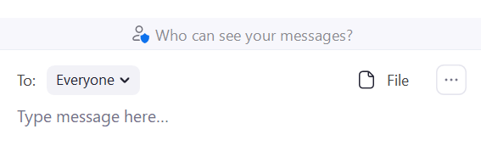
Below is an image showing the pop-up menu that appears when you click on the three dots. Select, “Save Chat.”
Once you save chat, you will see “Show in Folder” in blue. Go ahead and click on that. It will bring you to where Zoom placed the chat on your computer. It is highly recommended you immediately open that file and save it to a location on your computer where you will easily find it later.
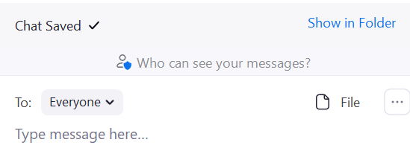
  - Save locally on your computer as “Zoom Chat Breakout Event [NAME]” (fill in your group number). Be sure to remember where you are the saving the document (e.g., on Desktop)
- Save this Breakout Discussion Worksheet as “Breakout Discussion Worksheet Event [NAME]” (fill in your group number). Be sure to remember where you are saving the document (e.g., on Desktop)
- When the Forum ends, you must email the following documents to the Lead Facilitator. The contact information for the lead facilitator is provided at the top of the Run of Show document.
  - Breakout Discussion Worksheet with your notes
  - Zoom chat .txt document
  - PDF of Ideaboardz (received from Breakout Facilitator)

Breakout Discussion Worksheet (for in-person events)
The following information is to be recorded during the first phase of the breakout sessions. For easy reporting and compiling, please use electronic format, such as a Word doc on a computer for ease of sharing notes.

Facilitator:
Date
Venue:
City:
County:

Ground Rules & Introductions (Led by Facilitator) (5 minutes)
- Once all participants are in gathered, facilitate introductions and icebreaker:
  - “Thank you for joining us today. In this Breakout session, I’d like to start with a quick round of introductions. If you’re comfortable, please share your name, whether you’re attending on behalf of an organization, and tell us your favorite thing about living in Maine.”

- Share the ground rules:
  - “This is an open discussion.
  - All views are accepted.
  - Listen and speak in equal measure.
  - Respect that everyone reads and understands data differently. Please save technical questions for follow up later.
  - Be open to learning about data or situations beyond your personal experience.”

- Review the purpose of the discussion:
  - “The purpose of today’s session is to identify health priorities, any gaps and barriers or resources and assets related to each of those priorities.”

- Review the reference materials:
  - County Health Profile
  - Health Equity Data Sheets
  - Priority Handout
  - PowerPoint presentation
  - Handout of past priorities and their strategies (if made available—local decision)

QUESTION 1: DATA DISCUSSION (5 minutes)
Facilitator: “We want to start by taking some time to discuss the data presentation we just watched together. What stood out to you? When thinking about public health data, we tend to look at:
- The size (number of people affected), the seriousness (how sick people can get), trends (is it getting worse or better?), equity (are some groups affected more than others?)
- Past priorities
- Interventions (What’s working now? Are there solutions your community is able to implement?)
- Values (does your community care about it?)
- Resources (can you build on current work or is there available funding?)”
Scribe notes:

QUESTION 2: CHOOSE INDICATORS (10 minutes)
Facilitator: “Before this session, you received a copy of a Priority Handout – if you have that with you, there is a list of indicators in the left-hand column of that document. This list of indicators includes the data points we saw in the presentation today, among others. Go ahead and pull that handout out now and check off as many indicators as you like.

Please do not hit submit just yet, as you will be referring to your choices during the next activity.

You will be referring to your list when we move to the next activity: choosing your priorities.”
(After everyone has checked their choices): “Does anyone want to share the indicators they chose, and why?” “After hearing from others, feel free to adjust your own list.”
Scribe notes:

QUESTION 3: CHOOSE PRIORITY HEALTH TOPIC AREAS (10 minutes)
This activity will be led by the plenary facilitator and all participants at your event will participate at once.

Plenary Facilitator: “We now want you to identify the four Priority Health Topic areas you’re most concerned about. The list of Priority Health Topics is included on the same Priority Handout sheet we just used in the previous activity. For this activity, refer to the right-hand column. When considering what your priorities may be, it may be helpful to take into account:

- The health indicators that you chose in the previous activity. Which health topic area has the greatest proportion of indicators checked?
- The data. Specifically, the seriousness, (how sick people can get), trends (is it getting worse or better?), equity (are some groups affected more than others?)
- Past priorities
- Interventions (what’s working now?)
- Values (does your community care about it?)
- Resources (can you build on current work or is there available funding?)”

“I’m going to launch a Mentimeter poll up here on the screen. Got to Menti.com and fill in this code displayed here on the screen. (This will be the unique Menti poll you created for this event. Your poll options will be the Topics listed in the right-hand column of the Priority Handout.

Within this poll, you’re able to choose up to four Priority Health Topic areas. All of the priority areas from the worksheet are listed in this poll. The order in which you choose your top 4 does not matter. If you’ve chosen 4 but have second thoughts and want to change your choice, you are free to do so, but you will need to de-select a previous choice first.

If you want to choose a priority that isn’t on our list, you can choose ‘Other’ in the poll. If you’re choosing ‘Other’, please share what that “other” is with your breakout facilitator and scribe.

Go ahead and vote now.

(After poll is completed and back in discussion groups): “Does anyone want to tell us which Health Topic areas they prioritized, and why? Are there other concerns you have outside of the indicators you chose?”
Scribe notes (note any ‘Other’ priority topic areas chosen; note any discussion that occurs):

QUESTION 4: GAPS/BARRIERS AND RESOURCES/ASSETS (10 minutes)
Now ask participants to share their knowledge of their communities’ gaps/barriers and resources/assets related to each of the top four priorities just identified. Ask them to list the priority at the top of the sticky note and add ONE gap/barrier or ONE resource/asset on each sticky note. They can make as many sticky notes as they like.

Once they have completed this ask matter. them to place their sticky notes onto the Flip Charts that have been placed around the room: one for each identified health priority.

Priority Handout
Health Indicators: check top concerns |  |  |  |  |  | Topics: circle 4 Priorities
- Rate of uninsured  - MaineCare enrollment rates  - Adults who have a regular doctor  - Adults with regular check ups |  |  |  |  | - Number of primary care providers  - Cost of care  - Children with a medical home | Access to Care
- Rate of cancer deaths (all types)  - Types of cancer (colorectal breast lung prostate HPV skin bladder obesity or tobacco-related)  - Number of new cases of cancer (all types)  - Late-stage cancers (related to screening and early diagnosis)  - Screenings: mammograms, cervical, colorectal, late stage lung |  |  |  |  |  | Cancer
- Stroke or other coronary heart disease deaths  - Chronic conditions such as high blood pressure high cholesterol  - Aftercare for stroke or heart attack |  |  |  |  |  | Cardiovascular Disease
- Children with special health care needs  - Developmental screening |  |  |  |  |  | Children with special health care needs
- Rate of diabetes deaths  - Number of those identified with diabetes or pre-diabetes  - Clinical measures such as eye and foot exams  - Diabetes education and management resources |  |  |  |  |  | Diabetes
- Arthritis  - Cognitive decline  - Those providing care 20+ hours/week  - Other topics that affect elderly people disproportionately |  |  |  |  |  | Older Adult Health/Healthy Aging
- Well testing  - Lead screening |  |  |  |  | - Children with elevated lead levels  - Radon testing | Environmental Health
- Ambulatory care-sensitive condition hospitalizations (acute episodes that are not stabilized in the emergency room)  - Non-emergent emergency department use  - Hospital readmissions w/in 30 days of discharge |  |  |  |  |  | Health Care Quality
- Two-year old’s up to date  - Flu vaccines  - Pneumonia vaccines  - Philosophical exemptions among kindergarteners for immunizations  - Adolescent vaccines |  |  |  |  |  | Immunizations
- Number of new cases of intestinal diseases  - STD’s (Chlamydia, Gonorrhea, HIV, Syphilis) |  |  |  |  | - Tuberculosis  - Pertussis  - Hepatitis A B or C Lyme disease | Infectious Disease
- Firearms  - Suicide deaths  - Child maltreatment  - Rape |  |  | - Intimate partner violence  - Bullying  - Self-harm  - Violent crime rate |  |  | Intentional Injury
- Availability of mental health providers  - Mental health emergency department usage |  |  |  |  | - Anxiety  - Depression  - Suicide ideation | Mental Health
- Number of available dentists  - Visits to a dentist in the past 12 months  - Emergency room visits for tooth pain  - Tooth loss  - Access to dental insurance |  |  |  |  |  | Oral Health
- Obesity & overweight  - Sedentary lifestyle  - Meets aerobic physical activity recommendations  - Fruit and vegetable consumption  - Soda/sports drink consumption  - Food insecurity (see also Social Determinants of Health)  - Access to healthy foods |  |  |  |  |  | Physical Activity Nutrition and Weight
- Infant deaths  - Low birth weight  - Pre-term births  - Unintended births  - Prenatal care  - Teen pregnancy | - Smoke or drink during pregnancy  - Breastfeeding  - C-sections among low-risk births  - Drug-affected babies (see also Substance and alcohol use) |  |  |  |  | Pregnancy and birth outcomes
- Asthma  - Chronic Obstructive Pulmonary Disease (COPD)  - Pneumonia  - Chronic lower respiratory disease |  |  |  |  |  | Respiratory
- Individuals, families or children living in poverty  - People living in rural areas  - Household income  - Unemployment  - Living in rural areas  - 65+ living alone  - Access to broadband  - No vehicles in household |  | - Long commutes driving alone  - Adolescent homelessness  - Housing costs as a percentage of income  - Food insecurity (See also Physical Activity Nutrition and Weight)  - Adverse Childhood Experiences  - Children eligible for free or reduced lunch  - High school graduation rate |  |  |  | Social Determinants of Health
- Drug overdose deaths  - Alcohol-induced deaths  - Overdoses: opiate and other substance use poisonings & hospitalizations  - Non-medical prescription drug use  - Substance use treatment (needed and not provided) |  |  |  |  | - Marijuana use  - Alcohol-impaired driving  - Adult chronic heavy drinking  - Youth past-30-day and binge drinking  - Drug-affected baby referral  - Opioid prescribing rates | Substance and alcohol use
- Current smokers  - Tobacco Helpline Users |  |  |  | - Vaping/electronic device use  - Second hand smoke exposure |  | Tobacco
- Injury deaths  - Fall-related injuries or deaths  - Unintentional poisonings  - Traffic crashes  - Work-related injuries or deaths  - Traumatic brain injury  - Seatbelt use |  |  |  |  |  | Unintentional injury
Other: (please explain) |  |  |  |  |  | Other

Health Prioritization Worksheet (for in-person events only)
Topic | Number of People chose topic
Unintentional Injury | 1

Flip Chart Sample (in-person only)
Health Topic: |  | # of votes:
Gaps | Resources

Participant Feedback Form (all events)

Link: Participant Feedback Form
- Used to collect participant’s impression of the event and any additional information they may wish to share
- This is a single centralized SurveyMonkey created for use in all events
- Participant Feedback Form link available on the Run of Show and in the Community Engagement SmartSheet
- Provided link in the chat box at the end of your virtual event.
- For all events, send link in follow up emails sent either by Local Planning Committee members (for Mainstream Forums) or community host (for Community Sponsored Events).

Reporting the Results
Purpose: To collect the following information:
- a description of the significant health needs of the community;
- a description of resources potentially available to address those significant health needs;
- any gaps or barriers that pose a challenge to address, or community members experiences in overcoming those significant health needs
- any feedback on implementation strategies that were implemented since the last CHNA;
- a list of attendees, who ideally represent the broad interest of the community, including but not limited to the medically underserved, low-income, those who experience health disparities, or minority populations. Representation can be in the form of either organizations who work with these populations or individuals with lived experience.

Post Event Checklist (virtual events)
Immediately Following Forum or Community Sponsored Events:

Post Event Checklist:
Breakout Room Facilitator | Scribe
At Conclusion of Breakout Session:
- Download Ideaboardz as a PDF  - Download chat (as backup) | - Download Chat & save on desktop  - Save Breakout Discussion Worksheet (BDW)on desktop  - Look Ideaboardz PFD in your inbox
Send Document to: | Send all three documents to:
Scribe | Lead facilitator
Host/Local planning team | Lead Facilitator
Within 24 hours of Event:
- Email link to the Participant Feedback Form 1 day and 1 week post event. | - Complete the CORT  - Upload Chat, BDW, Ideaboardz, and Mentimeter results to SmartSheet  - Update the Vote Tallying Tool  - Send recording of event to info@mainechna.org
Contact information for Breakout Room Facilitators, Scribes, Local Host or Planning Teams, and Lead Facilitators can be found on the top of the Run of Show for your event.
Update the Vote Tallying Tool | Maine Shared CHNA Community Engagement SmartSheet | Facilitator

Post Event Checklist (in-person)
- As soon as practical after the conclusion of your event, complete the Community Outreach Reporting Tool A template of that tool is provided on the following pages for your reference.
- Collect and upload the following materials into their respective collection portals:
What | Upload to where: | By Who
Breakout Discussion Worksheets/Notes | (URL TK) | Facilitator
Priority Handouts | (URL TK) | Facilitator
Health Prioritization Worksheets | (URL TK) | Facilitator
PDFs of Participant Feedback | (URL TK) | Facilitator
Photos of Flip Charts with sticky notes | (URL TK) | Facilitator
PDFs of Registrations/Sign in Sheets | (URL TK) | Planning Team
Photos of your event | Drop Box (URL TK) | Planning Team
Handouts for posting to website | (URL TK) | Planning Team

Community Outreach Reporting Tool
The following information is to be reported by the event facilitator. This is an online tool. Please visit Community Outreach Reporting Tool Survey to fill this out. The reporting fields are provided here for your reference.

- If event was for a specific county, please choose from the drop-down menu. If the event was not for a specific county, please choose ‘other’, and specify who the event was for/with:
- If event was for a specific community, please choose from the drop-down menu:
Veterans
Adults 65+ with chronic conditions
Youth
People experiencing homelessness
LGBTQ+
Rural residents
People experiencing mental health challenges
People experiencing a substance use disorder or are in recovery
People who are deaf or experience hearing loss
People with a physical disability
People living with HIV/AIDS

- Name of event:
- Date of event:
- If event was held in-person, please report the name and location of the venue:
- Number of participants:
- Lead facilitators’ name(s):
- Lead facilitators’ email(s):

List the organizations represented at this event (this information may be found in the event registration information)

List the top four Priority Health Topic Areas identified at this event, along with the total number of votes, in ranked order.
Priority Health Topic Area | Number of Votes Received

List the indicators identified for each of the top 4 Priority Health Topic Areas, and note the number of times they were identified. For example: “Rate of uninsured (3)”

Indicators for Priority Health Topic Area 1:
Indicators for Priority Health Topic Area 2:
Indicators for Priority Health Topic Area 3:
Indicators for Priority Health Topic Area 4:

List the assets/resources participants identified for each Priority Health Topic Area (regardless of whether they were in the top 4). For example, “Mental health: local clinics, peer navigators.”

List the gaps/barriers participants identified for each Priority Health Topic Area (regardless of whether they were in the top 4). For example, “Mental health: lack of psychiatric services, affordability.”

Summarize notes from Question 1: Data Discussion (From presentation, what data stood out to participants)

Summarize notes from Question 2: Choose Indicators (What indicators stood out to people, and why?)

Summarize notes from Question 3: Choose Priority Health Topic Areas (Why did you choose the priority health topic areas that you did?)

Summarize notes from Question 4: Sticky Note Exercise (Why did you identify these gaps/barriers or resources/assets? Any reactions to others input?)

Please describe any special circumstances that you feel may impact any results from this event:

Additional comments or feedback:

In addition to completing this form, please remember to upload the following materials in the appropriate collection tool, as described below:

What | Upload to where: | By Whom
Breakout Discussion Worksheets/Notes | MSCHNA Engagement SmartSheet | Scribe
Indicators results (from SurveyMonkey) virtual event | MSCHNA Engagement SmartSheet | JSI
Priority Handouts (in-person) | MSCHNA Engagement SmartSheet | Scribe
Health Prioritization Worksheets (in-person) | MSCHNA Engagement SmartSheet | Scribe
Priority Health Topic Area results (from Mentimeter) | MSCHNA Engagement SmartSheet | JSI
Ideaboardz PDFs virtual event | MSCHNA Engagement SmartSheet | Scribe
Exports of Zoom Breakout chats (virtual event) | MSCHNA Engagement SmartSheet | Scribe
Registration list (in-person events) | MSCHNA Engagement SmartSheet | Local host
Photos of sticky note exercise (in-person) | MSCHNA Engagement SmartSheet | Local host
Handouts for posting to website | MSCHNA Engagement SmartSheet | Local hosts

Key Stakeholder Interview Reporting Tool
Please use this form if you have been provided approval to submit your findings from independently conducted Key Stakeholder Interviews to the Maine Shared CHNA county reports. It is best practice to complete this form as soon as practical, following your interview(s).

Name of interview subject:
Name of interviewer:
Email address of person filling in this form:
Date of interview:

Description of medically underserved group:

Description of the geographic region the subject represents:

Description of the sector representation:

Open text fields for notes from KSIs to be cut and pasted into for each question.

Communication
The following template provides the minimum information necessary to promote your events.

Save the Date Template
Save the Date!
<<DAY OF THE WEEK, MONTH, DAY, YEAR>>
<<TIME>>
<<LOCATION IF KNOWN>>
Community Engagement Forum
<<List hosts>> will be hosting an event for the
Maine Shared Community Health Needs Assessment to present
<<NAME OF COUNTY>> County health data.

We want to hear your thoughts on the health of your community, and together with your neighbors, identify the top health concerns, populations most at risk, as well as resources and gaps to address those concerns.

Look for County Health Profiles in your inbox late August, 2021.

<<insert partner logos here>>
About Maine Shared CHNA
Vision
The Maine Shared Community Health Needs Assessment helps turn data into action so that Maine will become the healthiest state in the U.S.

Mission
The Maine Shared Community Health Needs Assessment is a dynamic public private partnership that:
- Creates Shared Community Health Needs Assessment Reports;
- Engages and activates communities; and
- Supports data-driven health improvements for Maine people.

Learn more at www.mainechna.org.

The Maine Shared CHNA is made possible through the support and collaboration of our signatory partners including Central Maine Healthcare, Maine Center for Disease Control and Prevention, MaineGeneral Health, Maine Health, and the Northern Light Health and countless community partners.

Event Invitation Template for Email
While this is focused on in-person events, the same template may also be used for virtual events.
Event invitations should include:
- a link to your online event registrations
- A link to the MSCHNA 2021 Events page
- Logos from the MSCHNA signatory partners:
Suggested invitation copy:
The Maine Shared Community Health Needs Assessment is a dynamic public-private partnership that compiles health data and engages and activates our community to discuss that data in order to build plans which address our most pressing health needs.

We invite you to join us in this conversation so that together, we can become the healthiest state in the nation.
To make the most of your experience, please review the County Health Profile, Health Equity Data Sheets, and the Health Priority Worksheet found on our Events page prior to attending an event.

Press Release Template: Forum Announcement/Invite
While this is focused on in-person events, the same template may also be used for virtual events.
FOR IMMEDIATE RELEASE FMI: [NAME]
[INSERT DATE] [PHONE]
[EMAIL]

Public Forum to discuss County Health Profile
Maine Shared Community Health Needs Assessment

[CITY/TOWN OF EVENT], ME— Stakeholders from across [name of county] County will be given an opportunity to shape priorities for community health at a special forum aimed at providing input to the region’s public health and healthcare organizations.

The forum will discuss the [name of county] County Health Profile and is scheduled for [date/time] at [location]. The [name of county] County Health Profile contains data that describe health outcomes, health behaviors, healthcare access and quality, and the social, community, and physical environment that affect our health. Previous forums were held in 2011, 2015, and 2018.

[Insert name of event organizer known to community members] said, “We want to share this data and get our neighbors’ input about what they see as our biggest health issues. The presentation will also include a list of past priorities and what our partners have been doing to address them.”

The event is free and open to the public. To reserve a seat, please register here [insert registration link].

In addition to collecting input on local health priorities, the forum will also collect information about local resources that could help to address those priorities. Forums and other community feedback will be used as guidance to create new, county-specific health improvement plans in the spring of 2022. As in the past, this forum is an important step in the Maine Shared Community Health Needs Assessment (Maine Shared CHNA).

The Maine Shared CHNA process will roll out in three stages:
- County Health Profiles are scheduled to be released in August, 2021.
- Forums and other outreach are scheduled to be held between September –December 2021. This includes community presentations, conversations and other input.
- Final CHNA reports are scheduled to be released in April, 2022. These reports will include a summary of the input collected from our communities.

For more information, go to the Maine Shared CHNA website (www.mainechna.org) for schedules, local contacts, Health Profiles, and an interactive data portal. The website will also host event agendas, handouts, presentations and when available, the final CHNA reports.

This forum is a collaborative effort among [name local partners].

The Maine Shared CHNA is a public-private statewide effort. Funding for the Maine Shared CHNA is provided by the partnering healthcare systems with generous in-kind support from the Maine CDC and our community partners.

Community Health Needs Assessment Reports
Maine Shared CHNA Community Health Needs Assessment Reports will be published in April, 2022. There will be a report for each of Maine’s 16 Counties, 5 multi-county Public Health Districts, and 1 Statewide Report. Other Reports will be considered on an as-need basis. These reports will include qualitative data on the identified top health concerns, including a summary report of major themes that emerged from the community feedback gathered in the fall of 2021. These reports will inform the creation of health improvement plans.

Public Health Improvement Planning
The CHNA reports will be used to craft State Health Improvement Plan(s) as well as hospital implementation strategies.
- Non-profit hospitals must complete what they call either their Implementation Plans or Implementation Strategies and have them adopted by their Board of Trustees according to the fiscal year and deadlines imposed by the IRS.

Please see previous CHNA Reports and Hospital Implementation Strategies here: (https://www.maine.gov/dhhs/Maine CDC/phdata/MaineCHNA/final-CHNA-reports.shtml )

