Breakout Discussion Worksheet (for virtual events)
Session name, date, time: Lead facilitator, fill in prior to session
Facilitator name: Scribe - fill in
Scribe name: Scribe - fill in

Indicators Survey link: https://www.surveymonkey.com/r/YV82R9Q
Mentimeter link: Entered by JSI prior to event
Ideaboardz link: https://ideaboardz.com/ (for setting up your own board)
Participant Feedback Form: https://www.surveymonkey.com/r/NJN82CY

NOTE: If at any time you need assistance from the host, click ASK FOR HELP ICON in the Zoom control menu/tray. The meeting host will be notified and join your room.

Ground Rules & Introductions (Led by Facilitator) (5 minutes)
- Once all participants are in the Breakout Room, repeat Zoom tips, facilitate introductions and icebreaker:
  - “Thank you for joining us today. In this Breakout session, we’ll be using the chat box – does everyone know where that is? You may also use the Reactions and Hand raising options. If you have not done so already, go ahead and unmute since this is your turn to talk.”
  - “I’d like to start with a quick round of introductions. I will call on each of you individually. If you’re comfortable, please share your name, whether you’re attending on behalf of an organization, and tell us your favorite thing about living in Maine.”

- Share the ground rules:
  - “This is an open discussion.
  - All views are accepted.
  - Listen and speak in equal measure.
  - Respect that everyone reads and understands data differently. Please save technical questions for follow up later. Email technical questions to info@mainechna.org.
  - Be open to learning about data or situations beyond your personal experience.”

- Review the purpose of the discussion:
  - “The purpose of today’s session is to identify health priorities, any gaps and barriers or resources and assets related to each of those priorities.”

- Review the materials the participants were sent links to prior to the event:
  - County Health Profile
  - Health Equity Data Sheets
  - Priority Handout
  - PowerPoint presentation
  - Handout of past priorities and their strategies (if made available—local decision)

QUESTION 1: DATA DISCUSSION (5 minutes)
Facilitator: “We want to start by taking some time to discuss the data presentation we just watched together. What stood out to you? When thinking about public health data, we tend to look at:
- The size (number of people affected), the seriousness (how sick people can get), trends (is it getting worse or better?), equity (are some groups affected more than others?)
- Past priorities
- Interventions (What’s working now? Are there solutions your community is able to implement?)
- Values (does your community care about it?)
- Resources (can you build on current work or is there available funding?)”
Scribe notes:

QUESTION 2: CHOOSE INDICATORS (10 minutes)
Facilitator: “Before this session, you received a copy of a Priority Handout – if you have that with you, this contains a list of all of the Maine Shared CHNA 200+ data points. This list of indicators includes the data points we saw in the presentation today, and then some. The data is organized by health topics. This is important to note, as we will refer to those health topics in the next activity.
I’m going to put a link to a SurveyMonkey poll into the chat. Clicking that link will take you to a poll that will allow you to mark the indicators that are most important to you. You may choose as many indicators as you like.
Please do not hit submit just yet, as you will be referring to your choices during the next activity.
(Facilitator, copy and paste this link into the chat: https://www.surveymonkey.com/r/YV82R9Q
Go ahead and click that link now. I will give you a few minutes to make your choices. Remember not to hit submit, as you will be referring to your list when we move to the next activity.”
(After everyone has checked their choices): “Does anyone want to share the indicators they chose, and why? After hearing from others, feel free to adjust your own list.”
Scribe notes:

QUESTION 3: CHOOSE PRIORITY HEALTH TOPIC AREAS (10 minutes)
Facilitator: “We now want you to identify the four Priority Health Topic areas you’re most concerned about. As discussed earlier, all the data is organized by health topics. For this activity, refer to those health topics—these are the list of health topics we will ask you about when choosing your top four health priorities.
When Meeting host sends prompt to launch poll state: “I’m going to put a link to a poll into the chat. (Facilitator, copy and paste the link to the Mentimeter poll into the chat). <<MENTIMETER LINK HERE, HIGHLIGHTED>> Within this poll, you’re able to choose up to four Priority Health Topic areas. All of the priority areas from the worksheet are listed in this poll. The order in which you choose your top 4 does not matter. If you want to choose a priority that isn’t on our list, you can choose ‘Other’ in the poll. If you’re choosing ‘Other’, please type the priority topic into the chat so we can log it. If you’ve chosen 4 but have second thoughts and want to change your choice, you are free to do so, but you will need to de-select a previous choice first.
If you are unable to access the Mentimeter go ahead and chat in your top 4 votes now.
Go ahead and vote now. The votes from this group will be combined with votes from all other groups to arrive at a set of priority areas for the session.
If you are joining us on the phone, you can add your Health Priorities in the chat now.”
After you choose your Priority Health Topic Areas, go ahead and hit submit on your indicator list. We will use this as one piece of information to get a fuller picture of what’s driving your communities’ health concerns.”
Meeting Host will send a message to all Breakout Groups when there is 1 minute left to vote. Please relay this message to your Breakout Participants when it comes through, in the chance they don’t see it.
Once the poll is closed, the Meeting Host will close the poll and will Screen share the poll results to all Breakout Rooms.
Breakout Facilitator should email the Lead Facilitator any priority votes that were collected in the chat box.
They will also circle the top 4-6 priority areas (depending on how votes shake out). This slide will stay up for approximately 3 minutes to ensure that the Scribe has time to write them down. Your participants may begin to discuss the results, which is fine.
SCRIBE –Record the top 4-6 priorities that are circled on the slide. This information will be used in the next activity. Once the Meeting Host stops screen sharing, type or copy the top 4-6 priorities into the Zoom Breakout Chat, so that your participants are able to reference them during the Sticky Note Exercise. You may also log any discussion or comments on the priority areas in this section, if discussion occurs:

QUESTION 4: STICKY NOTE EXERCISE (10 minutes)
Breakout Facilitator: “We want to know about community gaps and barriers, as well as resources and assets related to the top health priorities. We are going to use a tool called Ideaboardz for this exercise. I’m going to share my screen to show you what this looks like. (Share screen to show your Ideaboardz now). I want to remind you that you can close the chat box and the participant list to better see my screen.”
“Here you will see two columns – one labeled Gaps and Barriers and another labeled Resources and Assets. Please note that our Scribe has typed the top priorities from the poll into the chat for your reference
Create a new note for each Priority’s Gap/Barrier or Resource/Asset you want to share. For example, if mental health were one of the top 4-6 identified priorities, you’ll create one note for a gap/resource related to mental health, and a new note for any resources or assets related to mental health. You can add a note under either column by pressing the green plus sign symbol.” I am also adding the first note to our board with a list of those topics for easy reference. (Facilitator, demonstrate now – see Screenshot below of what your demo might look like). For each new note, add the name of the health topic followed by the gap or resource you wish to share under the appropriate heading. You can edit your own notes at any time by clicking back on it (Demo this). You can also agree or like somebody else’s item by clicking the plus sign in the bottom left corner of a sticky note (Demo this). Please do not edit or delete somebody else’s sticky note.

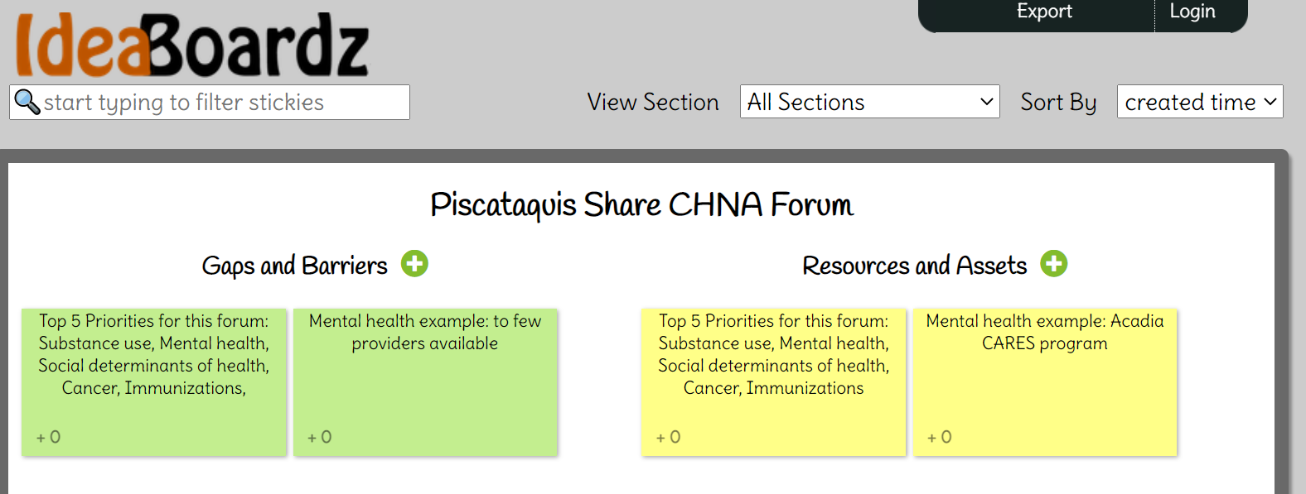
(Facilitator, copy and paste link to the IdeaBoardz you created into the Zoom chat). I’m now going to put a link to our group’s IdeaBoardz in the chat – please click on that link now. Go ahead and log your gaps and barriers or resources and assets now. If you’re joining us on the phone, you can use the Zoom chat to type in your assets and gaps/barriers for each of the priority areas. Just please be sure to note which priority area you’re talking about when you chat your responses.”
(Facilitator, watch as the sticky notes start appearing. Be sure to remind people to include the name of the Priority Health Topic Area on each of their notes. Frequently check in to make sure everyone understands how to do the activity, offer to assist anyone who may be struggling to add notes). If somebody asks to create a sticky note for a Priority Health Topic Area that is NOT in the top 4-6, that’s ok. However, the focus should be on the top results.
(After people have stopped creating sticky notes): “Would anyone like to talk about what they put on their sticky note, or any reactions to what others are putting?”
Scribe notes (Be sure to note any gaps/barriers or assets/resources that are put in the Zoom chat by those connecting via phone):

(Meeting Host will send a message when it is time to start the Wrap Up. NOTE: Do not close the Ideaboardz. You will need to export this and email to your Scribe – see instructions below)
WRAP UP (5 minutes)
Breakout Facilitator (Stop screen share): “Thank you for taking the time to participate in this process. We appreciate you sharing your lived experience and first-hand knowledge. How did you feel about this process?”
“When we get moved back into the full group session, a link to a Participant Evaluation Form will be posted in the Chat. We ask that you please fill this out. It will give you an opportunity to provide any additional feedback that you wish to share. Thank you again.”
SCRIBE: When the Wrap up starts, save and export the Zoom chat by following the directions below.
Save Breakout Zoom chat to .txt by clicking the three dots at the bottom of the Chat, and select Save. It is encouraged the Breakout Facilitator also do this only as a backup measure. Below is the image showing where to locate the three dots.
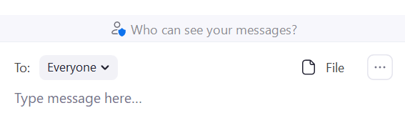
Below is an image showing the pop-up menu that appears when you click on the three dots. Select, “Save Chat.”
Once you save chat, you will see “Show in Folder” in blue. Go ahead and click on that. It will bring you to where Zoom placed the chat on your computer. It is highly recommended you immediately open that file and save it to a location on your computer where you will easily find it later.
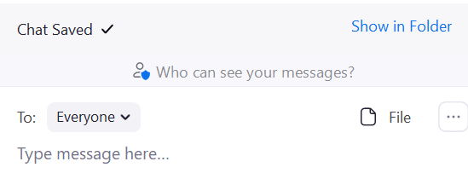
  - Save locally on your computer as “Zoom Chat Breakout Event [NAME]” (fill in your group number). Be sure to remember where you are the saving the document (e.g., on Desktop)
- Save this Breakout Discussion Worksheet as “Breakout Discussion Worksheet Event [NAME]” (fill in your group number). Be sure to remember where you are saving the document (e.g., on Desktop)

Post Event Checklist:
Breakout Room Facilitator | Scribe
At Conclusion of Breakout Session:
- Download Ideaboardz as a PDF  - Download chat (as backup) | - Download Chat & save on desktop  - Save Breakout Discussion Worksheet (BDW)on desktop  - Look Ideaboardz PFD in your inbox
Send Document to: | Send all three documents to:
Scribe | Lead facilitator
Host/Local planning team | Lead Facilitator
Within 24 hours of Event:
- Email link to the Participant Feedback Form 1 day and 1 week post event. | - Complete the CORT  - Upload Chat, BDW, Ideaboardz, and Mentimeter results to SmartSheet  - Update the Vote Tallying Tool  - Send recording of event to info@mainechna.org
Contact information for Breakout Room Facilitators, Scribes, Local Host or Planning Teams, and Lead Facilitators can be found on the top of the Run of Show for your event.

