 |  | 

CLIENT SEARCH AND ADDING A CLIENT

The ImmPact2 Immunization Registry is a population-based Web application containing consolidated demographic and immunization history information. ImmPact2 is able to perform a variety of functions for health care providers, including, but not limited to:
- ADA compliancy
- VFC Annual Agreement Integrated with Org/Site Management
- Comprehensive client and vaccine management
- Fully integrated VMBIP/Vaccine Management
- Integrated Optical Character Reader Technology
- Time savings data entry Page designed (integrated administration and batch entry SCREEN - 5 pages down to 1)
- CASA-Like Reports (Up To Date Report and Immunization Coverage Reports )
- Program Activity Tracker (Track VFC and Program related interventions across all 12 Grant Components)
- Medicaid Well Child Forms
- Medicaid Contact Management Functionality
- Obesity Data Collection and Connections to Medicaid Data Collection
- School Access (View Only Currently)
- Ability to Import/Export the Vaccine Schedule for centralized maintenance and contracting
- CDC Annual Report Generation- Non validated Dose Collection (Collect doses from WIC, HeadStart, Schools, etc. and validate in Provider Offices)
- Ability to create forms online and store within the Database
- Ability to import past CASA/Co-CASA
- Data Exchange (outbound completed, inbound pending)
- VPD Surveillance Initiation Form (2008 deliverable)
- Hep B. Surveillance Functionality (slated for 2009)
ImmPact2 is provided free of charge to health care providers in Maine. To use the registry, providers are required to participate in an ImmPact2 training session and sign an enrollment agreement.

The following instructions were developed for use as a resource within your practice.

CLIENT SEARCH

The client search functionality within ImmPact2 has changed over the course of the last few years. Early users will remember that originally the ImmPact2 system required full last name, full first name & full date of birth in order to search for a client. What we found over time was that this inflexible search resulted in many duplications of clients. Nearly all children born in Maine within the last 10 years, as well as all individuals of all ages who have ever been eligible for MaineCare, have been put into the ImmPact2 system. Many 0-18 year olds who reside in the State of Maine are within our system; therefore, when you do a flexible search in ImmPact2 there is a very good chance that you will find the client that you are looking for. Because of this, MIP has modified the ImmPact2 system to allow flexible searching.

The flexible search provides the function to search by less than the entire last name, less than the entire first name and does not require a date of birth in order to find clients. The instructions below will show you how to correctly search for clients within the system.

Log onto ImmPact2

From the blue menu bar on the left side of your screen, click on manage client.
This link is found under the Clients heading.

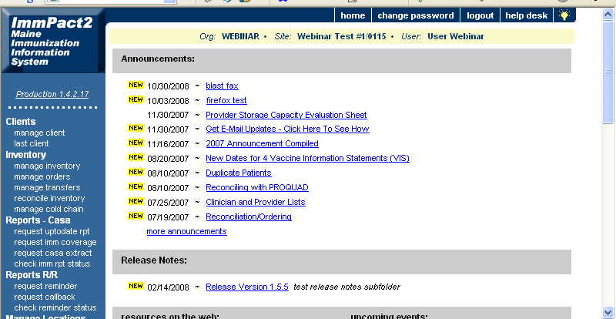

NOTE: Our recommendation for all searching is to start with the first 3 letters of the last name and the first 3 letters of the first name.

For this example, we will search for a client named JEANNINE XOOXOO.

Enter the first 3 letters of the client’s last name into the text box next to Last Name.

Enter the first 3 letters of the client’s first name into the text box next to First Name.

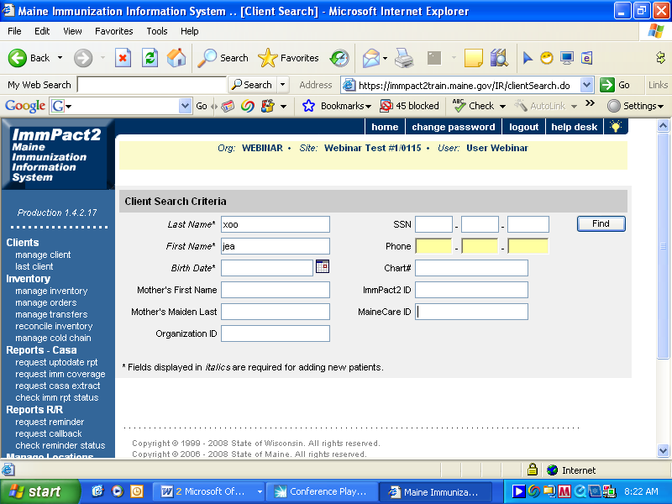

As you can see in the example above, we have begun our search with 3 letters of the last name XOO and 3 letters of the first name JEA. Often times this will be enough to assist you in finding a particular patient.

Click the Find button.

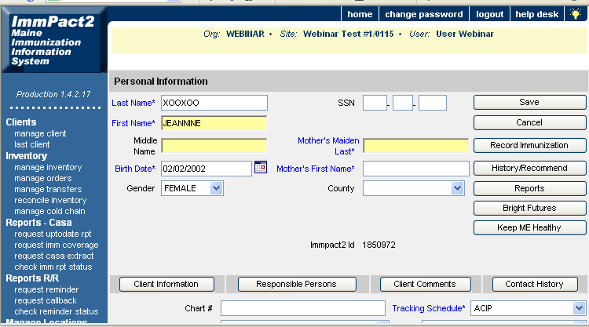

ImmPact2 recognizes that there is only 1 match in the entire system, regardless of birth date, and takes you directly to the record. Once you verify that this is your client, no additional search is required. You can begin to do transactions for this client.

If this is not the client you were searching for, you can continue your search. When doing a new search, you can put in less search information and potentially get more results.

We will use the same client for this next example.

Enter the first 3 letters of the client’s last name into the text box next to Last Name.

Enter only the first letter of the client’s first name into the text box next to First Name.

Click the Find button.
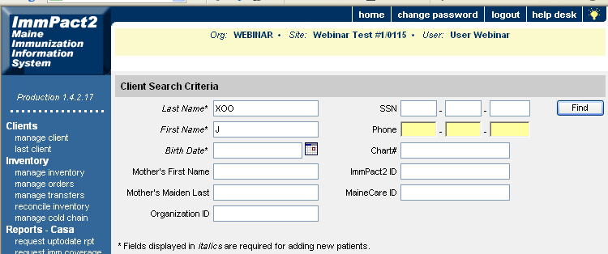
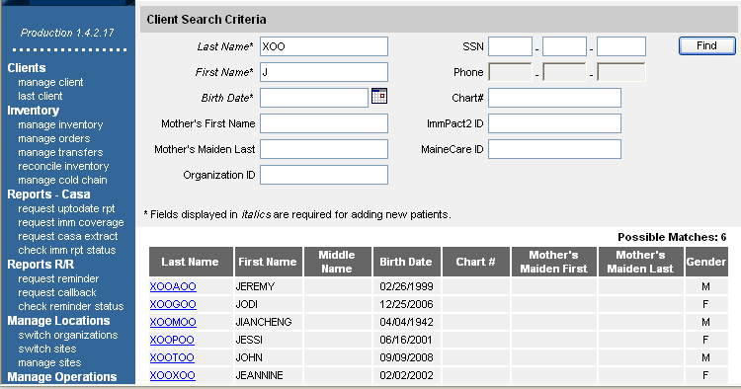

As you can see there are 6 clients that fit your new search criteria. If you are looking for Jeannine, you would note that her name is on the list, confirm her birth date and be able to click her highlighted last name to move into her client record. Even though Jeannine’s last name is significantly different from all the other last names on this list, the fact that they all started with the same first 3 letters of the last name and the same first letter of the first name allowed us to get this short list.

We can again change the search criteria to shorten the possible matches by including 2 letters of the first name.

We will use the same client for this next example.

Enter the first 3 letters of the client’s last name into the text box next to Last Name.

Enter the first 2 letters of the client’s first name into the text box next to First Name.

Click the Find button.
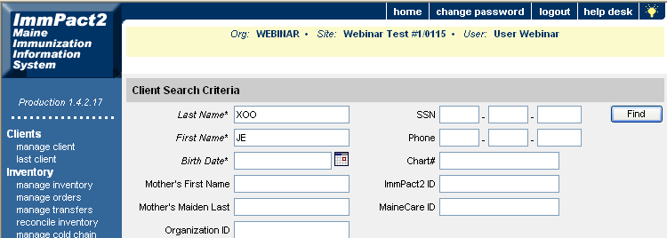

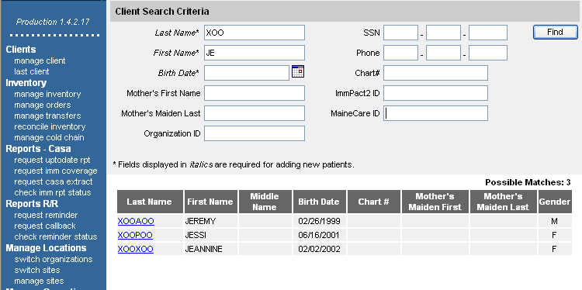

As you can see by this example, the list is much shorter by adding just 1 extra letter to the first name. This allows you to find your clients much faster.

Note: It is not recommended to search using more than 3 letters of the last name and 3 letters of the first name unless your return has more possible matches than the system will allow. Normally the system can return between 1 and 500 matches. However, for common names such as Smith, you may actually get more possible matches than the system allows, in which case you would want to use more letters in your search.

To summarize the instructions above:

Enter the first 3 letters of the last name and first 3 letters of the first name and click find.

You can broaden your search by entering the first 3 letters of the last name and first letter of the first name. You can decrease the number of names in your returned search by adding 1 additional letter at a time to the first name.

Do not add a birth date unless you are unable to find your client using the directions given above. Remember that all children born within the past 10 years in the State of Maine and any person regardless of age that has been MaineCare eligible should already be in the ImmPact2 system.

Adding a Client

If after searching for your client using the above steps, you do not get a successful match, you may add your client to the ImmPact2 system following the instructions below. Remember to first use all of the steps shown in client search to ensure your client is not currently in the system before adding the client yourself.

Enter the client’s full last name into the text box next to Last Name.

Enter the client’s full first name into the text box next to First Name.

Enter the client’s full date of birth into the box next to Birth Date.

Click the Find button.
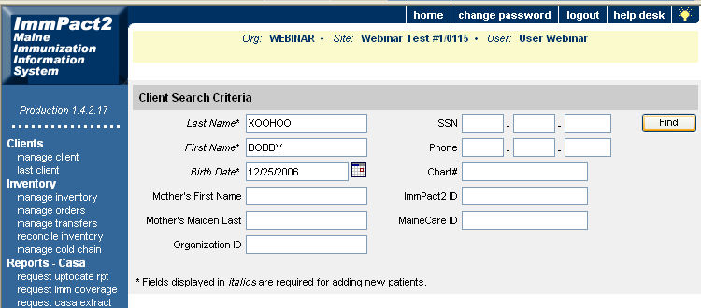

Note: Birth Date format within ImmPact2 is mm/dd/yyyy. You may also click on the calendar icon next to the birth date text box and choose your date from the calendar. Select the correct month and year from the drop downs, click on your correct date until highlighted and hit the OK button.

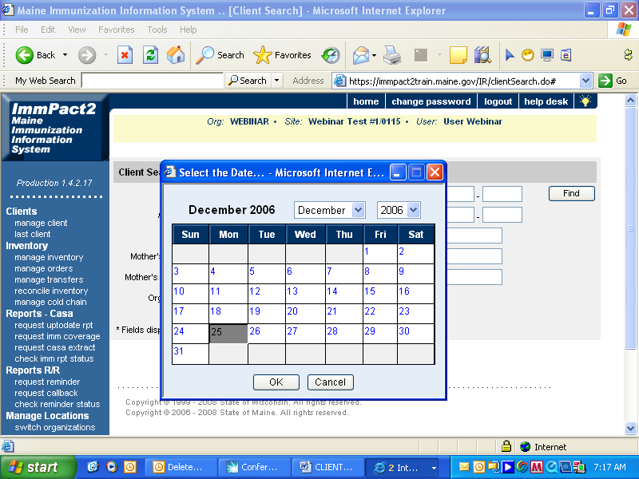

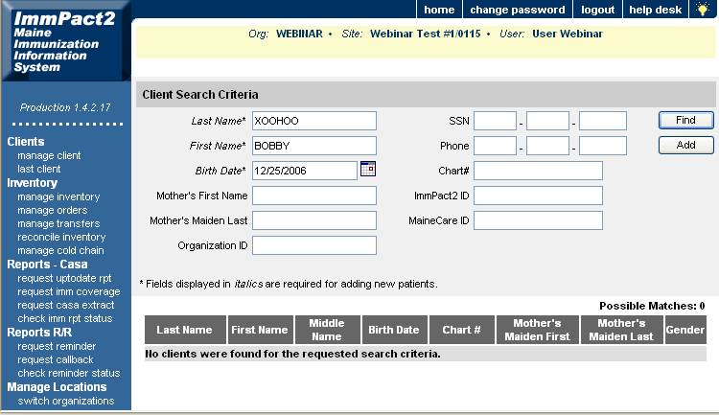

As you can see from this example, the system was unable to find a match to BOBBY XOOHOO with date of birth 12/25/2006.

Note: When a match is not found in ImmPact2 the system will show this in two different ways. Possible Matches: 0 and a text message: No clients were found for the requested search criteria.

To add this client to ImmPact2, verify that the full Last Name, full First Name and Birth Date are correct.

Click the Add button.

A personal information screen will appear. You will now be able to enter information regarding this client into the system.

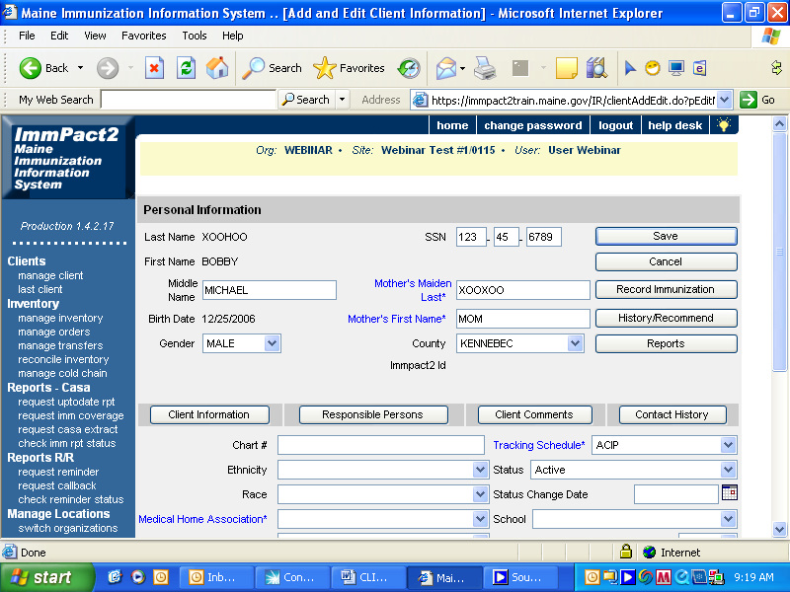
2
1
3
4
5
6

Note: Most of the fields marked in Blue are required fields and information should be added to these fields when adding a client. It is recommended to add information to other fields shown on this screen; however, it is not necessary to fill these in to add a client.

- Last Name, First Name and Birth Date: This will be pre-filled with the information provided on the previous screen.

- Middle Name: Enter the client’s Middle Name.

- Gender: Choose the correct Gender from the drop down box.

- SSN: Enter the client’s 9 digit Social Security Number.

- Mother’s Maiden Last & Mother’s First Name: Enter the client’s Mother’s Maiden Last Name and First Name. Although these fields are highlighted in blue, it is not necessary to fill these in to add a client. However, MIP highly recommends inputting this information.

- County: Choose the County your client lives in from the drop down box.

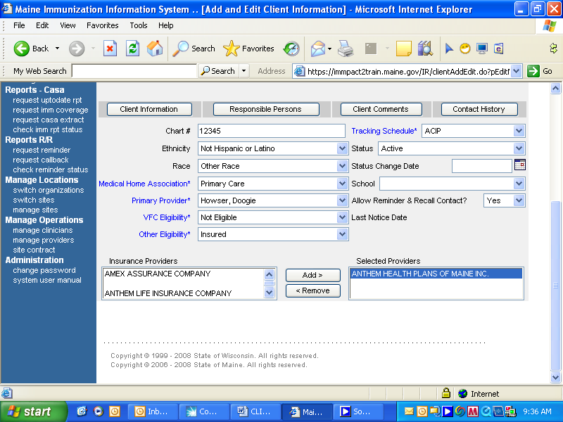
1
2
3
4
5
6
7
8
9

- Chart #: If you identify clients in your practice by Chart Numbers you can enter that information in this field.

- Ethnicity: Choose client’s Ethnicity from the drop down box.

- Race: Choose client’s Race from the drop down box.

- Medical Home Association: Choose your Association’s relationship with the client, based on the following criteria:

- Primary: You are the Primary Care Provider/Medical Home of the client.
- Secondary: You are not a Primary Care Provider, but do see the client for immunizations or as a seasonal client.
- Not Associated: You are not a Primary or Secondary Medical Provider to this client, but are inputting immunization history information into the ImmPact2 system.

- Primary Provider: Also known as Primary Physician, please choose the client’s Primary Provider from the drop down box. This information will not identify who gave the immunization, but rather which Provider is responsible for the client. All physicians within your practice should be listed here. If the physician you are looking for is not listed, please call the MIP at 800-867-4775 for guidance.

- VFC Eligibility: Choose the client’s reason for VFC eligibility from the drop down box. As you know, you are required to screen your clients for VFC eligibility at EVERY IMMUNIZATION VISIT. Under VFC eligibility requirements, a child is defined as 18 years of age or younger. If the client entered is 19 years of age or older this field will be pre-filled with Not Eligible. The only acceptable reasons why a client of appropriate age can be VFC Eligible include those who fall within the guidelines below:

  - Medicaid: a child who is eligible for the Medicaid program.
(For the purposes of the VFC program the terms Medicaid-eligible and Medicaid-enrolled are equivalent and refer to children who have health insurance covered by a state Medicaid program)
- American Indian or Alaskan Native: as defined by the Indian Health Care Improvement Act (25 U.S.C. 1603)
  - Underinsured: Children who have commercial (private) health insurance but the coverage does not include vaccines, children whose insurance covers only selected vaccines (VFC- eligible for non-covered vaccines only), or children whose insurance caps vaccine coverage at a certain amount-- once that coverage amount is reached, these children are categorized as underinsured
  - Not Insured: a child who has no health insurance coverage

If the client does not qualify for VFC eligibility, Not Eligible would be chosen from this drop down box.

- Other Eligibility: If you chose Not Eligible from the VFC Eligibility drop down box, you need to choose the reason why the client is not eligible. This option will not be available if you have chosen any of the other VFC eligibility options from the VFC Eligibility drop down box.

- Not Insured: Client is 19 years of age or older with no insurance coverage
- Insured: Client has insurance that covers the cost of vaccines
- IHS Client: Client is 19 years of age or older and is classified as Native American or Alaskan Native
- Medicare: Client is eligible for Medicare coverage
- SH Client: Sexual Health Client
- Unknown Eligibility: Client is 19 years of age or older and eligibility status is unknown

- Insurance Providers: If you chose Insured from the Other Eligibility drop down box please scroll down the list of Insurance Providers given and choose the client’s insurance company. Once the option is highlighted click the Add button and the Insurance Provider will move to the Selected Providers box. If an incorrect choice is made simply click the Remove button and search for a correct provider. The insurance companies are listed in alphabetical order. If you are in this drop down box, you can quickly move up or down the list by typing in the first letter of the name of the insurance company you are looking for. This will bring you to the top of the list of the companies with the same first letter as the company you are looking for and may enable you to find the company you are looking for faster than if you scroll down the list.

- Tracking Schedule: This is a highlighted blue required field; however the only choice to be made is the ACIP schedule which is already pre-filled.

Once all information has been added, click the Save button.

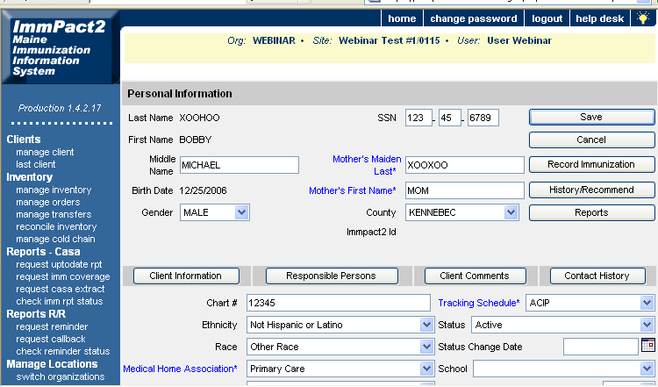

You will receive a warning at the top of the screen that states “At least one Responsible Person is required.” The next step is to fill out information on the client’s Responsible Person. If the client is a minor this should be a legal guardian or someone who has the ability to make decisions for the client.

Click on the Responsible Persons button.

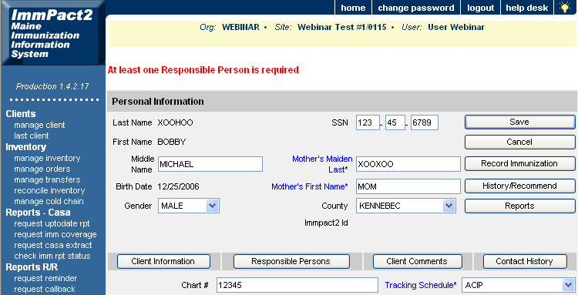

You will search for the responsible person following the same steps as searching for a client – by entering the first 3 letters of the last name and the first 3 letters of the first name. If the responsible person you are looking for does not show on the possible matches list given you can broaden or lessen your search 1 letter at a time by either decreasing or increasing the number of letters in the First Name field.

This first example will show you how to search and add an already existing responsible person to your client. This would be useful for multiple children with the same guardian. We will search for a responsible person named Shawn Box.

Enter the first 3 letters of the last name in the text box next to Last Name.

Enter the first 3 letters of the first name in the text box next to First Name.

Click the Find button.

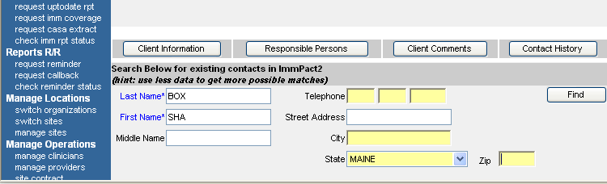

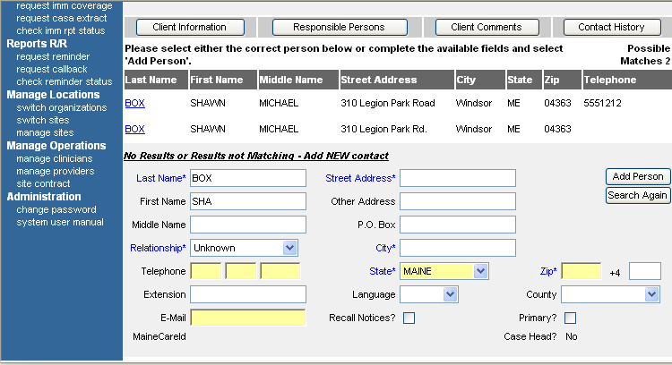

As you can see, 2 Possible Matches have been made for this search.

If your search was successful and you have found the correct responsible person from the list provided you can click on the Last Name blue hyperlink of that person.

In our example, we were searching for Shawn Box and found 2 possible matches. We would confirm the address and phone number is correct and click on the blue highlighted last name Box.

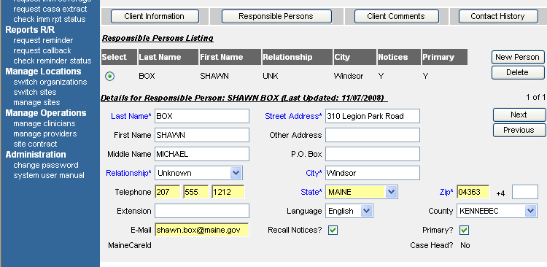
1
2
3
4
5
6

By clicking on the highlighted blue last name, the responsible person has now been selected for this client.

- Confirm all demographic information for this responsible person including, Name, Address, and Phone Number.

- Relationship: Choose the correct Relationship between this responsible person and the client.

- Language: Choose the Primary Language spoken by the responsible person.

- County: Choose the County the responsible person resides in.

- Recall Notices: Select this box if you would like to send Reminder Recall Notices to this responsible person.

- Primary: Select this box if this responsible person is the Primary Responsible Person for this client.

Once all information has been verified, click on the Save button.

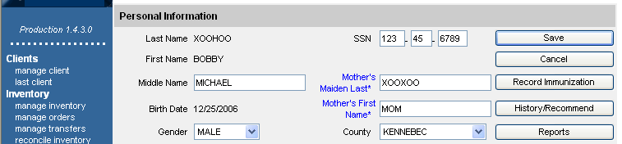

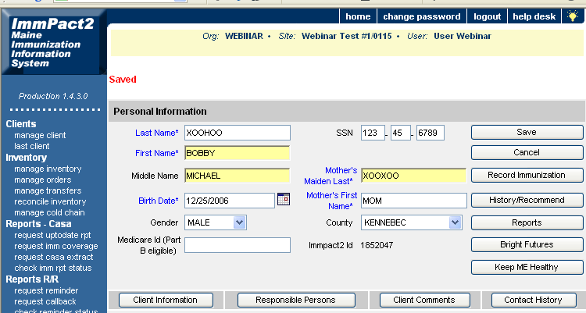

You can see by the red message Saved that your client information has been saved into ImmPact2. You are now able to Record Immunizations for this client or view History/Recommend.

If your search for a responsible person was unsuccessful and there were no matches found you will need to follow the steps below to add a new responsible person.

In this next example we will search for a Responsible Person named Abraham Lincoln who is currently NOT within the ImmPact2 system and will be added as a new Responsible Person.

Again, we will begin by searching by the first 3 letters of the last name and first 3 letters of the first name following our standard search criteria.

Enter the first 3 letters of the last name in the text box next to Last Name.

Enter the first 3 letters of the first name in the text box next to First Name.

Click the Find button.

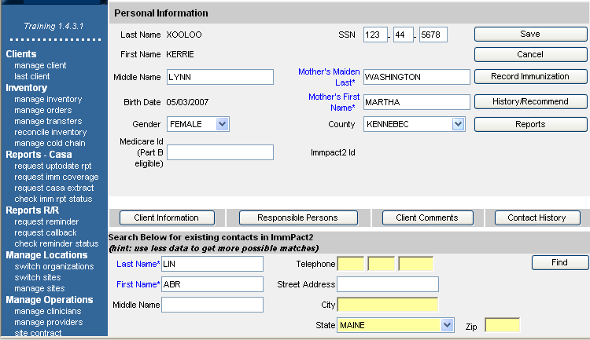

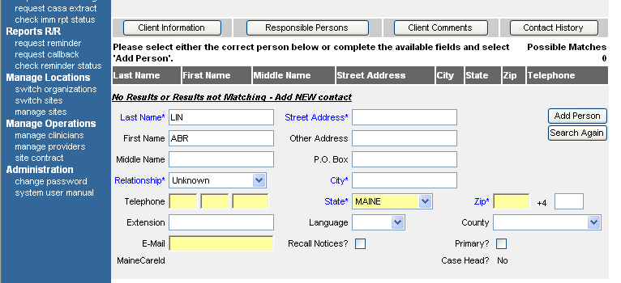

As you can see, ImmPact2 was unable to find a match for our search criteria. This is indicated by the message “No Results or Results not Matching - Add NEW contact” and by the Possible Matches 0. Now we will enter responsible person information.

Note: If you are sure that the responsible person is in the system you can decrease the number of letters used in the search 1 letter at a time until you have exhausted the recommended search criteria. You would do this by clicking the Search Again button before beginning another search. This will bring you back to the original search responsible person page.

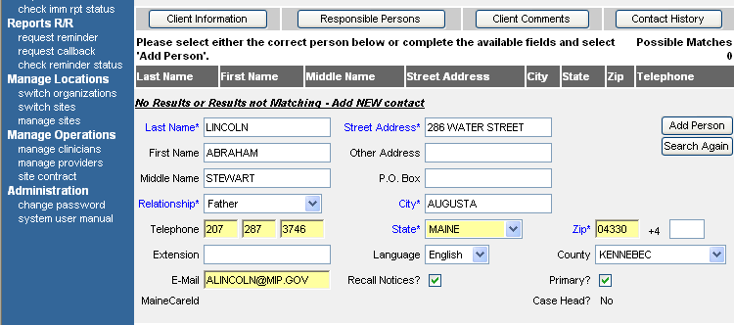
1
2
3
4
5
6

To enter information for a new responsible person contact:

- Enter all demographic information for this responsible person including, Full Last Name, Full First Name, Middle Name, Telephone, E-Mail, and Address.

- Relationship: Choose the correct Relationship between this responsible person and the client.

- Language: Choose the Primary Language spoken by the responsible person.

- County: Choose the County the responsible person resides in.

- Recall Notices: Select this box if you would like to send Reminder Recall Notices to this responsible person.

- Primary: Select this box if this responsible person is the Primary Responsible Person for this client.

Once all information has been entered and verified for the Responsible Person,

Click the Save button.

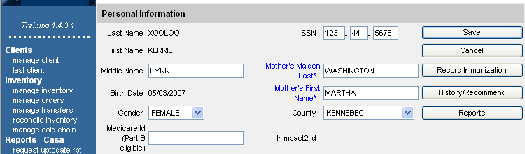

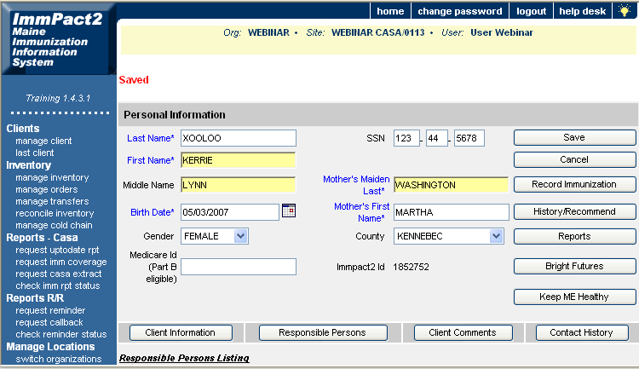

You can see by the red message Saved that your client information has been saved into ImmPact2. You are now able to Record Immunizations for this client or view History/Recommend.

