

Entering Historical Doses

## ImmPact

Maine’s Immunization Information System

Maine Immunization Program

286 Water Street. 9th floor

Augusta, Maine 04333

ImmPact Support Desk: 1-800 906-8754

Fax: 207-287-8127

ImmPact Support Email: [immpact.support@maine.gov](mailto:immpact.support@maine.gov)

TTY Users call Maine Relay 711

Log-in at [https://portal.maine.gov/wir](https://portal.maine.gov/wir/security_ui.showLogin)

Enter:

1. Organization Code
2. Username
3. Password
4. 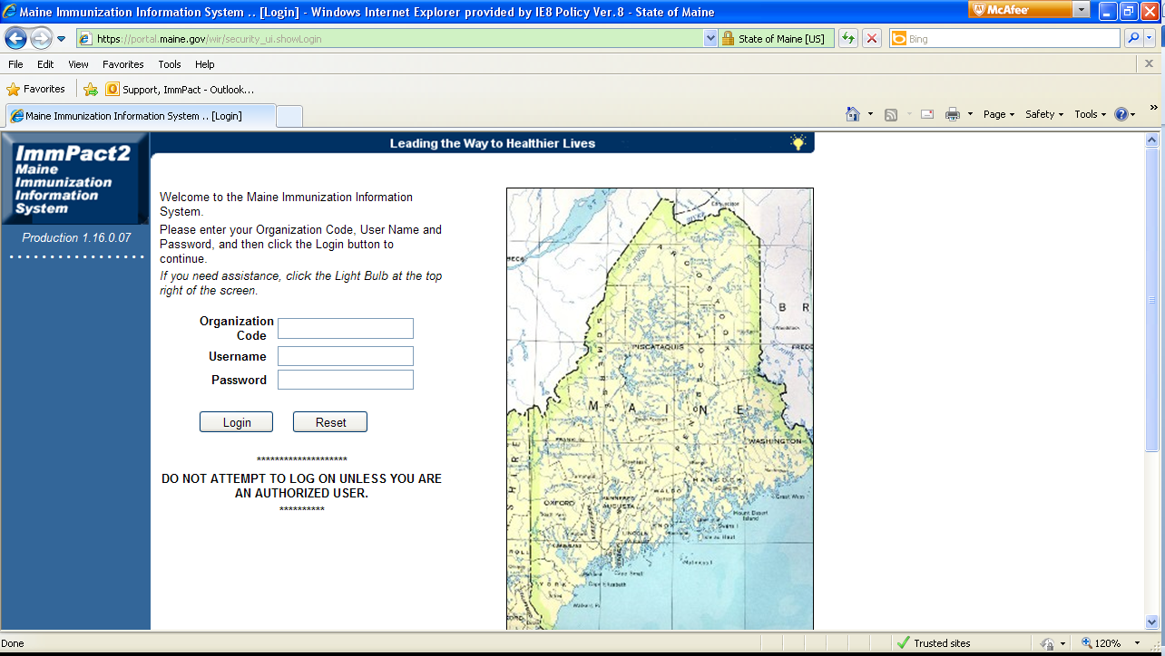Click Login

**3.**

**2.**

**1.**

1. Read all required announcements marked with the red triangle Warn! as well as any other announcements that may pertain to your site

**4.**

1. 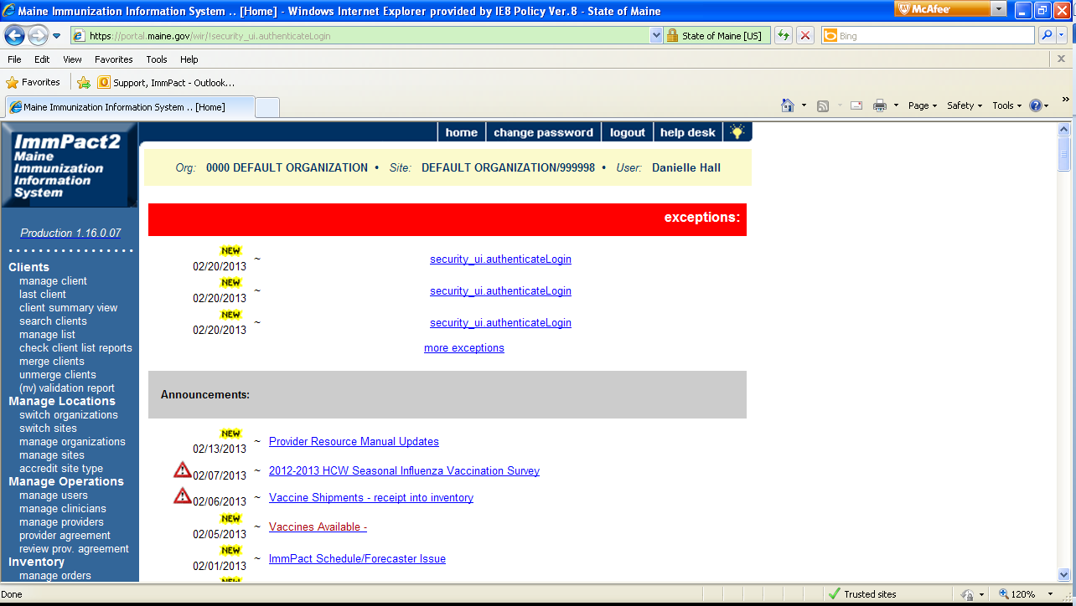Click manage client under the Clients heading

**5.**

**6.**

1. Enter the first three letters of the client’s last name that is being searched
2. Enter the first three letters of the client’s first name that is being searched
3. Click Find
4. Select appropriate client record by clicking the blue link

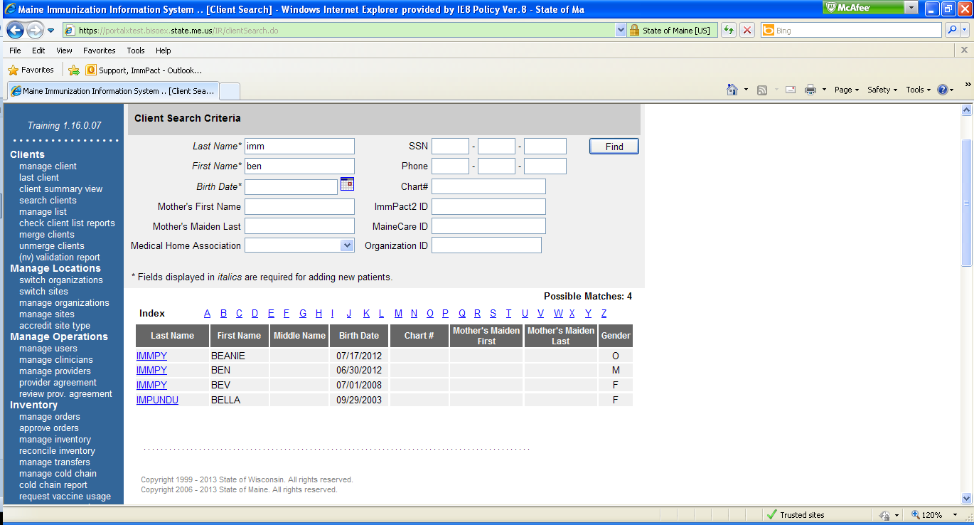* If the client is in the system and there are no similar matches to the search ImmPact will go directly to the client record

**8.**

**9.**

**7.**

1. Ensure that it is the correct client record with the correct information in the Personal Information section. All fields in blue and with an * are required

**10.**

1. Click Save once all the information has been verified
2. 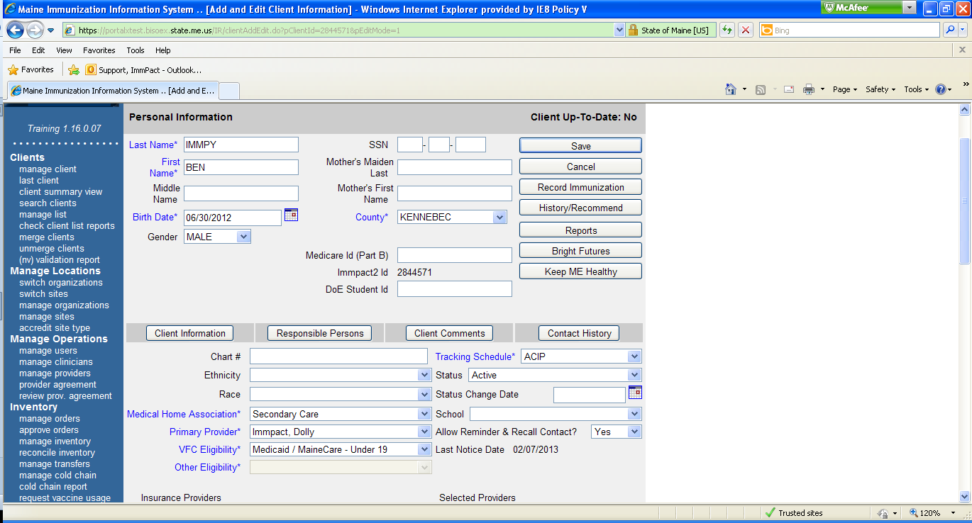 Click History/Recommend

**13.**

**12.**

**11.**

1. 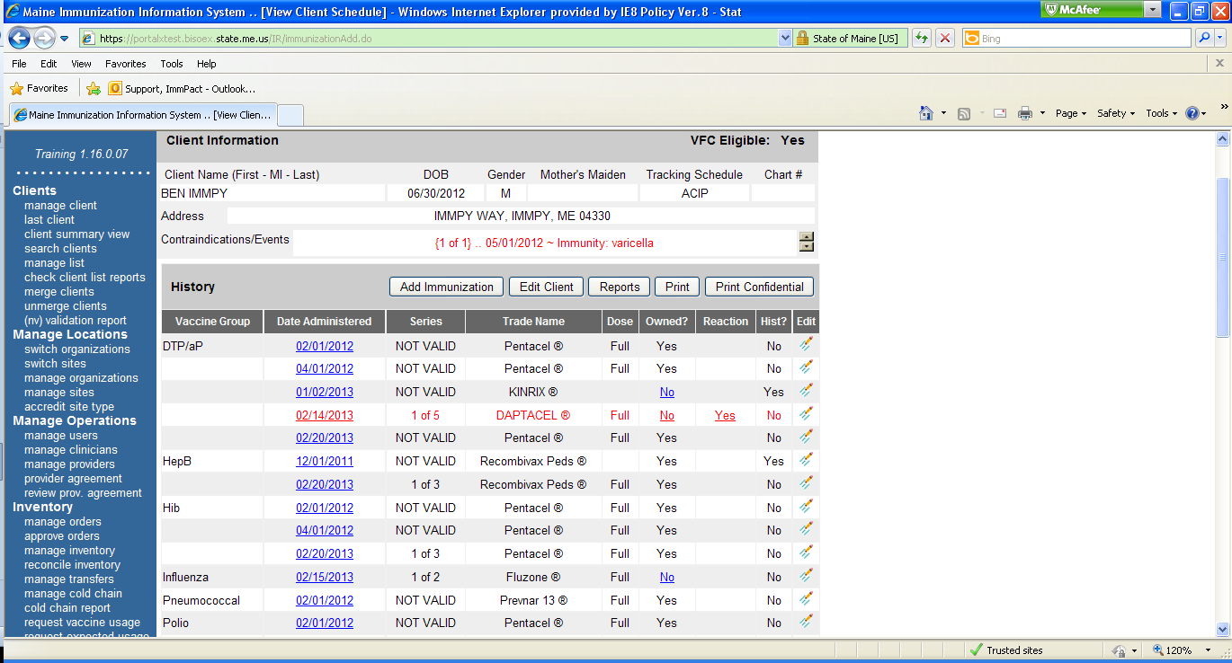Check the client history to ensure that the data that you are about to enter has not already been done
2. Click Add Immunization

**15.**

**14.**

1. Scroll to Record/Display Immunization History section and in the vaccine column locate the vaccine that will be entered
2. Locate the appropriate vaccine row
3. If the dose was administered outside your site, enter where the immunization was administered (if known) in the Transcribed from Official Records column

*This column is for entering information of where the dose was given, type of record the information came from etc. Without the information the system will consider the dose as given at your site

1. The Default Dates section can be used when there are multiple vaccines to enter

*Enter the immunization date into the Default Dates box then in each appropriate vaccine row below, double click in the date box to insert the date

1. To record only one immunization use the appropriate row and column and select the calendar and the date of the immunization.
2. If the vaccine that is needed is not listed, open the drop down menu in the last row and select the appropriate vaccine

**22.**

**21.**

**20.**

**19.**

**18.**

**17.**

**16.**

1. 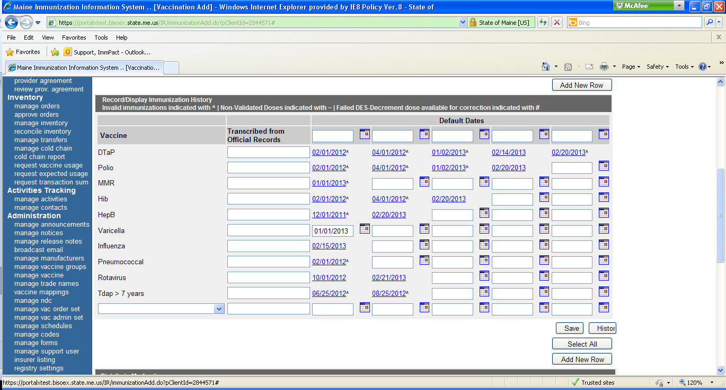Click Save
2. 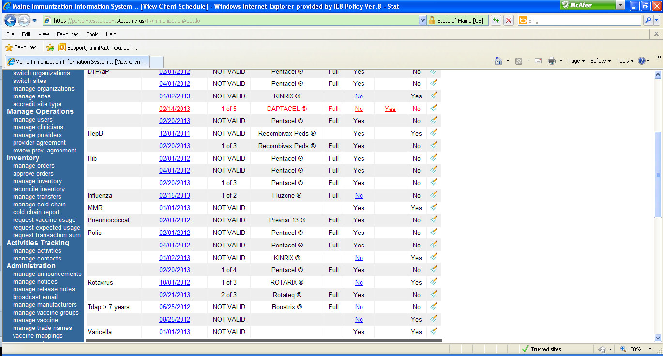Ensure that the immunization is displayed on the history/recommend with the correct date

**23.**