Maine’s Lifetime of Good Health
These are the shots your teen needs – Immunize as soon as possible!
Age | Vaccine
Ages 11 – 18 | Tdap (Tetanus, Diphtheria and Pertussis)  Protects against tetanus, serious breathing problems, and whooping cough
Ages 11 – 18 | HPV (Human Papillomavirus)  Protects against cervical cancer
Ages 11 – 18 | Heb A (Hepatitis A)  Protects against hepatitis A, a liver disease
Ages 11 – 18 | MCV4 (Meningococcal)  Protects against meningitis
Ages 11 – 18 | HepB (Hepatitis B)  Protects against hepatitis B, a liver disease
Ages 11 – 18 | Influenza (Flu)  Protects against serious respiratory disease.

- This is a routine schedule. Some teens may need additional shots.
- Please speak with your health care provider to see if your teen needs
additional shots.
- Influenza recommendations change frequently; please contact your healthcare provider to see if your teen needs influenza vaccine.

For more information please contact the Maine Immunization Program at 1- 800- 867- 4775
TYY line 711

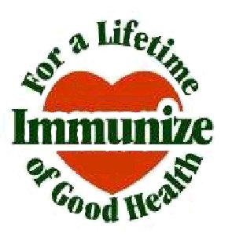 | Maine’s Immunization Schedule is compatible with the current recommendations of the Advisory Committee on Immunization Practices (ACIP)  of the Centers for Disease Control and Prevention (CDC), the American Academy of Pediatrics (AAP), and the American Academy of Family Physicians (AAFP).  Rev: 02/07/2013

