State of Maine

2009 HIV/AIDS
Epidemiologic Profile
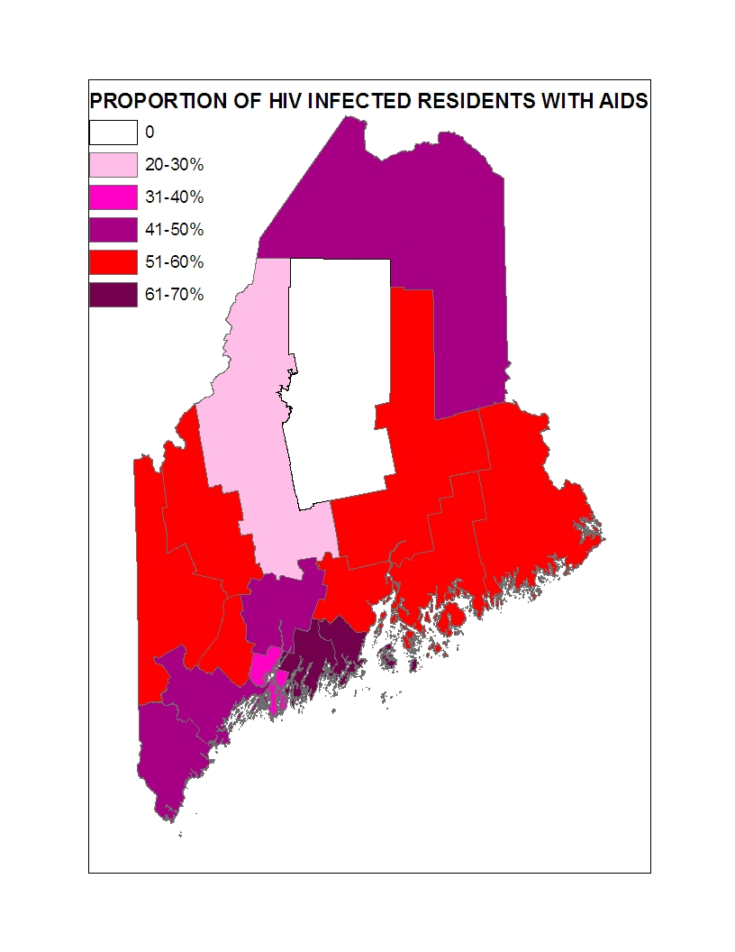
Maine Department of Health and Human Services (DHHS)
Maine Center for Disease Control and Prevention (Maine CDC)
Division of Infectious Disease
HIV, STD and Viral Hepatitis Program
(207) 287-3747

BLANK
SPACE

Cover Page: Proportion of Prevalent HIV Cases Diagnosed with AIDS by Current County of Residence-2008

Contact Resource
HIV/STD Epidemiologist
Maine CDC
HIV, STD and Viral Hepatitis Program
State House Station 11
286 Water Street, 9th Floor
Augusta, ME 04333
Telephone (207) 287-5193
Fax: (207) 287 3498
Email: robert.funa@maine.gov
Table of Contents
Introduction………………………………………………………………………....1
1.Sociodemographic Characteristics of the General Population….. 3
1.1 Geographic… 3
1.2 Demographic…………………………………………………………………… 4
1.2.1 Age and Sex 4
1.2.2 Race and Ethnicity 5
1.3 Socioeconomic Status 6
1.3.1 Poverty 6
1.3.2 Educational Attainment 7
1.3.3 Health Insurance Coverage 8
1.4 Key Points 9

2. Scope of the Epidemic in Maine… 10
2.1 Data Sources and limitations… 10
2.2 Newly Diagnosed HIV Infections… 10
2.3 Newly Diagnosed AIDS Cases…. 11
2.4 Increasing AIDS Prevalence… 12
2.5 HIV/AIDS Deaths in Maine
2.6 Causes of Death among HIV/AIDS Cases in Maine 15
2.7 Ranking HIV/AIDS Mortality 16
2.8 Demographic Characteristics of People Living with HIV/AIDS 17
2.8.1 Sex 17
2.8.2 Age 18
2.8.3 Race and Ethnicity 20
2.8.4 Exposure Category 22
2.9 County and Regional Data 25
2.9.1 Northern Maine 40
2.9.2 Central Maine 42
2.9.3 Southern Maine 44
2.10 Key Points 47

3. Indicators of Risk for HIV Infection 49
3.1 Indirect Measure of Risk: Maine CDC STD Data 49
3.1.1 Chlamydia 49
3.1.2 Gonorrhea 52
3.1.3 Syphilis 56
3.2 Key Points about STD Data 57
3.3 Direct Measures of Risk: Maine Studies 58
3.3.1 2003 CPG Needs Assessment 58
3.3.2 IDU Needs Assessment (2003) 59
3.3.3 CPG Needs Assessment-IDU (2008) 59
3.3.4 CPG Needs Assessment-MSM 60
3.3.5 MSM Behavioral Surveillance 61
3.3.6 Youth Risk Behavior Survey 62

Conclusion 63

List of Tables

Table 1.1 Regions of Residence, Maine Population 4

Table 1.2 Maine DHHS Districts 4

Table 1.3 Distribution of the General Population in Maine 5
by Age Group and Sex, 2000

Table 1.4 Percentage Distribution of the Population in Maine, By Race/Ethnicity 5
for Each Sex, 2000

Table 1.5 Percentage Distribution of the Population in Maine, by Race/Ethnicity 6
and County Subpopulation, 2000

Table 1.6 Percentage of the Population Under the Poverty Level by County 7
(2005)

Table 1.7 Percentage of the Population 25 Years and Older, with High School 8
Diplomas or Higher or with Bachelor’s Degree or Higher, 2000

Table 1.8 Insurance Status in Maine and the US 8

Table 2.1 Causes of Death among HIV/AIDS cases in Maine 16

Table 2.2 Ranking of 10 Leading Causes of Death in Maine Among 16
Persons 25-44 Years of Age, 2001 to 2005

Table 2.3 2008 HIV Diagnoses and People Living with Diagnosed 17
HIV/AIDS in Maine, by Sex

Table 2.4 Age at HIV Diagnosis for 2008 HIV Diagnoses and for 18
People Living with Diagnosed HIV/AIDS in Maine

Table 2.5 Race and Ethnicity for 2008 HIV Diagnoses and for People 20
Living with Diagnosed HIV/AIDS in Maine

Table 2.6 Mode of Transmission for 2008 HIV Diagnoses and for 22
People Living with Diagnosed HIV/AIDS in Maine

Table 2.7 Mode of Transmission among Males for 2008 HIV Diagnoses 24
and for People Living with Diagnosed HIV/AIDS in Maine

Table 2.8 Mode of Transmission among Females for 2007 HIV Diagnoses 24
and for People Living with Diagnosed HIV/AIDS in Maine

Table 2.9 County of Residence for 2007 HIV Diagnoses in Maine 26

Table 2.10 Rate (per 100,000) of New HIV Infections in Maine Counties 26

Table 2.11 County of Residence for Prevalent HIV Cases in Maine ª 27

Table 2.12 DHHS Districts of Residence for 2008 HIV Diagnoses 27

Table 2.13 DHHS District of Residence for People Living with Diagnosed 28
HIV/AIDS in Maine

Table 2.14 Sex of 2008 HIV Diagnoses and People Living with Diagnosed 40
HIV/AIDS in Northern Maine

Table 2.15 Mode of Transmission for 2008 HIV Diagnoses and for People 41
Living with Diagnosed HIV/AIDS in Northern Maine

Table 2.16 Age Group at HIV Diagnosis for 2008 HIV Diagnoses and for 41
People Living with Diagnosed HIV/AIDS in Northern Maine

Table 2.17 Race and Ethnicity for 2008 HIV Diagnoses and for People 42
Living with Diagnosed HIV/AIDS in Maine in Northern Maine

Table 2.18 Sex of 2008 HIV Diagnoses and People Living with 42
Diagnosed HIV/AIDS in Central Maine

Table 2.19 Mode of Transmission for 2008 HIV Diagnoses and for People 43
Living with Diagnosed HIV/AIDS in Central Maine

Table 2.20 Age Group at HIV Diagnosis for 2008 HIV Diagnoses and for 43
People Living with Diagnosed HIV/AIDS in Central Maine

Table 2.21 Race and Ethnicity for 2008 HIV Diagnoses and for People 44
Living with Diagnosed HIV/AIDS in Central Maine

Table 2.22 Sex of 2008 HIV Diagnoses and People Living with 44
Diagnosed HIV/AIDS in Northern Maine

Table 2.23 Mode of Transmission for 2008 HIV Diagnoses and for People 45
Living with Diagnosed HIV/AIDS in Southern Maine

Table 2.24 Age Group for 2008 HIV Diagnoses and for People Living 45
with Diagnosed HIV/AIDS in Southern Maine

Table 2.25 Race and Ethnicity for 2008 HIV Diagnoses and for People 46
Living with Diagnosed HIV/AIDS in Southern Maine

Table 3.1 County of residence for 2007 Chlamydia Diagnoses 51

Table 3.2 County of residence for 2007 Gonorrhea Diagnoses 54
List of Figures

Figure 2.1 Maine HIV Diagnoses, 1987 to 2008 11

Figure 2.2 Maine AIDS Cases and Deaths among Persons 12
with AIDS, 1984 to 2008

Figure 2.3 Maine* AIDS Cases, Deaths† and AIDS Prevalence, 1984 to 2008 13

Figure 2.4 Proportion of Prevalent * HIV/AIDS Cases in Maine by Disease 14
Classification (HIV or AIDS), 2007-2008

Figure 2.5 Deaths among HIV and AIDS Cases in Maine, 1983-2008 15

Figure 2.6 Proportion of Females Diagnosed with HIV in Maine, 2004 to 2008 18

Figure 2.7 Age Group for Maine HIV Diagnoses, 2004 to 2008 19

Figure 2.8 Current Age Groups for Maine Residents Living with 20
HIV, 2008

Figure 2.9 Comparing Race/Ethnicity in the Total Maine Population 21
with People Living with Diagnosed HIV Infection

Figure 2.10 Proportion of HIV Diagnosis among People of 22
Color in Maine, 2004 to 2008

Figure 2.11 Selected Modes of Transmission for Maine HIV Diagnoses, 25
2004 to 2008

Figure 2.12 Region of Residence for People Living with Diagnosed 29
HIV/AIDS in Maine, 2008

Figure 2.13 Region of Residence for People Living with Diagnosis 30
HIV/AIDS in Maine, by Case Rate

Figure 2.14 County Prevalence Rates (per 10,000 population) for Males 31
in Maine Counties , 2008

Figure 2.15 County Prevalence Rates for Females in Maine Counties 31
in Maine Counties, 2008

Figure 2.16 Case Counts for Prevalent HIV Cases Aged 0-13 Years-Maine, 2008 32

Figure 2.17 County Prevalence Rates (per 10,000 population) for HIV Cases 32
Aged 0-13 Years in Maine, 2008

Figure 2.18 Case Counts for Living HIV Cases Aged 14-17 Years-Maine, 2008 33

Figure 2.19 County Prevalence Rates (per 10,000 population) for HIV Cases Aged 33
14-17 Years-Maine, 2008

Figure 2.20 Case Counts for Living HIV Cases Aged 18-24 Years-Maine, 2008 34

Figure 2.21 County Prevalence Rates (per 10,000 population) for HIV cases 34
Aged 18-24 Years-Maine, 2008

Figure 2.22 Case Counts for Living HIV Cases Aged 25-44 Years 35

Figure 2.23 County Prevalence Rates (per 10,000 population) for HIV 35
Cases Aged 25-44 Years-Maine, 2008

Figure 2.24 Case Counts for Living HIV Cases Aged 45-64 Years-Maine, 2008 36

Figure 2.25 County Prevalence Rates (per 10,000 population) for HIV Cases 36
Aged 45-64 Years-Maine, 2008

Figure 2.26 Case Counts for Living HIV Cases Aged 65 or Older-Maine, 2008 37

Figure 2.27 County Prevalence Rates (per 10,000 population) for HIV 37
Cases Aged 65 or Older

Figure 2.28 Case Counts for Living HIV MSM Cases-Maine, 2008 38

Figure 2.29 Case Counts for Living HIV Cases Classified as Exposed through 38
Heterosexual Contact with a Partner At-Risk for HIV-Maine, 2008

Figure 2.30 County Case Count Distribution for Living IDU infected with 39
HIV-Maine, 2008

Figure 2.31 County Case Distribution for the Proportion of HIV infected 39
Cases with AIDS

Figure 3.1 Maine Chlamydia Diagnoses, 1996 to 2008 50

Figure 3.2 2008 Chlamydia Diagnoses by Age Group 51

Figure 3.3 US and Maine Chlamydia Incidence among Persons 52
Aged 15-19 Years, 1996-2007

Figure 3.4 Maine Gonorrhea Diagnoses, 1996 to 2008 53

Figure 3.5 2008 Gonorrhea Diagnoses by Age Group 54

Figure 3.6 US and Maine Gonorrhea Incidence among Persons 55
Aged 15-19 Years, 1996-2007
Figure 3.7 Infectious Syphilis Diagnoses in Maine, 1984 to 2008 56

Introduction

This Epidemiologic Profile is designed to provide a comprehensive description and thorough understanding of populations in the State of Maine infected with Human Immunodeficiency Virus (HIV) or at risk of HIV infection. The profile was developed by Maine’s Department of Health and Human Services (DHHS), Maine Center for Disease Control and Prevention (Maine CDC) to assist Maine HIV prevention and care planners and others interested in HIV epidemiology. This profile was designed to serve as a planning tool to identify present and future needs and to set priorities for activities that help reduce HIV-related morbidity and mortality in Maine. The data selected in this profile are intended to provide a thorough description of the effect of HIV/AIDS on Maine’s population in terms of geographic, sociodemographic, and behavioral characteristics.

The goals of this profile, as suggested by the U.S. Centers for Disease Control and Prevention (CDC), are as follows:

- Provide a thorough description of the HIV/AIDS epidemic among the various populations (overall and subpopulations) in the State.
- Describe the current status of HIV/AIDS cases in the state and provide some understanding of the future outlook of the epidemic in Maine.
- Identify characteristics of the general population and of populations who are living with, or at high risk for, HIV/AIDS in defined geographic areas and who need primary and secondary prevention or care services.
- Provide information required to conduct needs assessments and gap analyses.

To meet these goals, the Epidemiological Profile will address three essential epidemiological questions:

1. What are the sociodemographic characteristics of the general population in Maine?
2. What is the scope of the HIV/AIDS epidemic in Maine?
3. What are the indicators of risk for HIV infection risk and AIDS in Maine’s population?

The occurrence of sexually transmitted diseases (STDs) and populations at-risk for STDs will also be described in this profile.

This document primarily relies on disease data reported to Maine CDC by health care providers and laboratories in accordance with Maine’s Rules for the Reporting of Notifiable Conditions. It must be noted that Maine’s disease reporting laws, and these Rules, were modified in 2008, and as a result, more surveillance data are being collected; the expansion of surveillance data to include HIV Infection, HIV viral load test results and CD4⁺ counts may affect trend data. The document also considers local and national research concerning HIV risk behaviors and seroprevalence as well as U.S. Census data.

This document was first published in 2005, with annual updates in 2006, 2007, 2008 and this year, 2009. Achieved Profiles are available upon request. The 2009 annual update includes updated data through December 31st, 2008.

A companion document, “Addendum: Ryan White Treatment Modernization Act Data” that includes data from the Ryan White Part B program is available through the Health Resources and Services Administration website: http://hab.hrsa.gov/reports/data2a.htm. These data posted examine care service utilization patterns among selected people living with diagnosed HIV/AIDS, as well as the characteristics of persons living with HIV who are not receiving specifically defined primary medical care. This addendum is also available upon request by contacting the HIV, STD and Viral Hepatitis Program at (207) 287-5193.

What are the sociodemographic
characteristics of the general
population in Maine?

Question 1

Examining the general characteristics of Maine’s population provides an important broader context for understanding Maine’s HIV epidemic at the local level. This section will consider the geographic, demographic, and socioeconomic data available that describe Maine’s population. Understanding the geographic distribution of Maine’s residents, as well as their demographic and economic characteristics, helps to identify risk factors associated with HIV infection that may impact the delivery of HIV-related services.

1.1 Geographics

With a land area of 30,862 square miles and population estimate of about 1,274,923, Maine is a geographically large and sparsely populated state. According to the 2000 U.S. Census, approximately 55% of Maine’s residents live in rural communities, compared to 25% of the U.S. population as a whole. The major cities, towns and rural communities in Maine are linked by an extensive network of well maintained roadways that facilitate access to most rural and urban locations in the state. There are 41.3 persons per square mile in the state versus 79.6 persons per square mile for the nation as a whole. Approximately one third of the population lives in one of three large population areas, known as “metropolitan statistical areas” or MSAs. MSAs are located in the Portland, Lewiston, and Bangor areas, with Portland as the largest MSA (222,000 persons). Vast areas of western, northern, and downeast Maine are sparsely populated and access to medical services from many areas can be difficult because of the limited number of practicing healthcare workers and transportation challenges (long travel distances to healthcare facilities).

In 2008, the U.S. Census Bureau estimated that Maine’s total population was 1,316,456. The percent change in population from April 1, 2000 to July 1, 2008 is estimated to be an increase of 3.3%. This is well below the estimated percent change in population for the nation as a whole for the same time period (an increase of 8.0%). Maine experienced a 3.8% increase in population from the 1990 Census to the 2000 Census. This is just under one-third the population growth experienced nationally (13.1%). Population changes observed in Maine indicate that northern and downeast counties (except Penobscot county) experienced population decline between 1990 and 2005.

Because the Epidemiological Profile is used for many different purposes, geographic data are presented in three ways: county, region of residence, and Maine Department of Health and Human Services (DHHS) District.

Regions of residence are broad geographic categories that include multiple counties and center around one of the three MSA mentioned above. There are three definable regions – Northern, Central, and Southern. Table 1.1 shows the counties that comprise each region and the region’s population.

Table 1.1 Regions of Residence, Maine Population
Region of residence | Counties | Population (2000 US Census)
Northern | Aroostook, Hancock, Penobscot, Piscataquis, Washington | 321,824
Central | Androscoggin, Franklin, Kennebec, Knox, Lincoln, Oxford, Sagadahoc, Somerset, Waldo | 500,745
Southern | Cumberland, York | 452,354

There are eight DHHS Districts based on county boundaries, with some districts comprised of single counties and others including multiple counties. These districts were created by DHHS in 2007 as part of an effort to establish a coordinated, regionally-based public health system in Maine. The eight districts, and their corresponding populations, are listed below in Table 1.2.

Table 1.2 Maine DHHS Districts
DHHS District | Counties | Population (2000 US Census)
1: York | York | 186,742
2: Cumberland | Cumberland | 265,612
3: Western Maine | Androscoggin, Oxford and Franklin | 188,015
4: Mid Coast | Lincoln, Knox, Waldo and Sagadahoc | 144,728
5: Central Maine | Somerset and Kennebec | 168,002
6: Penquis | Piscataquis and Penobscot | 162,154
7: Downeast | Washington and Hancock | 85,732
8: Aroostook | Aroostook | 73,938
Source: US Census Bureau. State and County Quick facts http://quickfacts.census.gov/qfd/States/23/23031.html

1.2 Demographics
1.2.1 Age and Sex

Table 1.3 shows the distribution of Maine’s population by age breakdown and sex based on the most recent (2000) census data available. The median age in years for Maine residents was 38.6. For males and females, nearly one-third were under 25 years of age, close to 30% were 25-44 years old, and male and female individuals over 65 years of age account for just over 14% of the total population. Fifty one percent (51%) of Maine’s population are female. The proportion of Mainers less than 45 years of age is higher in metropolitan areas than in non metropolitan areas. The opposite is true for those aged 45+ years.

Table 1.3 Distribution of the General Population in Maine, by Age Group and Sex, 2000
Age Group (yrs) | Males, % |  | Females, % |  | Total, %
Age Group (yrs) | n = 620,309 |  | n = 654,614 |  | N = 1,274,923
<5 | 5.8 |  | 5.2 |  | 5.5
5-14 | 14.5 |  | 13.0 |  | 13.8
15-24 | 13.0 |  | 12.0 |  | 12.5
25-44 | 29.2 |  | 29.0 |  | 29.1
45-64 | 25.2 |  | 24.4 |  | 24.8
≥65 | 12.3 |  | 16.4 |  | 14.3
Source: US Census 2000 Summary File 1, http://factfinder.gov

1.2.2 Race and Ethnicity

The proportion of non-White and/or Hispanic residents in Maine is small-less than 4% in total as compared to almost 18% for the nation as a whole. Table 1.4 shows the percent distribution of the population by race/ethnicity and sex according to the 2000 Census. The greatest proportion of the population consists of Whites (about 97%). Other races alone account for less than 1% per race category. Persons reporting two or more races account for 1% of the total population. People reporting Hispanic ethnicity in Maine make up 0.7% of the entire population.

Table 1.4 Percentage Distribution of the Population in Maine, By Race/Ethnicity for Each Sex, 2000
Race | Males, % |  | Females, % |  | Total, %
Race | n = 620,309 |  | n = 654,614 |  | N = 1,274,923
White | 96.9 |  | 97.0 |  | 96.9
Black or African American | 0.6 |  | 0.4 |  | 0.5
American Indian or Alaskan Native | 0.6 |  | 0.6 |  | 0.6
Asian | 0.6 |  | 0.8 |  | 0.7
Native Hawaiian/other Pacific Islander | <0.1 |  | <0.1 |  | <0.1
Some other race | 0.2 |  | 0.2 |  | 0.2
≥ 2 races | 1.0 |  | 1.0 |  | 1.0

Ethnicity
Hispanic | 0.8 |  | 0.7 |  | 0.7
Not Hispanic | 99.2 |  | 99.3 |  | 99.3
Source: US Census 2000 Summary File 1, http://factfinder.gov

While there is geographic variability in the proportion of the minority population in Maine’s cities and counties, there are few identifiable areas where such populations are highly concentrated. Table 1.5 shows the two counties in Maine, Washington and Cumberland Counties, that have White populations that are slightly below the statewide average of 96.9%. In the northern region, Washington County has an American Indian/Alaskan Native population of 4.4%, the highest in the state. Of interest is that among American Indians in Maine, fewer than 30% live on the reservations in the state’s five tribes. As seen in Table 1.5, Cumberland County, the largest (population and land size) county in Maine’s southern region, has a more diverse racial population than any other Maine county. The White, non-Hispanic population in this county still greatly exceeds other race categories, however. No counties in the Central region of Maine have racial populations that differ significantly from the state’s racial distribution as a whole.

Table 1.5 Percentage Distribution of the Population in Maine, by Race/Ethnicity and County Subpopulation, 2000
Race | Washington County |  | Cumberland County | State of Maine
Race | n = 33,941 |  | n = 265,612 | n = 1,274,923
White | 93.2 |  | 95.2 | 96.9
Black or African American | 0.3 |  | 1.1 | 0.5
American Indian or Alaskan Native | 4.4 |  | 0.3 | 0.6
Asian | 0.3 |  | 1.4 | 0.7
Native Hawaiian/Other Pacific Islander | <0.1 |  | <.1 | <0.1
Some other race | 0.4 |  | 0.3 | 0.2
≥ 2 races | 1.1 |  | 1.1 | 1.0

Ethnicity
Hispanic | 0.8 |  | 1.0 | 0.7
Not Hispanic | 99.2 |  | 99.0 | 99.3
Source: US Census 2000 Summary File 1, http://factfinder.gov

The 2000 Census figures show that foreign-born persons account for 2.9% of Maine’s population (11.1% of the US population as a whole are foreign-born). In 2007, 3.4% of Maine residents were foreign born according to the U.S. Census Bureau. This percentage increased from 3.0% in 2005. The Immigrant Legal Advocacy Project based in Portland estimates that Maine’s foreign born population is currently 4.0 - 4.8% of the entire population in Maine. Cultural and language issues are critical for this population. Nearly 8% of Maine residents over five years of age report speaking a language other than English in the home (this figure is 11.1% for the nation as a whole). Maine has a relatively high proportion of Franco-Americans living in the state. Data from the 2001 US Census Supplementary Survey indicate that French and French-Canadian ancestry represents 21% of all ancestries reported by Maine residents, compared to 4% for the nation as a whole (US Census 2000). Some cities (Biddeford and Lewiston, among others) and areas of northern Maine have significantly greater proportions of Franco-American residents. Issues related to culture, socioeconomic status, and religion among Franco-Americans may influence public health prevention strategies.

1.3 Socioeconomic Status
1.3.1 Poverty

As of 2006, 12.9% of individual Maine residents were living below the federal poverty level of $10,294 (U.S.: 13.3%). At the same time, median household income in Maine ($ 43,439) fell below the reported U.S. median household income ($48,451). Per capital income for Maine residents in 2006 was also below the U.S. amount ($23,226 vs. $25,267). Slightly less than 9% of Maine’s families were living below the federal poverty level in 2006, which is less than the U.S. as a whole (9.8%).

Table 1.6 Percentage of the Population Under the federal Poverty Level by County (2005)
County Under poverty level, %
Washington 19.1
Somerset 16.9
Franklin 16.9
Aroostook 16.6
Waldo 16.6
Piscataquis 16.3
Oxford 14.6
Kennebec 13.0
Penobscot 12.8
State of Maine 12.3
Androscoggin 12.0
Knox 11.9
Lincoln 11.0
Hancock 10.4
Cumberland 10.0
York 9.9
Sagadahoc 9.0

Source: US. Census Bureau 2005 SAIPE: http://www.census.gov/hhes/www/saipe/county.html

Table 1.6 shows the percentage of individuals below the poverty level for Maine’s 16 counties. Nine of 16 counties in Maine had a higher proportion of residents living below the federal poverty level than the state proportion of 12.3%. Washington County had the highest proportion, with 19.1% of people living below the poverty level. Other counties with elevated proportions included Somerset, Franklin, Aroostook, Waldo, and Piscataquis, all in the northern and central regions of the state. The counties with the lowest proportion of residents living below the poverty level were Sagadahoc, Cumberland, and York.

1.3.2 Educational Attainment

Table 1.7 considers the percent of Mainers 25 years of age and older with a high school diploma or higher or bachelor’s degree or higher. As with poverty levels, educational attainment tended to be lower in the northern and central regions of the state. Counties with the lowest proportions of high school graduates included Aroostook, Androscoggin, Washington, Piscataquis and Somerset. Those with the highest proportion of graduates included Cumberland and Sagadahoc. In general, those counties with lower proportions of high school graduates also had lower rates of bachelor degree attainment.

Table 1.7 Percentage of the Population 25 Years and Older, with High School Diplomas or Higher or with Bachelor’s Degree or Higher, 2000
High school diploma Bachelor’s degree
County or higher, % or higher, %
Aroostook 76.9 14.6
Androscoggin 79.8 14.4
Washington 79.9 14.7
Piscataquis 80.3 13.3
Somerset 80.8 11.8
Oxford 82.4 15.7
Waldo 84.6 22.3
Franklin 85.2 20.9
Kennebec 85.2 20.7
State of Maine 85.4 22.9
Penobscot 85.7 20.3
York 86.5 22.9
Knox 87.5 26.2
Hancock 87.8 27.1
Lincoln 87.9 26.6
Sagadahoc 88.0 25.0
Cumberland 90.1 34.2

Source: 2000 model-based estimates, http://quickfacts.census.gov

1.3.3 Health Insurance Coverage

Health insurance coverage is an important indicator of access to preventive care and health services. Table 1.8 provides a breakdown of insurance status for Maine’s population as a whole as well as for adults aged 19 to 64. Comparisons with US insurance status figures are included.

Table 1.8 Insurance Status in Maine and the U.S.
Insurance Status | Maine  All age groups, % |  | US  All age groups, % |  | Maine  Adults 19-64, % |  | US  Adults19-64, %
Insurance Status | N = 1,272,010 |  | N = 287,368,410 |  | n = 779,590 |  | n = 175,111,560
Employer | 51 |  | 54 |  | 63 |  | 64
Individual | 5 |  | 5 |  | 6 |  | 6
Medicaid | 18 |  | 13 |  | 14 |  | 8
Medicare | 15 |  | 12 |  | 2 |  | 2
Uninsured | 11 |  | 16 |  | 15 |  | 20
Source: Urban Institute and Kaiser Commission on Medicaid and the Uninsured estimates based on pooled March 2003 and 2004 Current Population Surveys. Total US numbers are based on March 2004 estimates.

The percentage of uninsured individuals in Maine is less than the U.S. percentage for both the total population and for adults aged 19 to 64. For both groups, however, the number of individuals covered by Medicaid is significantly higher than the U.S. figure. The percentage of individuals aged 19 to 64 on Medicaid in Maine is close to twice the percentage for the U.S. as a whole.

1.4 Key Points

- Maine is a large, sparsely populated state, with more than half the population residing in rural communities. The most densely populated areas in Maine lie in either of the three Metropolitan Statistical Areas: Portland, Lewiston, and Bangor.

- Nearly one-third of Maine’s population is under 24 years-old and about 39% of Maine’s population is over 44 years-old.

- Maine’s population is predominantly White and non-Hispanic. The proportion of Hispanic and/or non-White residents in Maine is small – less than 4% in total as compared to almost 18% for the nation as a whole.

- Between 1990 and 2000, Maine’s population grew by only 3.8%, less than one-third the rate of national population growth. In 2008, Maine’s overall population was estimated to be 1,316,456.

- Per capita income for Maine residents in 2006 was below the US average ($23,226 vs. $25,265), but a smaller proportion of Maine families are living below the federal poverty level (8.7% vs. 9.8%).

- Counties in Northern and Central Maine tended to have lower proportions of high school and college graduates than Southern Maine counties. They also have a higher proportions of people living below the federal poverty level.

What is the scope of the HIV/AIDS
epidemic in Maine?

Question 2

This section of the Epidemiological Profile examines the extent and affect of the HIV/AIDS epidemic in Maine. The most recent and complete data available by calendar year, January 1st to December 31st, 2008, are presented, along with discussion about disease trends. The number, percentage distribution, and rates of new and existing HIV cases by age group, sex, exposure category, and race/ethnicity are examined. Regional data are also presented in this section.

2.1 Data Sources and Limitations

HIV infection and AIDS are both “notifiable conditions” in Maine, meaning that physicians, clinical laboratories, and all healthcare workers are required by law to report information about HIV and AIDS diagnoses using disease reports. Information included in these disease reports includes patient demographics such as age, sex, race, HIV risks, and region of residence. These data are used to help better understand the scope of the epidemic in Maine, and are crucial for planning, implementing and evaluating HIV-related care and prevention programs.

Although care is taken to ensure that disease reports are made in a timely and accurate manner, disease report data are not perfect. For example, public health data only include information about people who see health care providers; those who don’t seek care are not reflected in HIV/AIDS data. This includes individuals who are living with HIV infection or AIDS but don’t know about their infection because they have not been tested. In addition, public health data don’t always reflect recent changes in town, county or state of residence. Finally, there may be delays or lapses in reporting by physicians or laboratories.

Because of these limitations, it is important to remember that the public health data reported here represent estimates and may not be exact counts of people living with HIV infection and AIDS in Maine.

2.2 Newly Diagnosed HIV Infections

Since the Maine CDC began recording newly diagnosed HIV cases in 1987, more than 1,600 confirmed HIV positive test results have been reported to Maine CDC for purposes of epidemiologic investigation. Similar to national trends, the annual incidence of newly diagnosed HIV-positive cases in Maine has declined from more than 100 positive test reported annually in the late 1980s and early 1990s, to roughly half that number in recent years.

During 2008, 46 Maine residents were newly diagnosed with HIV infection. The 2008 rate of diagnosed HIV infections was 3.4 cases per 100,000 population in Maine.
Approximately 46% of newly diagnosed HIV cases in Maine in 2008 were ill enough to be classified as AIDS cases within one year of testing positive for HIV infection, probably indicating that they had been infected for a long while before diagnosis. Over the last 5 years the percentage annual HIV diagnoses that were classified as AIDS cases within one year of HIV diagnosis has increased from about 12% in 2004 to 46% in 2008 diagnoses. Figure 2.1 illustrates annual totals of new HIV diagnoses reported in Maine, spanning the years 1987 to 2008.

2.3 Newly Diagnosed AIDS Cases

In 2008, there were 37 new AIDS diagnoses reported to Maine CDC. Twenty-nine (78%) of these cases were male and 8 (22%) were female. By race/ethnicity, 89% were White and non-Hispanic (n=33), 8% were Black/African American and non-Hispanic (n=3), and 3% were of Hispanic ethnicity (n=1). Almost three quarters (73%) of 2008 AIDS diagnoses were aged 30-49 years at AIDS diagnosis.

Figure 2.2 illustrates Maine AIDS diagnoses and deaths among persons with AIDS, by year, from 1982 to 2008. The figure shows a general decline in both new diagnoses and deaths, with the numbers of deaths in recent years at their lowest point since the 1980s. In 2008 there were 24 deaths among Maine residents with HIV infection. This number includes HIV and AIDS cases diagnosed out-of-state and residing in Maine at time of death. Similar to new HIV diagnoses, the numbers of new AIDS diagnoses have remained steady during the last several years after experiencing peaks counts in the early 1990s. Overall declines in diagnoses and deaths among persons with AIDS are due, in large part, to widespread use of effective medical treatments and social management of HIV disease and AIDS.

2.4 Increasing AIDS Prevalence

Figure 2.3 shows three trend lines spanning the years 1984 to 2008. The trend data describe new Maine AIDS diagnoses by year of diagnosis, annual AIDS deaths, and the total number of people living with AIDS (AIDS prevalence).

Each year since 1985 there have been more new AIDS diagnoses than deaths in Maine, meaning that the overall number of people living with AIDS has continued to increase over time. These data suggest that there are more people living with HIV/AIDS in Maine than ever before. Of the over 1,200 AIDS diagnoses made among Maine residents since the start of the epidemic, an estimated 575 were living at the end of 2008. This tally does not include people who were diagnosed with AIDS in another state and subsequently relocated to Maine.

Data Note: Maine’s official AIDS prevalence counts only those diagnoses that are made among individuals who are resident in Maine at the time of diagnosis.
- In 2008 there were 709 individuals diagnosed with AIDS currently residing in Maine, irrespective of the state in which they were initially diagnosed as AIDS cases. Of these individuals, 84% (n=597) were male and 16% (n=112) were female. By race/ethnicity 86% (n=609) were White and non Hispanic, 8% (n=58) were Black/African American and non Hispanic, 5% (n=35) were of Hispanic ethnicity, and less than 1% were American Indian, Asian, or Multiracial.

* excludes AIDS cases diagnosed out-of-state
† excludes deaths among HIV only cases

Figure 2.4 below illustrates the distribution of prevalent HIV cases in Maine based on disease classification (HIV or AIDS). The proportion of prevalent cases who have been reported as diagnosed with AIDS can be affected by number of factors including: late HIV diagnoses, number of annual deaths, instate or out-of-state migration of infected individuals, and medical/social management of current HIV cases. Generally, about half of prevalent cases in Maine have been irreversibly diagnosed with AIDS.

* includes out-of-state HIV and AIDS cases that were residing in Maine in a given year.

2.5 HIV/AIDS Deaths in Maine

The total number of death among HIV/AIDS cases living in Maine at the time of death is shown in Figure 2.5 (including cases initially diagnosed out-of-state). Observations indicate a slight increase in the annual number of death since 2004. Figure 2.5 also shows an increase in number of deaths among cases that were only diagnosed with HIV (non AIDS) since 2004.Several potential reasons that may account for this increasing trend include: an increase in Maine’s HIV/AIDS prevalence, idiosyncrasies in disease progression or management, late HIV diagnosis, and an increase in non HIV causes of death.

Number

2.6 Causes of Death among HIV/AIDS Cases in Maine

Studies conducted in different parts of the nation show variation in the causes of death among AIDS cases after the introduction and use of Highly Active Anti-retroviral Therapy (HAART) in different populations. In general, observations show an increasing proportion of non AIDS related causes of death in the HAART era (recent years). Among Maine residents diagnosed with HIV/AIDS, the causes of death among 2007-2008 HIV/AIDS deaths are listed in the table 2.1. The majority of deaths were caused by malignancies not directly related to or caused by AIDS.

Table 2.1 Causes of Death Among HIV/AIDS Cases in Maine, 2007-2008
Cause of Death | Frequency (%)
Accidental Poisoning (prescribed drugs) | 2 (5)
HIV disease resulting in other infections (bacterial & viral) | 4(11)
HIV disease resulting in malignancy | 5(13)
Suicide (by self harm or self poisoning) | 2(5)
Cancers (Skin, Liver, Lung, Blood cells) | 8(21)
Others (Pneumonia, COPD, Immunodeficiency, Cardiomyopathy, Anemia, Hepatic failure) | 6 (16)
Accidents –Injured by motor vehicle | 1(3)
HIV disease resulting in unspecified conditions | 5(13)
Unspecified/Unknown | 5(13)
Total | 38 (100)

2.7 Ranking HIV/AIDS Mortality

During the period 2001-2005 (most up-to-date data), 2,380 deaths occurred among persons aged between 25 and 44 years in Maine. Of these, 25 deaths (1%) were directly attributable to HIV. Table 2.1 lists the top 10 causes of death in Maine for persons 25 to 44 years of age during 2001-2005. HIV was the ninth leading cause of death among this age group. There were only 2 (1%) HIV related death among 2008 deaths recorded in Maine.

Table 2.2 Ranking of 10 Leading Causes of Death in Maine Among Persons 25-44 Years of Age, 2001-2005
Cause of Death | Ranking | Deaths, #  (N = 2,380) | Total Deaths, %
Unintentional Injury | 1 | 713 | 30
Malignant Neoplasms | 2 | 422 | 18
Heart Disease | 3 | 322 | 14
Suicide | 4 | 270 | 11
Diabetes Mellitus | 5 | 61 | 3
Cerebrovascular diseases | 6 | 46 | 2
Chronic liver disease and cirrhosis | 7 | 42 | 2
Assault (homicide) | 8 | 38 | 2
HIV | 9 | 25 | 1
Influenza and Pneumonia | 10 | 24 | 1
Source: Maine CDC

2.8 Demographic Characteristics of People Living in Maine with Diagnosed HIV/AIDS

Tables in section 2.8 highlight age group, sex, exposure category, and race/ethnicity for people living in Maine with diagnosed HIV infection. In each table, data are presented for 2008 HIV diagnoses (assumed incident cases), and also for people living with diagnosed HIV/AIDS (prevalent cases). This second category includes all people living in Maine with diagnosed HIV/AIDS whose diagnoses were reported to Maine CDC; it does not include information about people with HIV who have not yet been tested or reported as HIV infected cases. In addition to these data, five-year trend data are presented - HIV incident cases from 2004 to 2008. The comparison of incident cases to prevalent cases allows for the assessment of trends.

2.8.1 Sex

Table 2.3 shows the sex of those diagnosed with HIV infection in 2008 and of all people living with diagnosed HIV/AIDS during the same year. Forty-six new HIV diagnoses were reported during 2008, including 7 women and 39 men. Fifteen percent (15%) of persons newly diagnosed last year were women, a slightly lower proportion than the 16% of prevalent cases.

Table 2.3 2008 HIV Diagnoses and People Living with Diagnosed HIV/AIDS, by Sex
 | 2008 HIV diagnoses |  |  | People living with diagnosed HIV/AIDSª
Sex | No. | % |  | No. | %
Male | 39 | 85 |  | 1,111 | 84
Female | 7 | 15 |  | 210 | 16
Male-to-female transgender / unknown | 0 | 0 |  | 2 | <1
Total | 46 | 100 |  | 1,323 | 100
ª Includes people living with AIDS or HIV diagnoses reported to Maine CDC as of 12/08.

In Figure 2.6, the proportion of females diagnosed with HIV from 2004 to 2008 is presented. The percentage of women diagnosed during this time period ranged from a high of 17% in 2005 to a low of 10% in 2007. During the 5-year period, an average 14% of HIV diagnoses in the State of Maine were among females, and 86% were among male residents.

2.8.2 Age

Table 2.4 shows the age group distribution of new HIV cases in 2008, as well as the age at HIV diagnosis for prevalent cases in 2008. Eighty-two percent (82%) of new diagnoses and 78% of all HIV diagnosis occurred in those 30 or more years of age at the time of HIV diagnosis. Fifteen percent (15%) of HIV diagnoses in 2008 were among persons in their twenties. Because about half of Maine’s annual HIV infections may have been infected for some time before being tested and diagnosed (late HIV diagnoses), it is likely that a large proportion of those who tested positive in this age category may have been infected when in their teenage years or early twenties. This emphasizes the need for continuing HIV prevention services for young people.

Table 2.4 Age at HIV Diagnosis for 2008 HIV Diagnoses and for People Living with Diagnosed HIV/AIDS in Maine
 | 2008 HIV diagnoses |  |  | People living with diagnosed HIV/AIDSª
Age at HIV Diagnosis | No. | % |  | No. | %
<13 | 0 | 0 |  | 10 | <1
13-19 | 1 | 2 |  | 22 | 2
20-29 | 7 | 15 |  | 266 | 20
30-39 | 11 | 24 |  | 458 | 35
40-49 | 15 | 32 |  | 357 | 27
>49 | 12 | 26 |  | 135 | 10
Unknown | 0 | 0 |  | 75 | 6
Total | 46 | 100 |  | 1,323 | 100
ª Includes people living with AIDS or HIV diagnoses reported to Maine CDC as of 12/08.

Figure 2.7 shows age group for new HIV diagnoses between 2004 and 2008. The number of new HIV diagnoses in each age groups have remained relatively stable over the last five years, with those between 30 and 49 years-old comprising a majority of new diagnoses each year. The percentage of new HIV diagnoses among those aged 50 years and older has shown a relatively steady though slight increase over the last 5 years.

Figure 2.8 shows the current age distribution of people living with HIV in Maine in 2008. About 1,323 people were reported to be living with a diagnosis of HIV in Maine. About 78% of Maine’s prevalent cases were aged 40 years or older in 2008.

2.8.3 Race and Ethnicity

In some sections of the Maine CDC HIV Epidemiologic Profile , race and ethnicity categories are presented separately so as to provide as much detail bearing in mind data quality and confidentiality standards. Table 2.5 illustrates that the majority of persons infected with HIV in Maine in 2008 were White by race, with this group comprising 91% of the diagnoses and 89% of all persons living with diagnosed HIV/AIDS. After Whites, Blacks/African Americans and American Indians are the next most represented races among people living with diagnosed HIV/AIDS. Blacks/African Americans comprised 9% of the 2008 diagnoses and of all people living with diagnosed HIV/AIDS. Individuals of Hispanic ethnicity comprised 2% of the 2008 diagnoses and 6% of all people living with diagnosed HIV/AIDS. Most (89%) Non-Hispanic individuals among people living with HIV infection belong to the White racial category.

Table 2.5 Race and Ethnicity for 2008 HIV Diagnoses and for People Living with Diagnosed HIV/AIDS in Maine

 | 2008 HIV diagnoses |  |  | People living with diagnosed HIV/AIDSª
Race | No. | % |  | No. | %
White | 42 | 91 |  | 1,173 | 89
Black or African American | 4 | 9 |  | 119 | 9
Asian | 0 | 0 |  | 3 | <1
American Indian/Alaskan Native | 0 | 0 |  | 9 | <1
Native Hawaiian or Other Pacific Islander | 0 | 0 |  | 0 | 0
More than one race | 0 | 0 |  | 1 | <1
Unknown | 0 | 0 |  | 18 | 1
Total | 46 | 100 |  | 1,323 | 100
Ethnicity
Hispanic | 1 | 2 |  | 71 | 6
Not Hispanic | 45 | 98 |  | 1,203 | 90
Unknown | 0 | 0 |  | 49 | 4
Total | 46 | 100 |  | 1,323 | 100
ª Includes people living with AIDS or HIV diagnoses reported to Maine CDC as of 12/08.

Figure 2.9 compares the overall state population by race and ethnicity (based on the 2008 U.S. Census estimates) with people living with diagnosed HIV/AIDS. Although racial and ethnic minorities make up less than 5% of Maine’s population, these minorities comprise 11% of Main residents living with diagnosed HIV/AIDS. This comparison demonstrates that minority populations in Maine, especially Black/African American and Hispanic populations, are disproportionately affected by HIV.

Figure 2.10 shows the racial and ethnic proportions of persons diagnosed with HIV in Maine between 2004 and 2008. Among racial and ethnic minorities in Maine, Blacks/African Americans represented the largest proportion, with 10% of diagnoses overall during the last five-year period. Another six percent of diagnoses were among Hispanics and less than one percent among Native Americans.

2.8.4 Exposure Category

In comparison to the general population, two key sub-populations are disproportionately affected by HIV in Maine. These include males who have unsafe sex with males (MSM) and injection drug users (non prescription drugs) who share works or needles (IDU). Heterosexual sex with an at-risk partner is also a significant mode of transmission (at-risk partners include partners who are infected with HIV, inject non prescription drugs, or are bisexual males (applies to females only)). Table 2.6 provides a breakdown of these and other exposure categories.

Table 2.6 Mode of Transmission for 2008 HIV Diagnoses and for People Living with Diagnosed HIV/AIDS in Maine
 | 2008 HIV diagnoses |  |  | People living with diagnosed HIV/AIDSª
Mode of Transmission | No. | % |  | No. | %
Males who have sex with males (MSM) | 28 | 61 |  | 771 | 58
Injection drug users (IDU) | 3 | 7 |  | 160 | 12
MSM/IDU | 0 | 0 |  | 47 | 4
Heterosexual contact with at-risk partners | 2 | 4 |  | 133 | 10
Heterosexual contact with no at-risk partners disclosed ^{b} | 13 | 28 |  | 187 | 14
Received contaminated blood products | 0 | 0 |  | 12 | 1
Child born to mother with HIV | 0 | 0 |  | 6 | <1
Undetermined transmission among pediatric cases | 0 | 0 |  | 7 | <1
Total | 46 | 100 |  | 1,323 | 100
ª Includes people living with AIDS or HIV diagnoses Maine CDC as of 12/08.
^{b} See information box below for detailed description.

In 2008, 61% (n=28) of HIV diagnoses were attributed to unprotected male-to-male sexual contact, followed by heterosexual transmission with no at-risk partners disclosed (28%-see information box below) and at-risk partners (6%). Three diagnoses were attributed to IDU. For people living with diagnosed HIV/AIDS, 58% (n=771) reported to having been infected through unprotected male to male sex, 12% (n=160) through injection drug use, and 4% (n=47) through a combined risk of male to male sex and injection drug use. Heterosexual sex with an at-risk partner comprised 10% of infections and heterosexual sex with no at risk partners disclosed accounted for 14% of all living HIV cases.

People infected through contaminated blood products and mother-to-infant transmissions represent a small number of individuals living with diagnosed HIV in Maine. Only six mother-to-infant transmissions have been reported since 1996, with some of the mother-to-child transmission accruing among foreign born cases. There has been no documented and reported instance of occupationally-acquired HIV infection in the State of Maine.

HIV Cases Reporting No Risk Factors

There are some behaviors that are more likely to put individuals at risk for HIV. When someone is diagnosed with HIV, it is public health practice to gather demographic information to better understand what behaviors are most likely to be associated with transmission. In Maine, Disease Intervention Specialists or healthcare providers gather this information through interviews with newly-diagnosed patients.

It is important to note that, in some instances, individuals may not report their true transmission risk because of fears about disclosure of culturally stigmatized behaviors or for some other reason. These behaviors may include injection drug use, male-to-male sex, or sexual contact with at-risk partners. Such nondisclosure of complete sexual behavior information may artificially inflate the heterosexual contact exposure categories; particularly for those cases when a heterosexual partner’s HIV risk status is reported as unknown.

Table 2.7 shows mode of transmission among males for 2008 HIV diagnoses and for all males living in Maine with diagnosed HIV/AIDS. Male-to-male sex is the most frequently reported mode of transmission among males, accounting for 71% of the new diagnoses made in 2008 and 73% of diagnoses among all males living with diagnosed HIV/AIDS (when combined with the MSM/IDU category). Other important HIV risk categories for males include injection drug use (IDU) and heterosexual sex (see above).

Table 2.7 Mode of Transmission among Males for 2008 HIV Diagnoses and for People Living with Diagnosed HIV/AIDS in Maine
 | 2008 HIV diagnoses |  |  | Males living with diagnosed HIV/AIDSª
Mode of Transmission | No. | % |  | No. | %
Males who have sex with males (MSM) | 28 | 71 |  | 772 | 70
Injection drug users (IDU) | 3 | 8 |  | 107 | 10
MSM/IDU | 0 | 0 |  | 47 | 4
Heterosexual contact with at-risk partners | 0 | 0 |  | 45 | 4
Heterosexual contact with no at-risk partners disclosed | 8 | 21 |  | 123 | 11
Received contaminated blood products | 0 | 0 |  | 11 | 1
Child born to mother with HIV | 0 | 0 |  | 3 | <1
Undetermined transmission among pediatric cases | 0 | 0 |  | 3 | <1
Total | 39 | 100 |  | 1,111 | 100
ª Includes people living with AIDS or HIV diagnoses reported to Maine CDC as of 12/08.

Table 2.8 shows mode of transmission among females for diagnoses made in 2008 and for all females living in Maine with diagnosed HIV/AIDS in 2008. The most often reported mode of HIV transmission for females was heterosexual sex. During 2008, 71% of female diagnoses were attributed to heterosexual sex with no at-risk partners identified. The rest (29%) were attributed to heterosexual contact with at-risk partners. Among women living in Maine with diagnosed HIV/AIDS, 41% (n=87) of diagnoses were attributed to sex with an at-risk male partner, 30% (n=63) to sex with a non-at risk male partner, and 25% (n=53) to injection drug use.

Table 2.8 Mode of Transmission among Females for 2008 HIV Diagnoses and for People Living with Diagnosed HIV/AIDS in Maine
 | 2007 HIV diagnoses |  |  | People living with diagnosed HIV/AIDSª
Mode of Transmission | No. | % |  | No. | %
Injection drug users (IDU) | 0 | 0 |  | 53 | 25
Heterosexual contact with at-risk partners | 2 | 29 |  | 87 | 41
Heterosexual contact with no at-risk partners disclosed | 5 | 71 |  | 63 | 30
Received contaminated blood products | 0 | 0 |  | 1 | 1
Child born to mother with HIV | 0 | 0 |  | 2 | 1
Undetermined transmission among pediatric cases | 0 | 0 |  | 4 | 2
Total | 7 | 100 |  | 210 | 100
ª Includes people living with AIDS or HIV diagnoses reported to Maine CDC as of 12/08

Figure 2.11 shows selected modes of transmission for HIV diagnoses in Maine from 2004 to 2008, including MSM, IDU and high-risk heterosexual contact. Rates for all three groups fluctuated in no predictable manner during the five-year period. Overall, 64% of new diagnoses were attributed to MSM, six percent (4%) to IDU and 9% to heterosexual contact with a partner at-risk for HIV infection.

2.9 County and Regional Data

The following section describes the impact of HIV diagnoses in Maine by county and region of residence, along with DHHS District.

In 2008, Cumberland county had the most diagnoses reported, with 16 (35%), followed by York (11), Androscoggin (7), and Kennebec (4)counties. Ten of the 16 Maine counties had residents who were newly diagnosed with HIV in 2008. Table 2.9 lists counties of residence for 2008 HIV diagnoses with counties listed in rank order by number of new diagnoses reported in that year while table 2.10 includes county rates for newly diagnosed HIV cases.

Table 2.9 County of Residence for 2008 HIV Diagnoses in Maine
County of Residence | No. | %
Cumberland | 16 | 35
York | 11 | 24
Androscoggin | 7 | 15
Kennebec | 4 | 9
Oxford | 3 | 7
Penobscot | 1 | 2
Lincoln | 1 | 2
Somerset | 1 | 2
Washington | 1 | 2
Franklin | 1 | 2
Hancock | 0 | 0
Aroostook | 0 | 0
Knox | 0 | 0
Waldo | 0 | 0
Piscataquis | 0 | 0
Sagadahoc | 0 | 0
Total | 46 | 100

Table 2.10 Rate (per 100,000) of New HIV Infections in Maine Counties, 2008
County of Residence | No. | % | Rate per 100,000 population
Androscoggin | 7 | 15 | 6.5
Cumberland | 16 | 35 | 5.8
York | 11 | 24 | 5.5
Oxford | 3 | 7 | 5.3
Maine | 46 | 100 | 3.4
Franklin | 1 | 2 | 3.3
Kennebec | 4 | 9 | 3.3
Washington | 1 | 2 | 3.1
Lincoln | 1 | 2 | 2.9
Somerset | 1 | 2 | 1.9
Penobscot | 1 | 2 | 0.7
Hancock | 0 | 0 | 0.0
Aroostook | 0 | 0 | 0.0
Knox | 0 | 0 | 0.0
Waldo | 0 | 0 | 0.0
Piscataquis | 0 | 0 | 0.0
Sagadahoc | 0 | 0 | 0.0

Table 2.11 shows county rates for people living with diagnosed HIV/AIDS in Maine. The table displays the number of persons along with the crude rate per 100,000 population. Counties are rank-ordered by rate, with the statewide rate included in the ranking.

Table 2.11 County of Residence for Prevalent HIV cases in Maine a
County of Residence | Rate per 100,000 | No. | %
CUMBERLAND | 165.2 | 456 | 34.5
ANDROSCOGGIN | 108.5 | 116 | 8.8
MAINE (STATE OF) | 100.5 | 1,323 | 100
YORK | 98.7 | 199 | 15
HANCOCK | 90.3 | 48 | 3.6
KENNEBEC | 90.1 | 109 | 8.2
KNOX | 66.4 | 27 | 2
WALDO | 65.2 | 25 | 1.9
WASHINGTON | 61.5 | 20 | 1.5
PENOBSCOT | 57.9 | 86 | 6.5
SAGADAHOC | 55.0 | 20 | 1.5
SOMERSET | 54.5 | 28 | 2.1
OXFORD | 49.3 | 28 | 2.1
AROOSTOOK | 41.9 | 30 | 2.3
LINCOLN | 40.4 | 14 | 1.1
FRANKLIN | 36.8 | 11 | 0.8
PISCATAQUIS | 17.7 | 3 | 0.2
UNKNOWN | NA | 103 | 7.8

ª Includes people living with AIDS or HIV diagnoses reported to ME CDC as of 12/08

Two counties, Androscoggin and Cumberland counties had rates that were higher than the statewide rate of 100.5 cases per 100,000 population.

The next two tables, 2.12 and 2.13, show the county data above segmented into DHHS Districts. Note that these tables present data in order by District number.

Table 2.12 DHHS District of Residence for 2008 HIV Diagnoses in Maine
DHHS District (corresponding counties in parentheses) | No. | %
1: York | 11 | 24
(York County) | 11 | 24
2: Cumberland | 16 | 35
(Cumberland County) | 16 | 35
3: Western Maine | 11 | 24
(Androscoggin, Oxford and Franklin Counties) | 11 | 24
4: Mid Coast | 1 | 2
(Lincoln, Knox, Waldo and Sagadahoc Counties) | 1 | 2
5: Central Maine | 5 | 10
(Somerset and Kennebec Counties) | 5 | 10
6: Penquis | 1 | 2
(Piscataquis and Penobscot Counties | 1 | 2
7: Downeast | 1 | 2
(Washington and Hancock Counties) | 1 | 2
8: Aroostook | 0 | 0
(Aroostook County) | 0 | 0
Total | 46 | 100

Table 2.13 DHHS District of Residence for People Living with Diagnosed
HIV/AIDS in Maine
DHHS District (corresponding counties in parentheses) | No. | % | Rate per 100,000 population
1: York  (York County) | 199 | 15 | 98.7
2: Cumberland  (Cumberland County) | 456 | 35 | 165.2
3: Western Maine  (Androscoggin, Oxford and Franklin Counties) | 155 | 11.7 | 80.1
4: Mid Coast  (Lincoln, Knox, Waldo and Sagadahoc Counties) | 86 | 6.5 | 57.3
5: Central Maine  (Somerset and Kennebec Counties) | 137 | 10.3 | 79.4
6: Penquis  (Piscataquis and Penobscot Counties) | 89 | 6.7 | 53.7
7: Downeast  (Washington and Hancock Counties) | 68 | 5.1 | 79.4
8: Aroostook  (Aroostook County) | 30 | 2.3 | 41.8
Total | 1,323† | 100 | 100.5
† = includes 103 cases with unknown current county of residence

The following maps in figures 2.12 to 2.31 show distribution (counts and/or rates) of prevalent HIV cases in Maine based on current age, county of residence (current), sex, HIV risk factor category and current HIV classification. Mapped prevalence rates may also be included.

In addition to counties and DHHS Districts, HIV distribution in Maine is often considered by region to assist health planners describe the geographic impact of HIV. These units are organized by county, as follows:
- Northern Region: Aroostook, Hancock, Penobscot, Piscataquis and Washington Counties (DHHS Districts 6, 7, and 8)
- Central Region: Androscoggin, Franklin, Kennebec, Knox, Lincoln, Oxford, Sagadahoc, Somerset and Waldo Counties (DHHS Districts 3, 4, and 5)
- Southern Region: Cumberland and York Counties (DHHS Districts 1 and 2).

The following maps show the distribution of people living with diagnosed HIV/AIDS in Maine by county and region. Figure 2.12 shows individual counties shaded according to case counts (the number of diagnosed cases). Figure 2.13 shows counties shaded by case rate (the number of cases per 100,000 population). Data for each map correspond to the case rates and case counts provided above in Table 2.11. In figures 2.12 and 2.13 regions of the state are divided by heavy blue lines, and selected cities and large towns are labeled (individual counties are not labeled because of space constraints).

Figure 2.12 Region of Residence for People Living with Diagnosed HIV/AIDS in Maine, 2008 (counties shaded by case counts)

Figure 2.13 Region of Residence for People Living with Diagnosed HIV/AIDS in Maine (counties shaded by case rate)

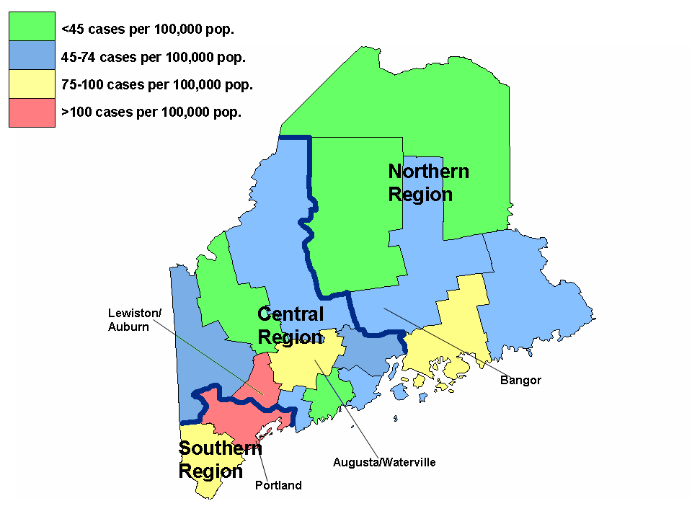

In both maps (Figure 2.11 and 2.12), Cumberland county in Southern Maine shows the greatest case count and case rate for prevalent HIV cases in Maine. In addition, the counties containing Maine’s largest cities and large towns tend to have higher than average case counts and rates. These include Androscoggin and Kennebec Counties in Central Maine and Penobscot County in Northern Maine.

The proceeding maps/figures in this section exclude county names or city location. Please refer to a State of Maine geopolitical map for county/city identification.
Figure 2.14 HIV Prevalence Rates among Males in Maine Counties, 2008 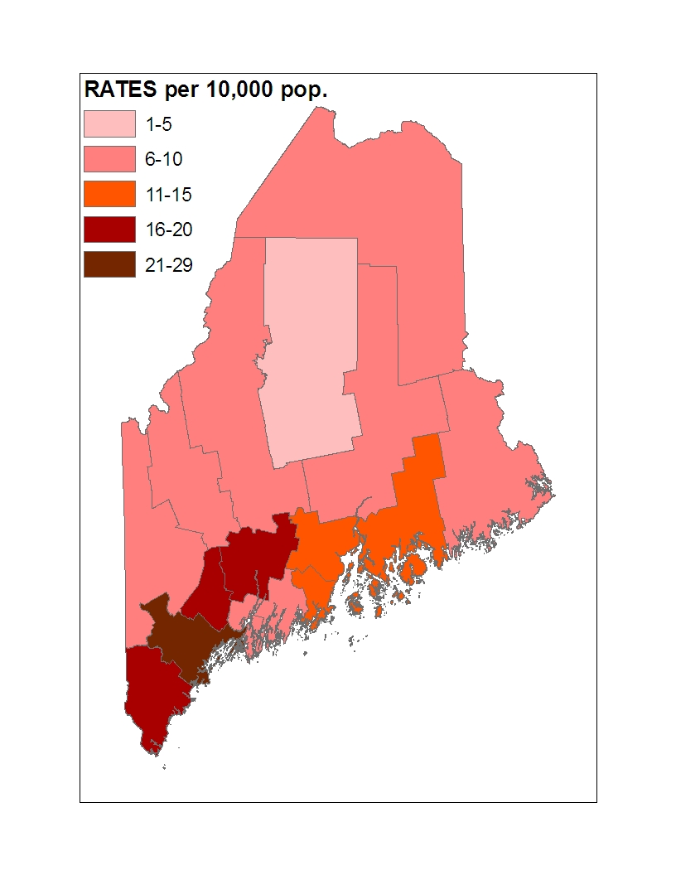

Figure 2.15 HIV Prevalence Rates among Females in Maine Counties, 2008
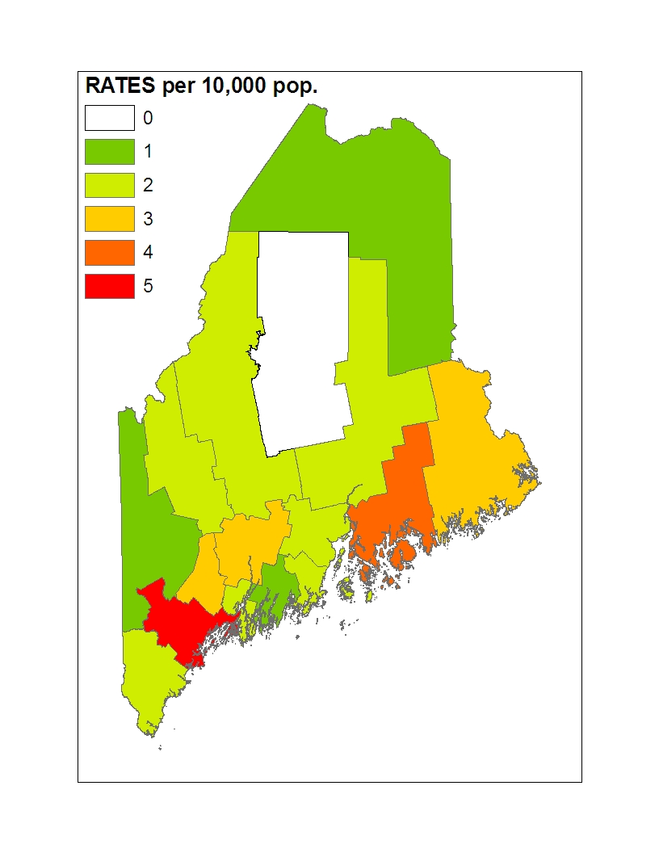

HIV prevalence rates (crude) were highest in Southern and Central Maine counties for males while female rates were highest in southern counties, particularly Cumberland county. As expected, male prevalence rates were much higher than female rates in all counties.

Figure 2.16 Case Counts for Prevalent HIV Cases Aged 0-13 Years-Maine, 2008
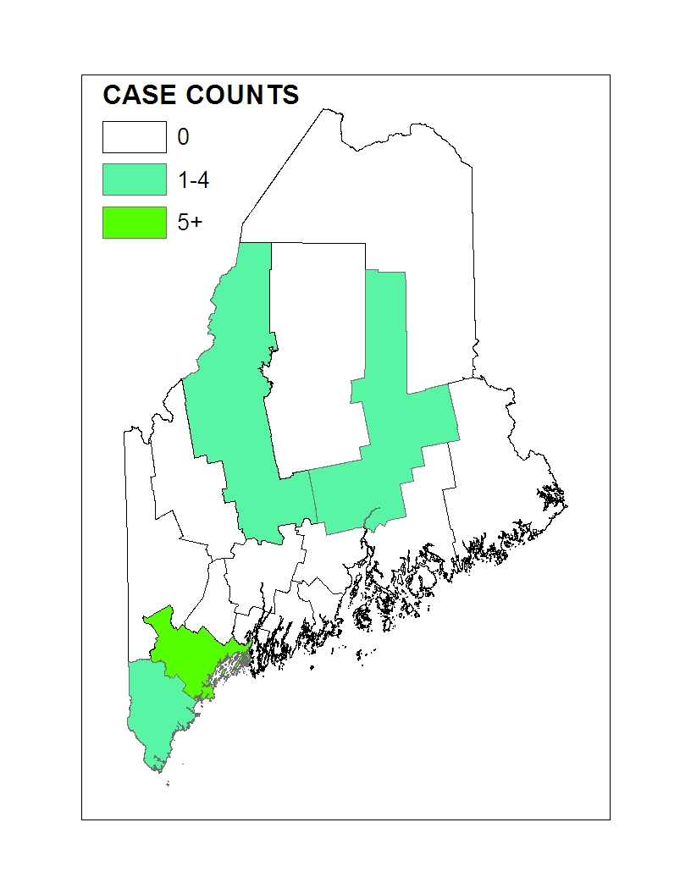
Figure 2.17 County Prevalence Rates (per 10,000 population) for HIV Cases Aged 0-13 Years, 2008
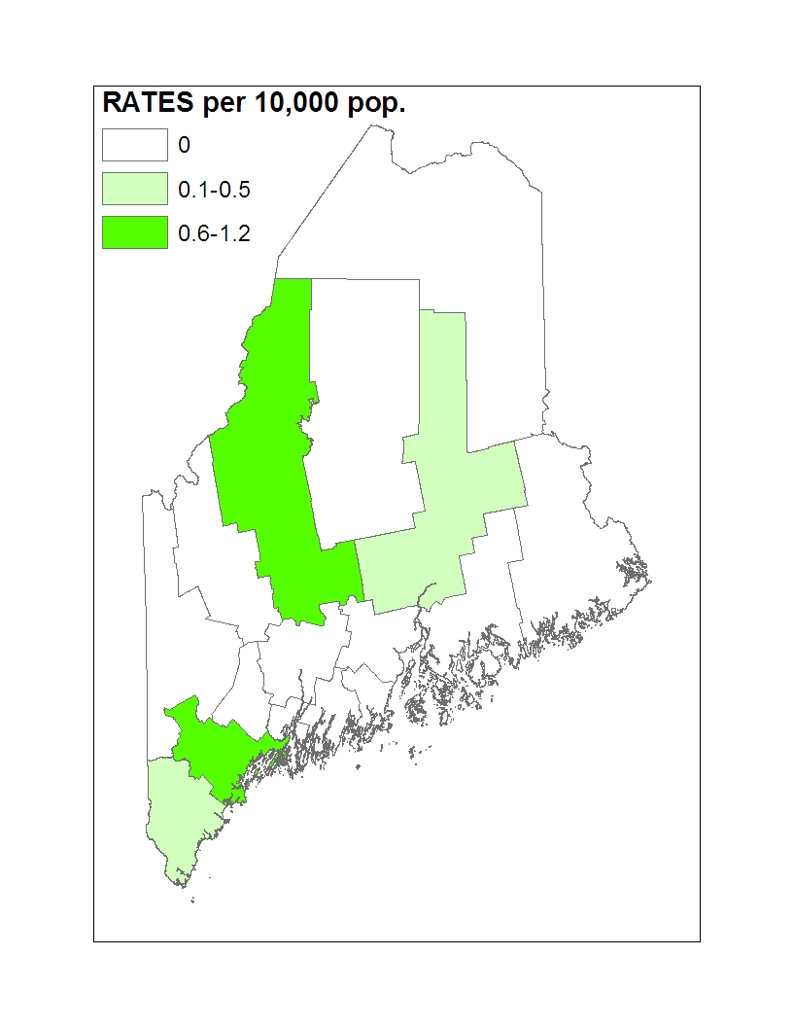

A few counties reported HIV cases less than 14 years of age living in those counties. These included Cumberland, York, Somerset, and Penobscot counties. Crude rates were highest in Cumberland county followed by Somerset county.

Figure 2.18 Case Counts for Prevalent HIV Cases Aged 14-17 Years- Maine, 2008

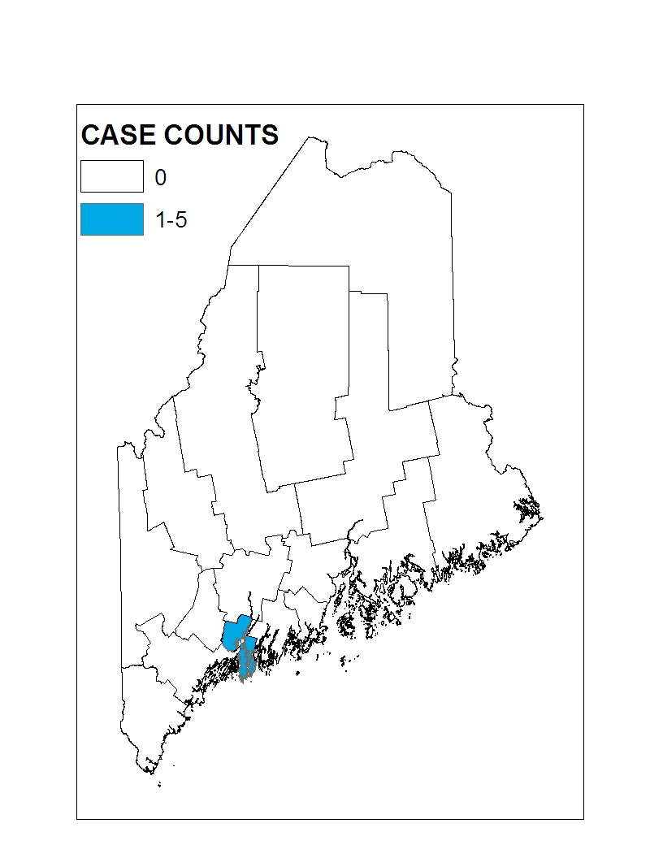

Figure 2.19 County Prevalence Rates (per 10,000 population) for HIV Cases Aged 14-17 Years- Maine, 2008

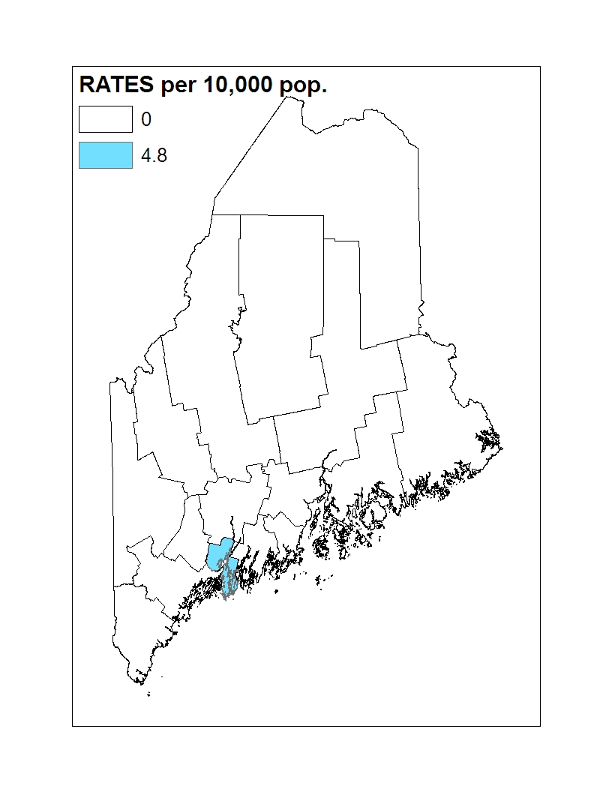

Figure 2.20 Case Counts for Living HIV cases aged 18-24 Years- Maine, 2008

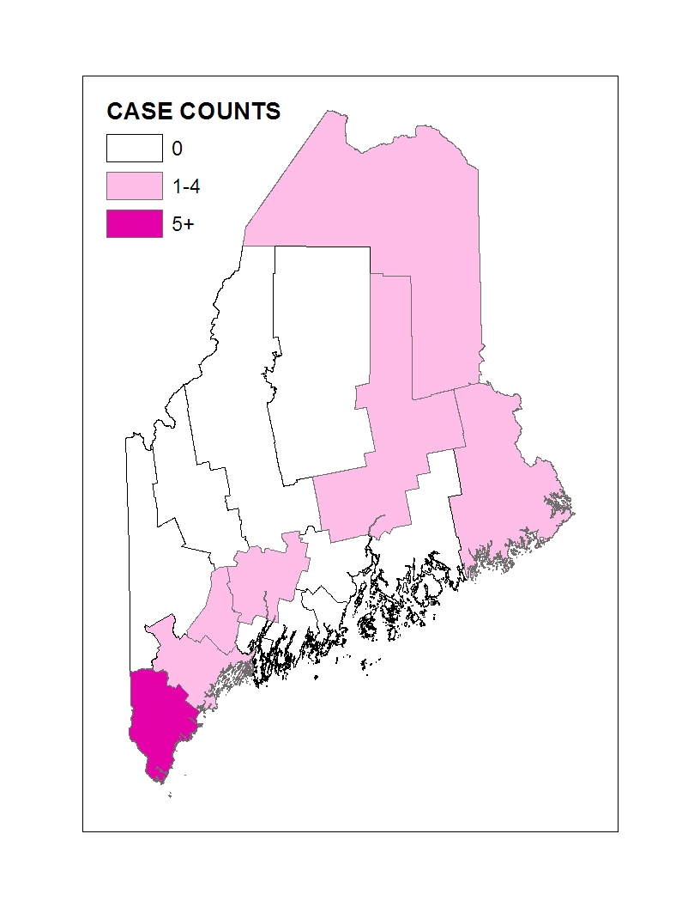

Figure 2.21 County Prevalence Rates (per 10,000 population) for HIV Cases Aged 18-24 Years- Maine, 2008

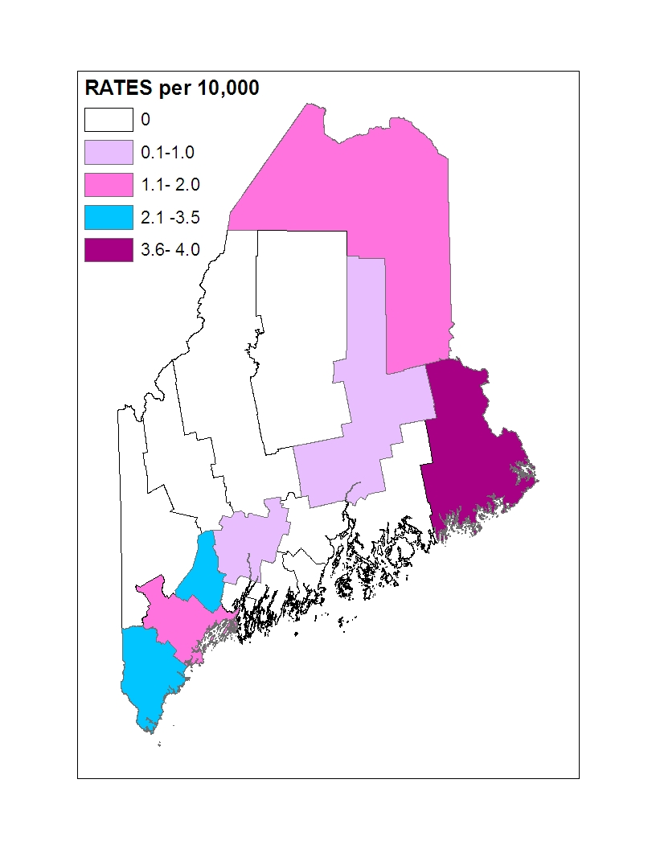
Figures 2.20 and 2.21 illustrate the disproportion burden of 18-24 year olds living in Washington county with HIV infection. The actual number of cases living in Washington county is between 1-4 cases.

Figure 2.22 Case Counts for Living HIV Cases Aged 25-44 Years- Maine, 2008
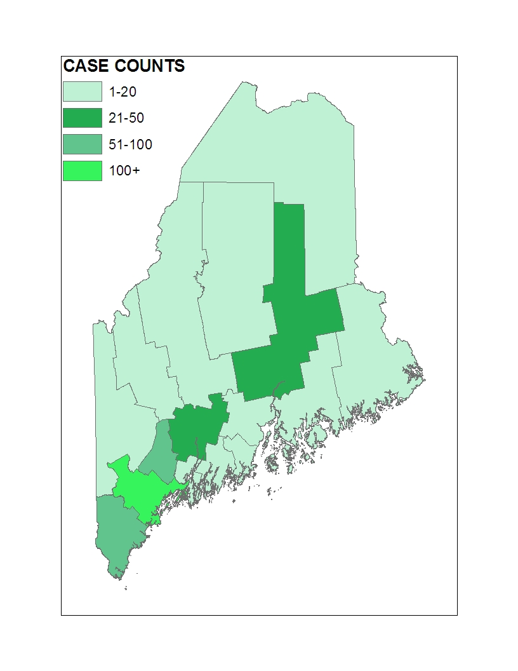
Figure 2.23 County Prevalence Rates (per 10,000 population) for HIV Cases Aged 25-44 Years- Maine, 2008

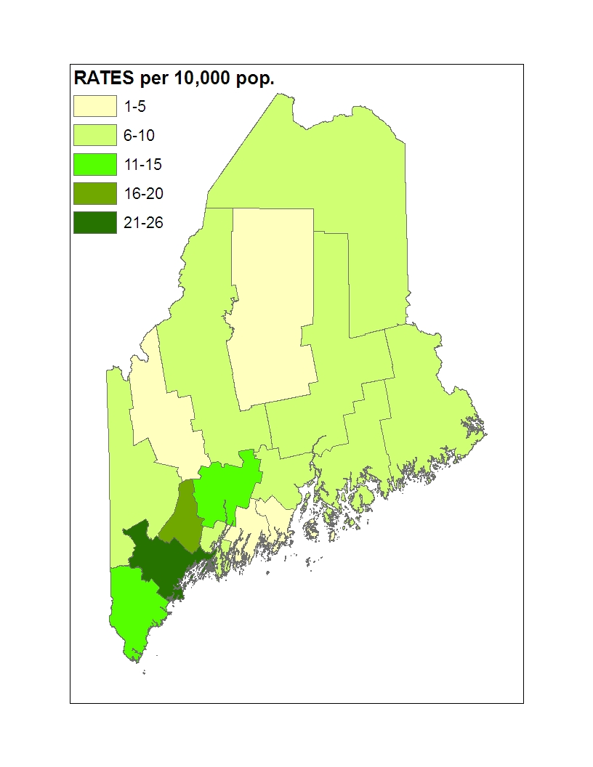
As shown in figures 2.22 and 2.23, Maine’s highly populated counties dominate the case counts and rates for living HIV cases in the 25-44 age group- which also happens to be the most represented age group among living HIV cases in Maine.

Figure 2.24: Case Counts for Living HIV Cases Aged 45-64 Years- Maine, 2008

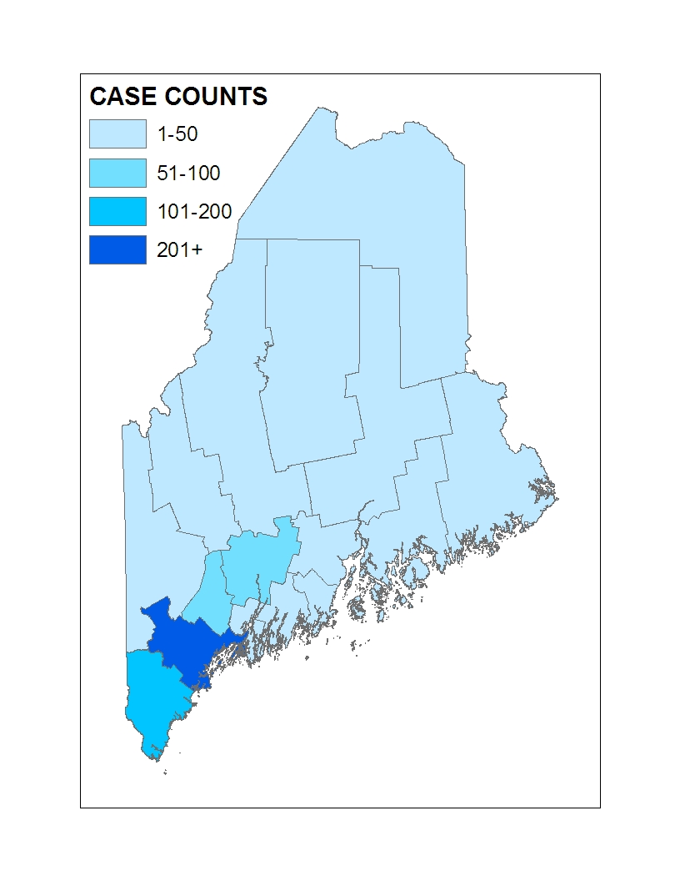
Figure 2.25: County Prevalence Rates (per 10,000 population) for HIV Cases Aged 45-64 Years- Maine, 2008
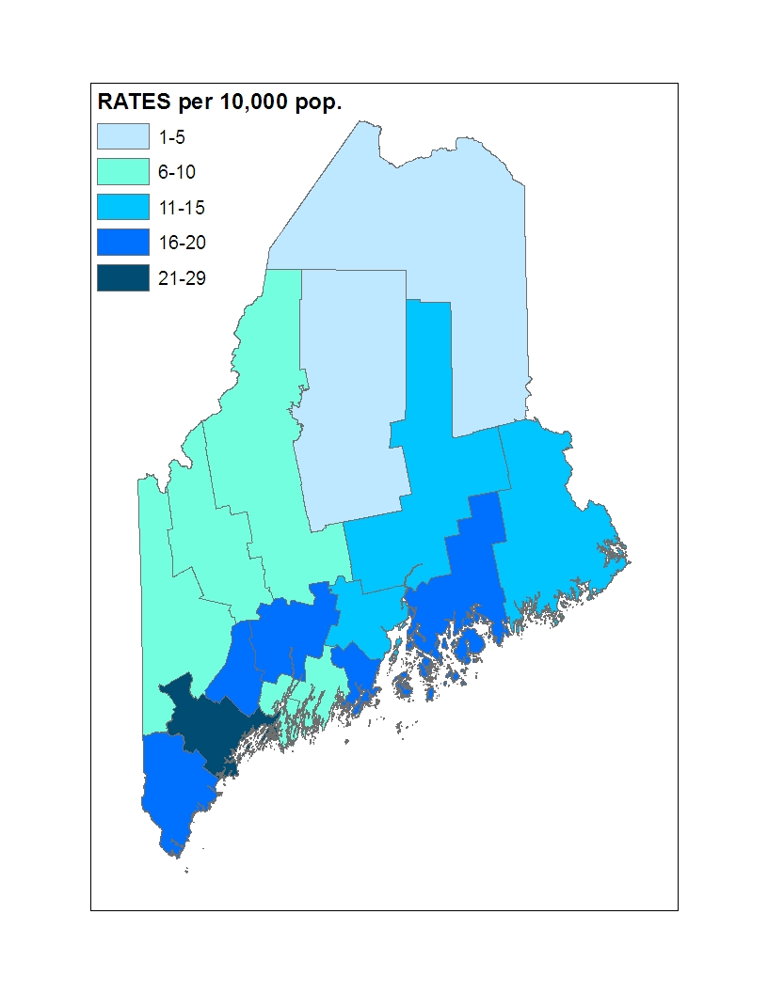
Figure 2.25 illustrates the county rate distribution of living HIV cases. Maine’s Southern and some of it’s coastal counties have the highest rates of prevalent HIV cases.

Figure 2.26 Case Counts for Living HIV Cases Aged 65 or Older- Maine, 2008

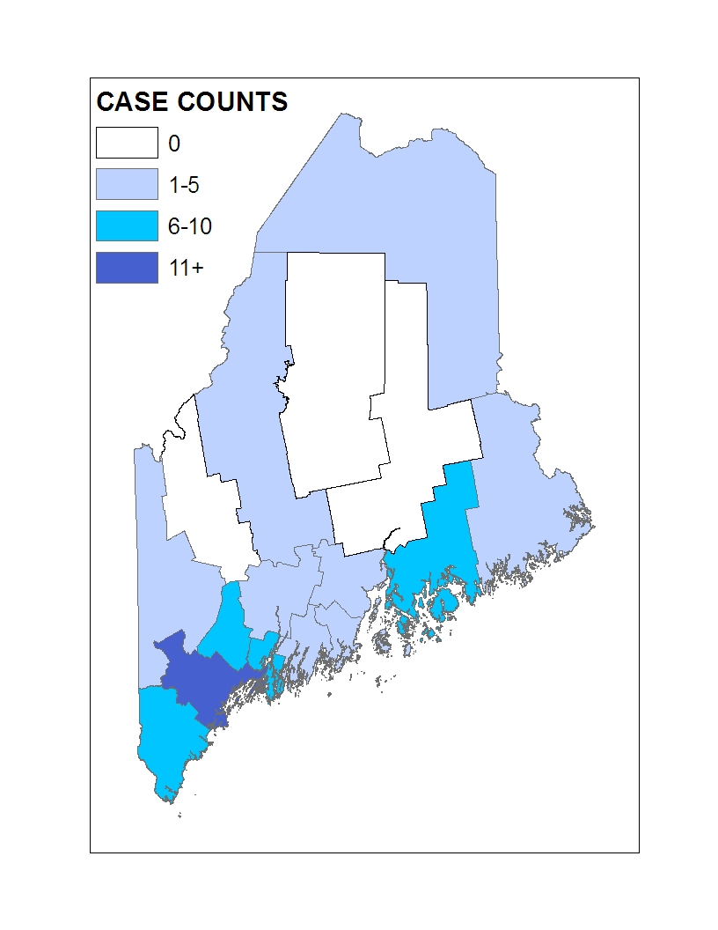
Figure 2.27 County Rates (per 10,000 population) for Living HIV Cases Aged 65 or Older - Maine, 2008
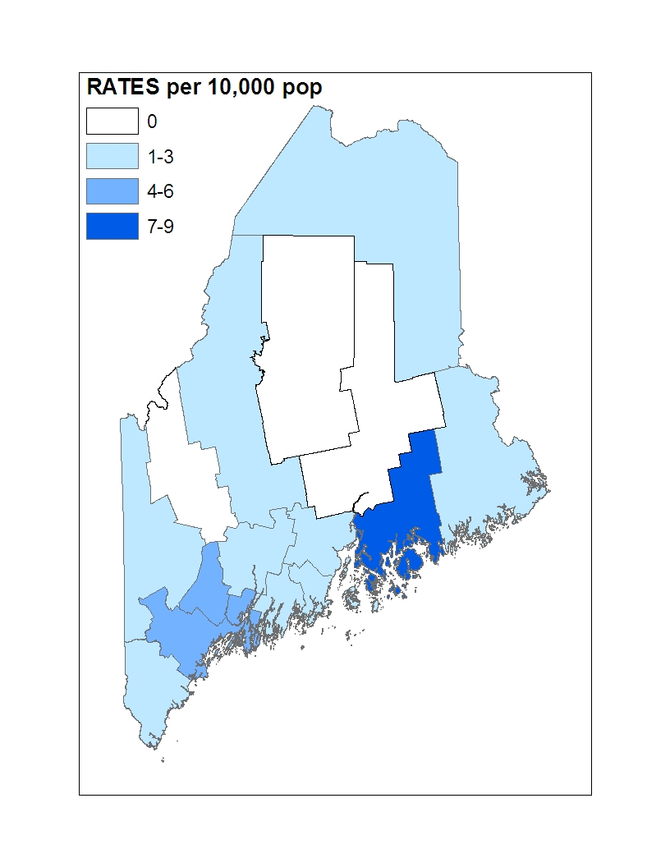

Figure 2.28 Case Counts for Living HIV MSM Cases-Maine, 2008
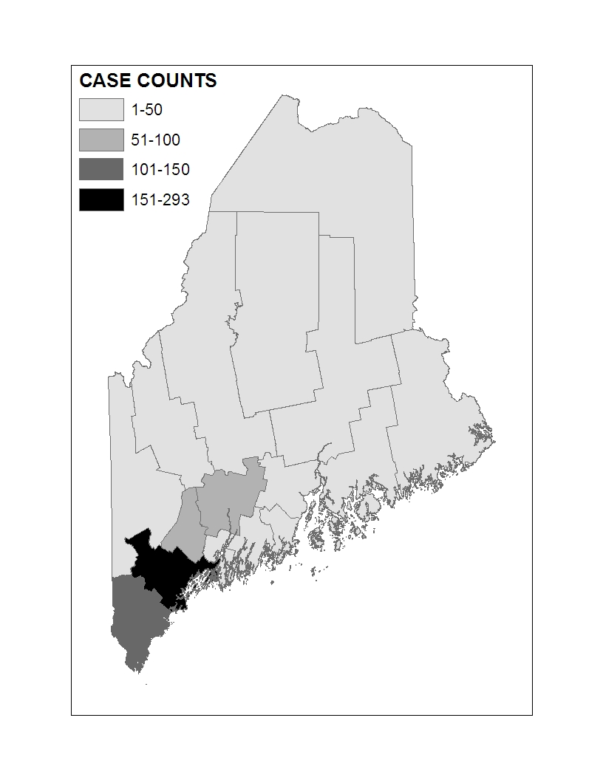
Figure 2.29 Case Counts for Living HIV Cases Classified as Exposed through Heterosexual Contact with a Partner At-Risk for HIV- Maine, 2008
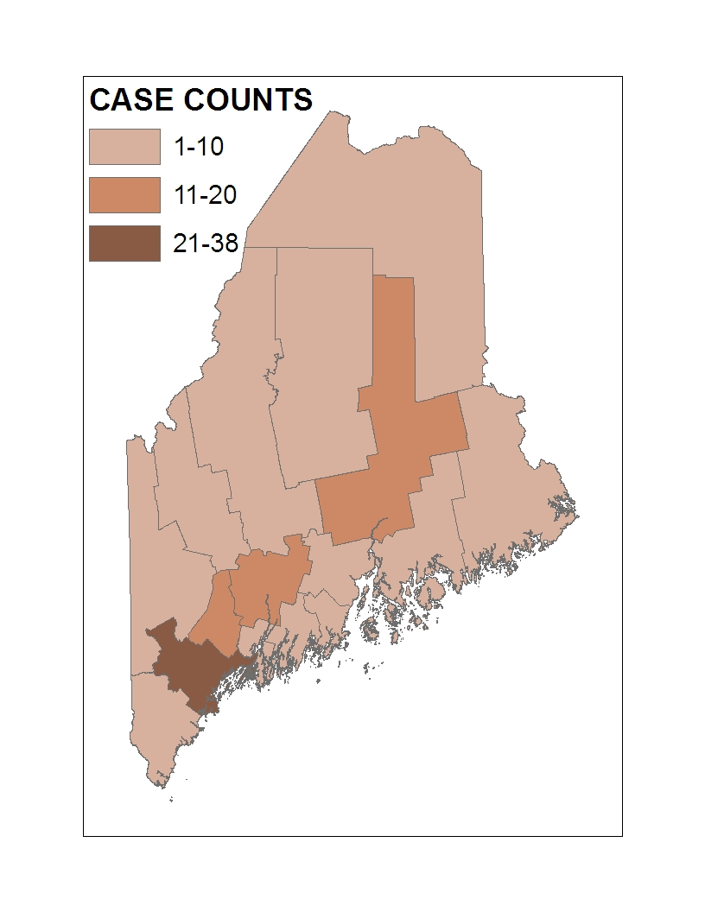

Figure 2.30. County Case Count Distribution for Living IDU HIV Cases-Maine, 2008
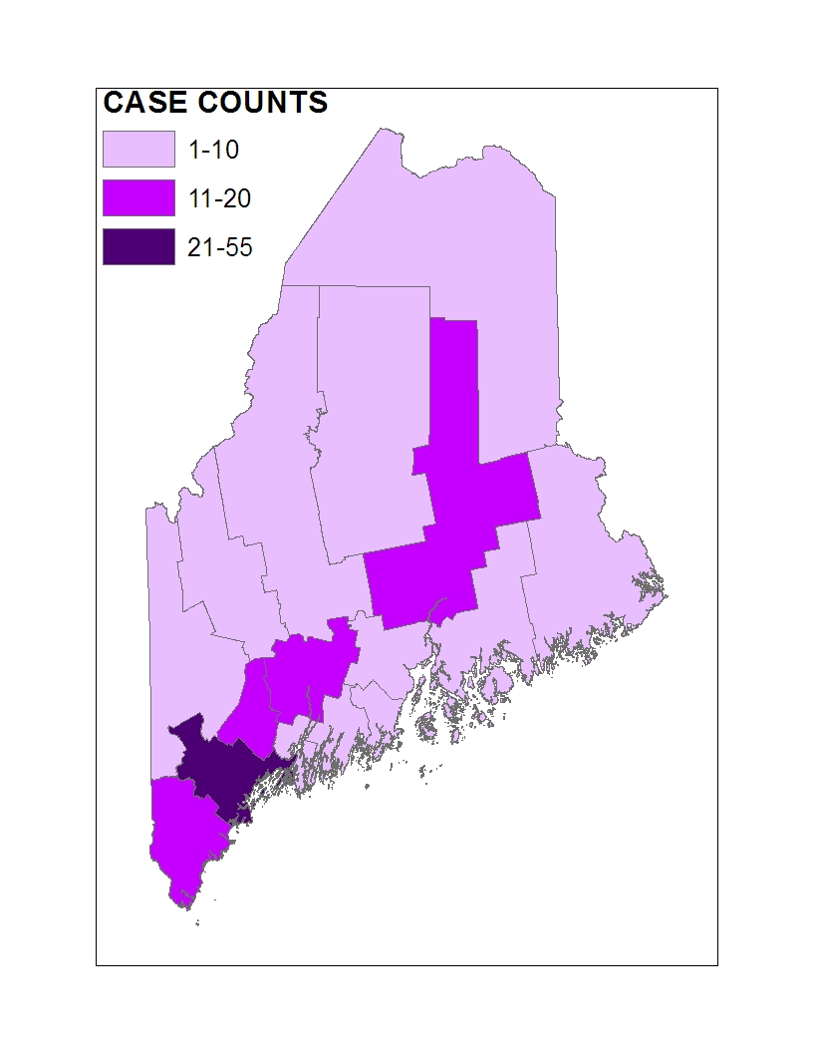
Figure 2.31. County Case Distribution for the Proportion of HIV Infected Cases with AIDS
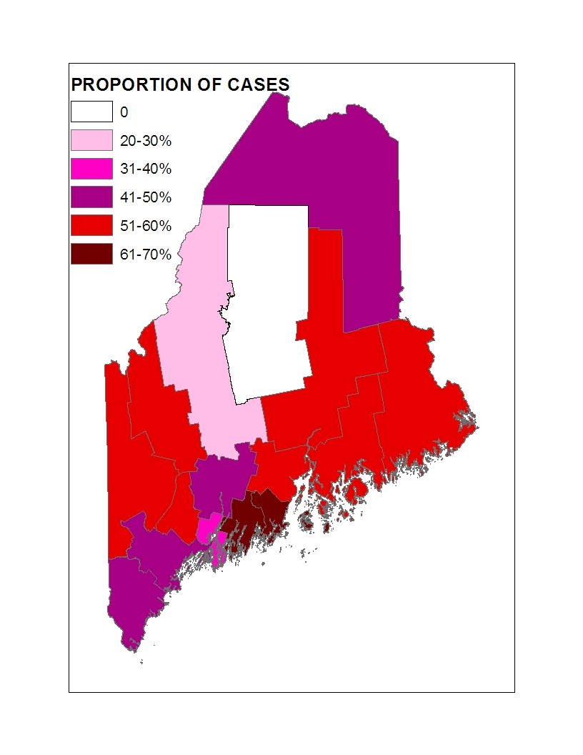
As shown in Figure 2.31, Lincoln and Knox counties have the highest proportion of living HIV cases that have progressed to AIDS.

In the following sections, the demographic characteristics of persons with HIV residing in Northern, Central and Southern Regions of Maine are explored. Note that 103 individuals for whom Maine CDC lacks information about their current county of residence are excluded in this upcoming section. Caution should be exerted when drawing conclusions based on small case counts.

    - Northern Maine
There were 2 new HIV diagnoses in Northern Maine last year, and an estimated 187 persons are living in Northern Maine with diagnosed HIV/AIDS. The above counts are less than those reported in 2007 (9 new cases and 197 prevalent cases). The following tables detail sex, mode of transmission, age group and race and ethnicity of HIV cases in Northern Maine.

In 2008, all new HIV diagnoses (100%) were among men (Table 2.14). This compares to 80% of all prevalent diagnoses in Northern Maine.

Table 2.14. Sex of 2008 HIV Diagnoses and People Living with Diagnosed HIV/AIDS in Northern Maine
 | 2008 HIV diagnoses |  |  | People living with diagnosed HIV/AIDSª
Sex | No. | % |  | No. | %
Male | 2 | 100 |  | 150 | 80
Female | 0 | 0 |  | 37 | 20
Male-to-female transgender | 0 | 0 |  | 0 | 0
Total | 2 | 100 |  | 187 | 100
ª Includes people living with AIDS or HIV diagnoses reported to ME CDC as of 12/08.

Table 2.15 shows mode of transmission for 2008 diagnoses and for people living with diagnosed HIV/AIDS. For both newly diagnosed cases and people living with diagnosed HIV/AIDS, male-to-male sex was the only or most often reported mode of HIV transmission (100% and 47% respectively), with injection drug use being the second most commonly reported mode of HIV transmission for all diagnoses made in Maine.

Table 2.15 Mode of Transmission for 2008 HIV Diagnoses and for People Living with Diagnosed HIV/AIDS in Northern Maine

 | 2008 HIV diagnoses |  |  | People living with diagnosed HIV/AIDSª
Mode of Transmission | No. | % |  | No. | %
Males who have sex with males (MSM) | 2 | 100 |  | 87 | 47
Injection drug users (IDU) | 0 | 0 |  | 31 | 17
MSM/IDU | 0 | 0 |  | 5 | 3
Heterosexual contact with at-risk partners | 0 | 0 |  | 28 | 15
Heterosexual contact with no at-risk partners disclosed | 0 | 0 |  | 29 | 16
Received contaminated blood products | 0 | 0 |  | 3 | 2
Child born to mother with HIV | 0 | 0 |  | 1 | <1
Undetermined transmission among Pediatric cases | 0 | 0 |  | 3 | 2
Total | 2 | 100 |  | 187 | 100
ª Includes people living with AIDS or HIV diagnoses reported to Maine CDC as of 12/08.

All new 2008 HIV diagnoses in Northern Maine were among individuals aged between 40 and 49 years (Table 2.16) For people living with diagnosed HIV/AIDS, the most frequently reported age group at time of HIV diagnosis was the 30-39 year old age group followed by 40-49 and 20-29 year olds.

Table 2.16 Age Group at HIV Diagnosis for 2008 HIV Diagnoses and for People Living with Diagnosed HIV/AIDS in Northern Maine

 | 2007 HIV diagnoses |  |  | People living with diagnosed HIV/AIDSª
Age Group at HIV Diagnosis | No. | % |  | No. | %
Under 13 | 0 | 0 |  | 3 | 2
13-19 | 0 | 0 |  | 3 | 2
20-29 | 0 | 0 |  | 44 | 23
30-39 | 0 | 0 |  | 71 | 38
40-49 | 2 | 100 |  | 44 | 23
50+ | 0 | 0 |  | 17 | 9
Undisclosed | 0 | 0 |  | 5 | 0
Total | 2 | 100 |  | 187 | 100
ª Includes people living with AIDS or HIV diagnoses reported to ME CDC as of 12/08.

In looking at all people living with diagnosed HIV/AIDS in Northern Maine, non-Hispanic Whites comprise 89% of cases, followed by Blacks/African Americans at 7%, Hispanics at 6% and Native Americans at 2% (Table 2.17) In 2008 all new HIV diagnoses were among non-Hispanic Whites.

Table 2.17 Race and Ethnicity for 2008 HIV Diagnoses and for People Living with Diagnosed HIV/AIDS in Maine in Northern Maine
 | 2007 HIV diagnoses |  |  | People living with diagnosed HIV/AIDSª
Race | No. | % |  | No. | %
White | 2 | 100 |  | 167 | 89
Black or African American | 0 | 0 |  | 14 | 7
Asian, | 0 | 0 |  | 0 | 0
American Indian/Alaskan Native, | 0 | 0 |  | 4 | 2
Native Hawaiian or Other Pacific Islander, | 0 | 0 |  | 0 | 0
More than one race, | 0 | 0 |  | 1 | <1
Some other race | 0 | 0 |  | 0 | 0
Unknown | 0 | 0 |  | 1 | <1
Total | 2 | 100 |  | 187 | 100
Ethnicity
Hispanic | 0 | 0 |  | 11 | 6
Non Hispanic | 2 | 100 |  | 166 | 88
Unknown | 0 | 0 |  | 10 | 0
Total | 2 | 100 |  | 187 | 100
ª Includes people living with AIDS or HIV diagnoses reported to Maine CDC as of 12/08.

2.9.2 Central Maine

There were 17 new HIV diagnoses in Central Maine last year, and an estimated 378 persons are living in Central Maine with diagnosed HIV/AIDS. In comparison to counts recorded in 2007 we observed higher regional incident and prevalent case counts in 2008.The following tables detail sex, mode of transmission, age group and race and ethnicity. Because the number of 2008 diagnoses in Central Maine is small, caution should be exercised while interpreting the 2008 incidence data presented below.

Table 2.18 shows the sex of 2008 HIV diagnoses and for people living with diagnosed HIV/AIDS. All 2008 diagnoses made in Central Maine were among men. The sex distribution of 2008 prevalent cases in central Maine defers from the incident cases as 15% of such cases were female.

Table 2.18. Sex of 2008 HIV Diagnoses and People Living with Diagnosed HIV/AIDS in Central Maine
 | 2008 HIV diagnoses |  |  | People living with diagnosed HIV/AIDSª
Sex | No. | % |  | No. | %
Male | 17 | 100 |  | 321 | 85
Female | 0 | 0 |  | 57 | 15
Male-to-female transgender | 0 | 0 |  | 0 | 0
Total | 17 | 100 |  | 378 | 100
ª Includes people living with AIDS or HIV diagnoses reported to Maine CDC as of 12/08.

Table 2.19 shows mode of HIV transmission for 2008 diagnoses and people living with diagnosed HIV/AIDS. Male-to-male sex was the most frequently (70%) reported mode of HIV transmission for 2008 diagnoses followed by individuals reporting no identifiable HIV risk factors (30%). For people living with diagnosed HIV/AIDS, the majority reported transmission through male-to-male sex, followed by heterosexual sex with at-risk partners, heterosexual intercourse with no at-risk partners reported, and injection drug use.

Table 2.19 Mode of Transmission for 2008 HIV Diagnoses and for People Living with Diagnosed HIV/AIDS in Central Maine
 | 2008 HIV diagnoses |  |  | People living with diagnosed HIV/AIDSª
Mode of Transmission | No. | % |  | No. | %
Males who have sex with males (MSM) | 12 | 70 |  | 224 | 59
Injection drug users (IDU) | 0 | 0 |  | 44 | 12
MSM/IDU | 0 | 0 |  | 10 | 3
Heterosexual contact with at-risk partners | 0 | 0 |  | 45 | 12
Heterosexual contact with no at-risk partners disclosed | 5 | 30 |  | 49 | 12
Received contaminated blood products | 0 | 0 |  | 3 | <1
Child born to mother with HIV | 0 | 0 |  | 1 | <1
Undetermined transmission among Pediatric cases | 0 | 0 |  | 2 | <1
Total | 17 | 100 |  | 378 | 100
ª Includes people living with AIDS or HIV diagnoses reported to Maine CDC as of 12/08.

Table 2.20 shows age group at HIV diagnosis of 2008 diagnoses and people living with diagnosed HIV/AIDS. The highest proportion of 2008 diagnoses was reported among those older than 50 years, followed by those in the 40-49 and 30-39 year-old age group. Similar trends were observed in 2007. For people living with diagnosed HIV/AIDS, a majority were in either of the 30-39 or 40-49 year old age groups.

Table 2.20 Age Group at HIV Diagnosis for 2008 HIV Diagnoses and for People Living with Diagnosed HIV/AIDS in Central Maine
 | 2008 HIV diagnoses |  |  | People living with diagnosed HIV/AIDSª
Age Group at HIV Diagnosis | No. | % |  | No. | %
Under 13 | 0 | 0 |  | 2 | <1
13-19 | 0 | 0 |  | 5 | 1
20-29 | 3 | 18 |  | 70 | 18
30-39 | 4 | 23 |  | 117 | 31
40-49 | 4 | 23 |  | 117 | 31
50+ | 6 | 35 |  | 49 | 13
Undisclosed | 0 | 0 |  | 18 | 5
Total | 17 | 100 |  | 378 | 100
ª Includes people living with AIDS or HIV diagnoses reported to Maine CDC as of 12/08.

Table 2.21 shows race and ethnicity for 2008 HIV diagnoses and for people living in Central Maine with diagnosed HIV/AIDS. For 2008 diagnoses, non-Hispanic Whites comprised most (94%) diagnoses. Similarly, for people living with diagnosed HIV/AIDS, non-Hispanic Whites comprised most (95%) of cases, followed by Blacks/African Americans at 5%.

Table 2.21 Race and Ethnicity for 2007 HIV Diagnoses and for People Living with Diagnosed HIV/AIDS in Central Maine
 | 2008 HIV diagnoses |  |  | People living with diagnosed HIV/AIDSª
Race | No. | % |  | No. | %
White | 16 | 94 |  | 356 | 95
Black or African American | 1 | 6 |  | 19 | 5
Asian | 0 | 0 |  | 1 | <1
American Indian/Alaskan Native | 0 | 0 |  | 2 | <1
Native Hawaiian or Other Pacific Islander, | 0 | 0 |  | 0 | 0
More than one race | 0 | 0 |  | 0 | 0
Some other race | 0 | 0 |  | 0 | 0
Unknown | 0 | 0 |  | 0 | 0
Total | 17 | 100 |  | 378 | 100
Ethnicity
Hispanic | 1 | 6 |  | 18 | 5
Non- Hispanic | 16 | 94 |  | 350 | 92
Unknown | 0 | 0 |  | 10 | 3
Total | 17 | 100 |  | 378 | 100
ª Includes people living with AIDS or HIV diagnoses reported to Maine CDC as of 12/08.

2.9.3 Southern Maine

There were 27 new HIV diagnoses in Southern Maine last year, and an estimated 655 persons are living in Southern Maine with diagnosed HIV/AIDS. The prevalent counts reported in 2008 were 14% higher than 2007 regional prevalent counts. The following tables detail sex, mode of transmission, age group, and race and ethnicity of these counts.

Table 2.22 shows the sex for 2008 HIV diagnoses and for people living with diagnosed HIV/AIDS. Last year, 74% of HIV diagnoses were among males and 26% among females. A slightly higher ratio of male to female cases is noted among regional prevalent cases (5.6 vs. 2.8).

Table 2.22 Sex of 2008 HIV Diagnoses and People Living with Diagnosed HIV/AIDS in Northern Maine
 | 2008 HIV diagnoses |  |  | People living with diagnosed HIV/AIDSª
Sex | No. | % |  | No. | %
Male | 20 | 74 |  | 560 | 85
Female | 7 | 26 |  | 95 | 15
Male-to-female transgender | 0 | 0 |  | 0 | 0
Total | 27 | 100 |  | 655 | 100
ª Includes people living with AIDS or HIV diagnoses reported to ME CDC as of 12/08.

Table 2.23 shows mode of transmission for 2008 diagnoses and people living with diagnosed HIV/AIDS. At 52% and 62%, male-to-male sex was most-often reported mode of transmission for both new diagnoses and people living with diagnosed HIV/AIDS respectively. For 2008 and prevalent diagnoses, the second most frequently reported mode of HIV transmission was through sexual contact with a partner not at-risk for HIV (29%).

Table 2.23 Mode of Transmission for 2008 HIV Diagnoses and for People Living with Diagnosed HIV/AIDS in Southern Maine
 | 2008 HIV diagnoses |  |  | People living with diagnosed HIV/AIDSª
Mode of Transmission | No. | % |  | No. | %
Males who have sex with males (MSM) | 14 | 52 |  | 406 | 62
Injection drug users (IDU) | 3 | 11 |  | 75 | 12
MSM/IDU | 0 | 0 |  | 26 | 4
Heterosexual contact with at-risk partners | 2 | 7 |  | 48 | 7
Heterosexual contact with no at-risk partners disclosed | 8 | 29 |  | 92 | 14
Received contaminated blood products | 0 | 0 |  | 5 | <1
Child born to mother with HIV | 0 | 0 |  | 1 | <1
Undetermined transmission for Pediatric cases | 0 | 0 |  | 2 | <1
Total | 27 | 100 |  | 655 | 100
ª Includes people living with AIDS or HIV diagnoses reported to ME CDC as of 12/08.

Table 2.24 shows age group at HIV diagnosis for 2008 diagnoses and people living with diagnosed HIV/AIDS. For newly diagnosed cases, the most frequently reported age group was the 40-49 age group. Among people living with diagnosed HIV/AIDS, the 30-39 year old age group was most frequently reported, followed by the 40-49 year old age group.

Table 2.24 Age Group for 2008 HIV Diagnoses and for People Living with Diagnosed HIV/AIDS in Southern Maine
 | 2008 HIV diagnoses |  |  | People living with diagnosed HIV/AIDSª
Age Group at HIV Diagnosis | No. | % |  | No. | %
Under 13 | 0 | 0 |  | 3 | 1
13-19 | 1 | 4 |  | 13 | 2
20-29 | 4 | 15 |  | 133 | 20
30-39 | 7 | 26 |  | 244 | 37
40-49 | 9 | 33 |  | 165 | 25
50+ | 6 | 22 |  | 60 | 9
Undisclosed | 0 | 0 |  | 37 | 6
Total | 27 | 100 |  | 655 | 100
ª Includes people living with AIDS or HIV diagnoses reported to ME CDC as of 12/08.

Table 2.25 shows race and ethnicity for 2008 HIV diagnoses and for people living in Southern Maine with diagnosed HIV/AIDS. For 2008 diagnoses, non-Hispanic Whites comprised 89% of diagnoses, followed by Blacks/African Americans at 11% (3 cases reported). For people living with diagnosed HIV/AIDS, Whites comprised 86% of cases, followed by Blacks/African Americans at 12%.

Table 2.25 Race and Ethnicity for 2008 HIV Diagnoses and for People Living with Diagnosed HIV/AIDS in Southern Maine

 | 2008 HIV diagnoses |  |  | People living with diagnosed HIV/AIDSª
Race | No. | % |  | No. | %
White | 24 | 89 |  | 558 | 86
Black or African American | 3 | 11 |  | 78 | 12
Asian | 0 | 0 |  | 2 | <1
American Indian/Alaskan Native | 0 | 0 |  | 2 | <1
Native Hawaiian or Other Pacific Islander | 0 | 0 |  | 0 | 0
More than one race | 0 | 0 |  | 0 | 0
Some other race | 0 | 0 |  | 0 | 0
Unknown | 0 | 0 |  | 15 | 2
Total | 27 | 100 |  | 655 | 100
Ethnicity
Hispanic | 0 | 0 |  | 40 | 7
Non-Hispanic | 27 | 100 |  | 589 | 90
Unknown | 0 | 0 |  | 26 | 3
Total | 27 | 100 |  | 655 | 100
ª Includes people living with AIDS or HIV diagnoses reported to ME CDC as of 12/08.

2.10 Key Points

- During 2008, 46 newly diagnosed HIV cases and 37 newly diagnosed AIDS cases were reported to Maine CDC.

- During 2008, 20 people living in Maine with AIDS died. Altogether, there were 24 deaths among Mainers infected with HIV in 2008. Of the 20 AIDS deaths observed in Maine, 15 were initially diagnosed in Maine while the rest were out-of-state AIDS diagnoses who migrated to Maine. AIDS is the ninth leading cause of death in Maine among persons aged 25 to 44 years based on data made available in 2005. The most frequently reported causes of death among HIV/AIDS cases residing in Maine at the time of death in 2007 and 2008 were cancers ( non-HIV related) and HIV related malignancies (cancers).

- The number of newly diagnosed HIV and AIDS cases in Maine has dropped markedly since the early 1990s. Despite this fact, HIV/AIDS prevalence continues to increase because deaths due to AIDS are at their lowest points since the beginning of the epidemic.

- Approximately 44% of persons diagnosed with HIV during the last five years were ill enough to be classified with AIDS within one year of testing positive, indicating that they had been infected a long while before their HIV diagnosis.

- It is estimated that approximately 1,674 people are living with HIV/AIDS in Maine. Of these, about 350 remain unaware of their HIV status. This is based on a national estimate that 21% of HIV infected cases remain undiagnosed.

- In 2008, 15% (n=7) of diagnoses were among females. A reported 16% of people living in Maine with diagnosed HIV/AIDS are female.

- Eighty-two percent of 2008 HIV diagnoses and 93% of persons living with diagnosed HIV/AIDS were 30 years of age and over.

- The majority of persons affected by HIV in Maine are of the White non-Hispanic racial ethnic category, with this group comprising 91% of 2008 diagnoses and 89% of persons living with diagnosed HIV/AIDS. After Whites, Blacks/African Americans comprise the second-largest racial/ethnic group, at 9% of 2008 diagnoses and 9% of people living with diagnosed HIV/AIDS in 2008. Hispanics are also disproportionately affected by HIV in Maine, comprising 2% of 2008 diagnoses and 6% of people living with diagnosed HIV/AIDS.

- In comparison to the general population, two ‘at-risk’ populations are disproportionately affected by HIV in Maine. These include males who have unsafe sex with other males (MSM) and injection drug users who shared works or needles (IDU). MSM comprised 61% of 2008 diagnoses and 58% of all people living with diagnosed HIV/AIDS in Maine. Heterosexual sex is also a significant mode of transmission.

- In 2008, only 2 counties were disproportionately affected by HIV in Maine: Cumberland and Androscoggin counties. These two counties had cumulative prevalence HIV case rates that were higher than the statewide rate. Cumberland county has the highest case rates and the most cumulative cases overall, with 456 cases or 35% of the state’s total.

- Lincoln and Knox counties have the highest proportion of AIDS case among HIV prevalent cases in each county.

Question 3
What are the indicators of risk for HIV infection and AIDS in Maine?

The data used to respond to Question 3 summarize factors that affect one’s risk of acquiring and transmitting HIV infection. These data include Maine-specific studies about the risk factors of populations most affected by HIV. In addition, Maine CDC Sexually Transmitted Disease (STD) case surveillance data are presented. Data used to complete this section include:

- Maine CDC STD case surveillance data (2008);
- HIV Community Planning Group (CPG) Needs Assessment: The Knowledge, Attitudes, Beliefs and Behaviors of Populations at Risk through Sexual Contact (Maine CPG, 2003);
- HIV Prevention and Injection Drug Use in Maine: A Statewide Needs Assessment –Attitudes and Knowledge related to HIV, Hepatitis C, and HIV Prevention (Maine CDC, 2008);
- Maine CDC MSM Behavioral Surveillance (Maine CDC 2005); and
- Youth Risk Behavior Survey (2007, Maine Department of Education).

These documents help create a better understanding of the behaviors and characteristics of at-risk populations in the state.

3.1 Maine CDC STD Surveillance Data

The Maine CDC collects disease surveillance data for gonorrhea, chlamydia, and syphilis. STD incidence indicates that individuals are engaging in unprotected sex. Research has shown that HIV-negative persons with an STD are two to five times more likely to become infected HIV if exposed. Likewise, HIV-positive persons who are infected with another STD are more likely to transmit HIV to their sexual partners. Therefore, those at risk for an STD may also be at increased risk for HIV. This section of the Profile reflects STD disease reports received through December 31, 2008. Trend data are included to present a more comprehensive picture of the STD numbers in Maine.

3.1.1 Chlamydia

Chlamydia is the most frequently reported STD in the state. As shown in Figure 3.1, more than 2,500 cases were reported in 2008. Apart from a slight decline in 2001, the number of diagnoses has increased each year between 1996 and 2007. The number of chlamydia cases reported in 2008 represents a slight increase of 2% over the 2007 total number of cases reported.

People 24 years old and under continue to be disproportionately affected by this disease, accounting for three-quarters of 2008 cases (Figure 3.2). Females are diagnosed with chlamydia more often than males, comprising 71% of all reports. This does not mean that greater numbers of women are infected with the disease; data in Maine show that women are tested for the disease more frequently than men are.

Males (n=756)
Females (n=1,838)

Although chlamydia is present in all counties, Androscoggin, Kennebec, Cumberland, Somerset, Penobscot and Sagadahoc counties had chlamydia rates that are higher than the statewide rate (Table 3.1).

Table 3.1 County of Residence for 2008 Chlamydia Diagnoses (Region in parentheses)

County of Residence | No. | % | Rate per 100,000 population
Androscoggin (Central) | 329 | 12.7 | 307.8
Kennebec (Central) | 310 | 12.0 | 256.3
Cumberland (Southern) | 644 | 24.8 | 233.3
Somerset (Central) | 114 | 4.4 | 221.9
Penobscot (Northern) | 326 | 12.6 | 219.3
Sagadahoc (Central) | 79 | 3.0 | 217.4
State of Maine | 2,594 | 100.0 | 197.0
Knox (Central) | 79 | 3.0 | 194.2
Hancock (Northern) | 90 | 3.5 | 169.4
Franklin (Central) | 48 | 1.9 | 160.8
Oxford (Central) | 88 | 3.4 | 155.1
Waldo (Central) | 56 | 2.2 | 146.1
York (Southern) | 278 | 10.7 | 137.8
Washington (Northern) | 36 | 1.4 | 110.8
Lincoln (Central) | 36 | 1.4 | 104.0
Piscataquis (Northern) | 17 | 0.7 | 100.2
Aroostook (Northern) | 64 | 2.5 | 89.3

Figure 3.3 compares Maine rates and US rates of chlamydia among 15-19 year-olds from 1996 to 2008 (the last year for which U.S. data are currently available).
Rates among Maine 15-19 year-olds increased during the past decade, rising from 480 per 100,000 population in 1996 to a recent high of 868 in 2007.
Despite increases among 15-19 year-olds, Maine rates are low compared to U.S. rates. In 2007, the Maine rate was approximately half the US rate.

3.1.2 Gonorrhea

There were ninety-six cases of diagnosed gonorrhea reported to the Maine CDC in 2008. As shown in Figure 3.4, gonorrhea rates were highest in 2003, but have continuously decreased during the last five years. Diagnoses in 2008 represent a 23% decrease over the 2007 total and a 140% decrease from the peak 231 cases reported in 2003.

Figure 3.5 shows 2008 gonorrhea diagnoses by age group and sex. Gonorrhea affects a slightly older age range than chlamydia. Slightly less than half of 2008 diagnoses occurred in the 20-29 age range, and 21% were less than 20 years-old. Males comprised approximately 55 % all gonorrhea diagnoses, a 8% decline compared to 2007 male representation. About 8% of all 2008 gonorrhea cases were among Men who have Sex with Men. The proportion of MSM cases accounting for annual gonorrhea cases has reduced from about 29% in 2006 to about 8% in 2008 probably signifying results of prevention efforts and awareness among communities at risk. In 2008, only 2 gonorrhea diagnoses were coinfected with HIV.
Six counties in Maine were disproportionately affected with gonorrhea. Cumberland, Oxford, Hancock, Androscoggin , Aroostook, and Sagadahoc counties had gonorrhea rates that are higher than the statewide rate (Table 3.2).

Table 3.2 County of Residence for 2008 Gonorrhea Diagnoses (Region in parentheses)

County of Residence | No | % | Rate per 100,000
Cumberland (Southern) | 40 | 41.7 | 14.5
Oxford (Central) | 6 | 6.3 | 10.6
Hancock (Northern) | 5 | 5.2 | 9.4
Androscoggin (Central) | 10 | 10.4 | 9.4
Aroostook (Northern) | 6 | 6.3 | 8.4
Sagadahoc (Central) | 3 | 3.1 | 8.3
State of Maine | 96 | 100.0 | 7.3
Franklin (Central) | 2 | 2.1 | 6.7
Washington (Northern) | 2 | 2.1 | 6.2
York (Southern) | 12 | 12.5 | 5.9
Kennebec (Central) | 5 | 5.2 | 4.1
Penobscot (Northern) | 4 | 4.2 | 2.7
Somerset (Central) | 1 | 1.0 | 1.9
Lincoln (Central) | 0 | 0.0 | 0.0
Piscataquis (Northern) | 0 | 0.0 | 0.0
Waldo (Central) | 0 | 0.0 | 0.0
Knox (Central) | 0 | 0.0 | 0.0
Figure 3.6 compares Maine rates and U.S. rates of gonorrhea among 15-19 year-olds from 1996 to 2007 (the last year for which US data are currently available).
Gonorrhea rates among 15-19 year-olds in Maine have fluctuated over the past decade, rising from 17 cases per 100,000 population in 1996 to 57 cases per 100,000 in 2004, with a decrease to 21 cases per 100,000 population in 2007.
Like chlamydia, Maine gonorrhea rates much lower than US rates; in 2006, the US rate among 15-19 year-olds was almost 22 times the Maine rate.

3.1.3 Syphilis

Over the past decade, annual syphilis counts have remained low, with fewer than 5 cases during most years. Notable exceptions are 2003, 2006, 2007, and 2008 with 15, 16, 14, and 20 diagnoses respectively. After peaking in the mid-1980s, syphilis steadily declined until 1999, when there were no diagnoses reported in the state. These increases between 2003 and 2007 are likely the result of out-of-state infections of Maine residents who traveled to urban areas, where syphilis incidence is higher. Anonymous sexual encounters are also contributing to the changes in syphilis disease rates observed in Maine. Of the 10 cases reported in 2008, 9 were among MSM, including 2 MSM who were HIV-infected. One syphilis case identified as a transgender individual.

Counts

3.2 Key Points about STD Data

- Chlamydia is the most frequently-diagnosed STD in the state, with more than 2,500 cases reported in 2008. During 2008, chlamydia diagnoses increased by 2% over 2007 diagnoses.

- Young people under 24 years old are at greatest risk for chlamydia, accounting for about three quarters of infections.

- In 2008, Androscoggin (Central Maine), Kennebec (Central Maine), Cumberland (Southern Maine), Somerset (Central Maine) Penobscot (Northern Maine) and Sagadahoc (Central Maine) counties all had chlamydia rates that were greater than the statewide rate.

- Chlamydia rates among 15-19 year-olds have increased in Maine during the past decade. The Maine rate in this age group is approximately half the nation-wide rate.

- There were 96 cases of gonorrhea diagnosed and reported in Maine in 2008, representing a 23% decrease over the 2007 total.

- MSM are disproportionately affected by gonorrhea, comprising 8% of all 2008 diagnoses. The proportion of MSM affected by gonorrhea has decreased over the past 3 years form 26% in 2006 to 8% in 2008.

- Gonorrhea rates in Maine among 15-19 year-olds have been decreasing slightly during the past two years unlike national rates for a similar age group. The national gonorrhea rate for 15-19 year olds is almost 20 times higher than the Maine rate.

- In 2008, the following counties had gonorrhea rates that were higher than the statewide rate: Cumberland (Southern Maine), Oxford (Central Maine), Hancock (Northern Maine), Androscoggin (Central Maine), Aroostook (Northern Maine) and Sagadahoc (Central Maine).

- Ten syphilis diagnoses occurred in 2008, four less syphilis cases than the previous year. All early syphilis diagnoses were among MSM, including 2 MSM who were HIV-positive.

3.3 Maine Studies about At-Risk Populations

Five state-wide Maine-specific studies are summarized below that examine HIV-related risk behaviors for males who have sex with males, injection drug users, people at risk for HIV through heterosexual contact, and youth.

3.3.1 Maine Community Planning Group (CPG) Needs Assessment (Maine CPG, 2003)

In an attempt to describe the met and unmet HIV prevention needs in the State of Maine, the Maine HIV Prevention Community Planning Group (CPG) conducted a statewide survey of people at risk for HIV infection through sexual contact. Three subpopulations were included in the study: Females who have Sex with Males (WSM); Males who have Sex with Females (MSW); and Males who have Sex with Males (MSM).

Key findings about sexual behavior include:

- Risk behavior, including unprotected anal and vaginal sex, occurred within each population.

- In all populations, people in non-monogamous relationships had anal sex without condoms, the sexual behavior with the highest risk of HIV transmission:
    - WSM -10%
    - MSW - 20%
    - MSM - 27% receptive and 34% insertive

- For all populations, oral sex occurred at high proportions without condoms.

- Among transgender individuals, both female-to-male and male-to-female, anal and vaginal sex occurred at higher levels without condoms than with condoms.

- In most cases, people who were not in monogamous relationships engaged in risky sex in lower proportions – and used condoms in higher proportions – than those in monogamous relationships.

- All populations surveyed reported poor use of condoms or barriers for oral sex.

- Significant proportions of all people who engaged in anal or vaginal sex did so both with and without a condom during the past six months, meaning that safe sex practices were not consistently used.

- Males who have Sex with Males, the population most at risk for HIV infection in Maine, reported engaging in at-risk sexual behavior at higher rates than MSW and WSM. Many MSM respondents also indicated that they had high numbers of sexual partners during the preceding six months.

In addition to sexual behavior, survey participants were asked about HIV testing. The data indicate that large proportions (close to half of each subpopulation) were tested for HIV within the past year. However, sizable numbers of respondents have never been tested, including 17% of the MSM sample. MSM respondents who were less open about their sexual orientation were also less likely to know their HIV status.

3.3.2 HIV Prevention and Injection Drug Use in Maine: A Statewide Needs
Assessment (Maine CDC, 2003)

This needs assessment provides general information about injection drug use in Maine based on information collected during the period 1996-2001 and 2008 using information from existing data sources on HIV, AIDS, Hepatitis C, substance abuse treatment, hospital discharges, deaths, poison control, and arrests. Information of current and former injection drug users and service providers for this population was also used.

The key findings that emerge from this needs assessment are:

- Males account for the majority of HIV and hepatitis C infections through injection drug use (90%).

- Stigma, fear and distrust are the biggest barriers to injection drug users accessing services. Peer-based models of outreach and prevention education were most acceptable to injection drug users as peers are versed in the language and culture of the community.

- Most injection drug users in this sample:
  - Know the basics of preventing HIV and hepatitis C, but may not practice safe behaviors when high and/or using with friends or partners.
  - Get clean needles from pharmacies, but experience discriminatory sales practices in some pharmacies.
  - Support and use needle exchange programs.
  - Had been tested for HIV, while only about half were tested for
Hepatitis C.
  - Disagree on the efficacy of bleach kits to prevent disease transmission.

There are regional differences in the scope and impact of injection drug use in Maine. After population is controlled for, Cumberland County experiences the greatest impact of injection drug use on blood-borne disease rates and health, social, and criminal justice services. Penobscot, Washington, Knox and Androscoggin Counties are the next most impacted regions.

3.3.3 2008 CPG Needs Assessment Report-Injection Drug Users (IDU)- 2008

The Maine CDC HIV Prevention Program conducted a Needs Assessment in 2008 to investigate the attitudes and knowledge related to HIV, Hepatitis C and HIV prevention services. Data were gathered from current or former IDUs who were participants at needle exchange and treatment centers.

Selected key findings from this study include:
- Most injection drug users in this sample found nothing to dislike about needle exchange services.

- About half (47%) of a sample of individuals using needle exchange services were fearful of using these services because of the police.

- Most study participants claimed that it was easy for them to get clean needles from either the pharmacy, needle exchange, or other sources.

- Despite having access to clean needles, most study participants had a history of needle sharing with partners of unknown HIV/Hepatitis C status.

- The level of HIV testing among study participants was high (88%) however, the concern and perception of risk for HIV was medium to low (56% and 47% respectively).

- A larger proportion of study participants reported not having used condoms during sexual intercourse in the last year yet a majority had combined drug use and sexual activity.

- Study participants consistently identified stigma as a major barrier to treatment for drug use and other health problems.

3.3.4 2006 Community Planning Group Needs Assessment Report

In 2006 the Maine CDC conducted a needs assessment to examine HIV related knowledge attitudes, and behaviors among MSM, with particular attention to young and ethnic minority MSM. Data for this needs assessment was made collected through surveys and focus group discussions. Key findings of the needs assessment are included below:
- The internet was the most frequently reported meeting location for young MSM. The internet was also reported as being safer to meet partners than other public sex environments.

- Young MSM were less likely to talk about HIV because it is a stigmatized topic.

- There was an existing need reported among young MSM for earlier education about living with HIV/AIDS and effects of taking medication.

- Reluctance to use condoms was linked to alcohol consumption during sexual activities, younger age, the perception that condoms reduced pleasure, and being with a steady partner.

- MSM had higher condom use during anal intercourse than oral intercourse.

- There were high HIV testing among study participants:
  - 88% reported ever being tested for HIV
  - Most frequently reported testing sites were
    - Health Clinic (27%)
    - Doctor’s Office (26%)
    - HIV Prevention Organization (21%)
    - Testing event (11%)

- Barriers to use of HIV prevention services reported included:
  - Cost
  - Lack of services in one’s locality
  - Stigma
  - Confidentiality is hard to maintain in smaller communities

3.3.5 Bureau of Health Behavioral Surveillance for MSM (Maine CDC, 2005)

In 2005, Maine CDC engaged in MSM behavioral surveillance to help understand recent increases in HIV and STD incidence among MSM. These efforts included key informant (KI) interviews with MSM, health care providers, AIDS Service Organization (ASO) staff and disease investigation specialists (DIS). In addition, DIS queried men testing positive for gonorrhea or HIV about their sexual behaviors, particularly in relation to their infecting sexual partner, if known.

Some key findings from both methods include:

- MSM are ‘hooking up’ through a number of venues. Internet and bars were most frequently cited by key informant (KI) interviews, bars were most frequently noted in DIS interviews.
  - Sex parties (southern ME) and internet hookups appear to be important emerging venues.

- Concerning the number of sex partners: KI interviews indicate that numbers have not significantly changed in the past year although some cite an increase. DIS interviews show that numbers of partners are generally low (1-2) or unprotected anal, and somewhat higher for oral sex.

- Concerning kind of drugs used, alcohol and marijuana were cited most often in both KI and DIS interviews, followed by crystal meth and cocaine.
  - Apart from crystal meth, other club drugs do not appear to have a significant presence in ME at this time.

- Key informant interviews asked respondents what men what think about HIV/STD prevention. Frequent responses are noted below:
  - Little or no concern. Some causes of this could be safe sex fatigue; hopelessness; emerging hedonism; a perception that these disease are treatable; an attitude that if guy looks healthy, he’s uninfected.
  - Some respondents said that MSM are in fact showing concern, including negative MSM and young MSM.

- Concerning sexual behaviors with infecting partners (DIS interviews only):
  - Nine of 13 knew the partner who infected them with HIV or GC (GC=5, HIV=4).
  - Bars were most frequently-cited venue for meeting infecting partners.
  - About half the men cited using alcohol or drugs when hooking up with infecting partner. All used alcohol. Some used other drugs too.
  - Overall, 10 of the 13 men reported using alcohol or drugs when hooking up for sex (with infecting and non-infecting partners).

3.3.6 Youth Risk Behavior Survey (Maine Department of Education, 2007)

The Maine Youth Risk Behavior Survey used data collected from middle and high school students in Maine public health schools. Data about six major youth health risk behavior trends, including sexual behaviors, were used to estimate the prevalence of risk behavior among these students. The most recent (2007) survey results released included information related to sexual behaviors among Maine youths.

Key findings pertaining to acquiring or transmitting HIV noted in this survey are listed as:

- Twelve percent (12%) of middle school students and 45% of high school students reported having had sexual intercourse at the time of the survey. These rates of sexual intercourse show a general decline since 1997 from 22.7% in 1997 to 11.9% in 2007 for middle school students and from 52% in 1997 to 45% in 2007 for high school students.

- The percentage of students involved in sexual intercourse increases with grade level from 27% among 9th graders to 65% among 12th graders. Students in higher grades are also more likely to have sexual intercourse with multiple sexual partners. Condom use among sexually active high school students increased from 47% in 1995 to 59% in 2007.

- The percentage of middle school students who had been taught about AIDS or HIV in school decreased from 85% in 1997 to 75% in 2007. Sexual education continues to be a useful prevention tool for HIV/AIDS.

- Students with same–sex partners were more likely to report having multiple sexual partners, being sexually active within the past 3 months, and rarely or never using condoms as compared to their peers with opposite-sex partners. (35% vs. 19% among males and 31% vs.18% among females). The participation in high risk sexual behaviors among middle and high school students may predispose these individuals to HIV and other STDs.

Note: Data Limitations:
- There are some data-specific limitations to consider when using this Profile; these are highlighted and discussed within the document.
- In this profile, sex refer to sex at birth rather than current sex or current gender.
- Maine HIV or AIDS cases refers to HIV or AIDS cases who were residing in Maine at the time of HIV or AIDS diagnosis.
- In estimating undiagnosed HIV cases, we used a national estimate of 21% undiagnosed HIV cases. Differences in local population characteristics may result in either under or over estimation of undiagnosed HIV cases in Maine.

Note: Data Presented in Tables: Data tables include number and percent columns, as well as totals. Percent totals may not be equivalent to 100 because percents within the table are rounded to the nearest whole number. As a result, some percent totals may appear to equal either 99% or 101%. Percent totals are always listed as the true total, or 100%.

Technical Terms:

Prevalence- Refers to the number of existing/living cases of a condition. Most prevalence references in this profile are to HIV or AIDS.

Rate-A proportion where the denominator is a measure of time.

Incidence- The number of new events e.g. new infections. Usually measured as a rate.

Conclusion

This document was produced to serve as a planning tool and to identify needs, set priorities, and project future needs for HIV prevention and care efforts. Despite medical advances and focused HIV prevention and care programs, HIV continues to have a devastating impact on the health and well-being of Maine people. Because a significant number of new infections are occurring in Maine even as HIV-related deaths decline, HIV prevalence is slowly but steadily increasing. For this reason, continued work in prevention and care services still continues to be important.

Sections of this Epi Profile dealing with HIV and STD data will be updated annually. Other sections pertaining to Maine population data and needs assessment activities will be updated as new data become available, likely on a biannual basis.

Acknowledgement:
The authors of this Profile would like to acknowledge the dedicated contribution received from the staff at the Maine HIV, STD, and Viral Hepatitis Program in preparation of this report. The document relied on disease reports sent to Maine CDC by healthcare providers and reporting laboratories. The Profile authors are therefore grateful for the timely reporting exhibited by reporting facilities in Maine.

Contact:
Please address questions or comments to:

Robert Funa
HIV Surveillance Coordinator,
Maine CDC
HIV, STD and Viral Hepatitis Program
State House Station 11
286 Water Street, 9th Floor
Augusta, ME 04333
phone: (207) 287-5193
email: robert.funa@maine.gov

