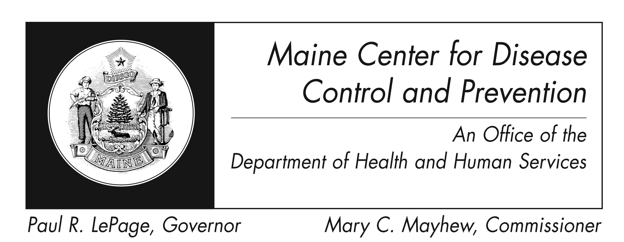
Leptospirosis
Fact Sheet

What is leptospirosis?
It is a disease caused by Leptospira bacteria. It affects humans and animals.

How is it spread?
There are some common ways that people get this disease:
● Drinking contaminated water or contact with soil contaminated by urine or body fluids of infected animals
● Exposure to broken skin while swimming, rafting or kayaking
● Exposure to the urine or body fluids of infected animals in work settings

The disease is rarely spread from person to person.

What are the symptoms?
In humans, symptoms include high fever, headache, chills, muscle aches, vomiting, and diarrhea. Yellowing of the skin and eyes, red eyes, belly pain, diarrhea, or a rash could be present. Some infected persons may have no symptoms at all. Some can have severe symptoms and breathing or kidney problems.
Symptoms usually start 1 to 2 weeks after exposure to the bacteria. Symptoms can last from a few days to three weeks or longer.

How will I know if I have this infection?
Your medical provider will order lab tests on your blood or urine.

How is it treated?
The infection can be treated with antibiotics that can cure it. Recovery may take several months if the infection is not treated. If it is not treated, it could lead to infection in the kidney, liver, brain, lungs or heart. In rare cases death occurs.

How can I prevent it?
● Avoid contact with animal urine or body fluids, especially if there are any cuts or scrapes of the skin.
● Do not swim in or swallow water that may contain animal urine.
● Wear clothing or footwear that protects your skin and feet when near dirt or water that may be contaminated with animal urine.
● See your pets’ vet to get vaccines for them that can protect against this disease.
● If your dog is diagnosed with this disease, use gloves to handle them or clean up after them. Wash hands well with soap and water after handling, even if gloves were worn. Speak to your vet about having any other dogs in the home tested.

Where is it found? These bacteria are found in cattle, pigs, horses, dogs, rodents, and wild animals. The disease occurs worldwide, but is more common in tropical regions.

Who is at risk?
There is always a risk of infection for people who have contact with infected animals, soil, or water where these germs are present. Those at higher risk are:
● Those who have scrapes on their skin
● People who work outdoors such as farmers, mineworkers, military personnel and sewer workers
● Veterinarians, fish workers, and dairy farmers
● Those participating in outdoor freshwater activities such as swimming, rafting, kayaking, adventure races, and triathlons.

This disease is also a problem where there are wild rat colonies and flooding.

Where can I get more information?
For more information, contact your healthcare provider or local health center. You can also contact the Maine Center for Disease Control and Prevention by calling 1-800-821-5821 or visiting the website at http://www.maine.gov/idepi . The federal Centers for Disease Control and Prevention website - http://www.cdc.gov – is another excellent source of health information.

