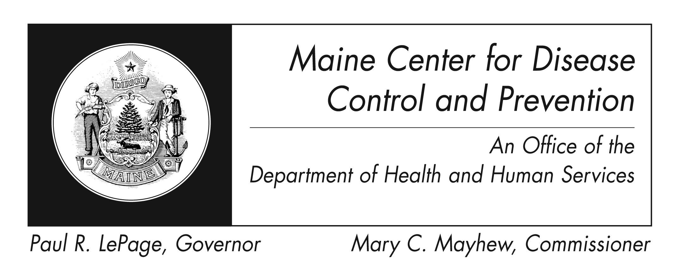
Yellow Fever
Fact Sheet

What is yellow fever?
Yellow fever is a disease caused by a virus. It is spread to people by the bite of an infected mosquito.

Who gets yellow fever?
Yellow fever virus is found in tropical and subtropical areas in South America and Africa. Yellow fever virus is very rare in U.S. travelers to these areas.

How is yellow fever spread?
Mosquitoes of the Aedes species carry the yellow fever virus from human to human. It is not transmitted through direct contact with another person.

What are some of the signs and symptoms of yellow fever?
Symptoms of yellow fever include sudden onset of fever, chills, severe headache, back pain, general body aches, nausea and vomiting, fatigue, and weakness. Many infections are mild and most people improve after these initial symptoms. However, some people can develop a severe form of the disease leading to high fever, jaundice (a condition that involves yellow discoloration of the skin and the whites of the eyes), bleeding and organ failure. Severe yellow fever infections can be fatal.

Upon recovering from yellow fever, a person has lasting immunity. There have not been any documented cases of second infections.

How soon do signs of yellow fever appear?
Symptoms appear 3-6 days after being bitten by an infected mosquito.

How is yellow fever diagnosed?
Diagnosis of yellow fever is based on signs and symptoms, and history of exposure to Aedes mosquitoes. Blood tests also aid in confirming diagnosis.

How is yellow fever treated?
There is no specific treatment for yellow fever. Treatment may include rest, fluids, and fever reducing medications (aspirin or other non-steroidal anti-inflammatory drugs such as ibuprofen should be avoided). Infected persons should be protected from further mosquito exposure so that they are not able to contribute to the transmission cycle.

How can I prevent yellow fever?
The best way to prevent yellow fever is to get vaccinated before visiting areas where yellow fever occurs. Travelers should also take precautions against mosquito bites when in areas with yellow fever transmission, and should keep in mind the following:
- Mosquitoes that spread yellow fever typically bite during the day
- When in indoor areas it is recommended to stay in well-screened areas as much as possible
- When outside wear long-sleeved clothing, long pants, and socks.
- Use insect repellent (with DEET) on your skin and apply permethrin to your clothes. Visit http://www.cdc.gov/westnile/faq/repellent.html for more information on insect repellents.

Is a vaccine available?
Yes, a vaccine for yellow fever is available. In the United States travelers can acquire the vaccine only at designated yellow fever vaccination centers. Yellow fever vaccination clinics can be found by visiting the following website: http://wwwnc.cdc.gov/travel/yellow-fever-vaccination-clinics/search.

For most travelers, a single dose of yellow fever vaccine provides long-lasting protection. However, some travelers may require a booster dose and a booster may be required to visit certain countries.
Additional information can be found at: https://www.cdc.gov/yellowfever/vaccine/index.htm.

Where can I get more information?
For more information contact your healthcare provider or local health center. You can also contact the Maine Center for Disease Control by calling 1-800-821-5821 or by visiting www.maine.gov/idepi. The federal CDC site http://www.cdc.gov/yellowfever – is another excellent source of health information.

