West Nile Virus (WNV)
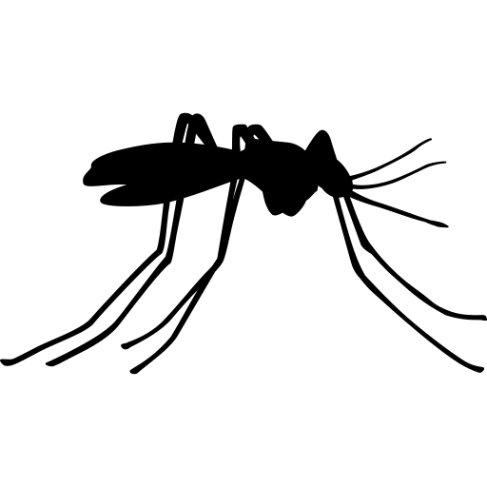Fact Sheet

West Nile Virus (WNV) spreads mostly through the bite of an infected mosquito. WNV can also spread through blood transfusions, organ transplants, breastfeeding, and from mother to baby during pregnancy.

Signs and Symptoms
Anyone can get WNV, but people who spend time outdoors are at the highest risk. WNV can also infect horses, birds, and other animals.

Fever and Chills
Weakness
Headache
Body and Muscle Pain

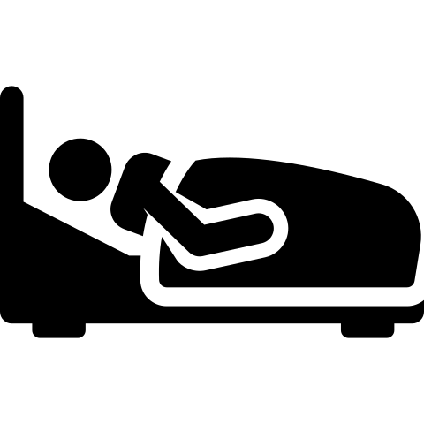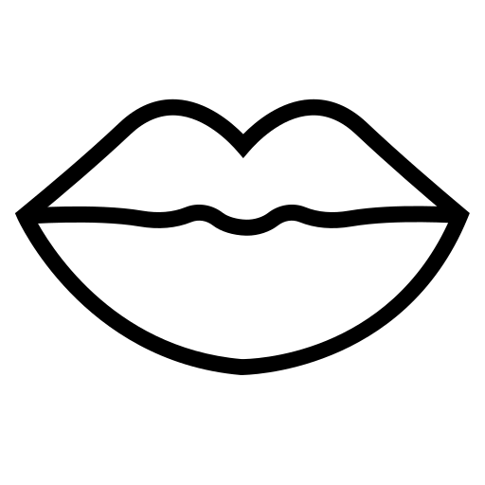

Inflammation of the Brain
Confusion
Neck Stiffness Coma

Most people infected with WNV will not show any signs of illness. Few people infected with WNV show mild signs and symptoms, which usually start 3 to 15 days after being bitten by an infected mosquito. This includes fever, head and body aches, weakness, and vomiting. Most people that show mild signs and symptoms recover completely, but fatigue and weakness can last for weeks or months.

Rarely people infected with WNV develop a severe illness affecting the brain and surrounding area. Signs and symptoms include high fever, headache, neck stiffness, confusion, coma, and paralysis. Severe illness can occur at any age, however people over 60 years of age have the highest risk. People with certain medical conditions are also at greater risk. A small number of cases with severe illness die.

Talk to your doctor if you have any of these signs or symptoms. Your doctor may take samples of blood and cerebral spinal fluid to test for WNV. There is no specific treatment for WNV. Severe WNV illness usually requires supportive treatment in the hospital.

Prevent West Nile Virus
The best way to prevent WNV is to protect yourself and your family from mosquito bites.

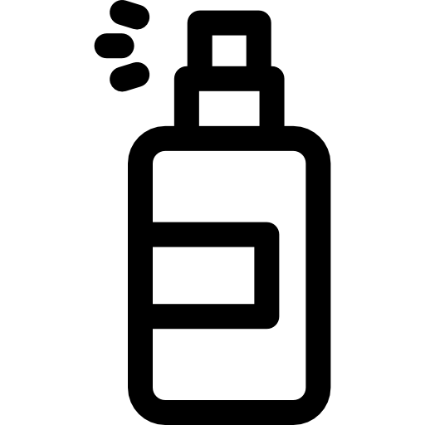Use an EPA-approved repellent for use on skin such as:
DEET
Oil of Lemon Eucalyptus IR 3535
Picaridin
Wear long-sleeved shirts and long pants when outside

Use permethrin on clothing
Get rid of places where mosquitoes can lay their eggs by draining standing water outside the house

Standing water should be drained at least once a week. This includes buckets, pet bowls, and bird baths. You can also drill holes in things like tires and buckets that are left outside and can collect water. Additional prevention includes avoiding being outdoors at dawn and dusk when many mosquitoes are most active and fixing holes in door and window screens.

For More Information, Visit:
- www.maine.gov/dhhs/westnile
- www.maine.gov/dhhs/mosquitofaq (For frequently asked mosquito questions)
- www.cdc.gov/westnile
- www.epa.gov/insect-repellents/find-repellent-right-you (For EPA approved repellents)
You can also call Maine CDC at 1-800-821-5821.

Updated February 2019 Icons from www.flaticon.com

