Lyme Disease Resource Links Maine Medical Center Research Institute Tick Submission Form: http://www.mmcri.org/lyme/lymeform.html
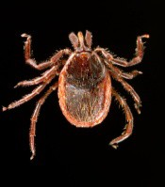

Lyme disease information from the Centers for Disease Control and Prevention:
http://www.cdc.gov/ncidod/dvbid/lyme/

Lyme disease information from Maine Medical Center Research Institute:
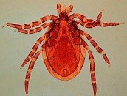

http://www.mmcri.org/lyme/

Lyme disease information from the Maine Centers for Disease Control and Prevention:
http://www.maine.gov/dhhs/boh/ddc/_lyme/lyme_1.htm
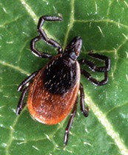

Lyme disease information for parents from KidsHealth:
http://kidshealth.org/parent/medical/brain/lyme.html

Lyme disease information for children from KidsHealth:
http://kidshealth.org/kid/ill_injure/bugs/tick.html

Maine Medical Center Research Institute Tick Submission Form:

http://www.mmcri.org/lyme/lymeform.html

Lyme disease information from the Centers for Disease Control and Prevention:
http://www.cdc.gov/ncidod/dvbid/lyme/

Lyme disease information from Maine Medical Center Research Institute:

http://www.mmcri.org/lyme/

Lyme disease information from the Maine Centers for Disease Control and Prevention:
http://www.maine.gov/dhhs/boh/ddc/_lyme/lyme_1.htm
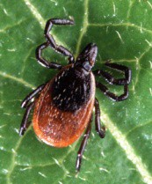

Lyme disease information for parents from KidsHealth:
http://kidshealth.org/parent/medical/brain/lyme.html

Lyme disease information for children from KidsHealth:
http://kidshealth.org/kid/ill_injure/bugs/tick.html

Maine Medical Center Research Institute Tick Submission Form:

http://www.mmcri.org/lyme/lymeform.html

Lyme disease information from the Centers for Disease Control and Prevention:
http://www.cdc.gov/ncidod/dvbid/lyme/

Lyme disease information from Maine Medical Center Research Institute:

http://www.mmcri.org/lyme/

Lyme disease information from the Maine Centers for Disease Control and Prevention:
http://www.maine.gov/dhhs/boh/ddc/_lyme/lyme_1.htm

Lyme disease information for parents from KidsHealth:
http://kidshealth.org/parent/medical/brain/lyme.html

Lyme disease information for children from KidsHealth:
http://kidshealth.org/kid/ill_injure/bugs/tick.html

