Eastern Equine Encephalitis (EEE)
Fact Sheet

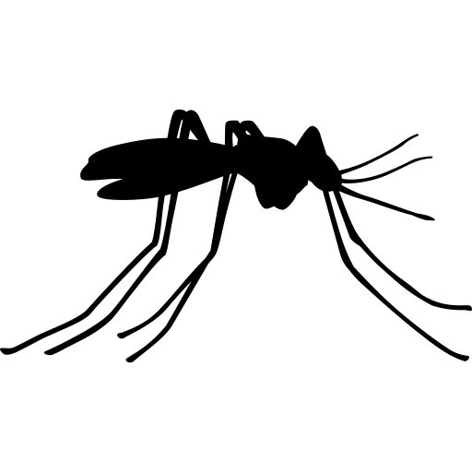

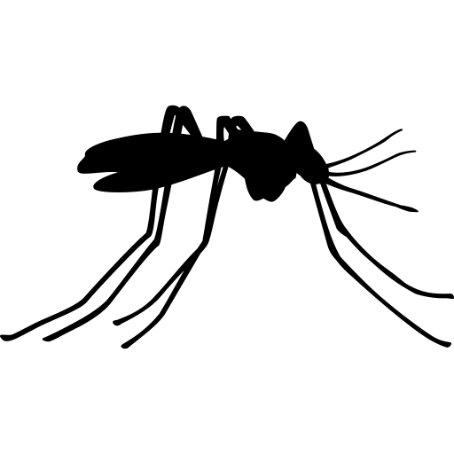
Eastern Equine Encephalitis (EEE) is a rare but serious disease that spreads through the bite of an infected mosquito.

Signs and Symptoms
Anyone can get EEE, but people who spend time outdoors are at the highest risk. EEE can also infect horses, birds, and other animals.

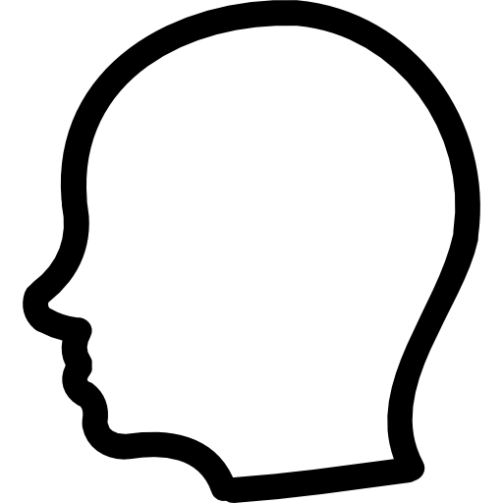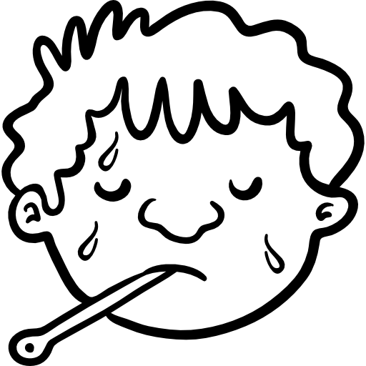

Fever and Chills
Weakness
Headache
Body and Muscle Pain

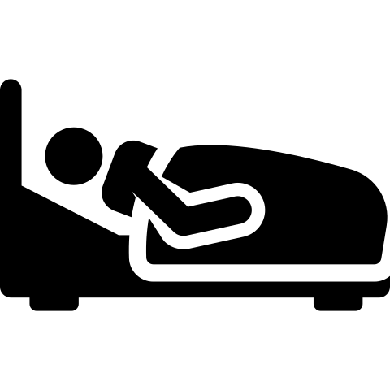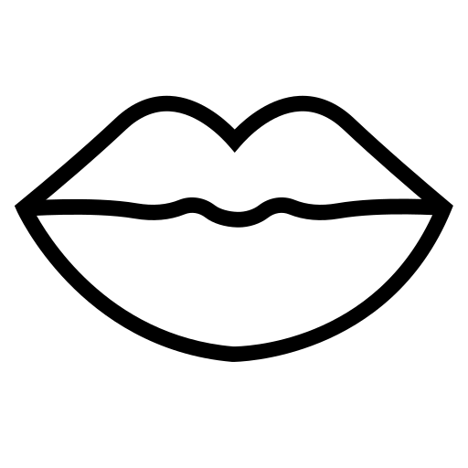

Inflammation of the Brain
Confusion
Neck Stiffness Coma

Signs and symptoms usually start four to ten days after being bitten by an infected mosquito and last one to two weeks. It is possible that some people infected with EEE will not show any signs of illness. Mild signs and symptoms include fever and chills, weakness, and body and muscle pain.
EEE can cause swelling of the brain and can lead to more severe illness. Signs and symptoms of severe illness include fever, headache, neck stiffness, confusion, seizures, and coma. About a third of people with EEE die. People over the age of 50 and under the age of 15 are at the greatest risk for severe illness.

Talk to your doctor if you have any of these signs or symptoms. Your doctor may take samples of blood and cerebral spinal fluid to test for EEE. There is no specific treatment for EEE. Severe EEE illness usually requires supportive treatment in the hospital.

Prevent Eastern Equine Encephalitis
The best way to prevent EEE is to protect yourself and your family from mosquito bites.

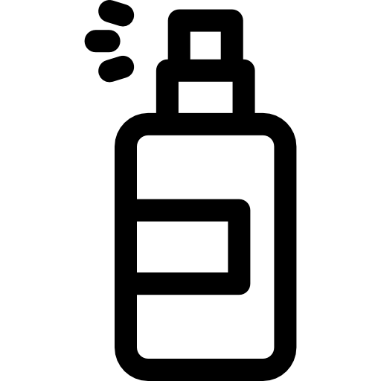Use an EPA-approved repellent for use on skin such as:
DEET
Oil of Lemon Eucalyptus IR 3535
Picaridin
Wear long-sleeved shirts and long pants when outside

Use permethrin on clothing
Get rid of places where mosquitoes can lay their eggs by draining standing water outside the house

Standing water should be drained at least once a week. This includes buckets, pet bowls, and bird baths. You can also drill holes in things like tires and buckets that are left outside and can collect water. Additional prevention includes avoiding being outdoors at dawn and dusk when many mosquitoes are most active and fixing holes in door and window screens.

For More Information, Visit:
- www.maine.gov/dhhs/EEE
- www.maine.gov/dhhs/mosquitofaq (For frequently asked mosquito questions)
- www.cdc.gov/EEE
- www.epa.gov/insect-repellents/find-repellent-right-you (For EPA approved repellents)
You can also call Maine CDC at 1-800-821-5821.

Updated February 2019 Icons from www.flaticon.com

