Borrelia miyamotoi
Fact Sheet

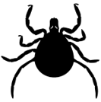

Borrelia miyamotoi disease is an illness caused by the bacteria Borrelia miyamotoi. It is spread by the bite of an infected Ixodes scapularis tick (also called the deer tick).
Anyone can get Borrelia miyamotoi disease, but people who spend time outdoors are at the highest risk.

Signs and Symptoms

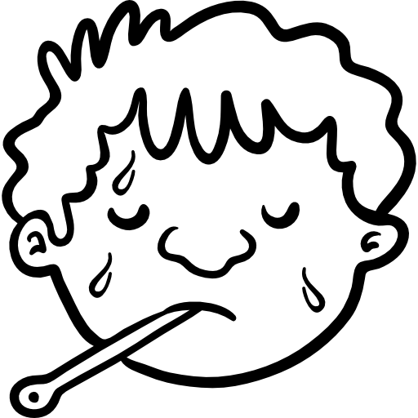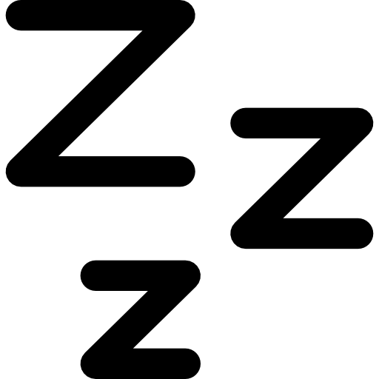

Fever and Chills
Headache
Muscle or Joint Pain
Fatigue

Other less common symptoms include rash, abdominal pain, diarrhea, and feeling dizzy or confused. Very few people experience ALL of these signs and symptoms.

Talk to your doctor if you have any of these signs or symptoms after being bit by a tick. Borrelia miyamotoi is diagnosed based on signs and symptoms and confirmed through blood tests.

Preventing Tick Bites
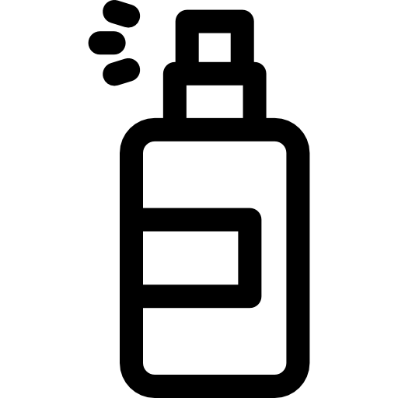

Wear light colored, long- sleeved clothing. Tuck your pants into your socks.
Use an EPA approved bug spray.
Rake your leaves and keep your lawn mowed.
Do daily tick checks and check your pets too.

Safe Tick Removal
Use a tick spoon or fine-tipped tweezers to remove a tick.
-Using tweezers, grab the tick by its mouth and use firm, steady pressure to pull the tick out. Do not use twisting motions.
-Using a tick spoon, line the notch of the spoon up with the head of the tick and gently scoop.
Do not use nail polish, matches, or petroleum jelly to remove the tick. These methods increase the risk of localized skin infection.

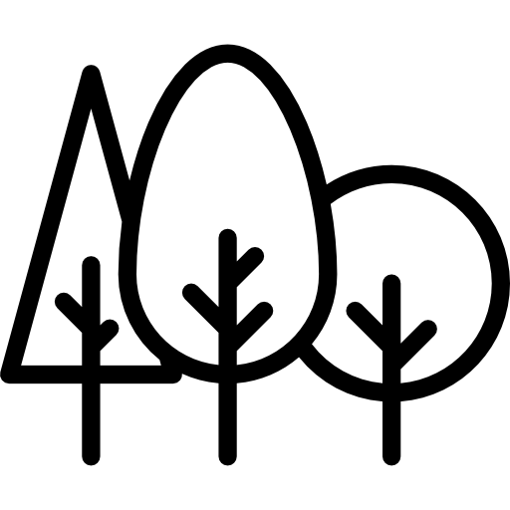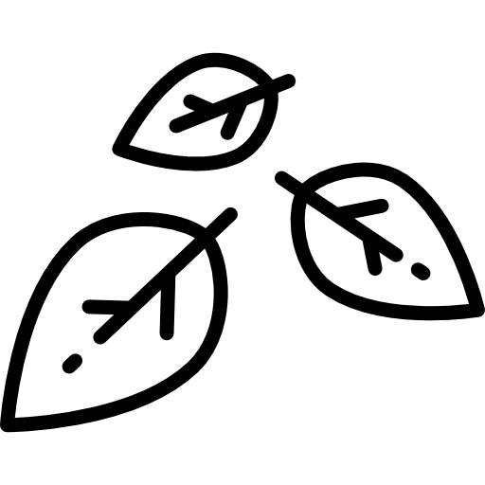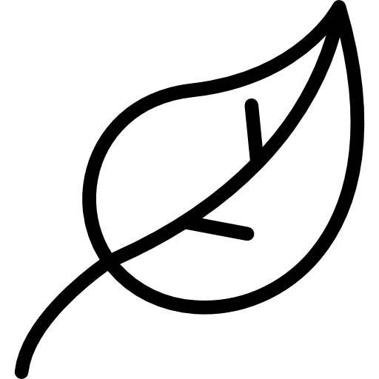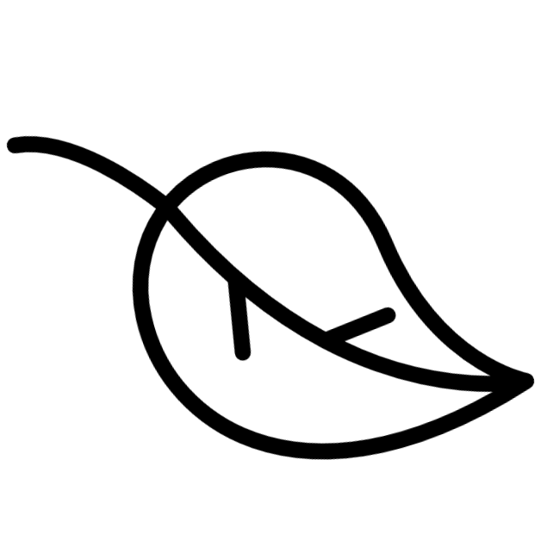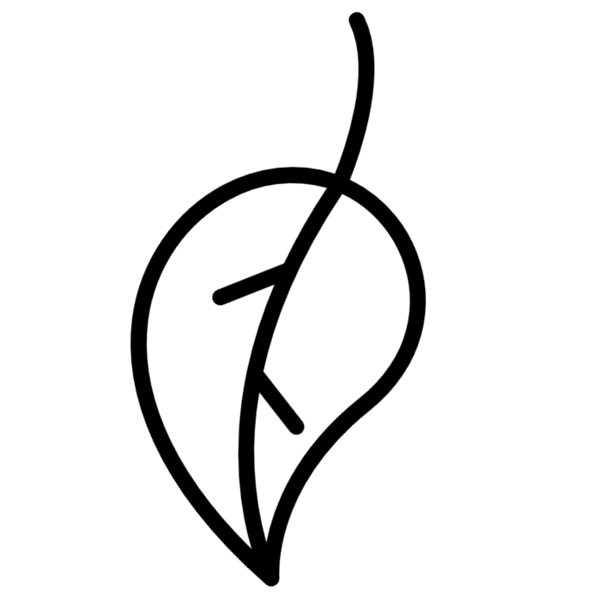
Where are Deer Ticks Found in Maine?
Deer ticks, which can carry the Borrelia miyamotoi bacteria, are found everywhere in Maine. Areas where deer ticks live include:
-Wooded or forested areas
-Wild, unmaintained landscapes with high grass
-Brush or leaf piles
Ticks are active at any temperature above freezing.

For More Information, Visit:
- www.maine.gov/dhhs/tickfaq (For frequently asked tick questions)
- www.cdc.gov/ticks/miyamotoi.html
- www.epa.gov/insect-repellents/find-repellent-right-you (For EPA approved repellents)
- www.extension.umaine.edu/ipm/tickid/ (To submit a tick for identification)
You can also call Maine CDC at 1-800-821-5821.

Updated May 2018 Icons from www.flaticon.com

