INSTRUCTIONS FOR COLLECTING NASOPHARYNGEAL SPECIMENS
This document is available electronically at: http://www.maine.gov/dhhs/etl/micro/download_forms.htm

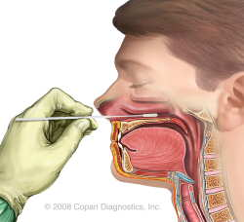
(2) Insert swab into anterior nares and gently swab posterior nasopharynx. For more info SEE:
(1)Use the Copan® Flocked Swab either Pediatric or Adult included in the kit. It is not necessary to bend the swab prior to collection.

http://copanusa.com/videos/education/index.php

STEP 3 IS FOR PCR + CULTURE.
FOR PCR ONLY, OMIT STEP 3.
STEP 4 IS FOR PCR + CULTURE.
FOR PCR ONLY, OMIT STEP 4.

(4) Swab surface of Regan-Lowe Transport Slant with swabbed specimen.
Cap and Place transport slant in shipping container for return to the Lab.

DO NOT COVER VISIBLE AREA OF SLANT WITH LABELS.
(3) Moisten swabbed specimen in 1% CAS solution.
Discard CAS tube after use Do not return with kit
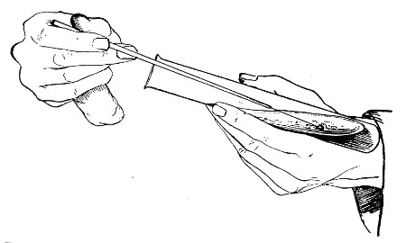
1% CAS
PCR + Culture -or- PCR ONLY
- PCR + Culture is recommended for greatest overall sensitivity and specificity.
- PCR ONLY kits are available and can be stored indefinitely at room temperature.
- Standard kits (PCR + Culture) with expired media can be used for PCR ONLY tests – simply discard the media slant and omit steps 3 and 4 above.
- If no kit is available, any metal-shafted, Dacron, Nasopharyngeal swab and appropriately sized screw cap tube can be used for PCR ONLY tests.
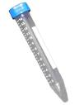
(5)Break swab at molded breaking point &drop inside the dry tube. Screw cap on tightly (sterility not required). Place dry tube with swab and transport slant into inner container and return to the State Lab.

For PCR + Culture: RETURN INOCULATED REGAN-LOWE TRANSPORT SLANT, DRY TUBE WITH SWAB AND COMPLETED PAPERWORK IN THE MAILING/Shipping CONTAINERS PROVIDED. DO NOT STORE AT ROOM TEMPERATURE.
The use of a same day courier or overnight transport is recommended to optimize the isolation of Bordetella pertussis. The use of cold packs may maintain the viability of the organism and is
recommended if transit time is anticipated to be greater than 24 hours.

NOTE: If specimens are collected late in the day or on the weekend, REFRIGERATE KIT AT 4°C until the morning of the next working day.

For PCR only: RETURN DRY TUBE WITH SWAB AND COMPLETED PAPERWORK IN THE MAILING/Shipping CONTAINERS PROVIDED. REFRIGERATION IS NOT REQUIRED.

SHIPPING: Use Enclosed Shipping Label with Mailer

SHIP TO: Health &Environmental Testing Laboratory
Department of Health and Human Services
221 state Street-Station 12 Augusta, ME 04333-00212
Tel: (207) 287-2727

