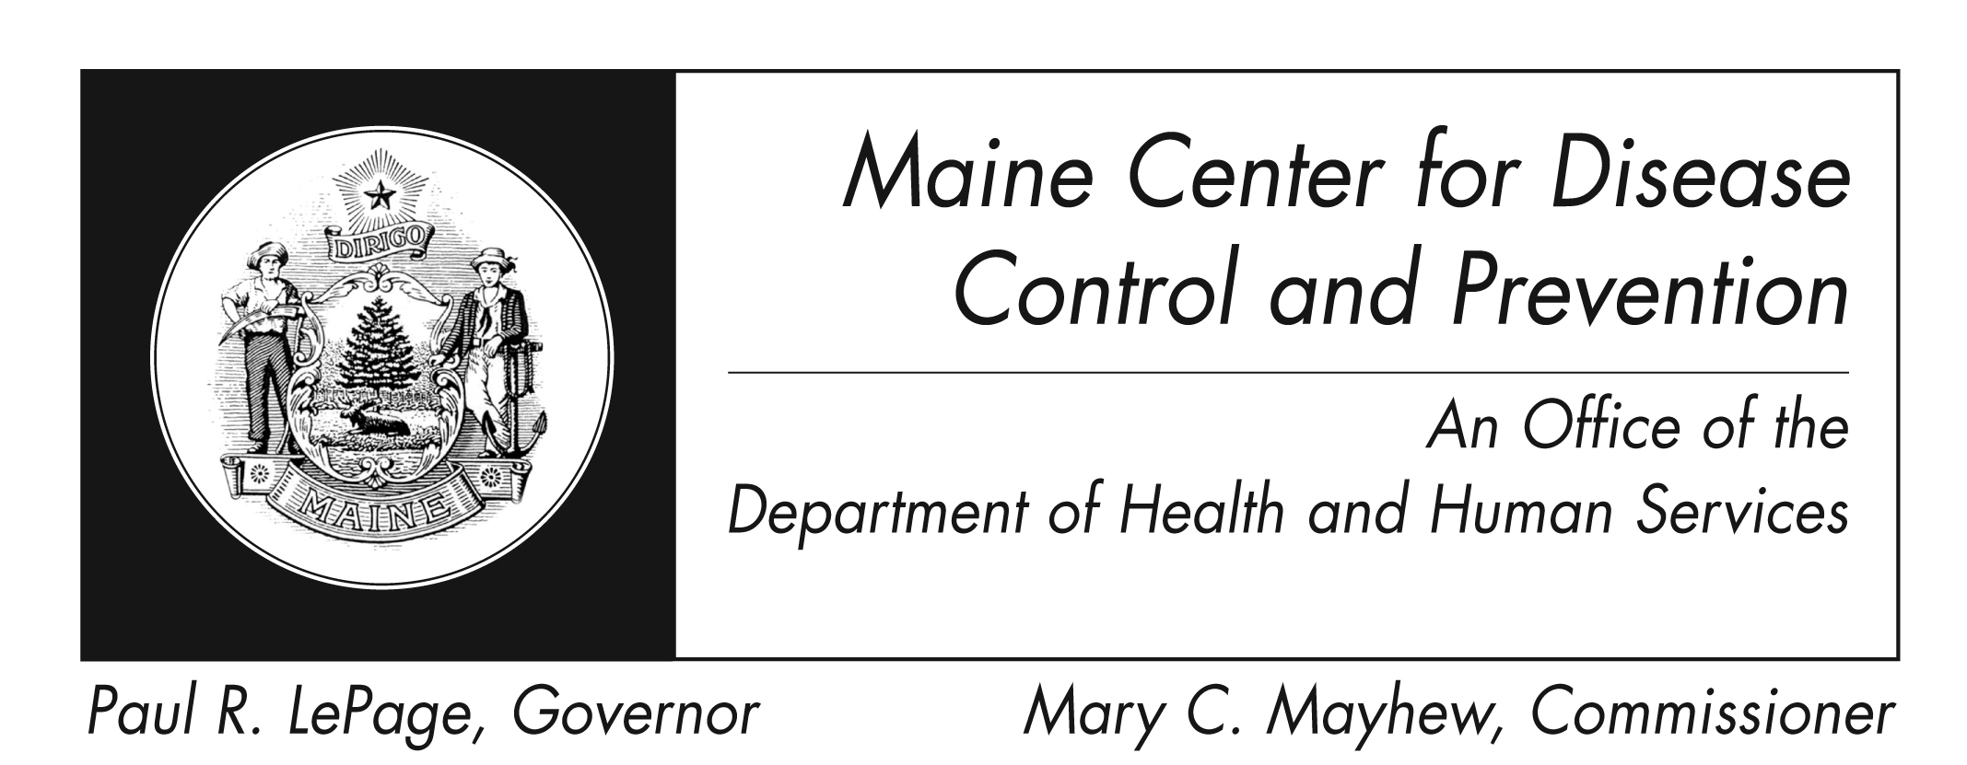
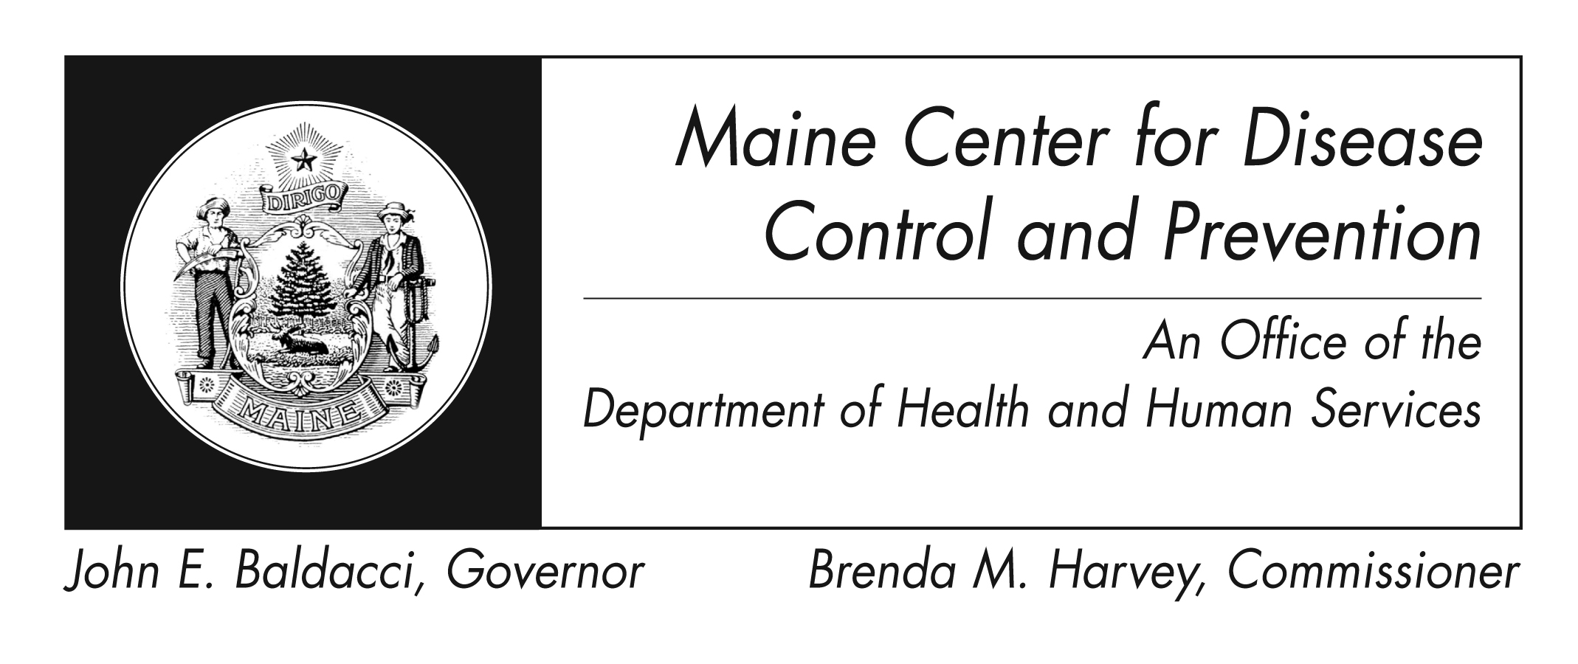
Smallpox
Fact Sheet

What is smallpox?
Smallpox was a serious disease caused by the variola virus. People who had smallpox had a fever and a distinct, progressive skin rash.

Most people with smallpox recovered, but about 3 out of every 10 people with the disease died. Many smallpox survivors have permanent scars over large areas of their body, especially their faces. Some were left blind.

Thanks to the success of vaccination programs, smallpox was eradicated. There have been no cases of naturally occurring smallpox since 1977. The last natural outbreak of smallpox in the United States occurred in 1949.

What are the signs and symptoms?
Smallpox begins with high fever, head and body aches, and sometimes vomiting. A rash develops that spreads and becomes raised bumps and pus-filled blisters. These will crust, scab, and fall off after about three weeks, leaving a pitted scar.
How is smallpox spread?
Smallpox can be spread by humans only. Scientists have no evidence that smallpox can be spread by insects or animals.

Before smallpox was eliminated, it was most often spread by direct and fairly lengthy face-to-face contact between people. Smallpox patients could spread it once the first sores appeared in their mouth and throat (early rash stage). They spread the virus when they coughed or sneezed and droplets from their nose or mouth spread to other people. They were contagious until their last smallpox scab fell off.

The scabs and the fluid found in the patient’s sores also contained the virus. The virus could spread through these materials or through the contaminated items such as bedding or clothing. People who cared for smallpox patients and washed their bedding or clothing had to wear gloves and take care to not get infected.

Rarely, smallpox has spread through the air in enclosed settings, such as a building (airborne route).

How is smallpox treated?
There is no proven treatment for this disease. Some antiviral drugs may help treat it or prevent it from getting worse. The CDC Strategic National Stockpile has these drugs and other medical supplies to protect the American public if there is a public health emergency, including one involving smallpox.

Patients with smallpox might benefit from intravenous fluids and medicine to control fever or pain. Antibiotics might be needed for any bacterial infections that may occur later.

How can smallpox be prevented?
Smallpox can be prevented through use of the smallpox vaccine. Currently, the vaccine is not widely available to the general public. However, in the event of a smallpox emergency, there is enough smallpox vaccine to vaccinate every person in the United States.
If smallpox vaccine is given to a person before exposure to the disease, the vaccine can completely protect them. After exposure to the virus, vaccination may still prevent disease or lessen the effects of the virus. Vaccination will not protect smallpox patients who already have a rash.

Where can I get more information?
For more information contact your healthcare provider or local health center. You can also contact the Maine Center for Disease Control and Prevention by calling 1-800-821-5821. The federal Centers for Disease Control and Prevention website - http://www.cdc.gov – is another excellent source of health information.

