Varicella (Chickenpox)
Fact Sheet

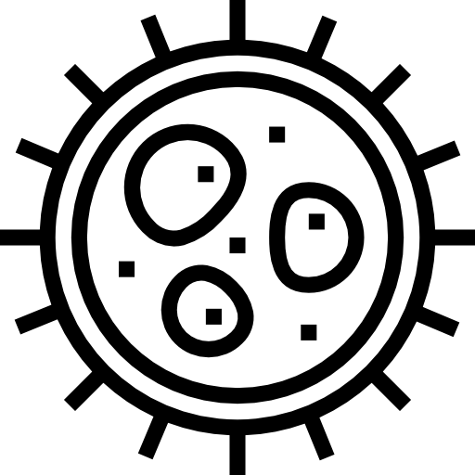

Varicella, commonly called chickenpox, is a very contagious infection. It is caused by the varicella zoster virus.

Signs and Symptoms
Anyone can get chickenpox.
People who are vaccinated are less likely to get chickenpox, but it can still occur. In these cases, it is usually a milder form.

Rash Fever Feeling Tired Loss of Appetite

Fever, feeling tired, loss of appetite, and headache may appear one to two days before the rash develops. The rash may show up first on the face, chest, and back then spread to the rest of the body. This includes inside the mouth, eyelids, or genital area. The rash turns into itchy, fluid-filled blisters that will scab over in about a week. Symptoms usually appear 14 to 16 days after infection, but can range from 10 to 21 days.
Chickenpox can be very serious especially in babies, children older than 12, adults, pregnant women, and people with weakened immune systems. Severe complications from chickenpox are rare but can include bacterial infections, pneumonia, inflammation of the brain, and death. Some deaths from chickenpox occur in healthy, unvaccinated children and adults.

Talk to your doctor if you think you have chickenpox. There is no specific treatment, but symptoms can be treated with over-the-counter drugs.
Do not use aspirin or aspirin-containing medications to relieve a child’s fever. This can cause a rare complication in children.

Spread of Chickenpox

Coughing and Sneezing
Direct contact by touching the blisters

The virus spreads easily by touching or breathing in the virus particles that come from chickenpox blisters. Surfaces and items, like toys, can spread the virus if someone who is sick touches them without washing their hands and someone else touches the same surface and then rubs their eyes, nose, or mouth.

Preventing Chickenpox

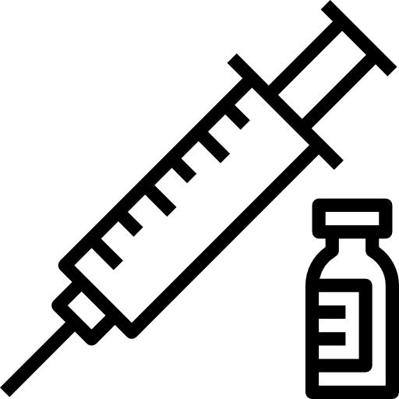

Vaccination is the best prevention
Wash your hands with soap and water
Do not share eating utensils
Clean surfaces that are touched on a regular basis

For More Information, Visit:
- www.maine.gov/dhhs/varicella
- www.cdc.gov/varicella
- www.cdc.gov/vaccines/vpd/vaccines-afe.html (For recommended vaccines by age)
You can also call Maine CDC at 1-800-821-5821.

Updated January 2019 Icons from www.flaticon.com

