Shingles
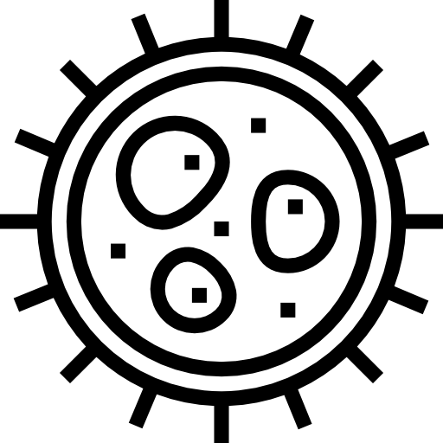Fact Sheet

Shingles is a painful skin rash caused by the varicella zoster virus. This is the same virus that causes chickenpox.

Signs and Symptoms
Anyone who had chickenpox or received the chicken pox vaccine can develop shingles. However, vaccinated people are less likely to get shingles. Shingles most commonly occurs in people 50 years old and older.

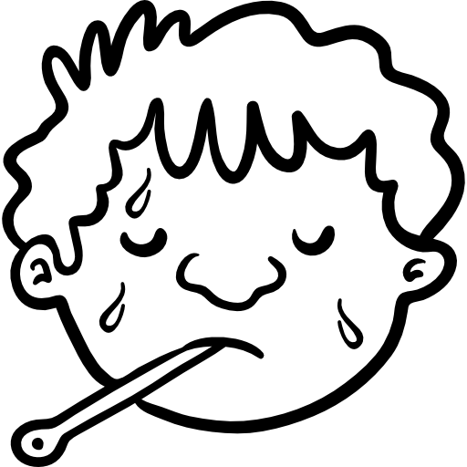

Rash
Fever and Chills
Headache
Upset Stomach

The rash forms clusters of blisters that typically scab over in seven to ten days and usually clears up within two to four weeks. Typically, the rash occurs on one side of the face or body in a single stripe but can be widespread. People with weakened immune systems are more likely to develop shingles for a longer period of time and have the rash over their entire body.

Before the rash develops, people may have pain, itching, or tingling in the area where the rash will develop. This may happen one to five days before the rash appears.

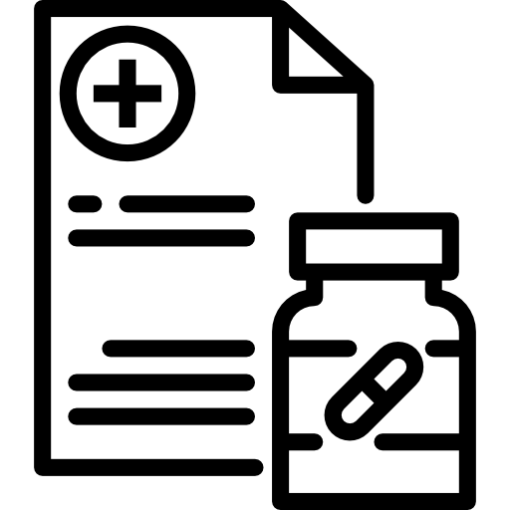
Talk to your doctor if you think you have shingles. Several drugs are available to treat shingles and must be started as soon as possible after the rash appears.

Spread of Shingles

The virus can be spread from a person with active shingles to someone who has never had chickenpox by direct contact with the fluid from the blisters. The person exposed to the virus might develop chickenpox, but they would not develop shingles.

Complications

Severe pain in the area of the rash called post-herpetic neuralgia (PHN)

Eye problems including vision loss

PHN is the most common complication of shingles and can last for weeks to months after the rash is gone. Nerve damage and severe bacterial infections can occur. In rare cases, shingles can lead to pneumonia, hearing problems, blindness, swelling of the brain, or death.
People with weakened immune systems are more likely to develop complications.

Preventing Shingles
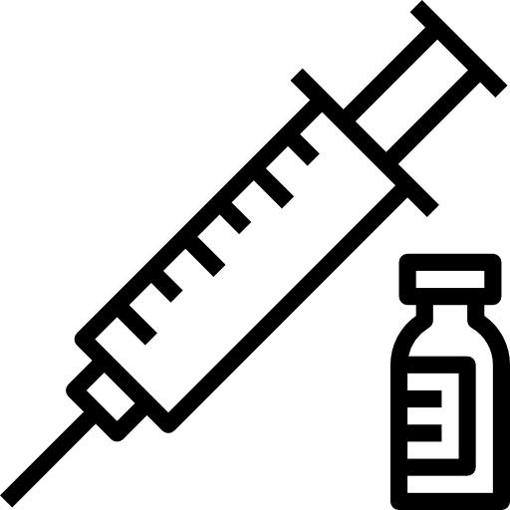The only way to reduce the risk of getting shingles to get vaccinated.
It is recommended that healthy adults 50 years and older get two doses of the shingles vaccine. You can get shingles more than once, so it is important to get the vaccine even if you already had shingles.
Recommendations for shingles vaccination changed in 2018. Anyone vaccinated prior to 2018 should check with their doctor to see if they are fully protected.

For More Information, Visit:
- www.maine.gov/dhhs/varicella
- www.cdc.gov/shingles
- www.cdc.gov/vaccines/schedules/downloads/adult/adult-combined-schedule.pdf (For the adult vaccine schedule)
You can also call Maine CDC at 1-800-821-5821.

Updated January 2019 Icons from www.flaticon.com

