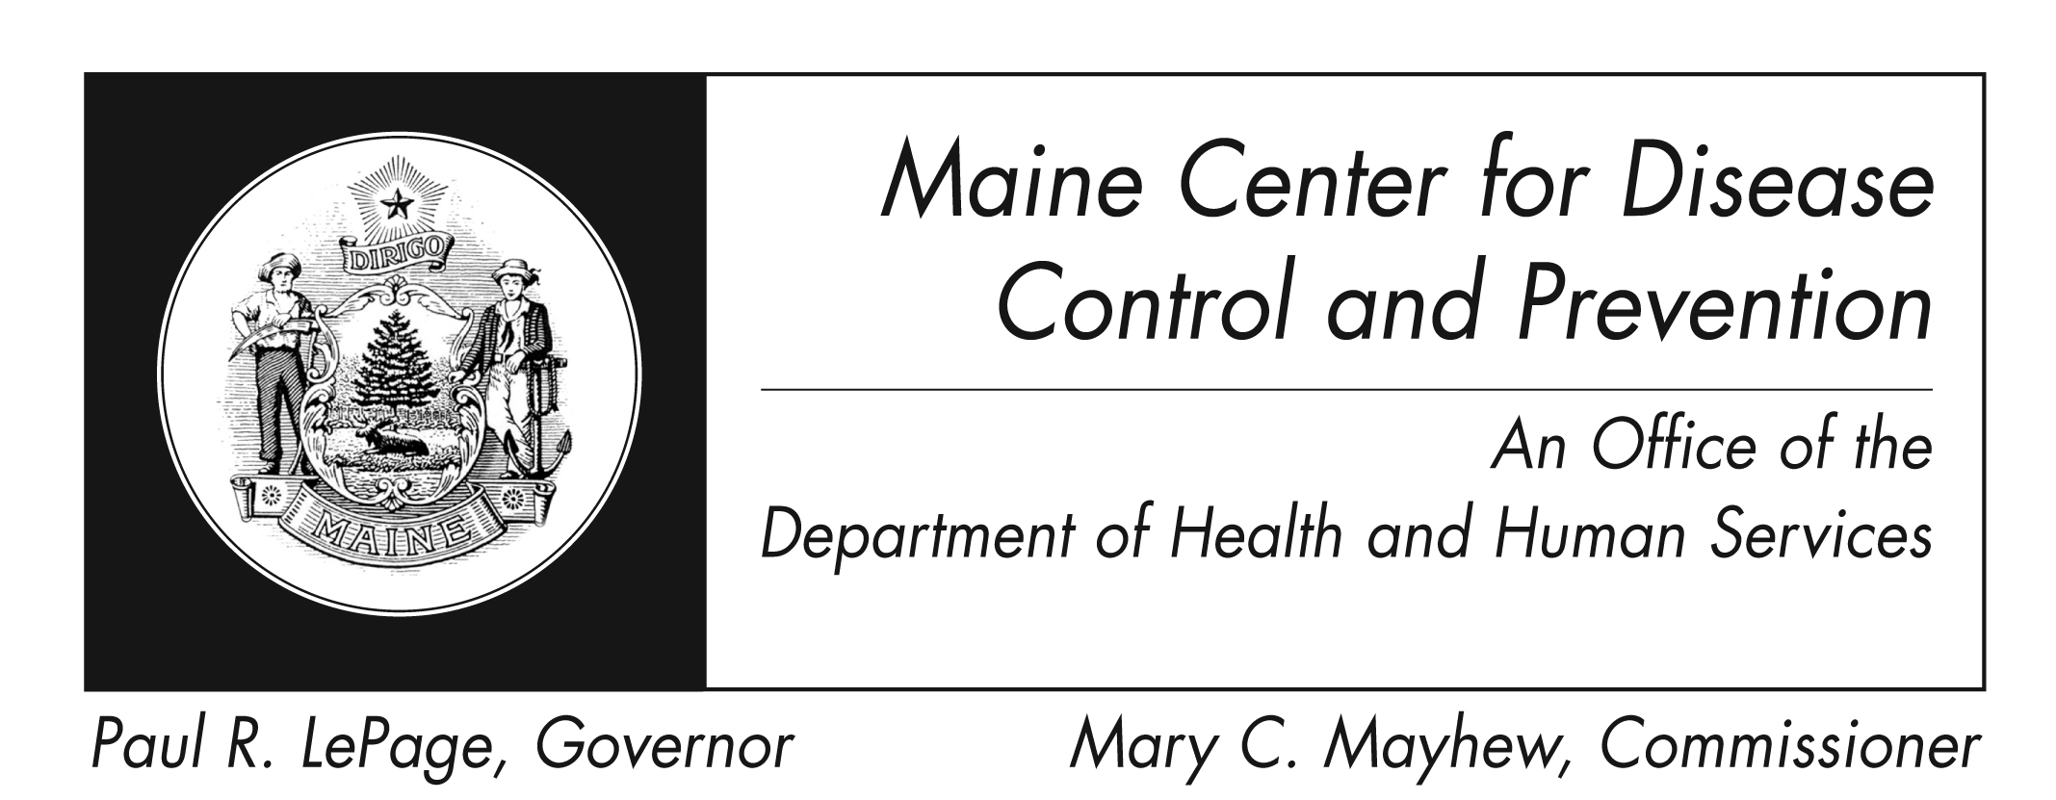
SARS
Fact Sheet

What is SARS?
SARS, or Severe Acute Respiratory Syndrome, is a viral respiratory disease caused by a coronavirus, called SARS-associated coronavirus (SARS-CoV). It first appeared in Southern China in November 2002 and was recognized as a global threat in March 2003.

How is SARS spread?
SARS is spread primarily by droplets produced when an infected person coughs or sneezes. The droplets can travel short distances (generally up to 3 feet) and be deposited on the mucous membranes of the mouth, nose, or eyes of persons who are nearby. The virus can also be spread by hand contact with contaminated surfaces or objects, followed by touching the mouth, nose, or eye(s).

What are the signs and symptoms of SARS?
The illness usually begins with a high fever (measured temperature greater than 100.4°F [>38.0°C]), and is sometimes associated with other symptoms such as chills, headache, general feeling of discomfort, and body aches. Some people also experience mild respiratory symptoms at the onset. Diarrhea is seen in 10-20% of patients. After 2 to 7 days, SARS patients may develop a dry, nonproductive cough. Low oxygen levels (hypoxia) may be present in blood. Most patients develop pneumonia, and 10-20% require mechanical ventilation.

How will I know if I have a SARS infection?
A patient with SARS might present with symptoms similar to a serious community-acquired atypical pneumonia. Laboratory testing would be done at federal CDC should the need arise, using specimens such as blood, stool, and nasal secretions.

How is SARS treated?
Patients with SARS receive the same treatment that would be used for any patient with serious community-acquired atypical or viral pneumonia. Hospitalization may be necessary to provide specialized care.

How can I prevent SARS?
Risk factors for developing SARS in the 2003-2004 outbreak were identified as recent travel to an area where SARS was spreading locally, or close contact with someone with SARS.

- Wash hands frequently with soap and water or use an alcohol-based hand rub.
- Avoid touching your eyes, nose, and mouth with unclean hands

- Cover your nose and mouth with a tissue or sleeve when coughing or sneezing; encourage those around you to do the same.

- If traveling, check the CDC travelers’ health website http://wwwn.cdc.gov/travel/ for information about SARS disease reports or alerts for your destination.

- Refrain from donating blood for at least 21 days if you have been in a site identified by public health authorities as at-risk for SARS.

What about work and daycare?

- Persons with SARS are most likely to be contagious only when they have symptoms, such as fever or cough.
- Patients are most contagious during the second week of illness.
- The federal CDC recommends that persons with SARS should not work or attend school, and should limit interactions outside the home.
- Normal activities may be resumed 10 days after fever has gone away and respiratory (breathing) symptoms have improved.

How common is SARS?
Currently, there are no known SARS cases anywhere in the world. The last cases were reported in April 2004.

