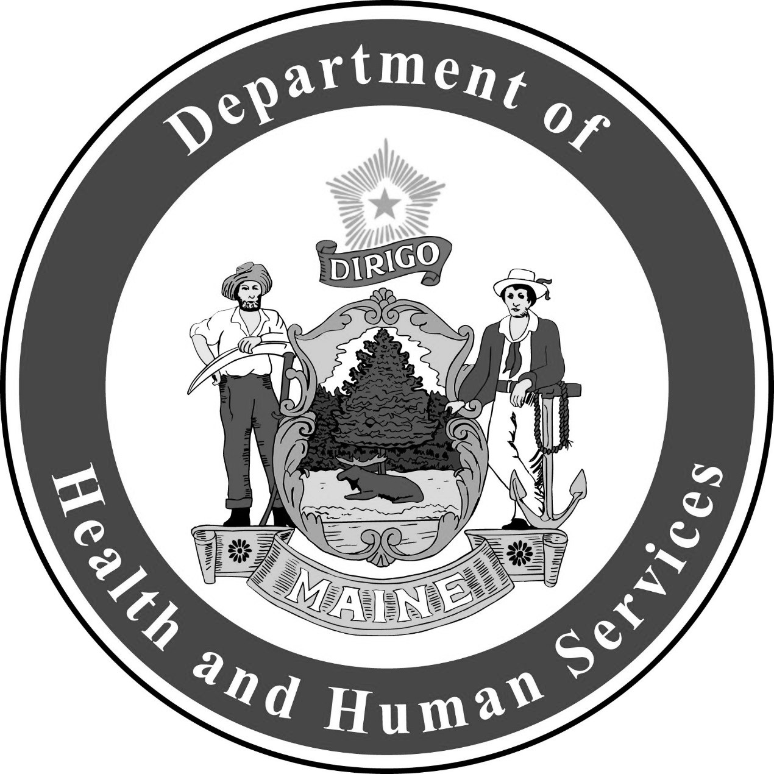
Campylobacteriosis
Fact Sheet

Campylobacteriosis is a diarrheal disease in humans caused by Campylobacter bacteria.
Many pigs, cows, chickens, and other birds and animals that show no signs of illness carry Campylobacter.

Common Signs and Symptoms

Diarrhea
Nausea and Vomiting
Stomach Pain
Fever

The most common symptom is diarrhea, which may have blood in it. Feeling tired is another common symptom. Signs and symptoms usually start two to five days after exposure and last about a week. Some infected people do not have any symptoms.
Spread of Campylobacter
People can get sick with Campylobacter through:

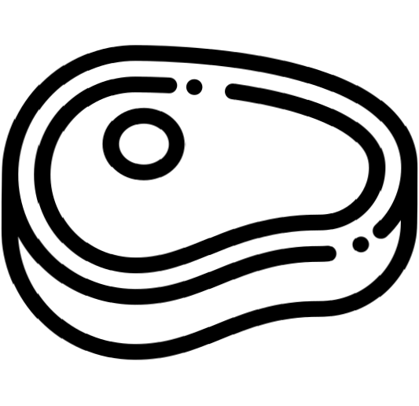

Eating Undercooked Food
Drinking Contaminated Water or Raw Milk
Contact with the Stool of Infected Animals

Campylobacter can also spread between people through poor hand hygiene.

Talk to your doctor if you think you have Campylobacter. Your doctor may ask for a stool sample to send to a laboratory. Most people do not need treatment. Few people with Campylobacter get very sick and may need antibiotics.

Prevent Campylobacter
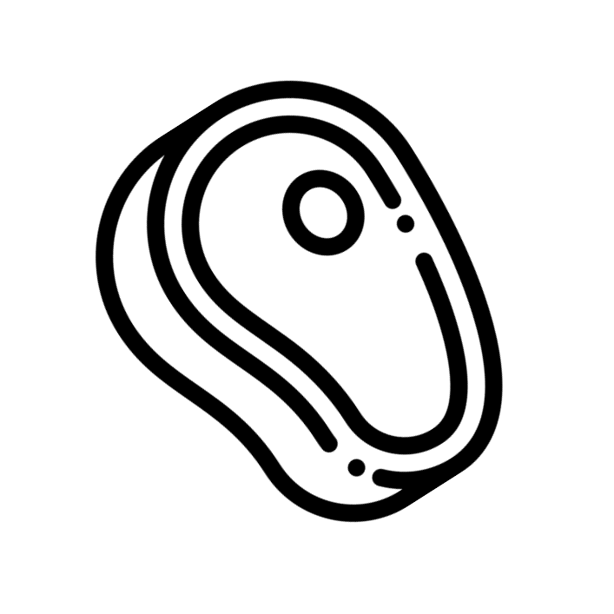
RAW MILK

Do not let infants and children touch raw poultry products or packaging
Use separate cutting boards for raw and cooked meat and vegetables, fruit, or cheese
Do not eat or drink unpasteurized dairy products, including raw milk
Cook poultry thoroughly

Always wash your hands with soap and water:
Before eating, preparing food, and after preparing food After using the toilet or changing diapers
After touching animals, especially chickens
If you are taking care of someone with Campylobacter after cleaning the bathroom, helping with toileting, changing diapers, or touching soiled clothing or linens

Additional prevention methods include:
Use only clean utensils, dishes, and cutting boards when cooking or preparing food Avoid drinking untreated water when hiking or camping
Avoid swallowing water when swimming or boating

Until 24 hours after diarrhea stops, people with Campylobacter should not: Work as food handlers or cooks
Provide direct patient care Attend daycare or school

For More Information, Visit:
- www.maine.gov/dhhs/campylobacter
- www.cdc.gov/campylobacter

You can also call Maine CDC at 1-800-821-5821.

Updated February 2019 Icons from www.flaticon.com

