Clostridium difficile
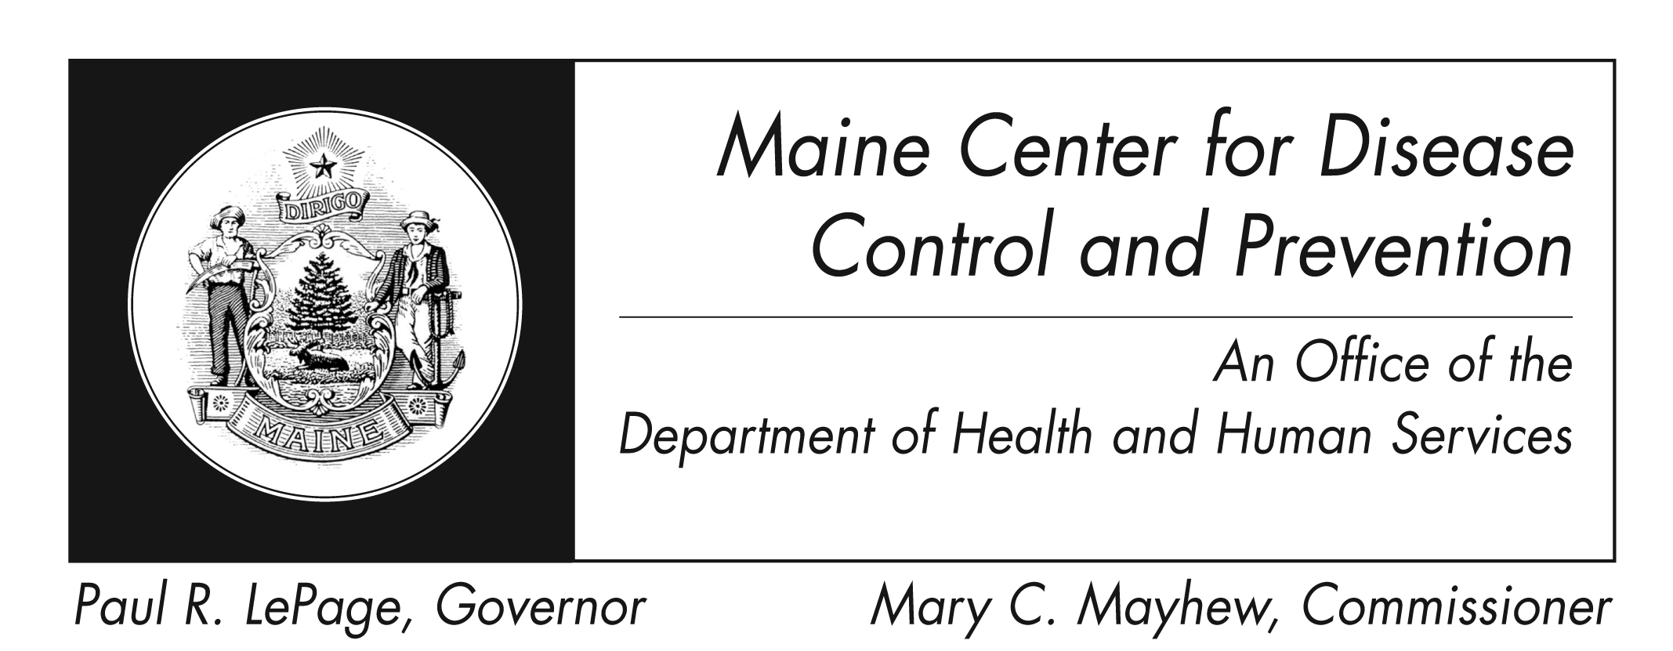
Fact Sheet

What is Clostridium difficile infection?
Clostridium difficile infection (sometimes called C. diff) is caused by Clostridium difficile bacteria. Most cases of C. diff infection occur in people taking antibiotics.

How is it spread?
C. diff produces spores which can live outside the body in the air or on objects for a long time. C. diff has been found in patient settings on objects such as bed linens, bed rails, bathroom fixtures, and medical equipment. C. diff infection can spread from person-to-person via contaminated equipment and a person’s hands.

What are the symptoms of C. diff infection?
Infection with C. diff can cause:
- watery diarrhea
- stomach cramping
- weakness
- dehydration
- fever
- nausea/vomiting.

Who is at risk of getting infected?
People taking antibiotics, especially more than one, or for a long time, are at greatest risk. Elderly persons, hospital patients, those who live in a nursing home, and those with underlying medical conditions are also at high risk. A person can get C.diff more than once.

How is it diagnosed?
C. diff is diagnosed with a lab test of the stool.

How is it treated?
Antibiotics are used to treat C. diff infection. In rare cases when C. diff does not respond to antibiotics, fecal biotherapy may be done. This is when “healthy” stool is transplanted inside a C. diff patient.

How can C. diff infection be prevented?
- Ask healthcare providers to wash their hands with soap and warm water before and after they care for you. Alcohol sanitizer does not destroy C. diff spores.
- Patients with C. diff will be on contact precautions. This means the patient is placed in a single room or with another patient at low risk. Providers and visitors wear gloves, gowns, mask, and wash their hands.
- Clean and disinfect high touch surfaces with a 1:10 chlorine bleach product.
- Only take antibiotics when necessary.

Where can I get more information?
Contact your healthcare provider or local health center for more information. You can also contact the Maine Center for Disease Control and Prevention by calling 1-800-821-5821 or at www.mainepublichealth.gov. The federal Centers for Disease Control and Prevention website - http://www.cdc.gov – is another excellent source of health information.

