Ascariasis
Fact Sheet

Ascariasis is an illness caused by the parasitic roundworm called Ascaris.

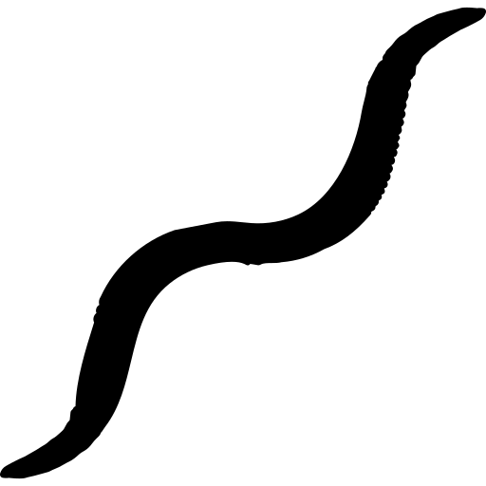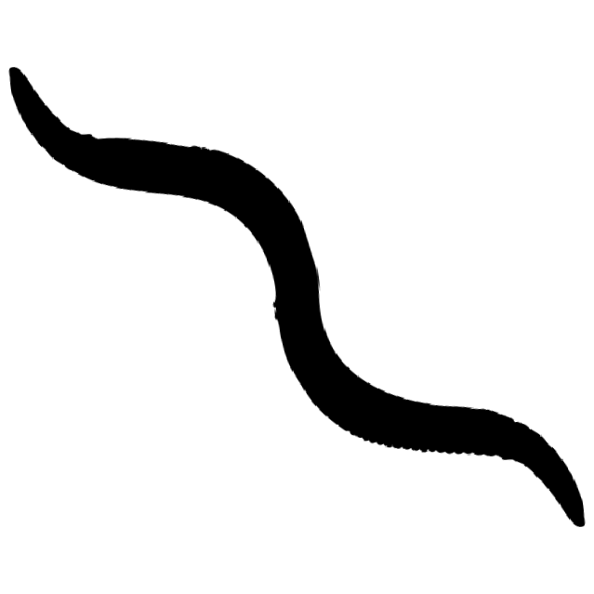Ascaris lives in the intestines of infected persons and animals. The eggs pass in their stool. Ascariasis happens when you swallow the eggs. It can also spread by eating contaminated vegetables or fruit.

Common Signs and Symptoms

Stomach Pain Cough

Most people infected with Ascaris do not show signs or symptoms. Heavy infections can cause blockage of the gut and slow growth in children. Medications that kill the parasitic worms are available and are usually taken for one to three days. Your doctor may order a stool sample to send to a laboratory.

Prevention

Wash hands with soap and water, especially:
Before touching or eating food
After doing farm chores
Wash, peel, or cook all raw vegetables and fruits before eating. This is very important for foods grown in soil fertilized with manure.

Good hygiene and sanitation practices are helpful to prevent infection. Avoid contact with soil that may be contaminated, including manure used to fertilize crops.

For More Information
Visit www.cdc.gov/parasites/ascariasis.
You can also call Maine CDC at 1-800-821-5821.

Updated March 2019 Icons from www.flaticon.com

