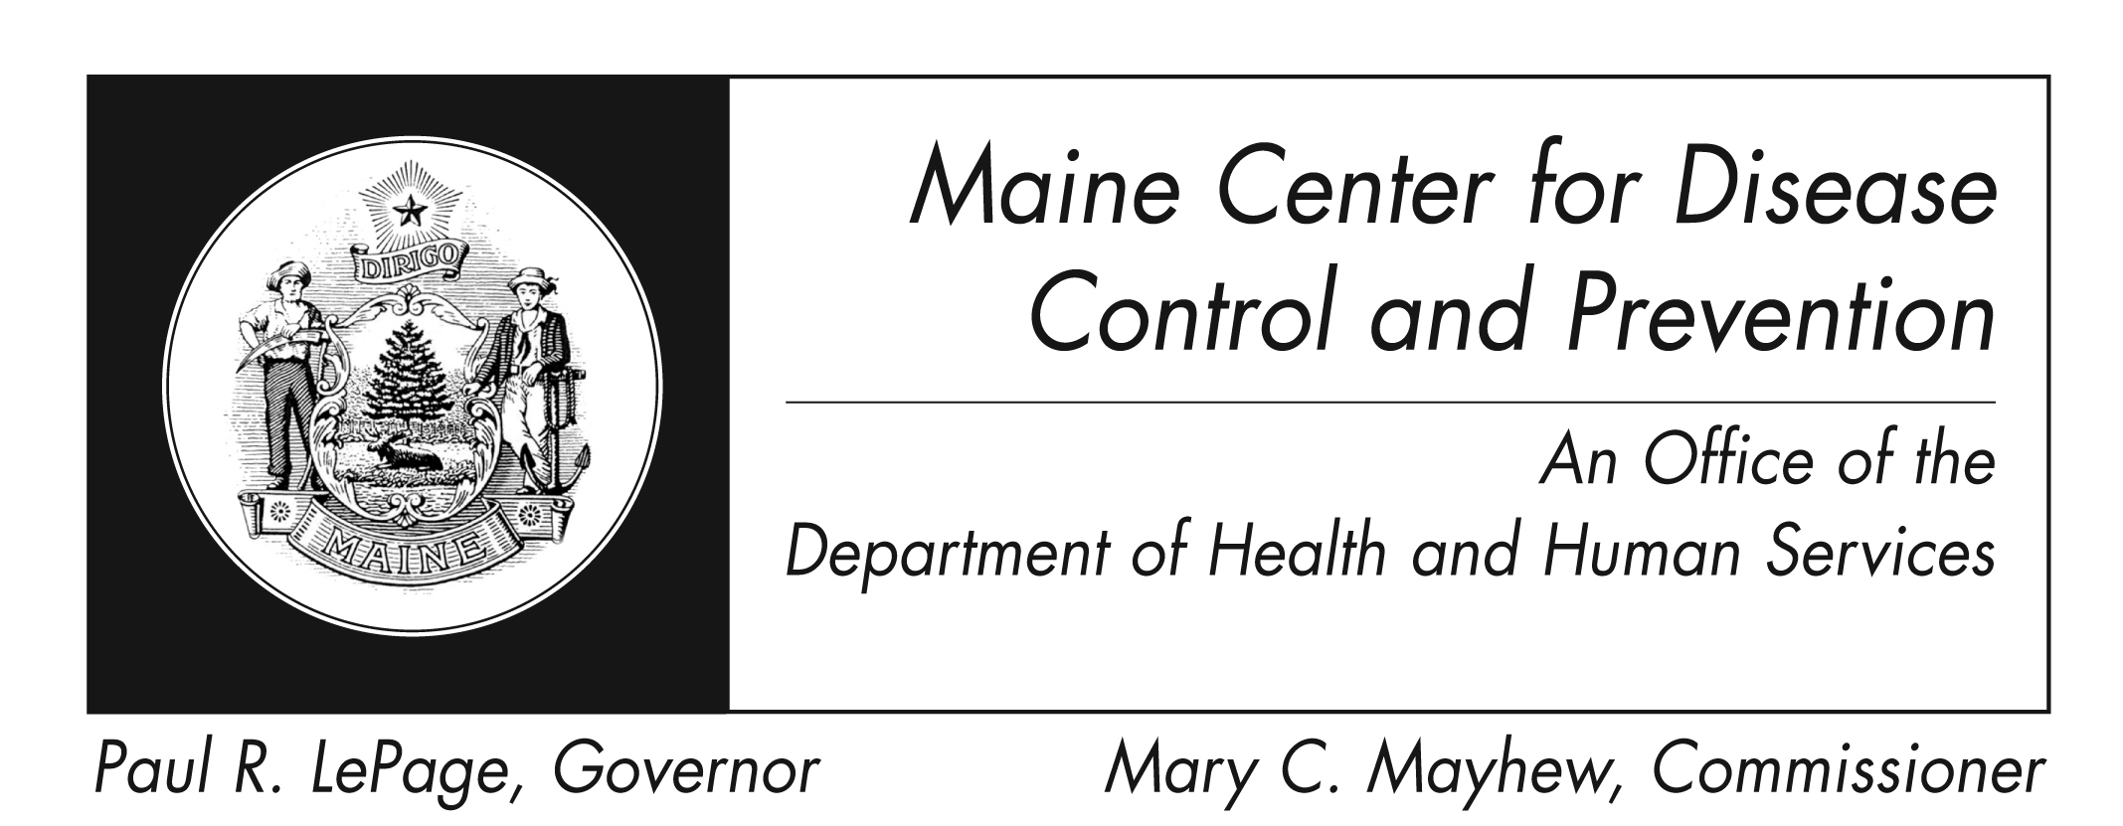

Acute Flaccid Myelitis
Fact Sheet

What is Acute Flaccid Myelitis (AFM)?
It is a condition that affects the nervous system, specifically the spinal cord, which can result from a variety of causes.

What causes AFM?
Unfortunately, the exact cause of AFM is unknown but research is ongoing. AFM can be caused by a variety of germs.

What are the symptoms of AFM?
Most patients will have sudden onset of limb weakness and loss of muscle tone and reflexes. Some patients may also experience facial droop / weakness, difficulty moving the eyes, drooping eyelids or difficulty with swallowing or slurred speech. Rare symptoms include numbness or tingling in the limbs and being unable to pass urine. In rare cases, a patient may have difficulty breathing due to muscle weakness.

How is AFM diagnosed?
AFM is diagnosed after an examination by a health care provider using a combination of clinical symptoms and special studies of the brain and spine.

What is the treatment for AFM?
There is no specific treatment for AFM, but a doctor who specializes in treating brain and spinal
cord illnesses (neurologist) may recommend certain interventions on a case-by-case basis. If you or your child is having problems walking or standing, or develop sudden weakness in an arm or leg, contact your doctor right away.

How can I prevent AFM?
Being up to date on all recommended vaccinations, including poliovirus, is one way to protect yourself and your family from diseases that can cause AFM. Check with your doctor to make sure your family is up to date on all recommended vaccines.

Protect against mosquito bites by using mosquito repellent and staying indoors at dusk and dawn, which is the prime period that mosquitoes bite. Remove standing or stagnant water from nearby property to minimize the number of mosquitoes.

Protect yourselves from other suspected causes of AFM by
- washing your hands often with soap and water
- avoiding close contact with sick people
- cleaning surfaces with a disinfectant, especially surfaces that a sick person has touched
Wash your hands often, and especially
- before you touch food
- after going to the bathroom, blowing your nose, changing a baby’s diaper, or touching an animal, an animal’s food, urine or feces
- Before and after taking care of a sick person or a cut or wound

Where can I get more information?
For more information contact your healthcare provider or local health center. You can also contact the Maine Center for Disease Control and Prevention by calling 1-800-821-5821. The federal Centers for Disease Control and Prevention website: http://www.cdc.gov/acute-flaccid-myelitis/ is another excellent source of health information.

