Mosquito Anatomy Puzzles

Directions
This activity is intended for grades 3-8.
Split class up into four groups and have each group put the mosquito puzzle together. Then, have the students put the labels on the arrows that correspond with each mosquito part. There will be some labels that won’t be used.
The goal of the game is to be the team that completes the puzzle and its corresponding labels the fastest. Refer to the key for the correct placement of parts and labels.
Discussion can include the function of each part with emphasis on the proboscis and how only the female uses it to pierce the skin.
Supplies
- Mosquito puzzles
- Labels
- Answer Key
Learning Objectives
- Knowledge of mosquito anatomy

Puzzle Labels (To Be Cut Out)

Abdomen
Head
Antenna
Scapula
Leg
Scutum

Claw
Tarsus
Stinger
Proboscis
Wing
Thorax

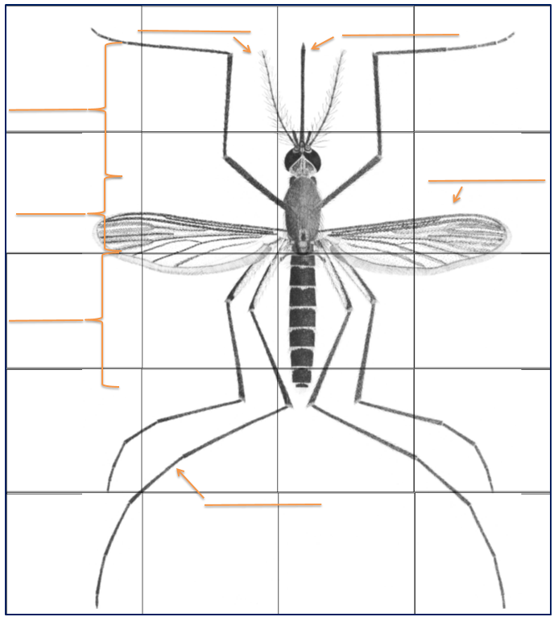

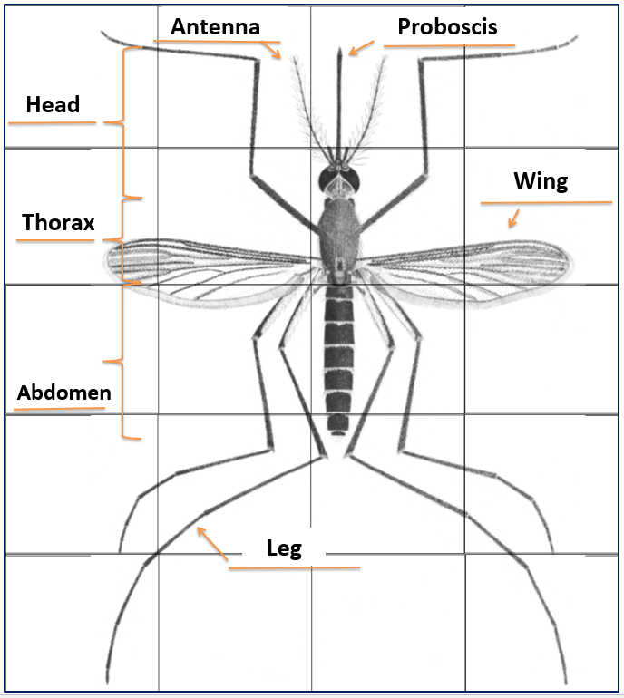
Mosquito Puzzle Answer Key

