Maine Weekly Influenza Surveillance Report

January 3, 2007

Synopsis
During the week ending December 30, 2006 (MMWR week 52)*, sporadic influenza activity was reported in Maine. Five cases of influenza from Penobscot and Franklin counties have been laboratory confirmed in Maine to date.

Moderate Disease Surveillance

Outpatient influenza-like illness (ILI)
During the week ending December 30, 2006, 0.7% of sentinel provider outpatient visits were due to ILI (range 0% - 5.1%).
Outpatient Visits for Influenza-like Illness -- Maine, 2005-07

# New England is defined as Connecticut, Maine, Massachusetts, New Hampshire, Rhode Island, and Vermont.

Severe Disease Surveillance

Hospital inpatients
During the week ending December 23, 2006 (week 51), 3.1% of admissions reported by three hospitals were due to respiratory illness (range 1.4% - 5.1%). During the week ending December 30, 2006 (week 52), 5.9% of admissions reported by two hospitals were due to respiratory illness (range 5.0% - 6.8%).

Hospital Admissions due to Respiratory Illness -- Maine, 2005-07

Laboratory Reporting
During the week ending December 30, 2006, six respiratory specimens were submitted to the Maine Health and Environmental Testing Laboratory (HETL). Of these, two specimen (33.3%) was positive for influenza A; results are pending on the remaining four specimens. As of December 30, 2006, a total of 50 respiratory specimens have been submitted for viral testing to HETL since October when influenza surveillance season began. Of these, three specimen (6.0%) was positive for influenza (2 for influenza A and 1 for influenza B), three specimens were presumptive positive for enterovirus, results are pending for 11 specimens, and the remaining specimens were negative.
Respiratory Specimens Positive for Influenza – Maine Health and Environmental Testing Laboratory, 2006-07

During the week ending December 30, 2006, a total of 51 respiratory specimens were submitted to two private reference laboratories in Maine. Of these, two specimens (3.9%) were positive for influenza B, one specimen was positive for respiratory syncytial virus (RSV), one specimen was positive for para-influenza 3, one specimen was positive for enterovirus, and the remaining specimens were negative. As of December 30, 2006, a total of 223 respiratory specimens have been submitted for viral testing to two reference laboratories in Maine since October when influenza surveillance season began. Two specimens (0.9%) were positive for influenza, 8 specimens were positive for RSV, 1 specimen was positive for parainfluenza-3, 8 specimens were positive for adenovirus, 9 specimens were positive for enterovirus, and the remaining specimens were nagative.
Respiratory Specimens Positive for Influenza – Two Reference Laboratories, Maine 2006-07

Fatalities Surveillance

Death Certificates
During the week ending December 30, 2006, 7.0% of deaths reported by three city vital records office were attributable to pneumonia and influenza (range 0% - 11.5%).

Percentage of Deaths Attributable to Pneumonia and Influenza – Maine, New England and the United States, 2005-07
^ New England includes the following reporting areas: Boston, MA; Bridgeport, CT; Cambridge, MA; Fall River, MA; Hartford, CT; Lowell, MA; Lynn, MA; New Bedford, MA; New Haven, CT; Providence, RI; Somerville, MA; Springfield, MA; Waterbury, CT; Worcester, MA.

Pediatric Fatalities
As of December 30, 2006, no influenza-associated pediatric deaths have been reported in Maine this season.

National Influenza Activity
State health departments report the estimated level of influenza activity in their states each week. States report influenza activity as: 1) no activity, 2) sporadic, 3) local, 4) regional, or 5) widespread (definitions of these levels can be found at: http://www.cdc.gov/flu/weekly/usmap.htm). Maine reported sporadic influenza activity for the week ending December 30, 2006.

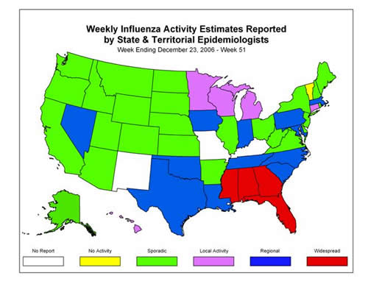

* At time of publication, reporting may be incomplete. Numbers presented here may change as more reports are received.

