Maine Weekly Influenza Surveillance Report

December 28, 2006

Synopsis
During the week ending December 23, 2006 (MMWR week 51)*, sporadic influenza activity was reported in Maine. Influenza B was laboratory confirmed in a young adult visiting Maine from out of state. A slight increase in outpatient visits for influenza-like illness has been observed in Maine since early December.

Moderate Disease Surveillance

Outpatient influenza-like illness (ILI)
During the week ending December 23, 2006, 0.8% of sentinel provider outpatient visits were due to ILI (range 0% - 1.7%).
Outpatient Visits for Influenza-like Illness -- Maine, 2005-07

# New England is defined as Connecticut, Maine, Massachusetts, New Hampshire, Rhode Island, and Vermont.

Severe Disease Surveillance

Hospital inpatients
During the week ending December 16, 2006 (week 50), 3.8% of admissions reported by four hospitals were due to respiratory illness (range 2.3% - 5.5%). During the week ending December 23, 2006 (week 51), 3.1% of admissions reported by three hospitals were due to respiratory illness (range 1.4% - 5.1%).

Hospital Admissions due to Respiratory Illness -- Maine, 2005-07

Laboratory Reporting
During the week ending December 23, 2006, five respiratory specimens were submitted to the Maine Health and Environmental Testing Laboratory (HETL). Of these, one specimen (20.0%) was positive for influenza B; results are pending on the remaining four specimens. As of December 23, 2006, a total of 44 respiratory specimens have been submitted for viral testing to HETL since October when influenza surveillance season began. Of these, one specimen (2.0%) was positive for influenza B, three specimens were presumptively positive for enterovirus, results are pending for 5 specimens, and the remaining specimens were negative.
Respiratory Specimens Positive for Influenza – Maine Health and Environmental Testing Laboratory, 2006-07

As of December 23, 2006, a total of 171 specimens have been submitted for viral testing to two private reference laboratories in Maine; all were negative for influenza, seven specimens were positive for RSV, eight specimens were positive for adenovirus, and eight specimens were positive for enterovirus.

Fatalities Surveillance

Death Certificates
During the week ending December 23, 2006, 8.6% of deaths reported by three city vital records office were attributable to pneumonia and influenza (range 5.9% - 10.0%).

Percentage of Deaths Attributable to Pneumonia and Influenza – Maine, New England and the United States, 2005-07
^ New England includes the following reporting areas: Boston, MA; Bridgeport, CT; Cambridge, MA; Fall River, MA; Hartford, CT; Lowell, MA; Lynn, MA; New Bedford, MA; New Haven, CT; Providence, RI; Somerville, MA; Springfield, MA; Waterbury, CT; Worcester, MA.

Pediatric Fatalities
As of December 23, 2006, no influenza-associated pediatric deaths have been reported in Maine this season.

National Influenza Activity
State health departments report the estimated level of influenza activity in their states each week. States report influenza activity as: 1) no activity, 2) sporadic, 3) local, 4) regional, or 5) widespread (definitions of these levels can be found at: http://www.cdc.gov/flu/weekly/usmap.htm). Maine reported sporadic influenza activity for the week ending December 23, 2006.

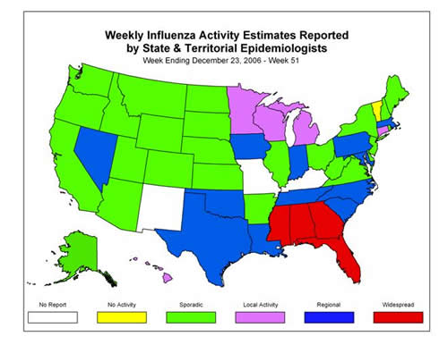

* At time of publication, reporting may be incomplete. Numbers presented here may change as more reports are received.

