Maine Weekly Influenza Surveillance Report

December 6, 2006

Synopsis
During the week ending December 2, 2006 (MMWR week 48)*, no influenza activity was reported in Maine.

Moderate Disease Surveillance

Outpatient influenza-like illness (ILI)
During the week ending December 2, 2006, 0.5% of sentinel provider outpatient visits were due to ILI (range 0% - 0.9%).
Percentage of Patient Visits for Influenza-like Illness -- Maine, 2005-2007

# New England is defined as Connecticut, Maine, Massachusetts, New Hampshire, Rhode Island, and Vermont.

Severe Disease Surveillance

Hospital inpatients
During the week ending November 25, 2006 (week 47), 4.0% of admissions reported by four hospitals were due to respiratory illness (range 1.7% - 7.1%). During the week ending December 2, 2006 (week 48), 1.8% of admissions reported by two hospitals were due to respiratory illness (range 1.2% - 2.3%).

Percentage of Hospital Admissions due to Respiratory Illness -- Maine, 2005-07

Laboratory Reporting
As of December 2, 2006 a total of 32 respiratory specimens have been submitted for viral testing to the Maine Health and Environmental Testing Laboratory. Twenty-one specimens were negative for influenza, three specimens were presumptive positive for enterovirus, and results are pending for eight specimens.

As of December 2, 2006, a total of 110 specimens have been submitted for viral testing to two reference laboratories in Maine; all were negative for influenza, three specimens were positive for RSV, seven specimens were positive for adenovirus, and seven specimens were positive for enterovirus.

Fatalities Surveillance

Death Certificates
During the week ending December 2, 2006, 7.9% of deaths reported by two city vital records offices were attributable to pneumonia and influenza (range 5.0%-13.0%).

Percentage of Deaths Attributable to Pneumonia and Influenza – Maine, New England and the United States, 2005-07
^ New England includes the following reporting areas: Boston, MA; Bridgeport, CT; Cambridge, MA; Fall River, MA; Hartford, CT; Lowell, MA; Lynn, MA; New Bedford, MA; New Haven, CT; Providence, RI; Somerville, MA; Springfield, MA; Waterbury, CT; Worcester, MA.

Pediatric Fatalities
As of December 2, 2006, no influenza-associated pediatric deaths have been reported in Maine this season.

National Influenza Activity
State health departments report the estimated level of influenza activity in their states each week. States report influenza activity as no activity, sporadic, local, regional, or widespread. Definitions of these levels can be found at: http://www.cdc.gov/flu/weekly/usmap.htm

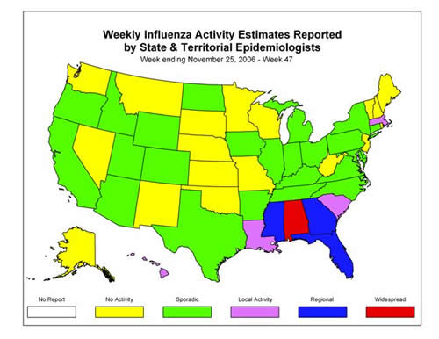

* At time of publication, reporting may be incomplete. Numbers presented here may change as more reports are received.

