Maine Weekly Influenza Surveillance Report

November 9, 2006

Synopsis
During the week ending November 4, 2006 (week 44)*, no influenza activity was reported in Maine.

Moderate Disease Surveillance

Outpatient influenza-like illness (ILI)
During the week ending November 4, 2006, 0.5% of sentinel provider outpatient visits were due to ILI (range 0% - 1.2%).
Percentage of Patient Visits for Influenza-like Illness -- Maine, 2005-2007

# New England is defined as Connecticut, Maine, Massachusetts, New Hampshire, Rhode Island, and Vermont.

Severe Disease Surveillance

Hospital inpatients
During the week ending October 28, 2006, 3.9% of admissions reported by four hospitals were due to respiratory illness (range 0% - 9.6%). During the week ending November 4, 2006, 3.5% of admissions reported by three hospitals were due to respiratory illness (range 0% - 9.0%).

Percentage of Hospital Admissions due to Respiratory Illness -- Maine, 2005-07

Laboratory Reporting
As of November 9, 2006 a total of 18 respiratory specimens have been submitted for viral testing to the Maine Health and Environmental Testing Laboratory. Seven specimens were negative for influenza, three specimens were presumptive positive for enterovirus, and results are pending for eight specimens.

As of the week ending November 4, 2006, a total of 12 specimens have been submitted for viral testing to two reference laboratory in Maine; all were negative for influenza.

Fatalities Surveillance

Death Certificates
During the week ending November 4, 2006, 9.1% of deaths reported by three city vital records offices were attributable to pneumonia and influenza (Range 6.5% - 15.8%).

Percentage of Deaths Attributable to Pneumonia and Influenza – Maine, New England and the United States, 2005-07
^ New England includes the following reporting areas: Boston, MA; Bridgeport, CT; Cambridge, MA; Fall River, MA; Hartford, CT; Lowell, MA; Lynn, MA; New Bedford, MA; New Haven, CT; Providence, RI; Somerville, MA; Springfield, MA; Waterbury, CT; Worcester, MA.

Pediatric Fatalities
As of November 9, 2006, no influenza-associated pediatric deaths have been reported.

National Influenza Activity
State health departments report the estimated level of Influenza activity in their states each week. States report Influenza activity as no activity, sporadic, local, regional, or widespread. Defintions of these levels can be found at the following web site: http://www.cdc.gov/flu/weekly/usmap.htm

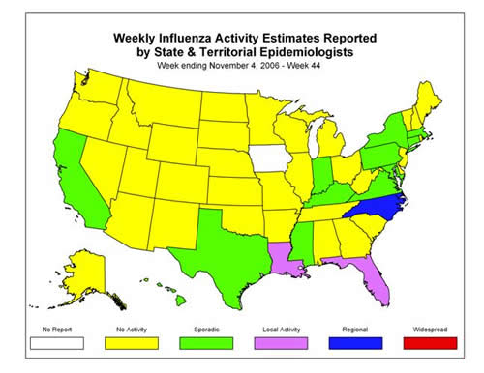
* At time of publication, reporting may be incomplete. Numbers presented here may change as more reports are received.

