Maine Weekly Influenza Surveillance Report

January 11, 2007

Synopsis
During the week ending January 6, 2007 (MMWR week 1)*, sporadic influenza activity was reported in Maine. Six cases of influenza have been laboratory confirmed to date. Moderate increases in outpatient influenza-like illness visits and inpatient admissions for respiratory illness have been observed.

Moderate Disease Surveillance

Outpatient influenza-like illness (ILI)
During the week ending January 6, 2007, 1.1% of sentinel provider outpatient visits were due to ILI (range 0% - 3.4%).
Outpatient Visits for Influenza-like Illness -- Maine, 2005-07

# New England is defined as Connecticut, Maine, Massachusetts, New Hampshire, Rhode Island, and Vermont.

Severe Disease Surveillance

Hospital inpatients
During the week ending December 30, 2006 (week 52), 4.8% of admissions reported by three hospitals were due to respiratory illness (range 2.5% - 6.8%). During the week ending January 6, 2007 (week 1), 6.0% of admissions reported by three hospitals were due to respiratory illness (range 2.0% - 11.3%).

Hospital Admissions due to Respiratory Illness -- Maine, 2005-07

Laboratory Reporting
During the week ending January 6, 2007, seven respiratory specimens were submitted to the Maine Health and Environmental Testing Laboratory (HETL); results are pending on these specimens. As of January 6, 2007, a total of 59 respiratory specimens have been submitted for viral testing to HETL since October when the influenza surveillance season began. Of these, four specimen (6.7%) was positive for influenza (2 for influenza A and 2 for influenza B), three specimens were presumptive positive for enterovirus, results are pending for 11 specimens, and the remaining specimens were negative.
Respiratory Specimens Positive for Influenza – Maine Health and Environmental Testing Laboratory, 2006-07

During the week ending January 6, 2007, a total of 78 respiratory specimens were submitted to two private reference laboratories in Maine. Of these, no specimens were positive for influenza, 17 specimen was positive for respiratory syncytial virus (RSV), and the remaining specimens were negative. As of January 6, 2007, a total of 332 respiratory specimens have been submitted for viral testing to two reference laboratories in Maine since October when the influenza surveillance season began. Two specimens (0.6%) were positive for influenza, 25 (7.5%) specimens were positive for RSV, 1 (0.3%) specimen was positive for parainfluenza-3, 8 (2.4%) specimens were positive for adenovirus, 9 (2.7%) specimens were positive for enterovirus, and the remaining specimens were negative.
Respiratory Specimens Positive for Influenza – Two Reference Laboratories, Maine 2006-07

Fatalities Surveillance

Death Certificates
During the week ending January 6, 2007, 8.1% of deaths reported by three city vital records office were attributable to pneumonia and influenza (range 3.2% - 25.0%).

Percentage of Deaths Attributable to Pneumonia and Influenza – Maine, New England and the United States, 2005-07
^ New England includes the following reporting areas: Boston, MA; Bridgeport, CT; Cambridge, MA; Fall River, MA; Hartford, CT; Lowell, MA; Lynn, MA; New Bedford, MA; New Haven, CT; Providence, RI; Somerville, MA; Springfield, MA; Waterbury, CT; Worcester, MA.

Pediatric Fatalities
As of January 6, 2007, no influenza-associated pediatric deaths have been reported in Maine this season.

National Influenza Activity
State health departments report the estimated level of influenza activity in their states each week. States report influenza activity as: 1) no activity, 2) sporadic, 3) local, 4) regional, or 5) widespread (definitions of these levels can be found at: http://www.cdc.gov/flu/weekly/usmap.htm). Maine reported sporadic influenza activity for the week ending January 6, 2007.

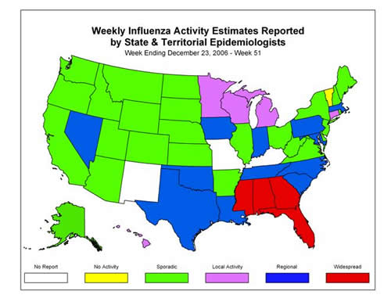

* At time of publication, reporting may be incomplete. Numbers presented here may change as more reports are received.

