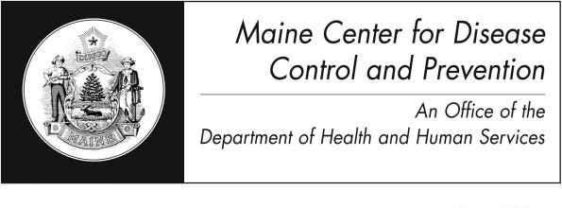
Plague
Fact Sheet

What is Plague?

It is an infection caused by the bacteria Yersinia pestis.

Who can get Plague?
Anyone who has not had the disease before can get plague. The bacteria are found in rodents like rats and their fleas. People get the disease if they are bitten by fleas carrying the disease. It is found all over the world and in the western United States.

What are the symptoms of Plague?

There are three forms of the plague.

Bubonic plague is the most common kind. It causes swollen tender lymph nodes, fever, headache, chills and weakness. People get this kind of plague when the bacteria enter through a break in the skin.

Septicemic plague is a blood infection caused by the plague bacteria. It is less common than bubonic plague.

Pneumonic plague happens when the bacteria gets into the lungs. It is the most severe kind – but the least common. People get pneumonic plague by breathing in droplets that have the bacteria in them. The droplets are released into the air when an infected person or animal coughs. If plague were to be used as a weapon, it would be released into the air on purpose and a person would have to breathe it in. Symptoms include high fever, chest pain, cough, shortness of breath, and coughing up blood. Pneumonic plague can also happen if a person with bubonic or septicemic plague is untreated and the bacteria get into the lungs. Unless antibiotics are started within 24 hours the person can go into shock and die.

Are there complications of Plague?
Plague is a very serious disease but all types of plague can be treated with antibiotics.

How soon do symptoms appear?

Symptoms appear 1-7 days after being exposed.

How is Plague spread?

Plague is spread by the bites of fleas infected by the bacteria, or by breathing in the bacteria.

How long is an infected person able to spread the disease?

Once a person has been taking antibiotics for 48 hours they cannot spread the disease.

What is the treatment for plague?

You doctor will treat you with antibiotics in the hospital if you have the plague.

How do I protect myself and my family?

If you travel to areas where plague occurs in nature, take measures to avoid rats and fleas. Use insect repellent and do not handle rodents. Do not camp near rodent burrows. Have your cat or dog treated with an insecticide. Wear gloves when hunting or handling animals.

What if I have been exposed?
Family and close contacts will be placed on antibiotics to prevent the disease.

Is there a vaccine to prevent plague?
There is no vaccine in the United States for general use.

Plague in Maine
There have been no cases of plague in Maine residents in the last ten years.

Where can I get more information?
For more information contact your healthcare provider or local health center. You can also contact the Maine Center for Disease Control and Prevention by calling 1-800-821-5821. The federal Centers for Disease Control and Prevention website - http://www.cdc.gov – is another excellent source of health information.

