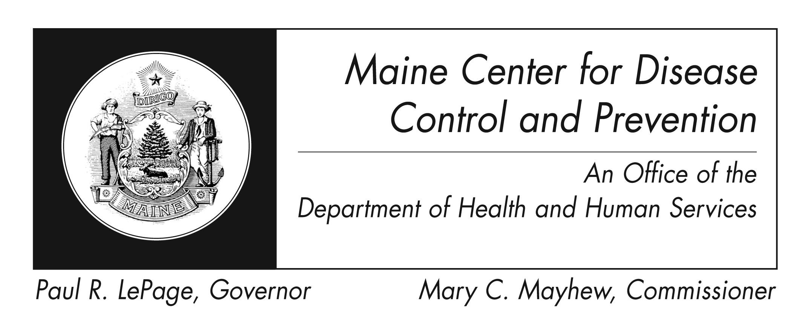
Methicillin-Resistant

Staphylococcus aureus (MRSA)
Fact Sheet

What is Staphylococcus aureus?
Staphylococcus aureus, also known as "staph," are bacteria. They are sometimes found on the skin or in the nose of healthy people who may not know they are carrying them and do not feel sick; this is called colonization. Sometimes these bacteria can cause infections, such as skin infections. Staph bacteria can cause more serious illness if they get into the bloodstream, the lungs, or a wound after surgery.

What is MRSA?
It is a type of staph bacteria that is resistant to certain antibiotics. This resistance can make infections harder to treat due to fewer treatment options.

How is MRSA spread?
Direct skin contact with another person or contact with items that have touched infected skin can spread staph, including MRSA. For example, sharing towels or athletic equipment can spread these bacteria. Fluid from staph infections such as boils is especially infectious.

What are the signs and symptoms of MRSA?
Staph bacteria, including MRSA, can cause skin infections. These infections may look like a pimple or boil. The area may also appear red, swollen, painful, or have pus or other drainage. Staph bacteria can also cause more serious infections such as lung, bloodstream, or wound infections after surgery.

How are MRSA infections treated?
Treatment for skin infections may include draining the boil. Antibiotics are not always necessary. If you receive antibiotics, take them exactly as your provider has instructed. If other people you know get the same infection, tell them to go to their healthcare provider.

Is it possible for a staph or MRSA skin infection to come back after it is cured?
Yes, staph or MRSA skin infections can come back after healing. To prevent this from happening, follow your healthcare provider’s directions while you have an infection and the prevention steps after the infection has healed.
What should I do if I think I have a MRSA infection?
Keep the area clean and dry. See your healthcare provider, especially if the infection is large, painful, warm to the touch, or does not heal by itself.

How will my healthcare provider know if I have a MRSA infection?
You usually will not receive testing for MRSA unless you have an active infection. If you have a skin infection, your healthcare provider may sample the area to find out what is causing the infection. A lab test will see which antibiotic would be best for you.

Does MRSA cause more serious infections than other staph?
MRSA does not usually cause more serious infections than other staph. However, MRSA infections can become severe if they are not properly treated.

How can I prevent staph or MRSA skin infections?
Practice good hygiene:
- Wash your hands with soap and water or use an alcohol-based hand sanitizer.
- Clean and cover cuts and scrapes with a bandage until healed.
- Avoid contact with other people’s wounds or bandages.
- Avoid sharing personal items such as towels or razors.
- Get care early if you think you may have an infection.

How common are staph and MRSA infections?
Staph bacteria are one of the most common causes of skin infection in the United States. Many MRSA infections happen among patients in hospitals or other healthcare settings. However, MRSA infections are becoming more common in the community. About 33% of the population is colonized with staph and 2% is colonized with MRSA.

Are certain people at increased risk for community-associated MRSA infections?
MRSA infection risk increases when a person is in activities or places that involve:
- Crowding
- Skin-to-skin contact
- Shared equipment or supplies

High-risk groups include:
- Athletes
- Daycare and school students
- Military personnel in barracks
- Individuals who recently received inpatient medical care

If I have a staph, or MRSA skin infection, what can I do to prevent others from getting infected?
You can prevent spreading infections to others by following these steps:
- Keep wounds that are draining or have pus covered with clean, dry bandages. Follow your healthcare provider’s instructions on proper care of the wound. Pus from infected wounds can contain staph and MRSA. You can throw away bandages or tape with the regular trash.
- You and anyone you are in close contact with should wash their hands often with soap and warm water or use an alcohol-based hand sanitizer. This is especially important after changing the bandage or touching the infected wound.
- Do not share personal items such as towels, washcloths, razors, clothing, or uniforms. Wash sheets, towels, and clothes that become soiled with water and laundry detergent. Drying clothes in a hot dryer, rather than air-drying, helps kill bacteria on clothes.
- Avoid contact sports and other skin-to-skin contact until your infection has healed.
- Skin infections should be evaluated by a healthcare provider for testing and treatment.
- Talk to your healthcare provider. Tell any healthcare providers who treat you that you have or had a staph or MRSA skin infection.

What about exclusions or school closure?
- Maine CDC does not recommend school closure when a student or staff member has a MRSA infection.
- Restrictions from work, school, or participation in school sports programs should only be considered if wound drainage cannot be covered and contained with a clean, dry bandage and for those who cannot maintain good hygiene practices.
- Food service workers with draining lesions that cannot be properly contained should not work as food handlers or cooks until lesions are healed, per Maine Food Code 2013.

Where can I get more information?
For more information contact your healthcare provider or local health center. You can also contact the Maine Center for Disease Control and Prevention by calling 1-800-821-5821 or visiting the website http://www.maine.gov/dhhs/mecdc/. The federal Centers for Disease Control and Prevention website - http://www.cdc.gov – is another excellent source of health information.

