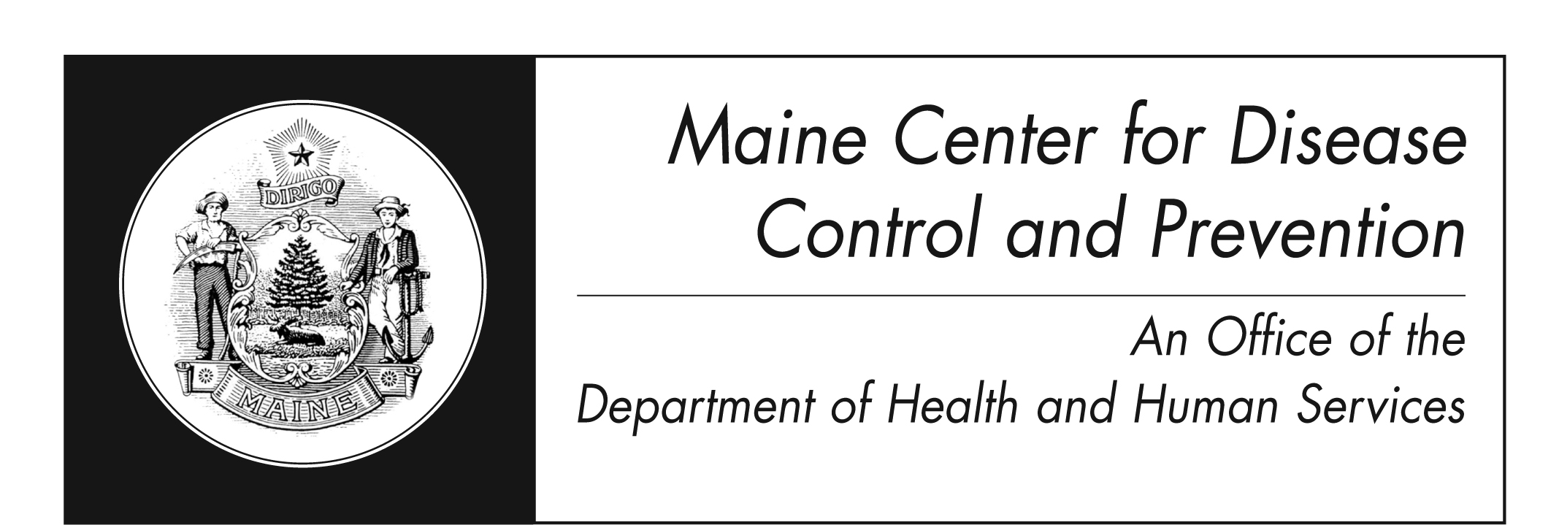
Listeriosis
Fact Sheet

What is Listeriosis?
Listeriosis is an illness caused by eating food that has the bacteria Listeria monocytogenes. The disease mostly affects pregnant women, newborns, and adults with weakened immune systems.

How is it spread?
You get sick by eating food contaminated with the Listeria bacteria. Babies can be born with it if their mothers become infected during pregnancy.

What are the signs and symptoms?
Symptoms may include: fever, muscle aches, nausea, and diarrhea. If infection spreads to the nervous system, symptoms such as headache, stiff neck, confusion, loss of balance, or convulsions can occur. Severe infections can result in death.

Infected pregnant women may have only a mild, flu-like illness, though infections during pregnancy can lead to miscarriage, stillbirth, premature delivery, or infection of the newborn. Healthy people sometimes get infected with Listeria, but they rarely become seriously ill.

How do you know if you have listeriosis?
Speak with your healthcare provider if you have symptoms. Lab tests can show if you have it.

Can listeriosis be treated?
Listeriosis is treated with antibiotics. Persons with serious medical problems and the elderly are more likely to become seriously ill.

How does Listeria get onto food?
The germ is found in soil and water. Vegetables can get contaminated from the soil or from manure used as fertilizer. Animals can carry the germ and contaminate foods such as meat and dairy products. The germ can also be found in raw (unpasteurized) milk or foods made with raw milk.

Listeria is killed by pasteurization and cooking. However, in certain ready-to-eat foods such as hot dogs and lunch meats, contamination may occur after cooking but before packaging.
How common is it?
In the United States, an estimated 1,600 persons become ill with listeriosis each year.

How can you reduce your risk of getting sick?
- Cook meat products to safe temperatures
- Wash raw vegetables and fruit before eating
- Dry produce with a clean cloth or paper towel
- Separate uncooked meats from vegetables, cooked foods, and ready-to-eat foods
- Avoid raw milk or foods made from raw milk
- Wash hands, knives, and cutting boards after handling uncooked foods
- The fridge should be kept at 40°F or lower
- Clean up all spills in the fridge right away; clean inside walls and shelves with hot water and liquid soap, then rinse
- Use leftovers within 3 to 4 days
- Store hot dogs in open package no longer than 1 week and unopened package no longer than 2 weeks in the fridge
- Store factory-sealed, unopened lunch meat no longer than 2 weeks; store open packages no longer than 3-5 days in the fridge

I’m pregnant, elderly or immune compromised; what foods should I avoid?
- Raw or unpasteurized milk or milk products
- Soft Cheeses (e.g. feta, goat, or Brie)
- Refrigerated pâté
- Hot dogs and lunch meats unless heated to 165°F, or until steaming hot
- Smoked seafood, unless contained in a cooked dish, such as a casserole, canned or shelf-stable product

Where can I get more information? For more information contact your healthcare provider or local health center. You can also contact the Maine Center for Disease Control and Prevention by calling 1-800-821-5821 or visiting www.maine.gov/idepi. The federal Centers for Disease Control and Prevention website - http://www.cdc.gov/listeria – is another excellent source of information.

