Hand, Foot, and Mouth Disease
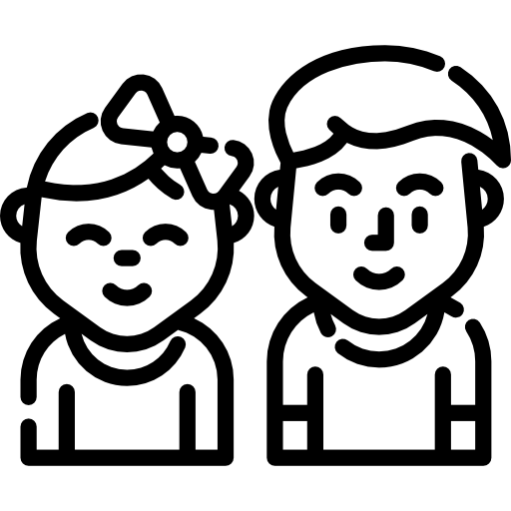Fact Sheet

Hand, foot, and mouth disease (HFMD) is caused by a group of viruses, called enteroviruses.
HFMD occurs mainly in infants and children under 5 years old, but it can also occur in adults.

Common Signs and Symptoms

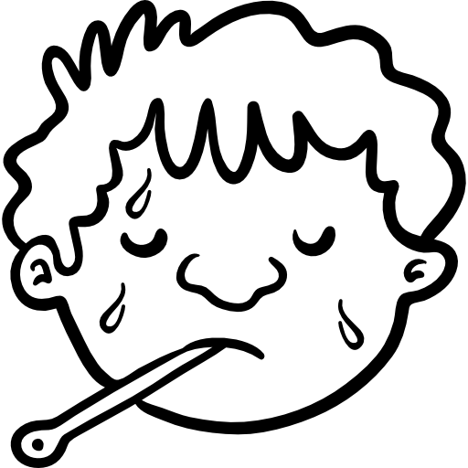

Sores in the Mouth

Poor Appetite
Fever

Feeling Tired
Skin Rash

Sore Throat

HFMD usually starts with a fever, reduced appetite, and a sore throat. One or two days after the fever starts, painful blister-like sores develop in the mouth. A skin rash on the palms of the hands and soles of the feet may also develop as flat, red spots, sometimes with blisters. It may also appear on the knees, elbows, buttocks, or genital area. Most patients recover in 7 to 10 days without medical treatment.

Talk to your doctor if you think you have HFMD. There is no specific treatment, but symptoms can be treated with over-the-counter drugs.

Spread of Hand, Foot, and Mouth Disease
The viruses that cause HFMD can be found in an infected person’s:

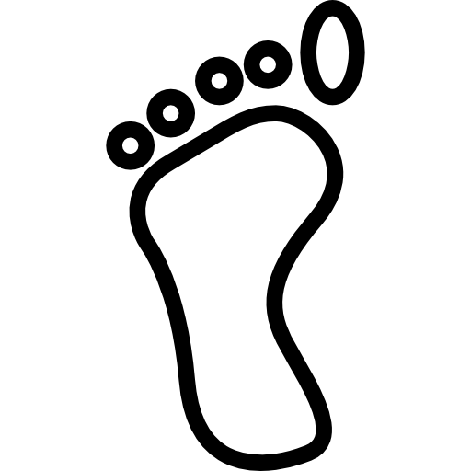

Nose Secretions
Throat Secretions
Blister Fluid Stool

Prevention

Wash your hands with soap and water, especially after:

- Changing a diaper
- Using tissues
- Feeding children
Clean and disinfect frequently touched surfaces, including:

- Doorknobs
- Toys
- Counters
Avoid close contact. Do not:

- Touch open blisters
- Hug or kiss a person with HFMD
- Share utensils

People with HFMD should cover their mouth and nose when sneezing or coughing.

For More Information:

Visit: www.cdc.gov/hand-foot-mouth
You can also call Maine CDC at 1-800-821-5821.

Updated October 2018 Icons from www.flaticon.com

