Fifth Disease
Fact Sheet

Fifth disease is a mild rash illness caused by parvovirus B19. It is more common in children than adults.

Parvovirus B19 spreads through coughing and sneezing. It can also spread through blood.

Common Signs and Symptoms

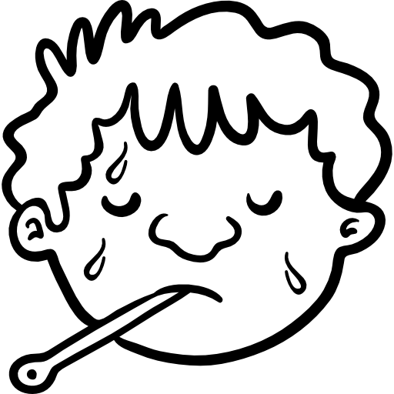

Rash on the Cheeks
Fever
Headache

Signs and symptoms also include a runny nose, joint pain, and joint swelling. The most recognized symptom is a red rash on the face called “slapped cheek” rash. Some people develop a second rash on their chest, buttocks, or arms and legs.

Prevention

Wash hands with soap and water
Cover your nose and mouth with a tissue or sleeve when coughing or sneezing

For More Information
Visit www.cdc.gov/parvovirusb19.
You can also call Maine CDC at 1-800-821-5821.

Updated November 2018 Icons from www.flaticon.com

