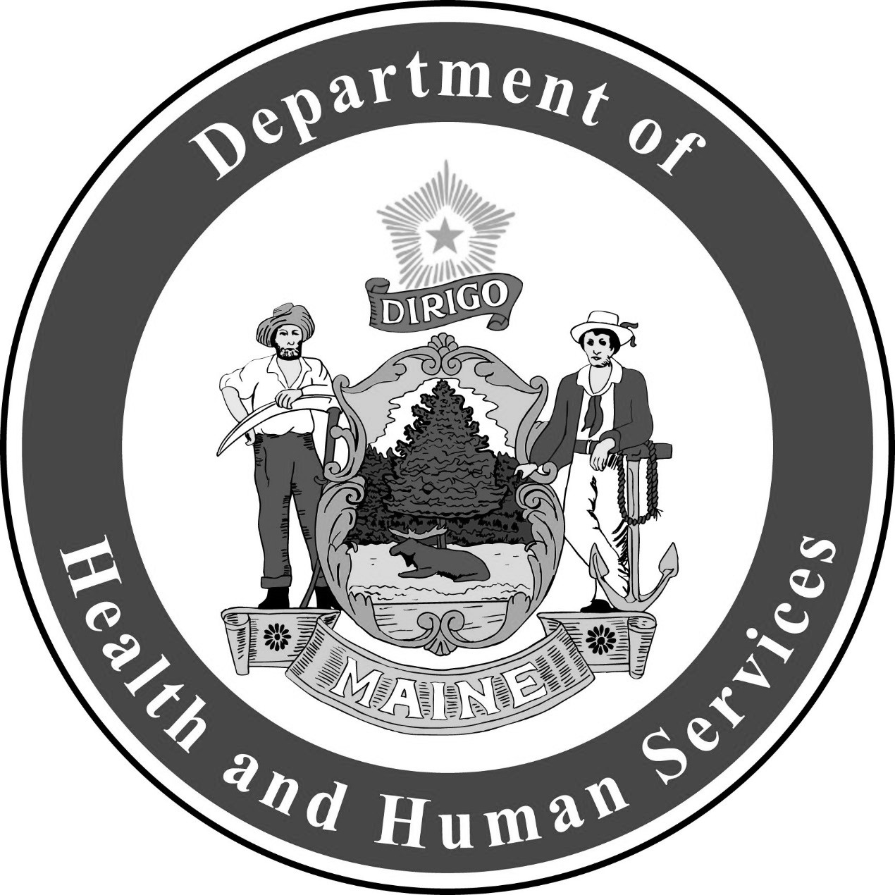
Cryptosporidiosis
Fact Sheet

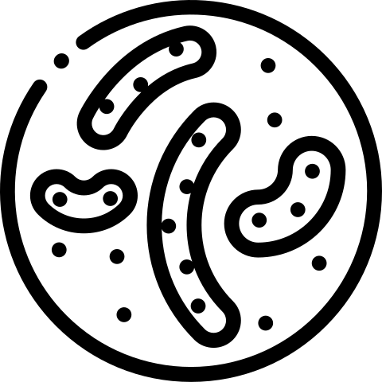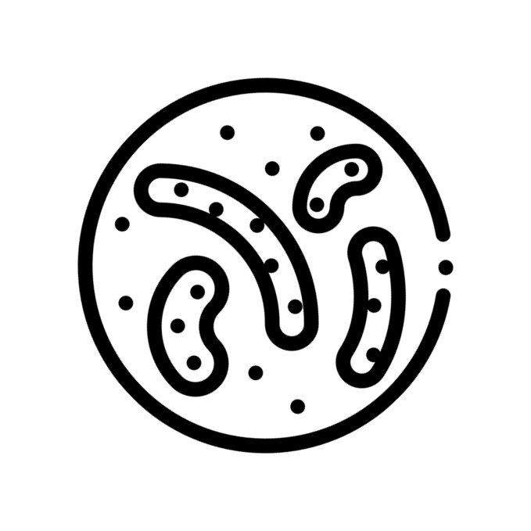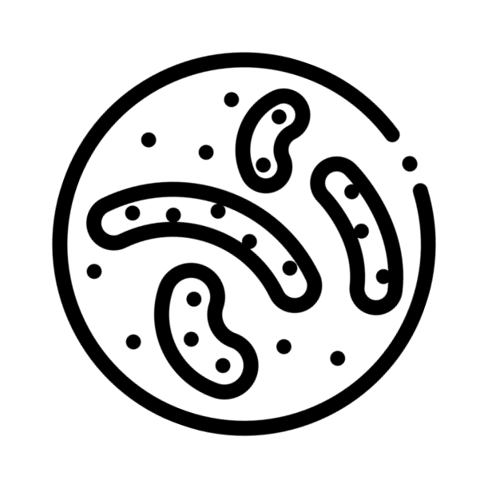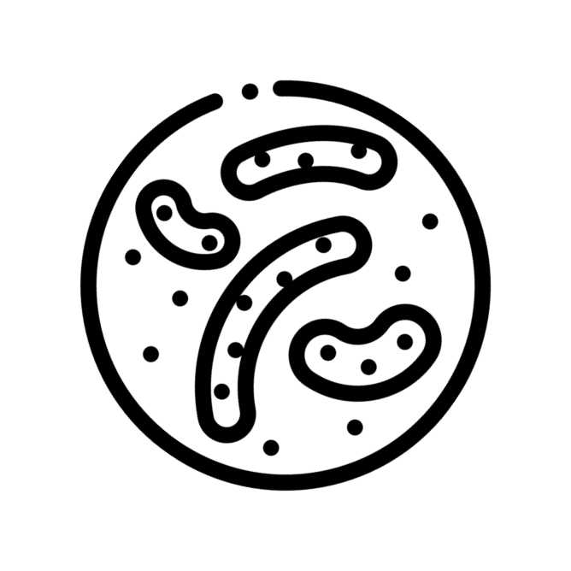Cryptosporidiosis (Crypto) is caused by a parasite called Cryptosporidium. The parasite has a hard outer shell, so it can live outside the body for a long time and is very hard to kill.
The parasite lives in the intestines of people and animals. An infected animal passes the parasite in their stool. People get the disease when they swallow the parasite.

Common Signs and Symptoms

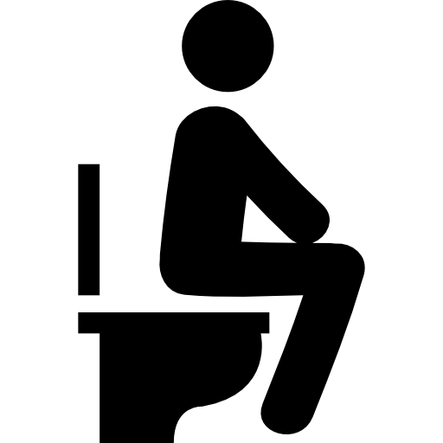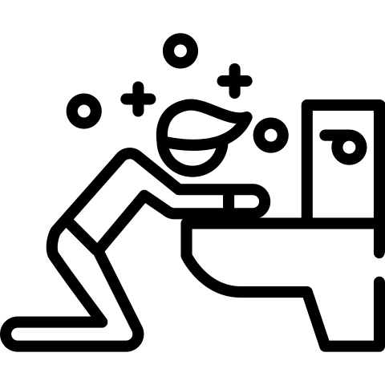

Diarrhea
Nausea and Vomiting
Stomach Pain
Fever

The most common symptom is watery diarrhea. Dehydration and weight loss are also common symptoms. Signs and symptoms usually start two to ten days after swallowing the
parasite. Symptoms last one to two weeks, but can range from a few days to four or more weeks. Symptoms may get better and then get bad again before they finally go away. Some infected people do not have any symptoms.
People with weakened immune systems may develop serious, chronic, and sometimes fatal illness.

Work as food handlers or cooks
Provide direct patient care Attend daycare or school
Talk to your doctor if you think you have Crypto. Your doctor may ask for a stool samples to send to a laboratory. Most people do not need treatment.
Drink plenty of liquids to prevent dehydration. Rapid loss of fluids from diarrhea can lead to death in babies. Talk to your doctor about fluid replacement therapy options for infants.

Until 24 hours after diarrhea stops, people with Crypto should not:

Spread of Cryptosporidiosis
Crypto can spread by:

Eating Contaminated Food
Swallowing Contaminated Water or Beverages
Swallowing Contaminated Recreational Water
Contact With Contaminated Stool

Crypto can be found in soil, food, water, or on contaminated surfaces. Crypto also spreads by touching your mouth with contaminated hands. Do not swim if you have diarrhea. Children in diapers should not be in the water if they have diarrhea.

Prevent Cryptosporidiosis
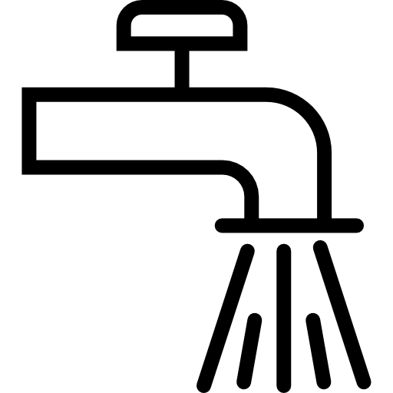
RAW MILK

Wash your hands with soap and water
Do not drink raw milk or unpasteurized juices
Wash all fruits and vegetables before eating

Always wash your hands with soap and water:
Before eating, preparing food, and after preparing food After using the toilet or changing diapers
After touching animals, animal living spaces, and animal waste After gardening

For More Information, Visit:
- www.maine.gov/dhhs/crypto
- www.cdc.gov/crypto

You can also call Maine CDC at 1-800-821-5821.

Updated February 2019 Icons from www.flaticon.com

