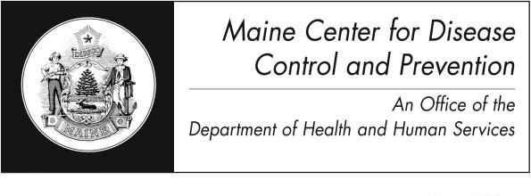
Anthrax
Fact Sheet

What is anthrax?
Anthrax is a disease of humans and animals caused by bacteria called Bacillus anthracis. The bacteria can form a type of shell, called a “spore,” that allows them to survive for years in the environment.

How is it spread?
These bacteria are found naturally in the soil, so animals that feed on grass and plants (e.g. cattle, sheep, goats, horses, etc.) can carry the bacteria.

Anthrax is not known to spread from person to person. Humans become infected with anthrax:
- when spores enter a cut, or break in the skin
- by eating undercooked meat from infected animals
- by breathing in the spores
- by injecting illicit contaminated drugs
Humans can come into contact with anthrax by handling wool, hides, or other animal products from infected animals. Naturally occurring cases of anthrax are very rare in the United States.

Anthrax spores could be used as a biological weapon. During the anthrax attacks in 2001, people got anthrax from handling mail that had spores in it. The most serious form of the disease occurs when anthrax spores are breathed in. Due to this, the release of the bacteria in a crowded area is of great concern.

What are the symptoms?
The symptoms and type of illness depend on how a person is exposed to the bacteria. There are four types of anthrax infections:
- Skin: The first symptom is a small sore that develops into a blister. The blister then turns into a skin ulcer with a black area in the center. The sore, blister and ulcer do not hurt. Five to 20% of infected people die if left untreated. With treatment, death is rare.
- Gastrointestinal: The first symptoms are nausea, loss of appetite, bloody diarrhea, and fever, followed by stomach or lower belly pain. 25% to 60% of cases result in death.
- Inhalation: The first symptoms of this type of anthrax are cold or flu like symptoms and can include a sore throat, mild fever and muscle aches. Later symptoms include cough, chest pain, shortness of breath, tiredness and muscle aches. This type of anthrax is usually fatal.

- Injection: Injection drugs contaminated with anthrax can cause infection. Symptoms can be similar to skin anthrax.

How soon do infected people get sick?
Symptoms of any type of anthrax can appear within 7 days of contact with the bacteria. Symptoms of the inhalation type of disease can take between a week and up to 60 days to appear.

How would a person know they have anthrax?
It is diagnosed when a lab finds the bacteria or specific markers of the bacteria in a sample of a person’s blood, skin sore, or lung fluids.

How is it treated?
Antibiotics, usually given for 60 days, are used to treat all four types of infection. Early identification and treatment are important. Success depends on the type of infection and how soon treatment begins.

Can it be prevented?
If a person has been exposed to anthrax, but is not yet sick, a doctor may use antibiotics and the anthrax vaccine to prevent infection. This treatment works best when started quickly.

Is there a vaccine against anthrax?
Yes, but vaccination is only recommended for those at high risk, such as military personal and workers in research labs that handle anthrax bacteria routinely.

Should I keep antibiotics on hand just in case of an anthrax attack?> >>>>>>>>>>>>>>
No. In an emergency, state and federal health officials can ship antibiotics from their stockpiles to areas where they are needed.
If a person has anthrax, do they need to stay out of work or school?
No. It is not known to spread from person to person. However, infected people should follow their doctor’s instructions.

What should I do if I think I have been exposed to anthrax?
Contact local police immediately if you think that you may have been exposed to anthrax on purpose. This includes handling a suspicious package or envelope that contains a powder. If you believe you have been exposed and you are showing signs of anthrax, seek medical help immediately.

Where can I get more information?
For more information contact your healthcare provider or local health center. You can also contact the Maine Center for Disease Control and Prevention by calling 1-800-821-5821 or visiting the website www.maine.gov/idepi. The federal Centers for Disease Control and Prevention website - http://www.cdc.gov – is another excellent source of health information.

