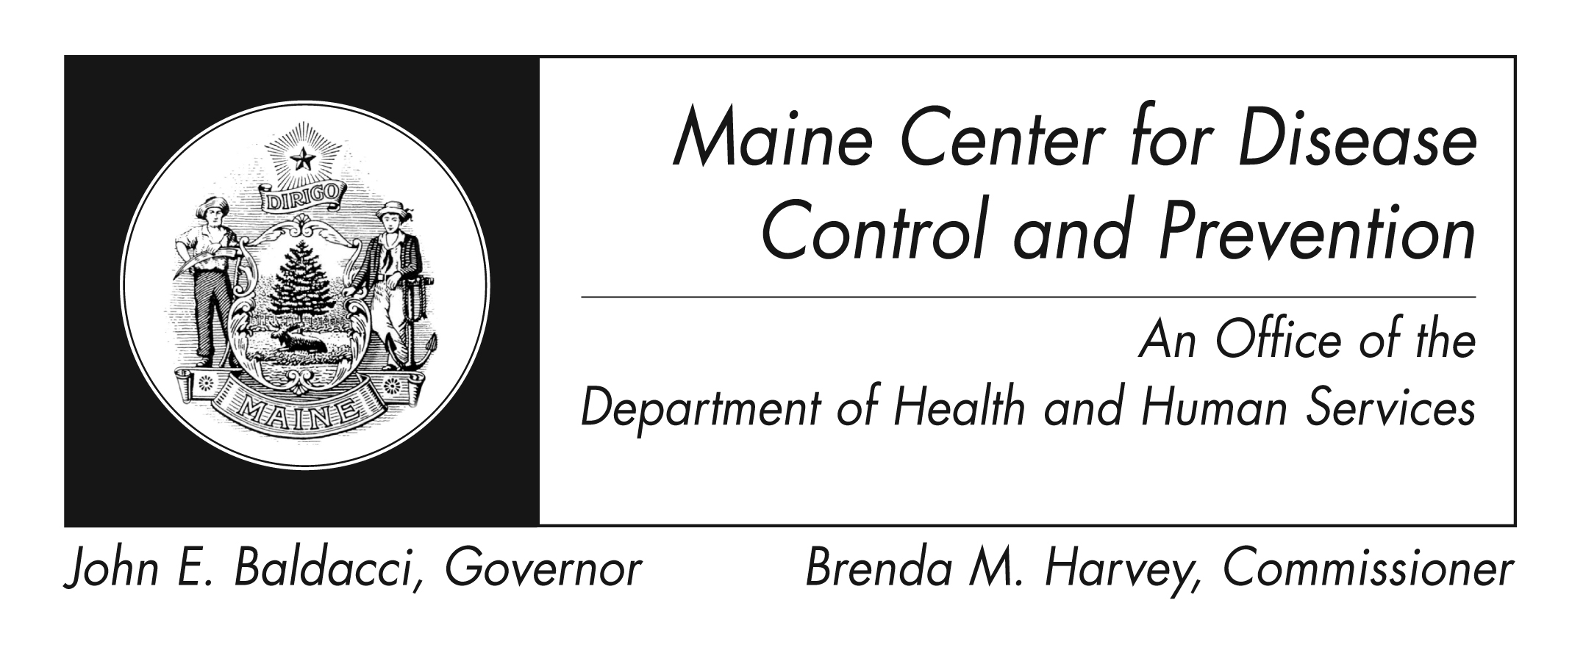
Mold
Fact Sheet

What are molds?

Molds are very small living organisms that are found indoors and outdoors. There are many different types of mold. Molds grow best in warm, damp, and humid conditions and can spread and increase in numbers by making spores. Spores help the mold to survive even in dry conditions. Some common molds include Cladosporium, Penicillium and Aspergillus.

Where are molds found?
Molds are found year round. Indoor mold grows best in warm and humid places such as in bathrooms, kitchens and laundry areas.

Can mold harm me?

Some people are more easily harmed by mold than others. Mold can cause you to have a stuffy nose, itchy, watery or red eyes, irritated skin, or difficulty breathing. If you are allergic to molds, you may have a worse reaction and may have a fever or find it hard to breath. If you have certain lung diseases, such as obstructive lung disease, you could develop a mold infection in your lungs.

How can I reduce mold exposure?
If you are sensitive to mold you should stay away from outdoor areas that are likely to have mold, such as compost piles, cut grass, and wooded areas. You can slow the growth of mold in your home by keeping the inside air dry. You can reduce the dampness in your home by:
- Ventilating bathrooms with showers and bathtubs and in the kitchen (cooking areas).
- Keeping basement windows closed to prevent warm humid air from entering.
- Using an air conditioner or dehumidifier during humid months.
- Making sure there is good ventilation such as fans, if exhaust fans are not installed.
- Adding mold inhibitor to paint, which slow the growth of mold, before painting.
- Cleaning bathrooms with mold killing products.
- Fixing water leaks that cause the mold and making sure you clean up the mold

How can I remove mold from my home? Mold growth can be removed from hard surfaces with commercial products, soap and water. Bleach does not remove the mold any better than a detergent.
If you choose to use bleach to clean up mold:
- Never mix bleach with ammonia or other household cleaners. Mixing bleach with ammonia or other cleaning products will produce dangerous, harmful fumes.
- Open windows and doors to provide fresh air.
- Wear non-porous gloves and protective eye wear.
- If the area to be cleaned is more than 10 square feet, see the U.S. Environmental Protection Agency (EPA) guide titled Mold Remediation in Schools and Commercial Buildings. Although written for schools and commercial buildings, this document also applies to other building types. This guide can be found at http://www.epa.gov/mold/mold_remediation.html. Always follow the manufacturer’s directions when using bleach or any other cleaning product.

Should I have the mold that is growing in my home tested?
Check with your healthcare provider. Maine Center for Disease Control and Prevention (Maine CDC) does not recommend regular testing for molds unless recommended by your health care provider.

A qualified environmental lab took samples of the mold in my home and gave me the results. Can Maine CDC tell me what these results mean?

No. There are no guidelines for judging what is a normal or acceptable amount of mold. Before you decide to have environmental sampling for molds done, you should ask the people who will do the work what kind of information they will be giving you about the results.

What type of doctor should I see concerning mold exposure?
You should first consult a family or general health care provider who will decide whether you need referral to a specialist.

My landlord or builder will not take any responsibility for cleaning up the mold in my home. Where can I go for help? If you feel your property owner, landlord, or builder has not responded to your concerns about mold where you are living, you can contact your Local Health Officer or Code Enforcement Officer. Maine law can protect you if a landlord will not repair a condition that is in violation to the “Warranty of Habitability.” http://www.ptla.org/cliented/tenants6.htm

What should I do if I think mold in my workplace is making me sick?
If you think you are ill because of exposure to mold in the building where you work, you should first speak to your health care provider to find out what to do to protect your health. Tell your employer and union representative, if you have one, about your concern.

What should I do if I am worried about mold in my children’s school and how it affects their health?
If you believe your children are ill because of exposure to mold in their school, you should first consult their health care provider to find out what to do to protect their health. Contact the school’s administration to express your concern. If needed, you could also contact the local school board.

Where can I get more information?

For more information contact Maine Center for Disease Control (Maine CDC) Office of Local Public Health at 1-207-287-6227 or Maine CDC Disease Reporting and Consultation at 1-800-821-5821 or visit the website http://www.mainepublichealth.gov

Additional information can be found at:
- Federal CDC: Facts About Mold and Dampness http://www.cdc.gov/mold/dampness_facts. html
- The Maine Indoor Air Quality Association http://www.miaqc.org has many references that can help.
- U.S. Environmental Protection Agency (EPA) guidelines, Mold Remediation in Schools and Commercial Buildings, http://www.epa.gov/iaq/molds/mold_remediation.html
- EPA’s IAQ Tools for Schools Action Kit http://www.epa.gov/iaq/schools/tfs/guidtoc. html
- An energy auditor can be found on line at http://www.efficiencymaine.com/residential_programs.htm

- Maine Coalition of Home Inspection Professionals – MeCHIPS http://www.mechips.org/
- WHO Guidelines for Indoor Air Quality: Dampness and Mould http://www.euro.who.int/en/what-we-do/health-topics/environmental-health/air-quality/publications/2009/who-guidelines-for-indoor-air-quality-dampness-and-mould

