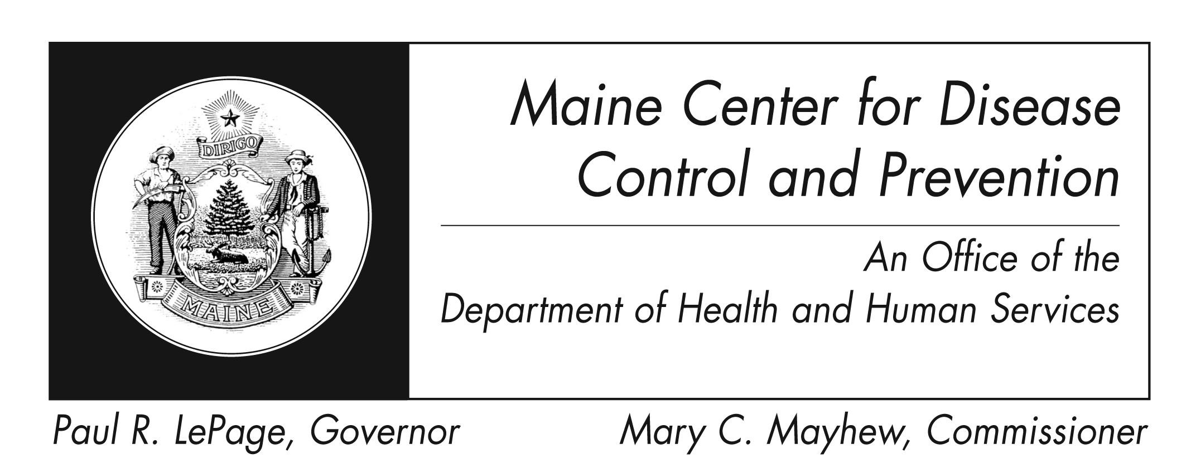
Group B Streptococcus
Fact Sheet

What is group B Streptococcus?
Group B streptococcus (group B strep) is a type of bacteria that causes illness in newborn babies, pregnant women, the elderly, and adults with other illnesses, such as diabetes or liver disease. Group B strep is the most common cause of life-threatening infections in newborns.

How does group B strep affect newborns?
Most cases of group B strep disease among newborns happen in the first week of life ("early-onset disease"), usually a few hours after birth. Infection of the blood, lungs and fluid and lining around the brain (meningitis) are the most common problems. Group B strep disease may also develop in infants one week to several months after birth ("late-onset disease"). Meningitis is more common with late-onset group B strep disease.

How is group B strep diagnosed and treated in babies?
If a mother received antibiotics for group B strep during labor, the baby will be watched to see if he or she should get extra testing or treatment. If the doctors suspect that a baby has group B strep infection, they will take a sample of the baby’s sterile body fluids, such as blood or spinal fluid. Group B strep infections in both newborns and adults are usually treated with antibiotics.
Can group B strep be prevented among newborns?
Yes! Most early-onset group B strep disease in newborns can be prevented by giving pregnant women antibiotics during labor. Any pregnant woman who had a previous baby with group B strep disease, who has a bladder (urinary tract) infection caused by group B strep, or who tests positive for group B strep during pregnancy should receive antibiotics during labor or when their water breaks.

How do you find out if you carry group B strep during pregnancy?
National guidelines recommend that a pregnant woman be tested for group B strep in her vagina and rectum when she is 35 to 37 weeks pregnant. The test is simple and does not hurt. A sterile swab (“Q-tip”) is used to collect a sample from the vagina and the rectum. This is sent to a laboratory for testing.

What happens if my pregnancy screening test is positive for group B strep?
To prevent group B strep bacteria from being passed to the newborn, pregnant women who carry group B strep should be given antibiotics at the time of labor or when their water breaks.

Are there any symptoms if you are a group B strep carrier?
Most pregnant women have no symptoms when they are carriers for group B strep bacteria. Sometimes, group B strep can cause bladder infections during pregnancy or infections in the womb during labor or after delivery.

Being a carrier (testing positive for group B strep, but having no symptoms) is quite common. Around 25% of women may carry the bacteria at any time. This does not mean that they have group B strep disease, but it does mean that they are at higher risk for giving their baby a group B strep infection during birth.

What should I do if my water breaks early?
If your water breaks before term, get to the hospital right away. If your group B strep test has not been done, or if you don’t know if you have been tested, you should talk with your doctor about group B strep disease prevention. If you have already tested positive for group B strep, remind the doctors and nurses during labor.

Where can I get more information?
For more information contact your healthcare provider or local health center. You can also contact the Maine Center for Disease Control and Prevention by calling 1-800-821-5821. The federal Centers for Disease Control and Prevention website - http://www.cdc.gov – is another excellent source of health information.

