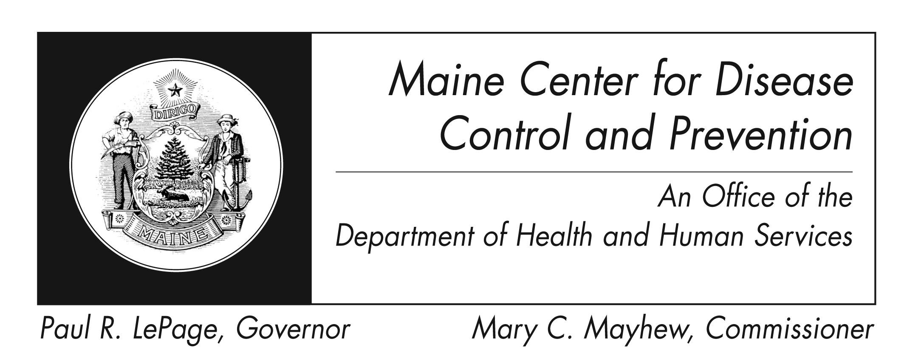

Enterovirus D68 Infection
Fact Sheet

What are non-polio enteroviruses?
Non-polio enteroviruses are very common and can infect anyone. They cause about 10 to 15 million infections in the United States each year.

What is enterovirus D68?

Enterovirus D68 (EV-D68) is one of about 100 types of enteroviruses. This virus was first identified in California in 1962, but it had not been commonly reported in the United States until outbreaks were reported in 2014.

How does the virus spread?

EV-D68 likely spreads from person to person when an infected person coughs, sneezes, or touches contaminated surfaces.

What are the symptoms of EV-D68 infection? EV-D68 can cause mild to severe respiratory illness. Mild symptoms may include fever, runny nose, sneezing, cough, and body and muscle aches. Most of the very ill children with EV-D68 infection in 2014 had difficulty breathing, and some had wheezing. Many of these children had asthma or a history of wheezing.

Respiratory illnesses can be caused by many different viruses and have similar symptoms. Anyone with respiratory illness should contact their doctor if they are having difficulty breathing, or if their symptoms are getting worse.

What time of the year are people most likely to get infected?

In general, the spread of these viruses is often quite unpredictable. In the United States, people are more likely to get these infections in the summer and fall.

Who is at risk?

Infants, children, and teenagers are most likely to get infected with enteroviruses and become ill. That is because they do not yet have immunity (protection) from previous exposure to these viruses. This is likely also true for EV-D68.

Children with asthma may have a higher risk for severe respiratory illness.

How is it diagnosed?

Specific lab tests on specimens from a person’s nose, throat or other bodily fluids need to be ordered by a medical provider. Many labs can test ill patients to see if they have enterovirus infection. However, most cannot do specific testing to determine the type of enterovirus, like EV-D68. CDC can do this sort of testing.

CDC recommends that providers only consider EV-D68 testing for patients with severe respiratory illness when the cause is unclear and the patient’s screening test is positive for enterovirus.

What are the treatments?

There is no specific treatment for people with respiratory illness caused by EV-D68. For mild respiratory illness, you can help relieve symptoms by taking over-the-counter medications for pain and fever. Aspirin should not be given to children. Some people with severe respiratory illness may need to be hospitalized.

Are there vaccines to prevent enteroviral infections?
No vaccines are available to prevent enteroviral infections.

How can I protect myself?

You can help protect yourself from respiratory illnesses by following these steps:
- Wash hands often with soap and warm water for 20 seconds; hand sanitizer will not kill enteroviruses
- Avoid touching eyes, nose, and mouth with unwashed hands
- Avoid kissing, hugging, and sharing cups or eating utensils with people who are sick
- Avoid close contact with sick people
- Cover your mouth and nose with a tissue when you cough or sneeze
- Put your used tissue in the waste basket
- If you don't have a tissue, cough or sneeze into your upper sleeve or elbow, not your hands
- Disinfect surfaces that are touched often, such as toys and doorknobs, especially if someone is sick
- Clean and disinfect surfaces with bleach
- Stay home from work, school and other activities when you’re sick
Where can I get more information?
For more information contact your healthcare provider or local health center. You can also contact Maine Center for Disease Control and Prevention by calling 1-800-821-5821 or visiting the website http://www.maine.gov/idepi. The federal Centers for Disease Control and Prevention website - http://www.cdc.gov is another excellent source of health information.

