 | Infectious Disease Epidemiology Report  Cryptosporidiosis Surveillance Report- Maine, 2006

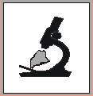

Introduction
Cryptosporidiosis, a diarrheal disease caused by parasites of the genus Cryptosporidium, is recognized as a leading cause of waterborne disease in the United States. It is transmitted through the fecal-oral route and can cause severe diarrhea, accompanied by abdominal cramps, nausea, vomiting, weight loss, and low-grade fever. This report provides a summary of the 2006 surveillance on Cryptosporidium infections reported to the Maine Center for Disease Control and Prevention (Maine CDC).

Methods
Cryptosporidiosis is a reportable disease in Maine. For surveillance purposes, cryptosporidiosis is defined as demonstration (in symptomatic or asymptomatic persons) of Cryptosporidium oocysts in intestinal contents; or antigens by immunodiagnostic methods or PCR techniques; or by demonstration of reproductive stages in tissue preparations. The Maine CDC collects surveillance data on all laboratory confirmed reports of Cryptosporidium infections. Maine-specific data presented here were extracted from the National Electronic Disease Surveillance System (NEDSS), a disease-reporting database. National level data are obtained from Morbidity and Mortality Weekly Reports (MMWR). Population denominators are based on 2000 census data.

Results
During 2006, a total of 52 confirmed cases of cryptosporidiosis were reported to the Maine CDC. This represents an overall rate of 4.1 cases per 100,000 population. Twenty-eight (53.9%) of the cases were female. The median age was 30 years with a range of 1 to 88 years. There were no deaths and there were two known overnight hospitalizations due to Cryptosporidium infection.

Five-Year Trend: The incidence of cryptosporidiosis in Maine has been rising over the last two years. The case rate for 2006 (4.1 per 100,000) was the highest since 2000 and was more than twice the five-year median case rate. Similarly, incidence at the national level in 2005 increased compared to previous years.

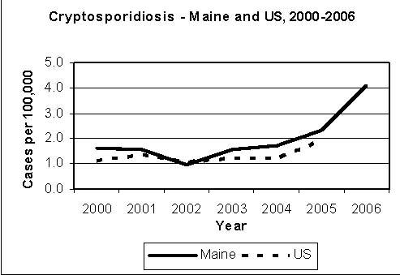

Distribution By Month: Cases of cryptosporidiosis occur year round, with an average of four cases per month reported. There was a general rise in cases in the summer months, although some of these cases can be explained by documented outbreaks.

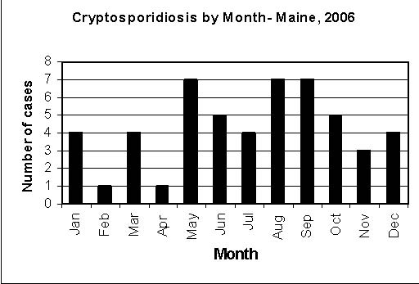

Distribution By County: In 2006, reports of cryptosporidiosis were received from 14 of 16 counties. There were no reports from Oxford County and Washington County. Kennebec County, Penobscot County, and Lincoln County had the three highest percentages of cases at 17.3%, 17.3% and 11.5%, respectively. Lincoln County recorded the highest case rate (17.8 per 100,000), followed by Piscataquis County and Waldo County at 17.4 and 8.3 per 100,000, respectively.

Cryptosporidiosis by County - Maine, 2006
County | Cases | Rate§ | Percentage
Androscoggin | 4 | 3.9 | 7.7
Aroostook | 1 | 1.4 | 1.9
Cumberland | 2 | 0.8 | 3.8
Franklin | 1 | 3.4 | 1.9
Hancock | 4 | 7.7 | 7.7
Kennebec | 9 | 7.7 | 17.3
Knox | 2 | 5.0 | 3.8
Lincoln | 6 | 17.8 | 11.5
Oxford | 0 | 0.0 | 0.0
Penobscot | 9 | 6.2 | 17.3
Piscataquis | 3 | 17.4 | 5.8
Sagadahoc | 2 | 5.7 | 3.8
Somerset | 3 | 5.9 | 5.8
Waldo | 3 | 8.3 | 5.8
Washington | 0 | 0.0 | 0.0
York | 3 | 1.6 | 5.8

§Cases per 100,000 population

Case Rates By Age Group: Cryptosporidiosis affects people of all ages. Nonetheless, children under five years of age appear to have the greatest risk of infection (7.1 cases per 100,000). This is consistent with national trends. Another higher-risk group was adults between the ages of 25 and 39.

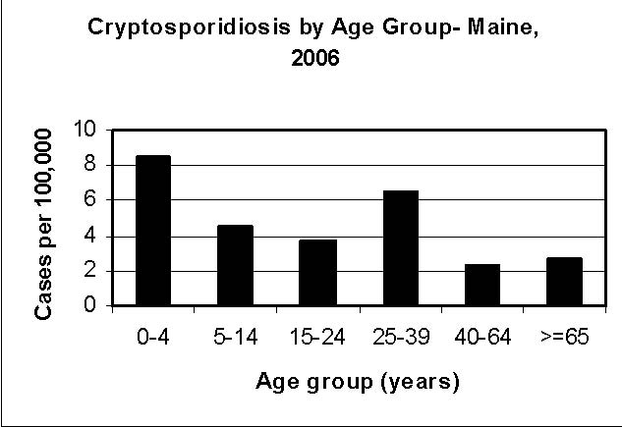

Outbreaks: In 2006, there were a total of three outbreaks associated with cryptosporidiosis. Seven (13.5%) of the 52 confirmed cases were related to these outbreaks. In addition, more than 20 probable1 cases were identified with these outbreaks. The outbreaks occurred in May, July, and October and involved farms, camp settings and an animal auction.

Discussion and Recommendations
The incidence of crytposporidiosis in Maine was somewhat steady over the period from 2000 to 2004. In the last two years, however, we have seen a substantial increase in the number of cases reported to the Maine CDC. Most of these reports were sporadic cases, but 13.5% were related to outbreaks. Nationwide, outbreaks of Cryptosporidium infections are not uncommon. In Maine, very few cryptosporidiosis outbreaks had been documented prior to 2006. It remains to be seen whether the observed changes are reflective of improved detection or actual changes in infections caused by Cryptosporidium.

Cryptosporidium lives in the intestine of infected humans or animals from where it is released during bowel movements. Excreted oocysts are found in soil, food, water or surfaces that have been contaminated with infected animal or human feces. Infection results from the consumption of contaminated food or water, or through person-to-person or animal-to-person transmission. The infection dose is low and healthy individuals are known to get sick from ingesting as few as 10-30 oocysts.

The fact that most cases occur during the warm months is not surprising. Summer and fall coincide with increased outdoor activities such as recreational swimming, camping, trips to farms, and visits to agricultural fairs and petting zoos. These activities present various opportunities for children and adults alike to come into contact with parasites that cause diseases including cryptosporidiosis. Persons who engage in outdoor activities or use group bathing facilities such as pools, spas or hot tubs are strongly encouraged to practice good personal hygiene (i.e. hand washing, not swimming if they have diarrhea, etc) and to avoid water that might be contaminated.

Prepared by:
Anthony K. Yartel, MPH
Anthony.yartel@maine.gov
http://www.MainePublicHealth.gov
1 There is no probable case classification for cryptosporidiosis at the national or state level. In outbreak settings, however, a probable case may be defined as a clinically compatible case that is epidemiologically linked to a confirmed case.

