Background

In June 1974 the state of Maine adopted a comprehensive set of rules covering the design, siting, permitting, and construction of septic systems, or as they are called today, subsurface wastewater disposal systems. These rules established criteria for site suitability, recognized various system components and construction techniques, required the use of a standard design form (HHE-200), and strengthened the system of permitting and inspecting systems at the local level.

The rules have evolved over time but retain many of the fundamental principles upon which the 1974 document was based. The most significant changes include licensing of all individuals preparing subsurface wastewater disposal system designs and implementation of a voluntary certification program for system installers.

Recently, the Department developed a voluntary program for inspection of existing systems. The following questions and answers provide an overview of that program.

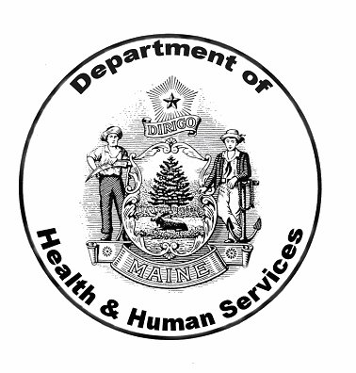

Maine Department of Health and Human Services
Division of Environmental Health
Subsurface Wastewater Program
286 Water Street, 3rd Floor
Augusta, ME 04333-0011
Phone: 207-287-5689
Fax: 207-287-3165
TTY: 207-287-5550
www.maine.gov/dhs/eng/plumb

Voluntary Subsurface Wastewater Disposal System Inspection Program

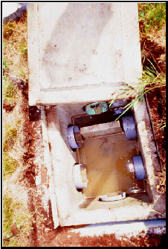

Division of Environmental Health
Subsurface Wastewater Program

Voluntary Subsurface Wastewater Disposal System Inspection Program

WHAT IS A SYSTEM INSPECTION?

The Department has established minimum criteria for evaluating and reporting on existing subsurface wastewater disposal systems. This voluntary program is being promoted as an important component of the real estate transaction process. The report criteria are not intended to provide a comprehensive evaluation of the various system components, or an analysis of site characteristics that are best evaluated by licensed site evaluators, but will provide the following important information:

1. Approximate age of the disposal system;

2. Verification that a design plan and plumbing permit exists or doesn’t exist;

3. A general description of the system components and their present condition;

4. A list of differences (if any) identified between the design plan and actual installation; and

5. Identification of any malfunctions or surface discharges needing correction under the current Rules.

The inspection is completed by an individual who has attended a voluntary certification program established by the Maine Department of Health and Human Services in cooperation with the Maine Department of Environmental Protection. The process includes a search of property owner, municipal, and state records and a visit to the property. The inspection report may include additional information beyond the minimum requirements and is the property of the inspector and the client. Copies are not provided to the municipality or the state by the inspector.

WHY ARE THEY DONE?

The voluntary inspection process is designed to provide the buyer and seller of property utilizing a subsurface wastewater disposal system with information regarding the age, status, and general condition of the system. The process will help identify those problems representing public health hazards such as system malfunctions and surface discharges that are required by law to be corrected; at a time when there are funds available to provide for a corrective action. The inspection program also provides assurances to the federal government that the state of Maine has adequate administrative controls relative to subsurface systems.

HOW DO I INTERPRET THE REPORT?

The report is structured in a checklist format to aid both the inspector and the client. Page 1 includes general information and the inspector’s findings and recommendations. The supplement to the report form contains descriptions of what YES, NO, UNKN, and N/A mean for each of the line items on page 2. Pages 3 and 4 include a list of problem areas found including a description of the specific problems and what corrective action, if any, is recommended by the inspector. The report may also include additional explanatory information provided by the inspector, along with photographs, sketches, and copies of existing design plans. Please read the disclaimer statement on page 1.

If the report indicates that corrective action is recommended, an existing or potential health threat has been identified and the property owner could be subject to administrative action if the problem is identified by the local plumbing inspector. If the report notes system deficiencies, but does not recommend corrective action, the deficiencies do not pose a health threat and do not require action by the property owner.

WHAT DO I DO WITH THE RESULTS?

As the buyer, the information contained in the report may be useful in negotiating a purchase price. If corrective actions are recommended, the costs could be incorporated into the final agreement. As the seller; the report information can be used to increase the value of your property by dealing with any problems in advance or documenting that no problems exist. Recipients of the report are not obligated to forward copies to any federal, state, or local officials.

WHERE DO I GO WITH QUESTIONS?

The first source of information is the inspector who completed your report. If you have questions regarding the format and intent of the state report form (HHE-240) you may contact us at 207 287-5689. Please note that we will not have a copy of your report to refer to and will not be able to comment on any observations, conclusions, or recommendations made by your inspector that go beyond the minimum criteria established by the Department of Health and Human Services.
Maine Department of Health and Human Services
Division of Environmental Health
Subsurface Wastewater Program
286 Water Street, 3rd Floor
Augusta, ME 04333-0011
Phone: 207-287-5689
Fax: 207-287-3165
TTY: 207-287-5550

